Lab 1: Cloud Virtualization and Data Center Architecture
Name : Ziad Muhammed
Group : SE2

Part A: VM vs Container
Comparison of resource usage between Virtual Machine and Docker Container.

VM Screenshot
Shows higher memory usage and many system processes.
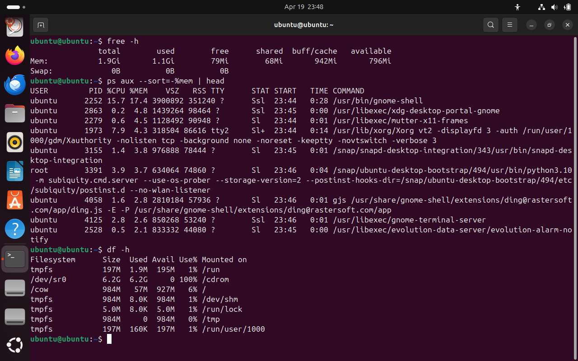

Container Screenshot
Shows minimal processes and lightweight resource usage.
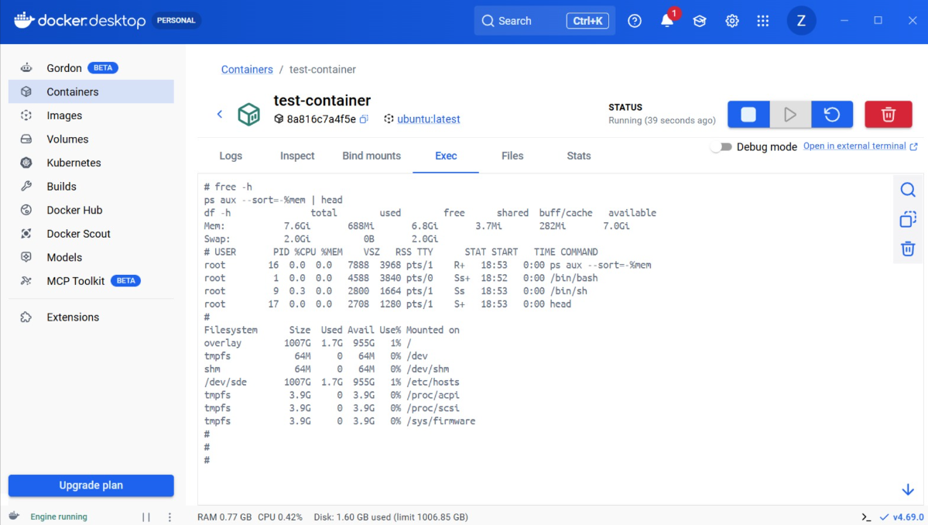

Conclusion
Containers are more efficient for microservices due to low resource usage and fast startup, while VMs provide stronger isolation.

Part B: Cloud Infrastructure
AWS EC2 instance was launched and inspected.

Nitro Check
Limited access to kernel logs demonstrates security isolation.

System Info
System identified as Amazon EC2 (t3.micro).
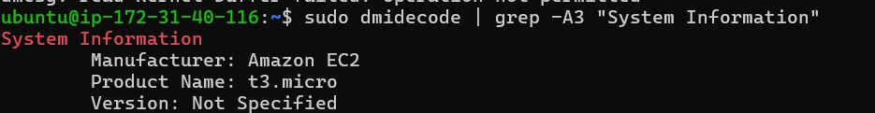

Top Command
Shows active processes and system performance.
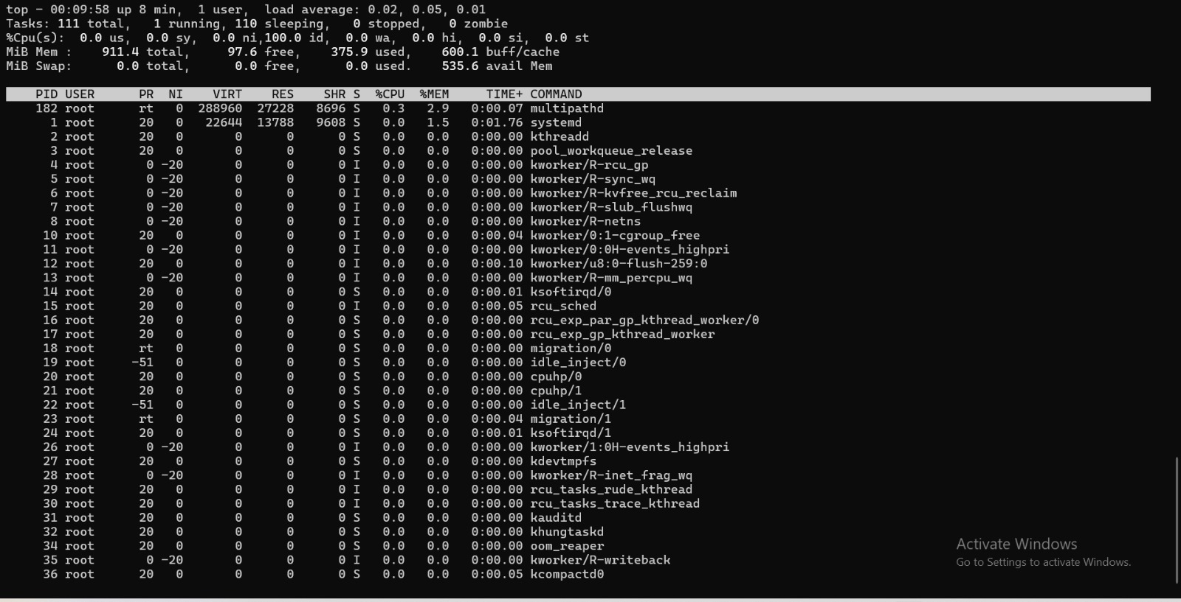

Part C: Tail Latency
Flask app tested with Apache Benchmark.

Results
Most requests were fast, but some were slow, demonstrating tail latency.
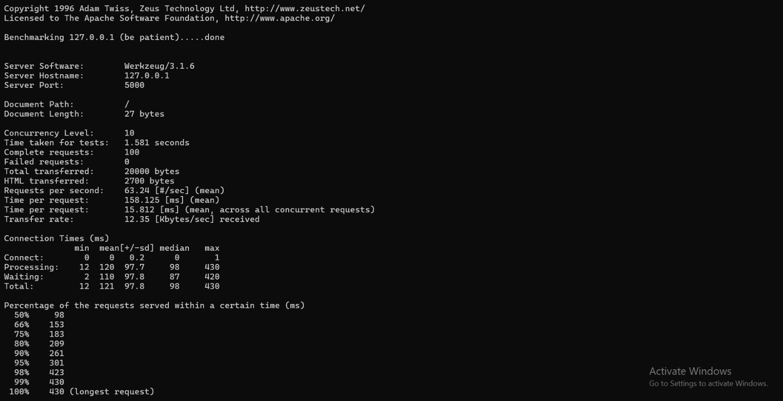

Conclusion
Tail latency increases with concurrency and affects performance.

Part D: Discussion Prompts Answers
1. Why does AWS split Nitro into hardware components?
AWS splits the Nitro system into dedicated hardware components to improve security, performance, and efficiency. By offloading tasks like networking, storage, and virtualization from the main CPU to specialized hardware, AWS reduces overhead, provides stronger isolation between tenants, and minimizes the attack surface. This ensures better performance and security.
2. In which scenarios would you use VMs over containers?
Virtual Machines are preferred when strong isolation is required, when running different operating systems, for legacy applications that cannot be containerized, or when strict security and compliance requirements exist. VMs provide a full OS environment, making them suitable for these cases.
3. How does tail latency change with the number of parallel calls?
Tail latency increases as the number of parallel requests increases. This is due to resource contention, queueing delays, and variability in processing times. As concurrency grows, a small percentage of requests become much slower, which impacts overall system performance.

