Lab 2: Distributed Consistency and Consensus
Name : Ziad Muhammed
Group : SE2

Part A: Redis Replication
This screenshot shows writing data to redis-node1 (master). The key 'student' was set and retrieved successfully, confirming the write operation on the master node.
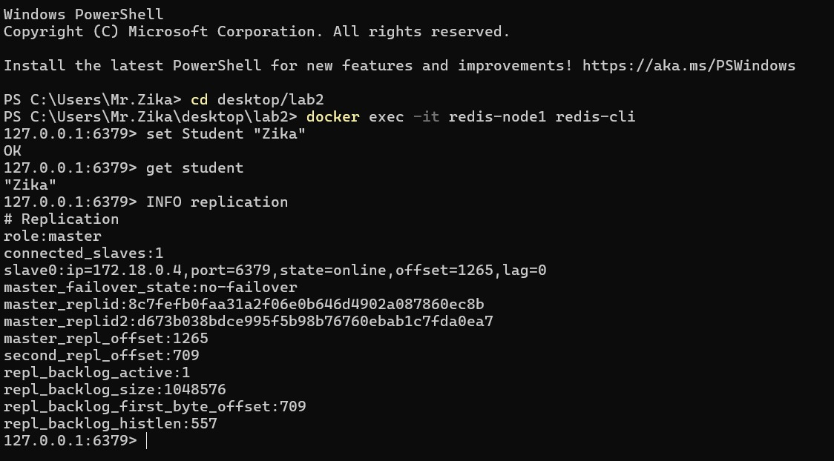

Part A: Replica Verification
This screenshot shows redis-node2 acting as a replica. The same key 'student' was retrieved successfully, proving replication from master to replica.
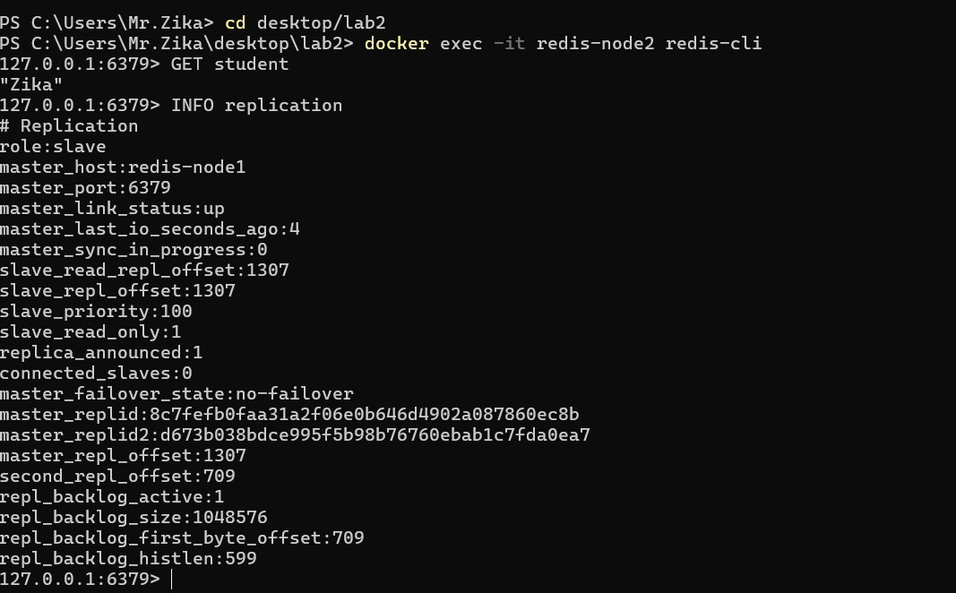

Part A: Network Partition Recovery
This screenshot shows redis-node2 after being stopped and restarted. The keys 'city' and 'course' were successfully synchronized, demonstrating eventual consistency after recovery.
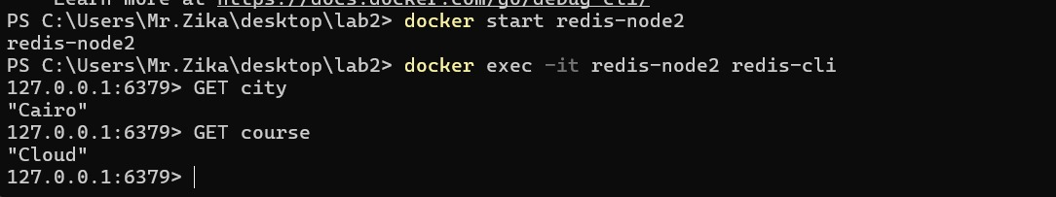

Part B: etcd Key-Value Operations
This screenshot shows etcd operations using etcdctl. A key-value pair (foo=bar) was stored and retrieved successfully, and endpoint status was checked to inspect the node state.
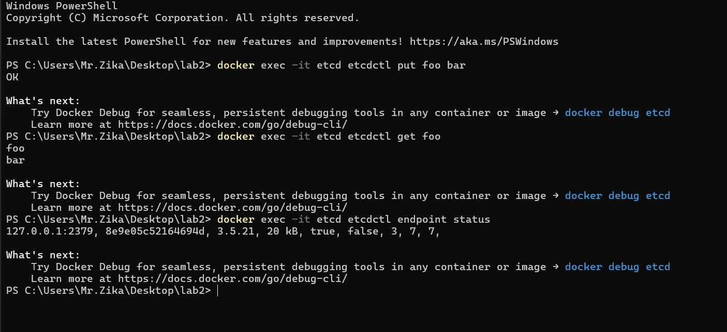

Conclusion
This lab demonstrated how distributed systems handle replication and consistency using Redis, and how etcd manages data using the Raft consensus model. Redis showed eventual consistency during network partitions, while etcd provided reliable key-value storage and system status monitoring.

