Lab 3: Containerization and Cluster Orchestration
Name : Ziad Muhammed
Group : SE2

Part A
Container environment showing isolated hostname, processes, and filesystem (Namespaces).
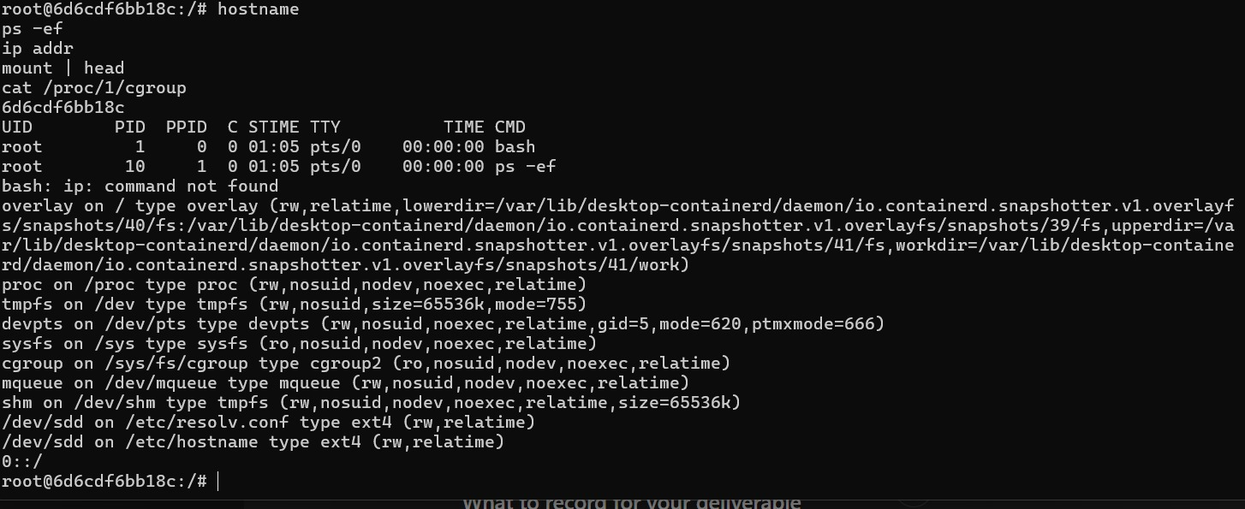

Part A
Docker container inspection and PID difference between host and container (PID Namespace).
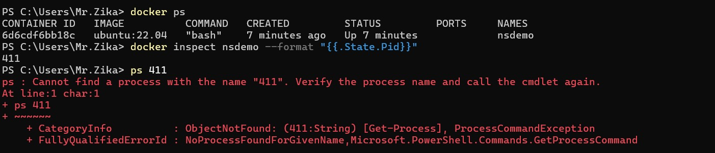

Part A
Docker stats showing CPU and memory limits using cgroups.

Part B
Docker image history for basic image showing layered structure.
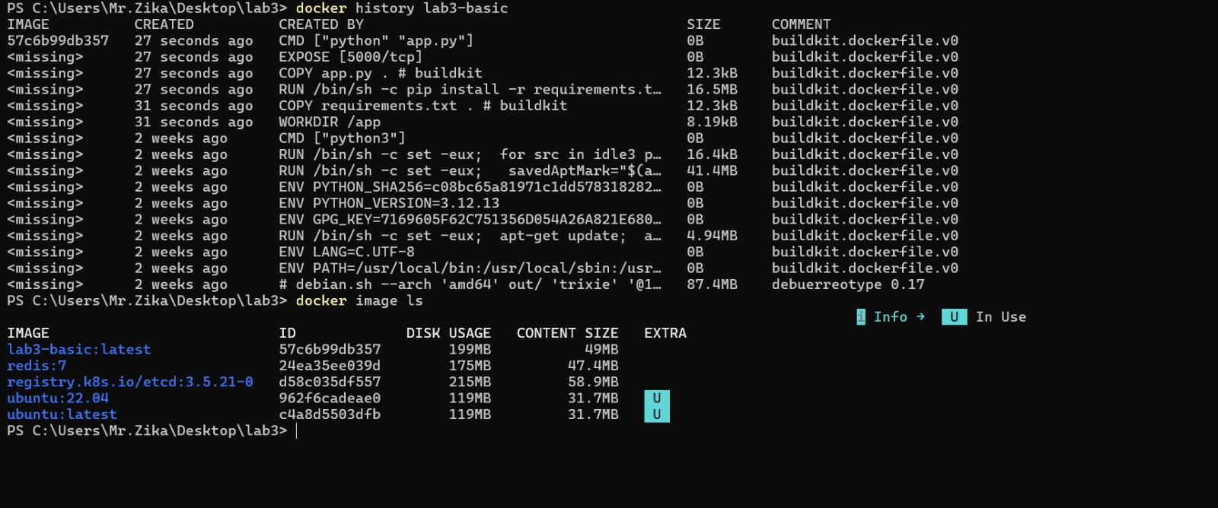

Part B
Docker image list comparing sizes of built images.
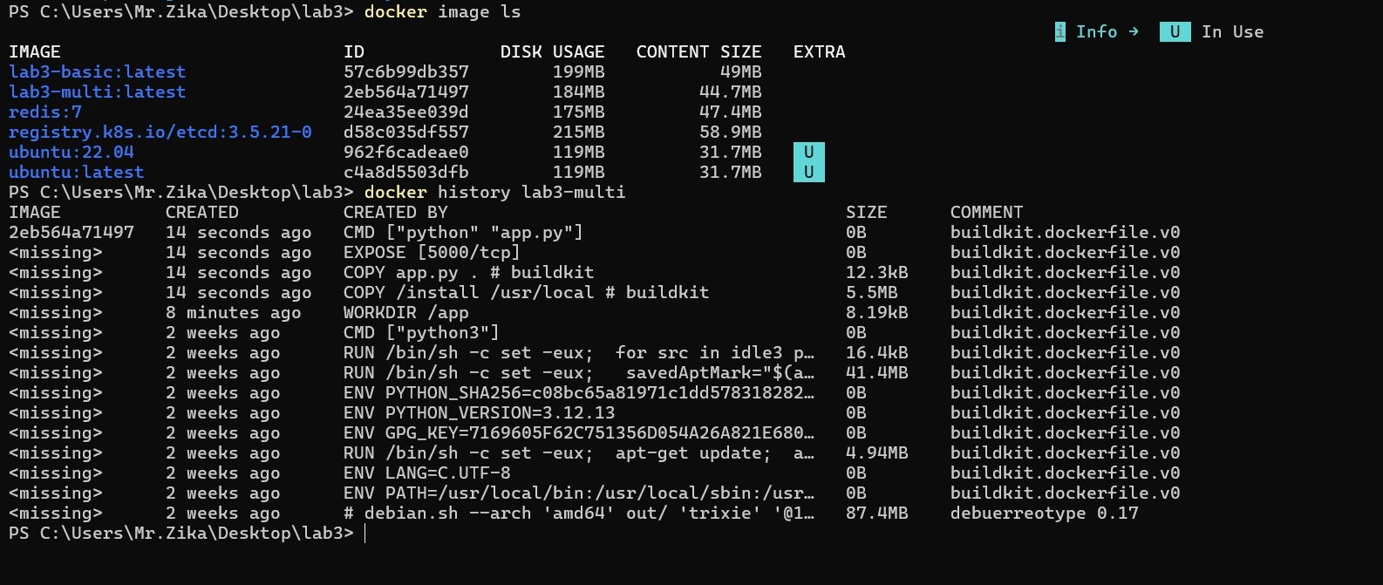

Part B
Docker multi-stage build history showing optimized layers.
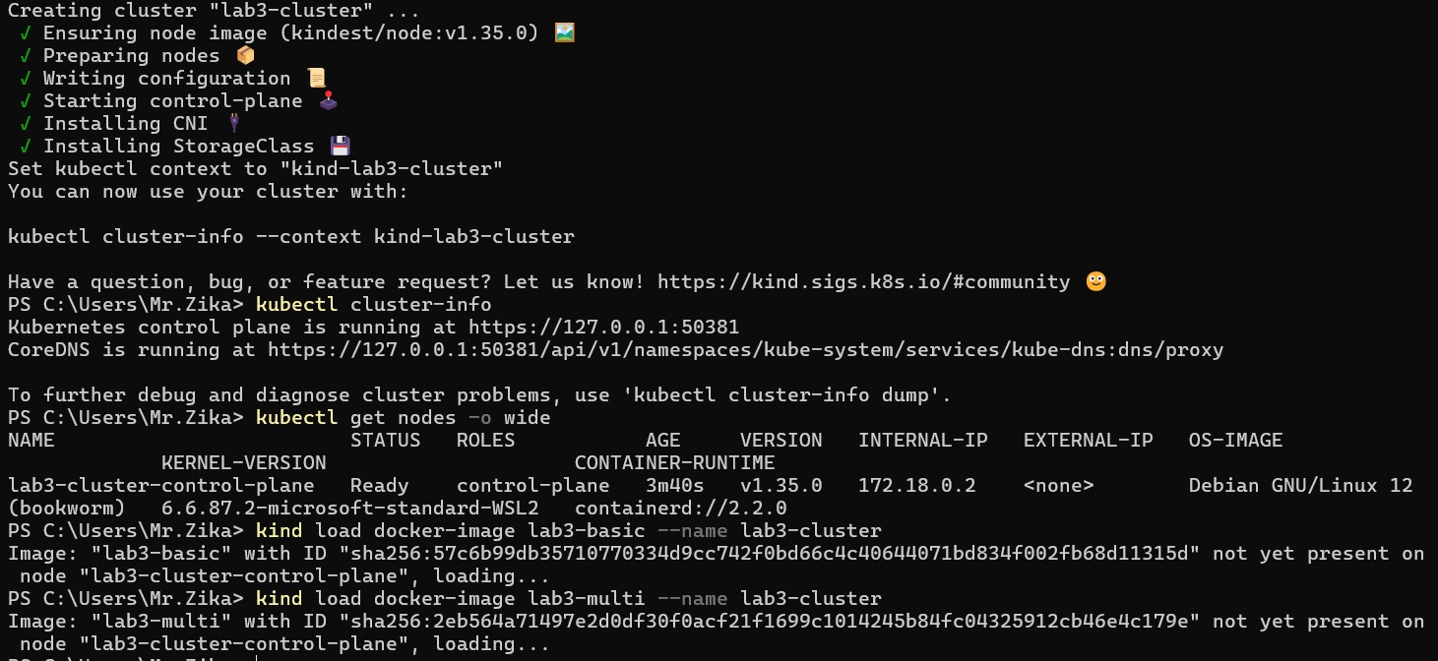

Part C
Kind cluster creation and Kubernetes node initialization.
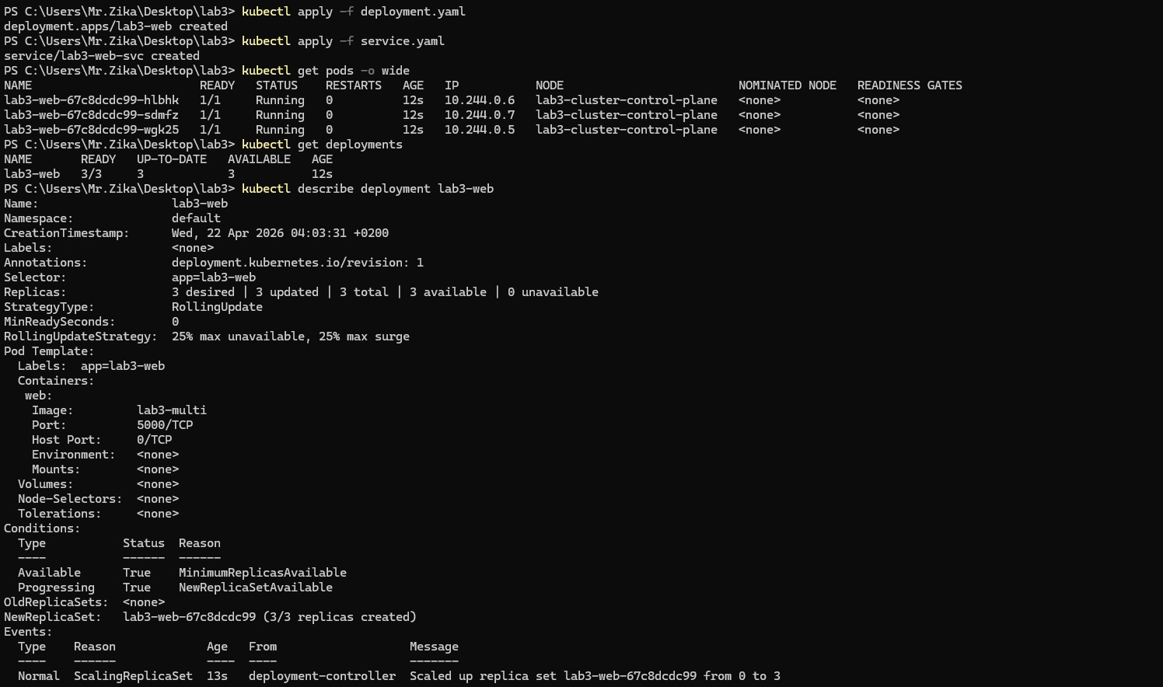

Part C
Loading Docker images into kind cluster.
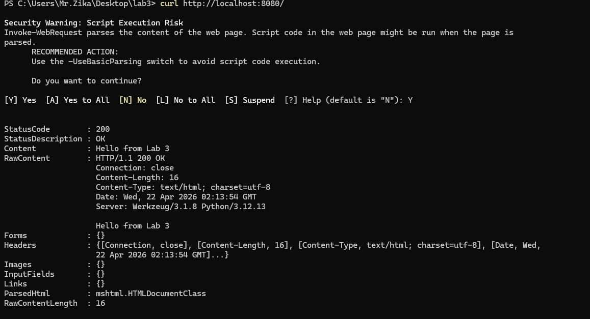

Part C
Kubernetes deployment and service creation with running pods.
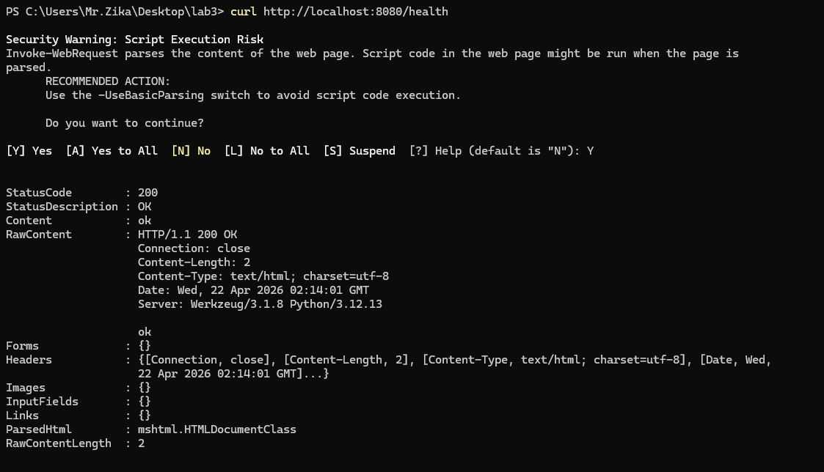

Part C
Accessing application via port-forward and verifying endpoints.

Part D
Node labeling and verification using kubectl.
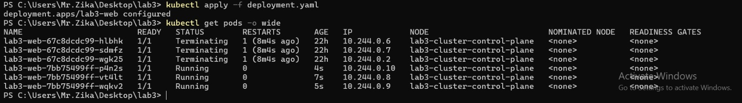

Part D
Applying deployment updates and observing pod scheduling.
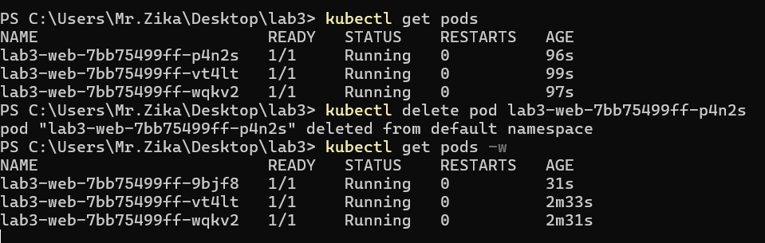

Part E
Deleting a pod and observing Kubernetes self-healing.
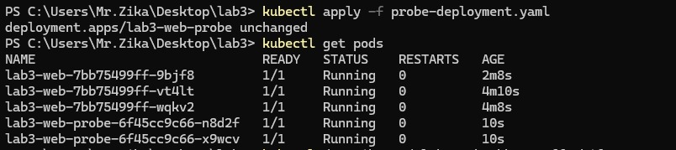

Part E
Probe deployment showing container restart behavior.
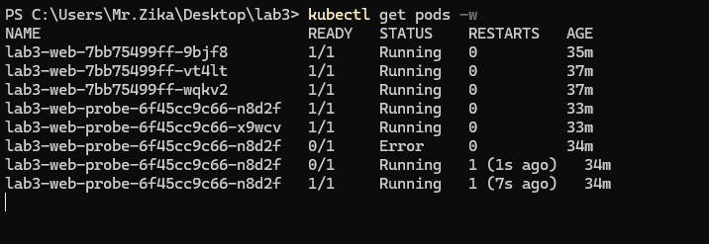

11. Reflection Questions
1. Why do namespaces alone not guarantee fair resource use?
Namespaces only isolate what a process can see, but they do not limit how much CPU or memory it consumes. Without cgroups, a container can still use excessive resources.
2. How do cgroups improve cluster stability?
Cgroups limit CPU, memory, and resource usage, preventing any container from overconsuming resources and ensuring system stability.
3. Why is Docker image layering important for large-scale orchestration?
It allows reuse of layers, reducing build time, storage, and network usage, making deployments faster and more efficient.
4. What does Kubernetes mean by desired state?
It is the defined configuration (e.g., number of replicas) that Kubernetes continuously maintains by comparing and correcting the actual state.
5. How is self-healing different from traditional manual operations?
Kubernetes automatically detects failures and restores services without manual intervention, unlike traditional systems.
6. Why are readiness probes and liveness probes not interchangeable?
Readiness checks if a container is ready to serve traffic, while liveness checks if it is still running correctly.
7. What is one limitation of observing scheduling in a single-node kind cluster compared with a real multi-node cluster?
In a single-node cluster, all Pods run on the same node, so real scheduling and load distribution cannot be observed.

