**A Comprehensive Analysis Report: The 2024 Indian General Election Results**

**Author:** Zeyad Ehab **Date:** September 20, 2025

**1. Executive Summary**

This report presents a comprehensive analysis of the 2024 Indian General (Lok Sabha) Election results. The findings indicate that the **National Democratic Alliance (NDA)** secured a parliamentary majority with **293 seats**, enabling it to form the government. However, the election was marked by a strong and competitive performance from the **Indian National Developmental Inclusive Alliance (I.N.D.I.A)**, which emerged as a formidable opposition with **233 seats**. The alliance exceeded expectations, particularly in the crucial states of Uttar Pradesh and Maharashtra. The analysis highlights that many constituencies were decided by narrow victory margins, underscoring the intense nature of the competition. Furthermore, the report reveals a notable discrepancy between the popular vote share and the seat share secured by the different alliances, reflecting the dynamics of India's electoral system.

**2. Detailed Results Analysis**

**2.1. National Overview**

The election was contested across **543** parliamentary constituencies, with **272** seats required for a majority. The final results depict a competitive political landscape.

* **Winning Alliance (NDA):** Secured **293 seats**, surpassing the majority threshold.
* **Main Opposition (I.N.D.I.A):** Won **233 seats**, establishing itself as a strong opposition bloc.
* **Other Parties:** Secured the remaining **17 seats**.

**2.2. Geographic Performance of Alliances**

The electoral map showed a clear geographic distribution of political power, with each alliance dominating specific regions.

* The **NDA** demonstrated clear dominance in the Northern and Western states, securing 100% of the seats in states like Madhya Pradesh and Delhi.
* Meanwhile, the **I.N.D.I.A** alliance established its stronghold in the South, achieving landslide victories in states such as Tamil Nadu and Kerala.

**2.3. Close Contest Analysis**

Narrow victory margins were a key feature of this election, where a small number of votes could alter the outcome of an entire constituency. A close contest was defined as one with a victory margin of less than **5,000 votes**.

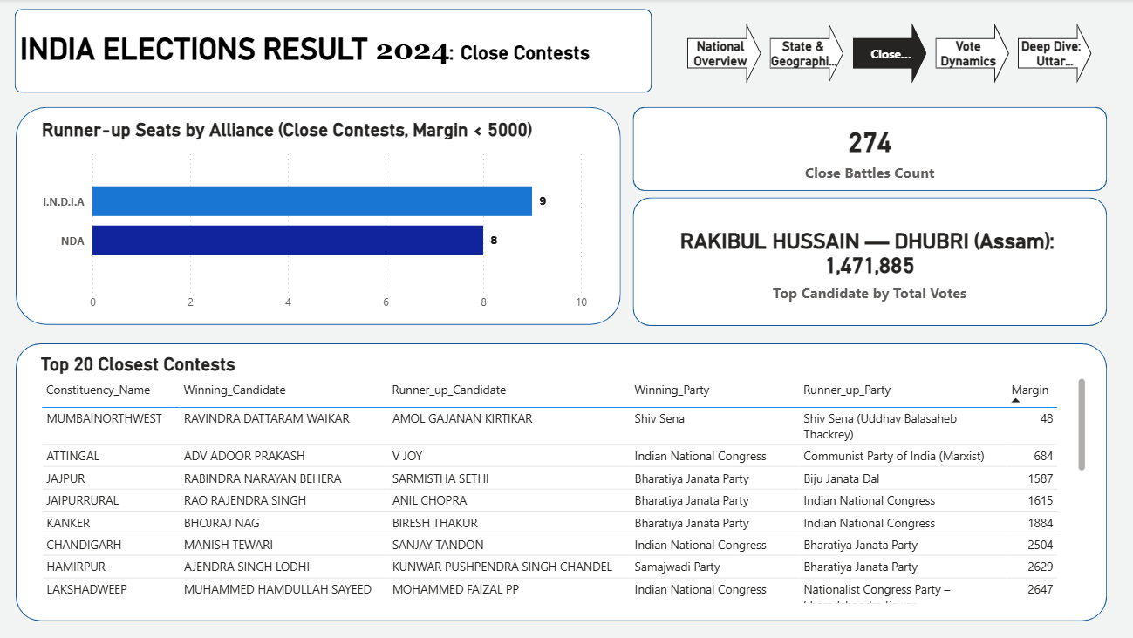

* **Most Competitive States:** **Maharashtra** (6 seats) and **Uttar Pradesh** (5 seats) topped the list of states with the highest number of nail-biting finishes.
* **Most Affected Alliance:** The **NDA** lost the highest number of these close contests, finishing as the runner-up in 14 constituencies with a narrow margin.

**2.4. Vote vs. Seat Share Efficiency**

This metric reveals how effectively each alliance converted its popular support (vote share) into actual parliamentary power (seat share).

* The **NDA** was the most efficient, securing **53.96%** of the seats with only **43.34%** of the national vote share. It required approximately **462,831 votes** per seat won.
* In contrast, the **I.N.D.I.A** alliance required **562,374 votes** per seat, reflecting a lower efficiency in converting votes into parliamentary representation.

**2.5. Battleground States: Uttar Pradesh vs. Maharashtra**

As the two largest states by number of seats, their outcomes were decisive in shaping the new parliament. Both states witnessed a significant political shift in favor of the **I.N.D.I.A** alliance.

* **Uttar Pradesh (80 seats):** The I.N.D.I.A alliance won **43 seats** compared to the NDA's **36**.
* **Maharashtra (48 seats):** The I.N.D.I.A alliance won **30 seats** compared to the NDA's **17**.
* These results indicate a notable shift in voter dynamics within critical political heartlands.

**3. Conclusion & Key Takeaways**

1. **A Hard-Fought Victory:** While the NDA secured a majority, its reduced seat count compared to previous elections suggests a more challenging political term ahead, with greater reliance on coalition partners.
2. **A Resurgent Opposition:** The I.N.D.I.A alliance has re-established itself as a formidable political force, making significant inroads in key battleground states.
3. **The Importance of Narrow Margins:** The election was effectively decided in a number of closely contested seats, highlighting that every vote was crucial in determining the final outcome.