**Student Name**: Ziad Emadeldin Mohamed

**Assignment (2)**

* **Create a Flutter app for a pizza store called WOW Pizza. The app should offer at least three food products that will be provided by details in three other screens as illustrated in figures below.**

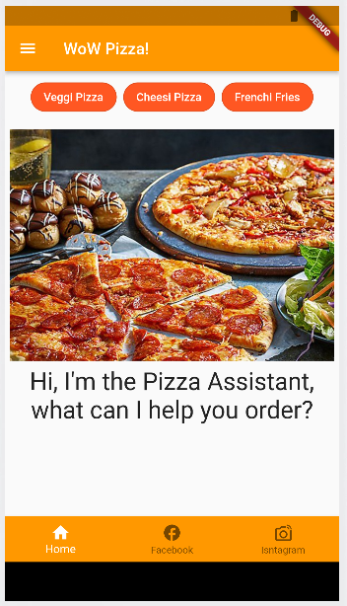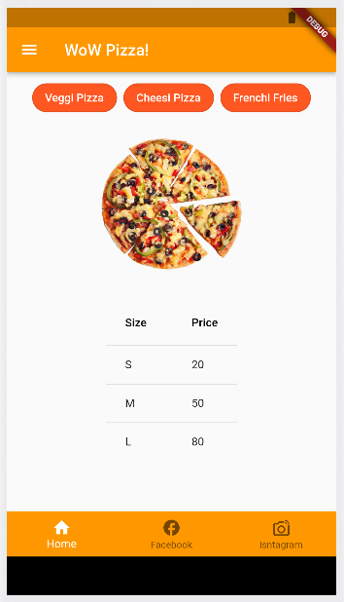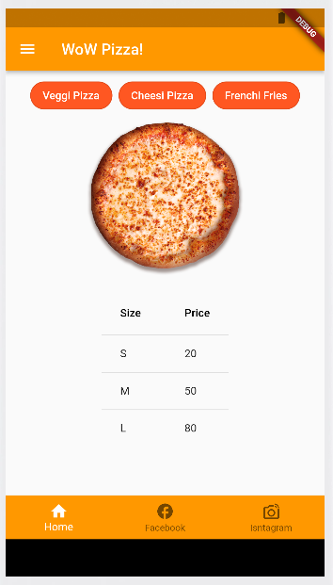

**Home Screen**

**Veggi Pizza Screen**

**Cheesi Pizza Screen**

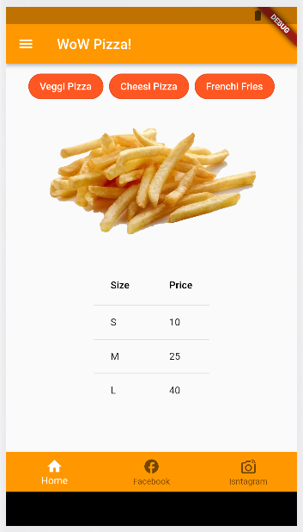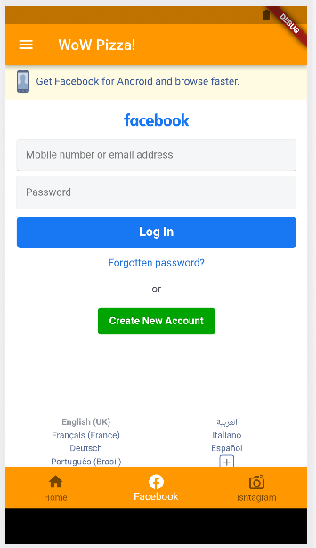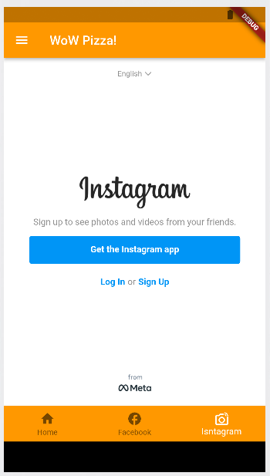

**Instagram Screen**

**Facebook Screen**

**Fries Screen**

* **Veggi Pizza, Cheesi Pizza and Fries screens should be navigated by using named routes techniques through the following two navigation areas:**

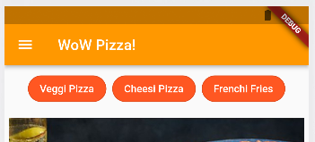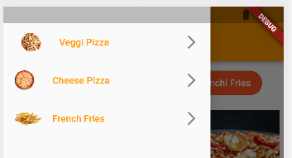

* **Home, Facebook, and Instagram screens should be navigated through the following navigation area.**



* **You must ensure that your assignment must fulfill all required tasks.**
* **Assignment should be delivered in form of compressed folder that contain your Dart file(s), any other files that you may configure to run your app, and any additional assets you might use in the app.**

**Assignment Grading Comments:**