


Helwan University
Faculty of Computers and Artificial Intelligence

COURSE CODE: CS352 SOFTWARE ENGINEERING-2
PROJECT: TASK MANAGEMENT SYSTEM (TMS)

Contents
1. Introduction 3
1.1 Purpose 3
1.2 Intended Audience 3
1.3 Product Scope 3
1.4 Definitions, Acronyms, and Abbreviations 3
2. Overall Description 4
2.1 User Needs 4
2.2 Assumptions and Dependencies 4
3. System Features and Requirements 4
3.1 Functional Requirements: 4
3.1.1 Authentication & Authorization Module 4
3.1.2 Project & Task Lifecycle Module 5
3.1.3 EARS Format (Easy Approach to Requirements Syntax) 5
3.1.4 Specification by Example (Gherkin/BDD) 5
3.2 Non-Functional Requirements 6
3.3 System Features (Microservices) 6
5. Other Requirements 6
4.1 Database Requirements 6
4.2 Risk Management (FMEA Matrix) 7
5.1 Use Case Diagram 8
5.2 Activity Diagram 9
5.3 Class Diagram 10

1. Introduction

1.1 Purpose
This document provides a comprehensive description of the Scrum-Based Task Management System (STMS). It specifies both functional and non-functional requirements and serves as a primary guide for the development team to ensure all project goals are met using Spring Boot Microservices and Docker.

1.2 Intended Audience
- Course Instructor: For project evaluation and grading.
- Development Team: To guide the backend (Spring Boot) and frontend implementation.
- Quality Assurance (QA): To design test cases based on defined requirements.

1.3 Product Scope
The STMS is an enterprise-level workflow management tool. It automates the interaction between Managers, Team Leaders, and Team Members. Key features include JWT-based security, automated notifications, task lifecycle management, and microservices-based scalability.

1.4 Definitions, Acronyms, and Abbreviations
- JWT: JSON Web Token (Authentication mechanism).
- AOP: Aspect-Oriented Programming (Used for Logging and Security).
- SRS: Software Requirements Specification.
- Microservices: Decoupled services communicating over REST APIs.

2. Overall Description

2.1 User Needs
Current manual task tracking methods lead to confusion and lack of accountability. There is a critical need for a system that:
- Validates task completion.
- Restricts status changes based on authority.
- Provides a clear audit trail of who did what and when.

2.2 Assumptions and Dependencies
- Docker: The system must be deployed as containerized services.
- Database: Each microservice may have its own schema to ensure isolation.
- Framework: Spring Boot 3.x is the primary backend framework.

3. System Features and Requirements

3.1 Functional Requirements:

3.1.1 Authentication & Authorization Module
- FR-1: The system shall allow users to log in using an email and password.
- FR-2: The system shall generate a JWT Token upon successful login to be used in subsequent API calls.
- FR-3: Access to specific endpoints shall be restricted based on user roles (Manager, Team Leader, Member).

3.1.2 Project & Task Lifecycle Module
- FR-4: Manager Role: The system shall allow Managers to create projects and define the initial backlog of tasks.
- FR-5: Team Leader Role: The system shall allow Team Leaders to view member profiles and assign tasks.
- FR-6: Team Member Role: The system shall allow Members to update status from 'Incomplete' to 'Pending' and finally to 'Complete'.
- FR-7: Integrity Rule: Once a task is marked 'Complete' by a Member, it shall remain locked unless the Team Leader resets its status.

3.1.3 EARS Format (Easy Approach to Requirements Syntax)
- When a new project is created, the system shall trigger a notification service to alert the Team Leader.
- Where a user attempts to access an unauthorized API, the system shall return a 403 Forbidden response.

3.1.4 Specification by Example (Gherkin/BDD)
- Scenario: Reopening a rejected task.
  - Given a task is marked as "Complete" by a Team Member.
  - And the Team Leader finds the work unsatisfactory.
  - When the Team Leader selects the "Reset Status" option.
  - Then the task status shall return to "Pending" and the Member shall be notified.

3.2 Non-Functional Requirements
- 3.2.1 Performance: The system shall process 95% of requests within 1.5 seconds under a load of 100 concurrent users.
- 3.2.2 Security: All API communications must be encrypted using HTTPS. Sensitive data like passwords must be hashed using BCrypt.
- 3.2.3 Scalability: The architecture shall support horizontal scaling of individual microservices using Spring Cloud.

3.3 System Features (Microservices)
- Auth-Service: Manages users, roles, and JWT generation.
- Project-Service: Handles project data and task creation.
- Notification-Service: Sends real-time alerts using AOP triggers.
- Profile-Service: Manages detailed developer skills and CV data.

Other Requirements

4.1 Database Requirements
The system shall utilize a Relational Database Management System (RDBMS) for structured data. A separate instance for the "Logging Service" may use a NoSQL database (like MongoDB) for performance.

4.2 Risk Management (FMEA Matrix)
Potential Failure | Severity | Mitigation Strategy
Service Downtime | High | Use Spring Cloud Gateway for load balancing.
JWT Token Theft | High | Set short expiration times and use HTTPS.
DB Connectivity Loss | Medium | Implement connection pooling and retry logic.

5. Appendices
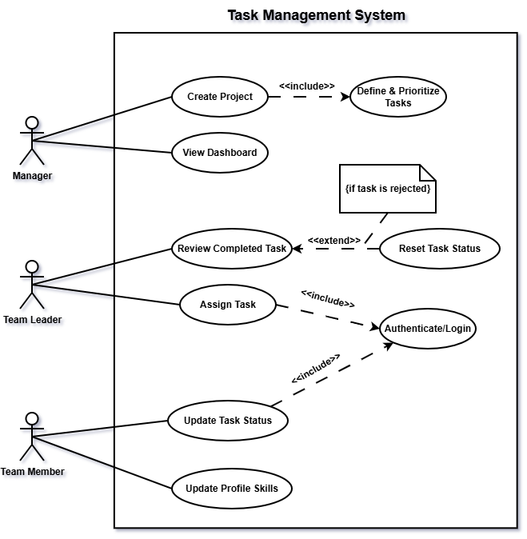

5.1 Use Case Diagram
Description: This diagram illustrates the functional scope of the system and the interactions between the actors (Manager, Team Leader, and Team Member) and the system’s core use cases. It highlights mandatory processes like Authentication through <<include>> relationships and conditional flows like Reset Task Status using <<extend>>.

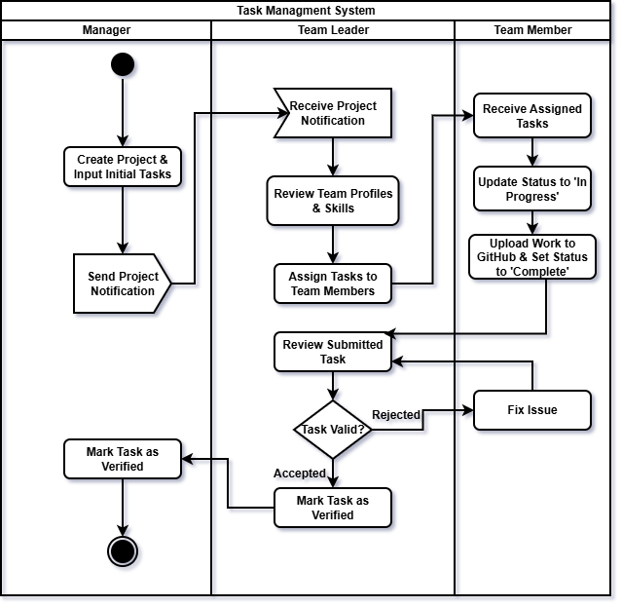

5.2 Activity Diagram
Description: This diagram models the dynamic workflow and business logic of the Task Management System. Using Swimlanes, it visually separates the responsibilities of the Manager, Team Leader, and Team Member. It details the lifecycle of a task from initial creation and assignment to GitHub submission, review, and final verification.

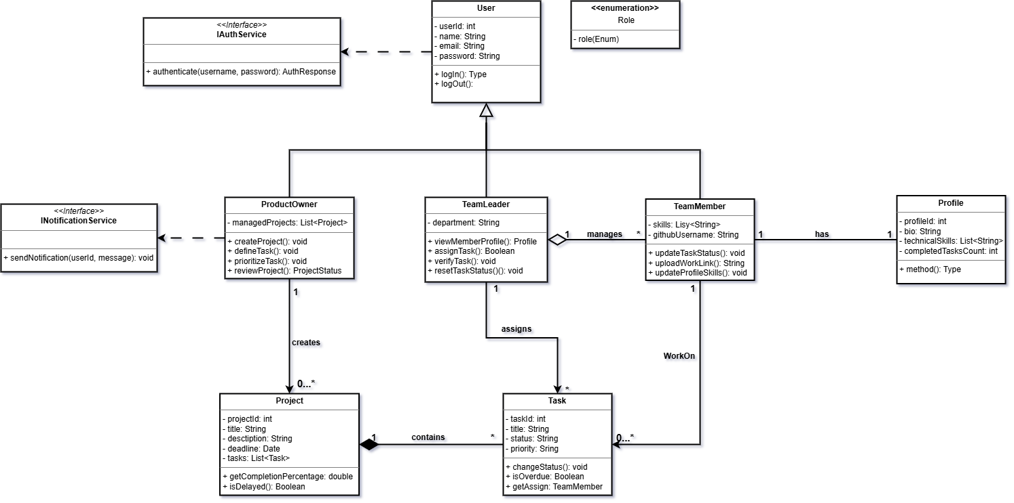

5.3 Class Diagram
Description: The Class Diagram defines the static structure and data model of the application. It applies SOLID principles through inheritance (Generalization from the User class) and modular interfaces (IAuthService, INotificationService). It also depicts key relationships such as the Composition between Projects and Tasks and the Association between Team Members and their Profiles.

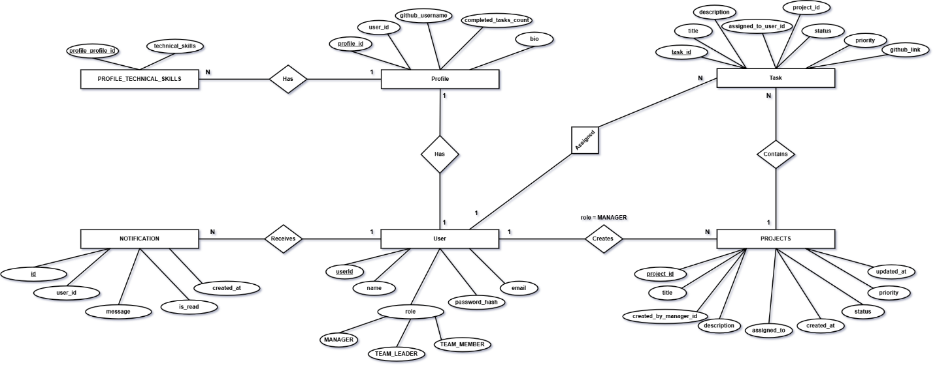

5.4 Entity Relationship Diagram (ERD)
The ERD represents the database structure of the Task Management System (TMS).
It illustrates the entities, attributes, primary keys, foreign keys, and relationships between system components such as Users, Projects, Tasks, Profiles, Notifications, and Technical Skills. The diagram models the relational database design used by the microservices architecture and ensures data consistency, integrity, and scalability.
Main relationships include:
- One Manager can create multiple Projects.
- One Project contains multiple Tasks.
- One User can receive multiple Notifications.
- One User has one Profile.
- One Profile can contain multiple Technical Skills.
- Tasks are assigned to Team Members through user references.

5.5 Sequence Diagrams
The following sequence diagrams describe the dynamic behavior of the Task Management System (TMS).
They illustrate how actors, frontend components, backend microservices, and databases interact to execute system operations securely using JWT authentication and role-based authorization.
The diagrams also demonstrate the communication between microservices in the Spring Boot microservices architecture.

5.5.1 Authentication Sequence Diagram
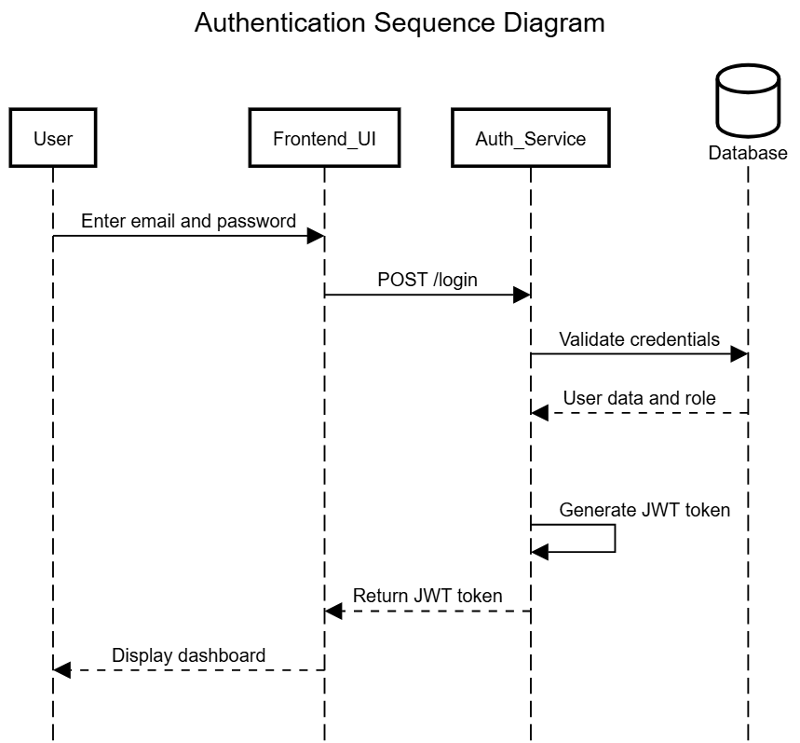
This sequence diagram illustrates the authentication workflow of the system.
The user submits login credentials through the frontend interface. The Auth Service validates the credentials against the database, generates a signed JWT token, and returns it to the frontend. The token is then used for secure communication with protected APIs.

5.5.2 Project Creation and Notification Sequence Diagram
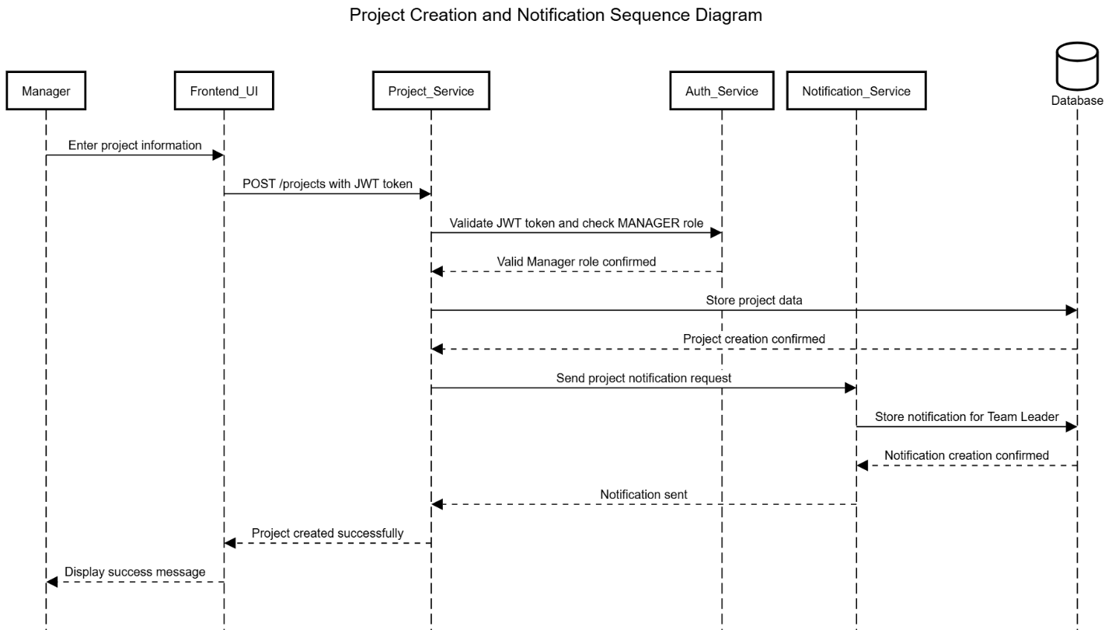
This diagram illustrates how a Manager creates a project using the Project Service.
The system validates the JWT token and Manager role before storing project data. After successful creation, the Notification Service generates notifications for Team Leaders.

5.5.3 Task Assignment Sequence Diagram
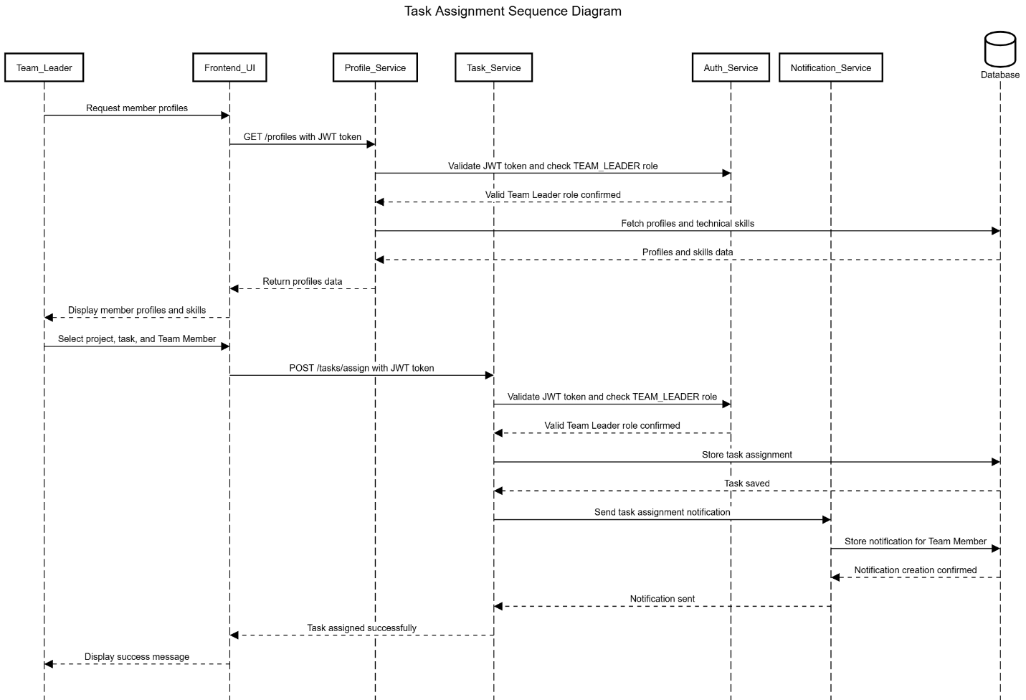
This diagram models the task assignment workflow.
The Team Leader first retrieves member profiles and technical skills through the Profile Service. After selecting a suitable member, the Task Service assigns the task and triggers the Notification Service to notify the assigned Team Member.

5.5.4 Task Update Sequence Diagram
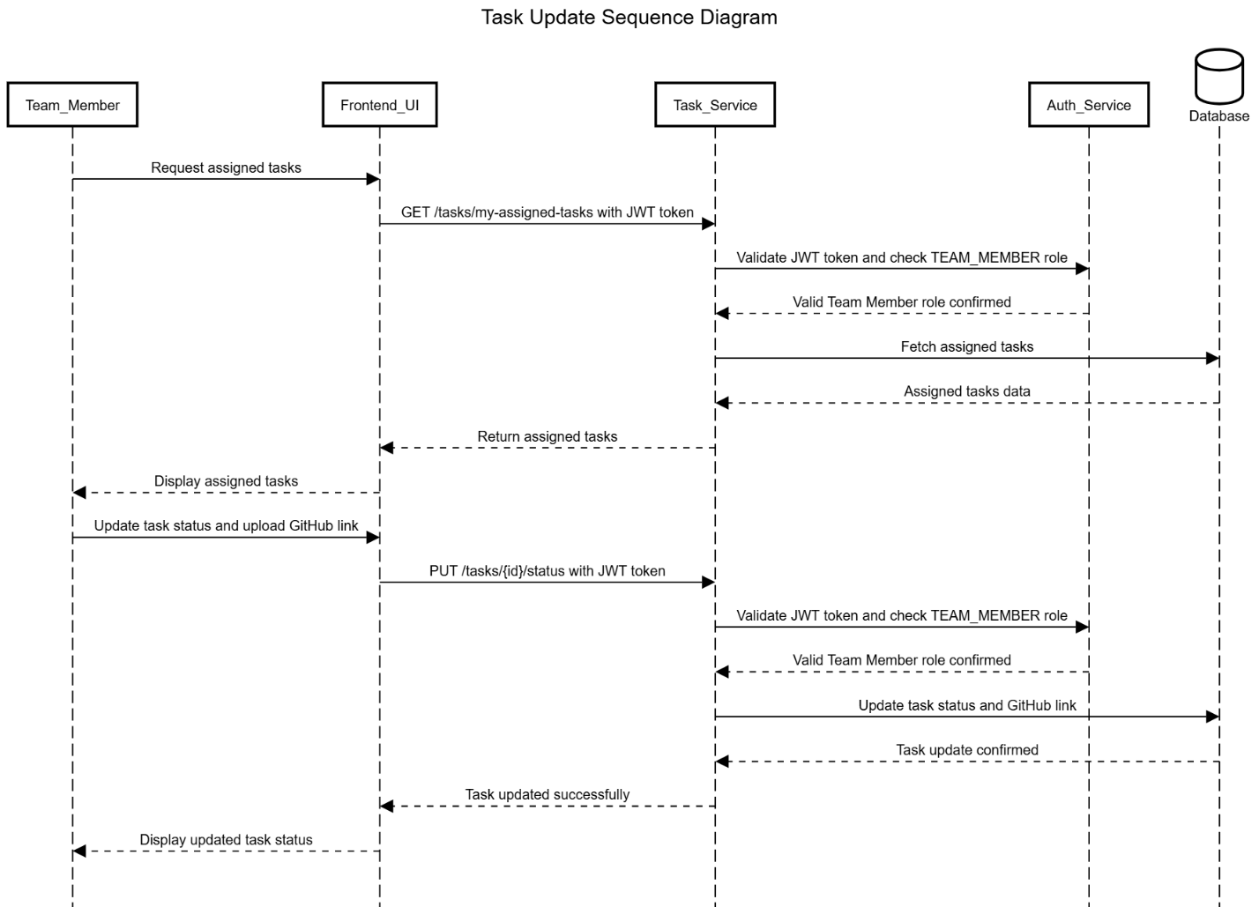
This sequence diagram describes how Team Members interact with assigned tasks.
The Team Member retrieves assigned tasks, updates task status, and submits the GitHub repository link. The Task Service validates authorization and updates task information in the database.

5.5.5 Task Review and Verification Sequence Diagram
