Student Complaint Ticketing and Resolution System

Supervised by:

Eng. Ashraf Sadek

Implemented by

|  |
| --- |
| Ahmed Mansour Kamal |
| Eman Hasanien Abdelhamid |
| Gehad Mohamed |
| Mostafa Tarek Mahmoud |
| Ziad Ahmed Mamdouh Mohamed |
| Abdelrahman Essam Shehata |

# Project planning & management

## System Overview

The Student Complaint Ticketing and Resolution System is a web-based platform designed to provide an efficient mechanism for students to submit complaints, track their status, and receive timely resolutions from the appropriate support teams. The system ensures streamlined communication between students, university support staff, and administrators while leveraging AI-powered categorization and recommendations to enhance resolution efficiency.

This project aims to automate complaint handling, improve transparency, and facilitate data-driven decision-making for institutions, ultimately enhancing student satisfaction.

## Users and Roles

The system will support three main user roles:

Students: Submit complaints, track status updates, and provide feedback on complaint resolutions.

Support Teams: Manage and resolve assigned complaints by updating their status and providing resolution notes.

Administrators: Monitor complaint trends, generate reports, and manage system configurations.

## Gantt Chart

Project Duration: 1 Month

Team Size: 6 Frontend Developers

**Milestones & Deliverables:**

Milestone 1: Project Setup Complete (Week 1)  
 - Deliverables: Repository setup, UI designs finalized

Milestone 2: Core Features Developed (Week 2)  
 - Deliverables: Student login, complaint submission, admin dashboard

Milestone 3: Integration & Initial Testing Completed (Week 3)  
 - Deliverables: API integration, validation, bug fixes

Milestone 4: Deployment & User Training (Week 4)  
 - Deliverables: Final bug fixes, optimized UI, system deployment

|  |  |  |  |  |
| --- | --- | --- | --- | --- |
| Task | Week 1 | Week 2 | Week 3 | Week 4 |
| Project Repository Setup | ✔ |  |  |  |
| UI Wireframing & Design | ✔ |  |  |  |
| API Endpoint Definition | ✔ |  |  |  |
| Student Login & Authentication |  | ✔ |  |  |
| Complaint Submission & File Upload |  | ✔ |  |  |
| Complaint Tracking & Feedback |  | ✔ |  |  |
| Admin Dashboard & Complaint Management |  | ✔ |  |  |
| Frontend-Backend Integration |  |  | ✔ |  |
| Form Validation & Error Handling |  |  | ✔ |  |
| Internal Testing & Bug Fixes |  |  | ✔ |  |
| User Testing |  |  |  | ✔ |
| Final Bug Fixes & Optimization |  |  |  | ✔ |
| Deployment & Training |  |  |  | ✔ |

|  |  |
| --- | --- |
| Ahmed Mansour Kamal | Login & Signup |
| Eman Hasanien Abdelhamid | Complaint ticket status |
| Gehad Mohamed | Admin Navigation & UI/UX |
| Mostafa Tarek Mahmoud | Complaint ticket submission & feedback |
| Ziad Ahmed Mamdouh Mohamed | Back-End Development (authentication) |
| Abdelrahman Essam Shehata | Support Team |

## Task assignments & Roles

# Literature review

## **Suggested improvements:**

Table view revised to closing paragraph.

## Final grading criteria:

# Requirements gathering:

## Stakeholder analysis

|  |  |
| --- | --- |
| Stakeholder | Needs & Expectations |
| Students | Submit and track complaints easily, receive timely updates, and provide feedback. |
| Support Teams | Manage, categorize, and resolve complaints efficiently. |
| Administrators | Monitor complaints, generate reports, and escalate issues if needed. |
| IT Department | Ensure system security, stability, and integration with institutional login. |

## Use case diagram

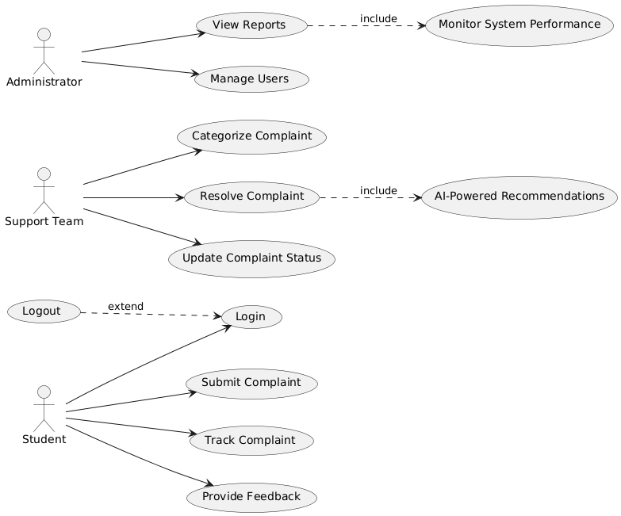

## Functional Requirements.

|  |  |
| --- | --- |
| Requirement | Description |
| R1 Complaint Submission | The system shall allow students to submit complaints through an interface, including necessary details. |
| R2 Complaint Tracking | The system shall allow students to monitor the status of their complaints. |
| R3 Complaint Notifications | The system shall send automated notifications to students about status updates of their complaints. |
| R4 Automated Ticket Routing | The system shall categorize and route complaints to the appropriate resolution team using AI-based classification and predefined rules. |
| R5 AI-Powered Recommendations | The system shall use AI to suggest complaint resolutions based on historical data. |
| R6 Complaint Resolution Management | The system shall allow resolution teams to update complaint statuses and provide resolution details. |
| R7 Feedback Mechanism | The system shall allow students to provide feedback on complaint resolutions. |
| R8 Analytics and Reporting | The system shall generate reports and insights on complaint trends and resolution performance. |
| R9 Authentication and Access Control | The system shall allow students to log in using their student ID and email via an institutional authentication system. |
| R10 Institutional System Integration | The system shall integrate with the institution’s authentication and student information system. |
| R11 Dashboard and Data Visualization | The system shall provide a dashboard with key complaint statistics and resolution performance metrics. |
| R12 Complaint Categorization | The system shall use Natural Language Processing (NLP) to classify complaints into predefined categories. |

## Non-Functional Requirements.

### Usability

|  |  |
| --- | --- |
| R# | Requirement |
| R1 | The system shall have a simple and intuitive interface for submitting and tracking complaints. |
| R2 | The system shall allow students to submit a complaint in no more than 5 clicks. |
| R3 | The system shall ensure that complaint status updates and feedback submission require no more than 3 clicks. |
| R4 | The system shall provide clear visual indicators (e.g., progress bars, status labels) for complaint tracking. |
| R5 | The system shall be fully responsive and work on desktop, tablet, and mobile devices. |
| R6 | The system shall use consistent colors, fonts, and layouts to enhance readability and user experience. |

### Performance

|  |  |
| --- | --- |
| R# | Requirement |
| R1 | The system shall process complaint submissions within 2 seconds under normal load conditions. |
| R2 | The system shall support up to 500 concurrent users without performance degradation. |
| R3 | The system shall process complaint status updates within 1 second to ensure real-time tracking. |
| R4 | The system shall ensure notifications for complaint status changes are delivered within 2 seconds. |
| R5 | The system shall process complaint categorization and routing within 3 seconds of submission. |
| R6 | The system shall generate analytics reports within 5 seconds under normal load conditions. |

### Reliability

|  |  |
| --- | --- |
| R# | Requirement |
| R1 | The system shall ensure that complaint-related operations (submissions, updates, feedback) are synchronized in real-time to prevent inconsistencies. |
| R2 | The system shall maintain data consistency during high-traffic periods, ensuring no duplicate or missing complaint records. |
| R3 | The system shall log and notify users of failed operations (e.g., complaint submission failures) while ensuring data recovery after unexpected failures. |

# System Analysis & Design

## Sequence diagram

## Student Side

### Login

Login using:

• Student ID

• Email

### Complaint Submission

1. Categories:

• Academic

• Facilities

• Administration

2. Complaint Description:

- Text input field for students to describe their complaint.

3. Supporting Documents:

- Option to upload supporting documents or images.

4. Priority Level:

• Normal

• Urgent

### Complaint Tracking

• Status Updates:

- Submitted

- In Progress

- Resolved

• Complaint History:

- View past complaints and their resolution status.

### Feedback

• Allow students to provide feedback once their complaint is resolved.

## Admin Side

### Dashboard

- Overview of active complaints, response time, and resolution status.

- Filter complaints by category, priority, or date.

- Assign complaints to specific departments or personnel.

- Add status updates and resolutions.

- Analytics: Reports on complaint categories and resolution time.

## Student Navigation

1. Home  
2. Submit Complaint  
3. My Complaints  
4. FAQs  
5. Contact Support

## Admin Navigation

1. Dashboard  
2. Manage Complaints  
3. Analytics

## After Student Login

### Student navigation:

Navigation Menu:

|  |
| --- |
| ***Logo Home Submit Complaint My Complaints FAQs***  ***Contact Support*** |

### Submit Complaint Page:

Form:

**Categories:**

**- Academic**

**- Facilities**

**- Administration**

|  |
| --- |
| **Upload button**  **Drop Down**  **In Progress bar . . . . . . .**  **Upload**  **Normal/Urgent**  **Priority Level**  **Select Category**  **Text Area**  **Describe your complaint** |

### My Complaints Page:

List of Complaints Displayed

Complaint Status Feedback

#### Complaint status:

- Green for Resolved

- Yellow for In Progress

***- Feedback Button appears if Status is Resolved***

### Admin navigation:

#### Navigation Menu:

|  |
| --- |
| ***Logo Dashboard Manage Complaints Analytics*** |

#### Dashboard page:

* Category

**Search . . . ↓**

* Priority
* Date

*(Revised to opening/closing paragraph)*

|  |  |  |  |  |  |
| --- | --- | --- | --- | --- | --- |
| Complaint | Category | Priority | Date | Status | Response time |
|  |  |  |  |  |  |
|  |  |  |  |  |  |
|  |  |  |  |  |  |
|  |  |  |  |  |  |
|  |  |  |  |  |  |

#### Manage complaint page:

#### Analytics page:

Variables: Response time/Complaint Category.