**Exploratory Data Analysis (EDA) Report**

**Objective**: This section focuses on uncovering key patterns and trends related to ETA variation, delivery efficiency, driver behavior, traffic, inventory levels, and other logistics KPIs from the cleaned supply chain dataset. Each chart is supported with analytical commentary to guide decision-making.

**ETA Variation Overview**

Insight: The distribution of ETA variation shows the right skew, indicating most deliveries were close to on-time, but a smaller subset experienced significant delays.

**Monthly Delay Patterns**

Insight: A clear seasonal trend is visible, with delays peaking in certain months (e.g., December due to holidays).

**Traffic Congestion & Weather Impact**

Insight: High traffic congestion correlates with longer ETA delays, especially when weather severity is also high.

**Customs Clearance Time Effect**

Insight: Positive linear trend indicates longer customs clearance processes consistently delay shipments.

**Driver Behavior & Delivery Efficiency**

Insight: Strong positive correlation: better driver behavior scores lead to higher delivery efficiency.

**Fuel Consumption Distribution**

Insight: Most vehicles operate within a consistent range, but outliers may point to inefficient driving or maintenance issues.

**Fatigue Monitoring vs ETA Variation**

Insight: As fatigue score worsens, ETA delays increase. This validates fatigue as a critical risk factor.

**Inventory Bins vs Order Fulfillment**

Insight: Moderate inventory levels are linked to higher fulfillment success.

**Hourly Delay Trends**

Insight: Peak delays occur during rush hours (e.g., 8–10 AM, 4–6 PM).

**Historical Demand vs Lead Time**

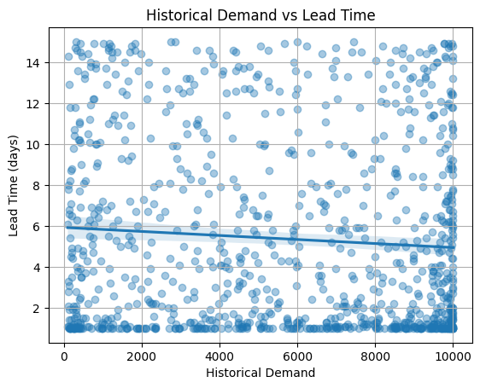

Insight: Lead times increase slightly with higher historical demand.

**Delay Category Frequency**

Insight: The majority of delays fall under one or two categories — e.g., 'Traffic' or 'Customs'.

**Temperature Bands vs Cargo Condition**

Insight: Higher temperatures correspond with worse cargo condition scores.

**Day of Week vs Delivery Efficiency**

Insight: Certain days (e.g., Mondays or Fridays) show lower efficiency.

**Risk Score Distribution**

Insight: The risk score clusters around a mid-range, with few extreme values.

**Disruption Likelihood vs Delay Probability**

Insight: Strong relationship confirms that delay risks can be predicted and managed using disruption signals.