**Supply Chain Analysis**

**Analysis Phase:**

**1.🛢️ Fuel & Efficiency Analysis**

Q1: What is the average fuel consumption? 

Q2: What is the average delivery efficiency by delay category?

Q3: Which hour of the day has the highest average fuel consumption?average fuel consumption? 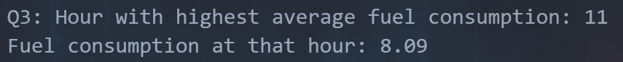

Q4: How does cost efficiency vary across different delay categories?**Q5: What are the distributions of fuel consumption, shipping costs, and total risk score across all records?

**2. ⏰Delays & Time Analysis**

Q6: How many times has "Very Late" happened? 

Delay Category Distribution:

Q7: During which hour of the day do deliveries experience the highest average delay?

Q8: What is the average delivery delay (in minutes) for each hour of the day, and during which hour does the peak delay occur?

Q9: What is the average ETA variation for each day of the week?

Q10: Which delay category has the longest average loading/unloading time?

**3 ⚠️ .Risk & Performance**

Q11: How many cases are classified as "High Risk"?

Q12:What is the distribution of cargo condition statuses across risk levels (Low, Moderate, High)?

**4 📦.Inventory & Warehouse Metrics**

Q14: What is the average delivery performance per risk level (Low, Medium, High)?

Q15: How does traffic congestion correlate with total risk score? 

**5. 🗺️ Geospatial/Distance Metrics**

Q16: What is the average warehouse inventory level per day of the week?

Q17: Does low equipment availability correlate with lower delivery performance?

Q18: What is the average delivery distance for each delay category?

Q19: What is the most frequent geographic location where late deliveries occurring?