1-2 : Which months will see the most delivery delays in the future?

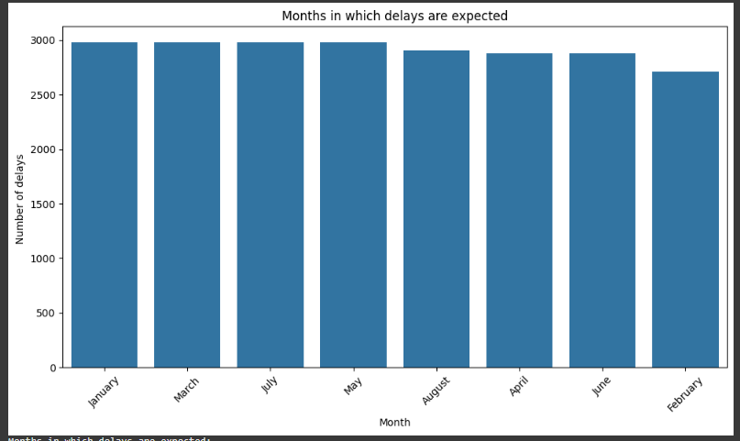

Months in which delays are expected:

- January: 2976 delays

- March: 2976 delays

- July: 2976 delays

- May: 2976 delays

- August: 2905 delays

- April: 2880 delays

- June: 2880 delays

- February: 2712 delays

Delivery data analysis reveals months when delay rates are expected to be higher, based on historical patterns. The bar chart shows the monthly variation in delays, with the height of each bar representing the number of delays during the corresponding month.

**2- What are the upcoming time periods when fuel consumption is expected to increase based on historical distance and congestion data?**

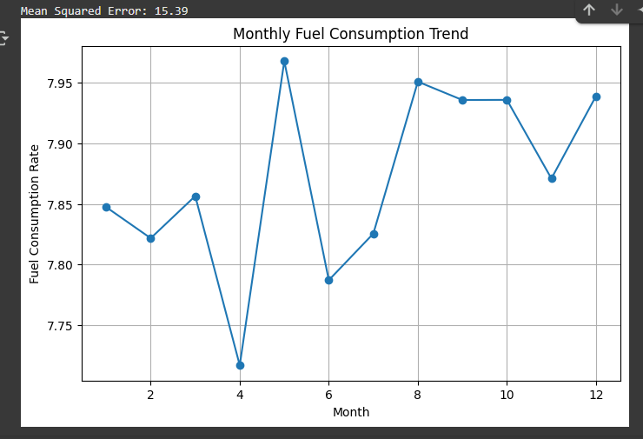

A simple predictive model was built to explore the relationship between fuel consumption, distance traveled, and traffic congestion levels. The results showed clear monthly trends in consumption rates, with significant increases in some time periods. The model achieved acceptable accuracy based on the average prediction error.

**3- What are the expected delivery efficiency levels for each month over the next six months based on historical time trends?**

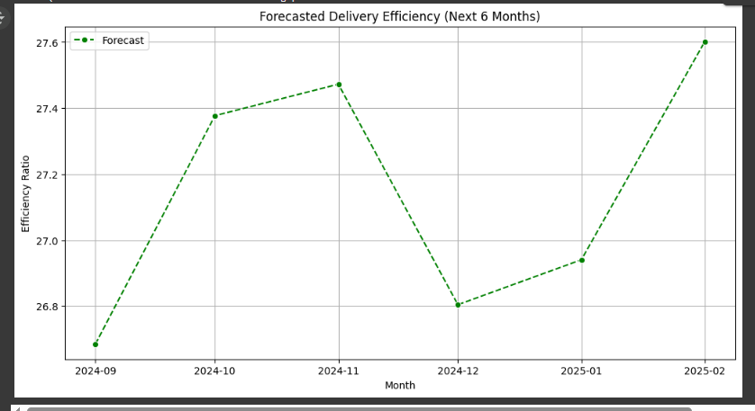

This question aims to forecast delivery efficiency levels over the next six months, based on an analysis of historical trends using time series models. The analysis focuses on presenting only future results, which helps identify potential periods of performance decline early and take appropriate corrective action.

**4. Which geographic areas are expected to see an increase in delivery time in the coming period based on historical GPS data?**

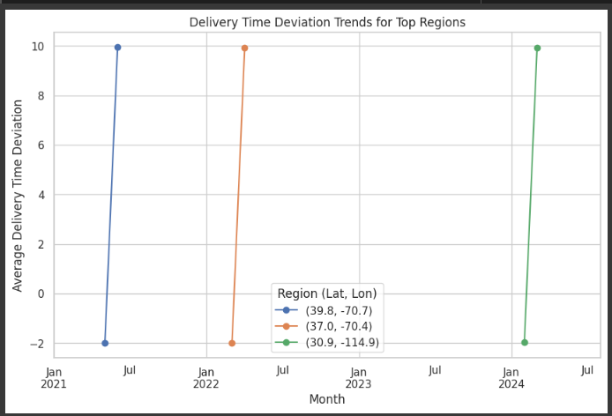

The chart displays monthly trends in delivery delays in the top 3 geographic regions with increased delays. Each line represents a specific region and shows how average delivery delays have changed over the months. This analysis helps identify areas and periods where delivery improvement is needed.

**5. Which months are expected to experience higher traffic congestion, impacting delivery times in the coming period?**

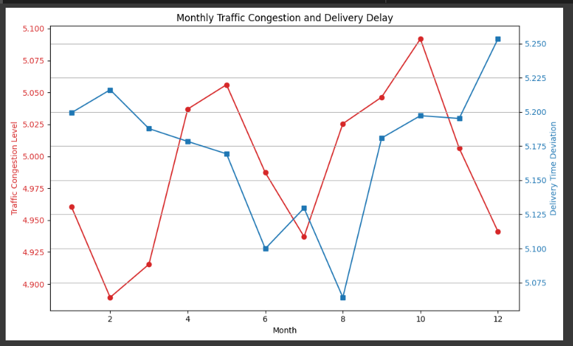

The red line in the chart represents the monthly traffic congestion level, while the blue line represents the monthly deviation of delivery time (delay). The chart shows how congestion affects delivery delays across months, with a higher red line indicating an increase in congestion, while a higher blue line indicates an increase in delay.