CryptoCare
Secure Healthcare Portal
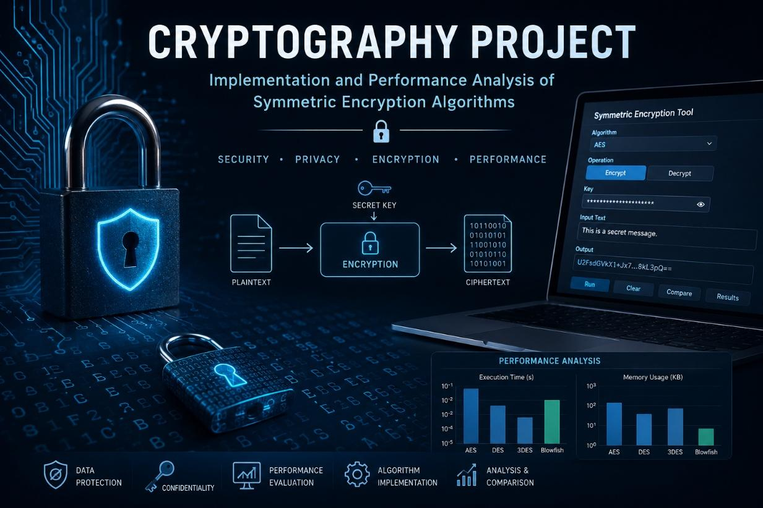

TEAM MEMBERS
Jana Yousri Attia
Student ID: 320230014
Amnah Hossam Elkheshn
Student ID: 320230082
Yassin Alaa Helmy
Student ID: 32023098
Course: Cryptography and Cryptanalysis— CNC 321
Instructor: Dr. Muhammad Hataba
Egypt-Japan University for Science and Technology

1. Introduction & Problem Statement

Cryptography secures information by transforming it into unreadable form unless the correct key is known. From ancient substitution ciphers to today’s rigorous mathematics, it underpins digital security. Its core goals are confidentiality, integrity, and authenticity, achieved through symmetric ciphers (shared secret keys), asymmetric systems (public/private pairs), and supporting primitives like signatures and hashes.
Protection is needed both for data in transit (moving across networks, vulnerable to interception) and data at rest (stored records, exposed to theft or insider misuse). Healthcare systems face escalating threats such as ransomware locking hospital networks, credential attacks exposing patient records, and man-in-the-middle exploits on unsecured APIs. Regulations such as HIPAA and GDPR impose strict obligations, making correct cryptographic deployment essential.
Our project, CryptoCare, builds a secure healthcare portal from scratch. It integrates:
- Two symmetric block ciphers (XTEA and IDEA in CBC mode) for patient data storage and transmission.
- An ElGamal asymmetric system for session-key exchange and digital signatures.
- A PKI Certificate Authority issuing and verifying X.509 certificates for authentication.
- A forward-looking Ring-LWE post-quantum scheme for quantum-resistant tokens.

2. Project Objectives

This project aimed to design and implement a complete cryptographic system CryptoCare from scratch, without relying on any external cryptographic libraries. The five core objectives below guided our implementation:
- Symmetric encryption for data at rest: We implemented two block ciphers XTEA and IDEA both in CBC mode with PKCS#7 padding to protect patient records stored on the server. Choosing two structurally different algorithms (XTEA uses XOR and bit-shifts; IDEA uses three algebraically incompatible group operations) allowed us to compare their design philosophies and performance side by side.
- Asymmetric encryption for key exchange: We implemented ElGamal encryption and digital signatures to solve the key-distribution problem. ElGamal is used exclusively for session-key exchange and physician authorisation signatures, while bulk data encryption is handed off to the faster symmetric ciphers — a standard hybrid model.
- Multi-party system with certificate-based authentication: We built a Certificate Authority (CA) that issues and revokes X.509-style certificates for all entities (server, patients, doctors). A TLS-style handshake uses these certificates to authenticate each party before establishing an encrypted session, with support for mid-session key rotation.
- Performance analysis: We benchmarked all implemented algorithms for encryption/decryption speed (MB/s), key-generation latency, memory usage, and ciphertext size overhead, providing a quantitative basis for the hybrid design choices made throughout the system.
- Post-quantum authentication (bonus): We implemented a Ring-LWE scheme inspired by CRYSTALS-Kyber to generate quantum-resistant authentication tokens. While the toy parameters (n=16, q=257) are not production-secure, the implementation demonstrates the mechanism and motivates why post-quantum cryptography matters for long-lived sensitive data.

3. Literature Review

Building CryptoCare required grounding each design decision in established research. The ten sources below drawn from IEEE, ACM, Springer, and NIST cover the five areas most relevant to our implementation: symmetric and asymmetric algorithms, key management and PKI, performance benchmarking, multi-party secure communication, and post-quantum cryptography.
Symmetric Encryption
- Needham, R. & Wheeler, D. (1997). Tea Extensions. Technical Report, University of Cambridge Computer Laboratory. The original unpublished report introduced XTEA, correcting the related-key and equivalent-key weaknesses in TEA by replacing the linear key schedule with a cyclic shift-based one. This was our primary reference when implementing the 64-round Feistel structure and the DELTA-based sum schedule.
- Lai, X. & Massey, J. L. (1991). "A Proposal for a New Block Encryption Standard." Advances in Cryptology EUROCRYPT 1990, Lecture Notes in Computer Science, vol. 473, pp. 389–404, Springer. The foundational paper for IDEA, introducing three algebraically incompatible group operations (XOR, addition mod 2¹⁶, multiplication mod 65537) as the basis for confusion and diffusion. Our IDEA implementation follows this specification exactly, including the 52-subkey schedule derived by rotating the 128-bit key left by 25 bits.
- Dudhat, H. et al. (2025). "A Comparative Analysis of Symmetric and Asymmetric Cryptographic Algorithms: Performance, Security, and Versatility." ICT Systems and Sustainability, Lecture Notes in Networks and Systems, vol. 1160, Springer. Provides a structured framework for comparing symmetric and asymmetric algorithms on key size, throughput, and computational cost. Confirmed our design choice to use symmetric ciphers for bulk record encryption, reserving asymmetric operations for session-key exchange only.
Asymmetric Encryption & Digital Signatures
- ElGamal, T. (1985). "A Public Key Cryptosystem and a Signature Scheme Based on Discrete Logarithms." IEEE Transactions on Information Theory, vol. IT-31, no. 4, pp. 469–472. The original ElGamal paper, establishing both the encryption scheme and the signature scheme on the hardness of the discrete logarithm problem. Our implementation follows the encryption and signing equations directly, using safe primes (p = 2q+1) to eliminate small-subgroup attacks that the original paper acknowledged as a concern.
- Jintcharadze, E. & Iavich, M. (2020). "Hybrid Implementation of Twofish, AES, ElGamal and RSA Cryptosystems." 2020 IEEE East-West Design & Test Symposium (EWDTS), pp. 1–5. Benchmarks hybrid cryptographic architectures combining symmetric and asymmetric algorithms, showing that wrapping a symmetric session key in an asymmetric envelope consistently outperforms full asymmetric encryption for payload data. This validated the hybrid design at the core of CryptoCare.
Key Management & Certificate Authorities
- NIST SP 800-57 Part 1 Rev. 5. (2020). Recommendation for Key Management: Part 1 — General. National Institute of Standards and Technology. doi: 10.6028/NIST.SP.800-57pt1r5. The authoritative federal guidance on cryptographic key lifecycle management, covering generation, distribution, storage, rotation, and revocation. Our session-key rotation logic and certificate revocation list are structured around the key-state transitions defined in this document.
- NIST SP 800-57 Part 3 Rev. 1. (2015). Recommendation for Key Management: Part 3 — Application-Specific Key Management Guidance. National Institute of Standards and Technology. — Extends Part 1 to application-layer PKI use cases, including how CAs should issue, verify, and revoke X.509 certificates. Directly informed the design of our CertificateAuthority class and the certificate body format (serial number, validity window, issuer signature).

Cryptographic Performance Studies
- Performance Analysis of Cryptographic Algorithms for Selecting Better Utilization on Resource Constraint Devices. (2019). IEEE Xplore, doi: 10.1109/ICCIDS.2019.8631957. Benchmarks AES, RC4, Blowfish, 3DES, DSA, and ElGamal across key size, data block size, and encryption time, confirming that asymmetric algorithms are orders of magnitude slower than symmetric ones for bulk data. Our benchmarking module uses the same metrics — throughput (MB/s), key-generation latency, and memory footprint — to report XTEA and IDEA performance comparably.
Multi-Party Secure Communication
- NIST FIPS 197. (2023). Advanced Encryption Standard (AES), updated May 2023. National Institute of Standards and Technology. doi: 10.6028/NIST.FIPS.197-upd1. While AES is not used in our implementation, this standard provides the conceptual baseline for block cipher design (128-bit block, CBC/GCM modes, key-schedule design) against which we contextualize XTEA and IDEA. The NIST framework for multi-party secure sessions built on block ciphers informed our TLS-style handshake structure.
Post-Quantum Cryptography
- Lyubashevsky, V., Peikert, C. & Regev, O. (2013). "On Ideal Lattices and Learning with Errors over Rings." Journal of the ACM, vol. 60, no. 6, pp. 43:1–43:35. ACM. doi: 10.1145/2535925. Introduced Ring-LWE and proved it is as hard as worst-case problems on ideal lattices, including under quantum reduction. This is the theoretical foundation for our Ring-LWE bonus implementation. The polynomial ring R_q = Z_q[x]/(x^n + 1), the small-error distribution, and the key-generation and encryption equations in our lwe.py follow the constructions in this paper.
Research Gap Addressed by This Project
No study we found combines XTEA and IDEA as a comparative symmetric pair, wraps them in an ElGamal hybrid with a full custom PKI, and extends the stack with a from-scratch Ring-LWE layer all within a single, coherent application domain. CryptoCare fills this gap by offering a fully self-contained, end-to-end educational implementation where every algorithm, every subkey, and every certificate field is computed by hand-written code, making the mathematical structure of each primitive directly observable and testable.

4. Methodology

Implementation Approach
Every cryptographic primitive in CryptoCare was implemented from scratch in Python using only the standard library.
no external cryptography packages were used. The codebase is split into self-contained modules: src/symmetric/ contains XTEA and IDEA; src/asymmetric/ contains ElGamal; src/ca/ contains the Certificate Authority; src/pqc/ contains Ring-LWE; and src/app/ wires everything into the healthcare portal with a TLS-style session layer.
The only mathematical primitives relied upon from outside the implementation are Python's built-in pow() for modular exponentiation and os.urandom() for cryptographically random bytes, all number-theoretic utilities (Miller-Rabin primality, extended GCD, modular inverse, safe-prime generation) were written by hand in src/utils/math_utils.py.
Handwritten Verification
Before writing any code, each algorithm was traced by hand using small numeric examples to confirm our understanding of the mathematical structure. The attached handwritten verification document covers all four algorithms:
XTEA: One full encryption round was computed manually with K = [1, 2, 3, 4] and plaintext block (v₀ = 1, v₁ = 2). Step-by-step arithmetic through the shift, XOR, and addition operations yielded v₀ = 36 after the first half-round and v₁ = 2,654,436,350 after the second, with the sum updated to 0x9E3779B9. These values were then matched against the encrypt_block_raw(1, 2) output of the code.
IDEA: The three group operations were verified individually — multiplicative inverse of 3 mod 65537 (= 21846, confirmed by 3 × 21846 = 65538 ≡ 1), additive inverse of 5 mod 65536 (= 65531) — before tracing one full round with a 16-zero-byte key and plaintext (X₁=1, X₂=2, X₃=3, X₄=4). All intermediate values (a, b, c, d, e, f, g, h) were computed and checked against encrypt_block_raw(1, 2, 3, 4).
ElGamal: Key generation was traced with p = 23, g = 5, x = 6, giving y = 5⁶ mod 23 = 8. Encryption of m = 10 with ephemeral key k = 3 produced ciphertext (c₁ = 10, c₂ = 14). The digital signature on m = 10 was computed step by step — k⁻¹ mod 22 = 15, s = 15 × (10 − 6 × 10) mod 22 = 20 — yielding signature (r = 10, s = 20), and the verification equation was confirmed by hand.
Ring-LWE: Using n = 4 and q = 17, polynomial multiplication of a(x) = [3,5,2,7] and s(x) = [1,0,−1,1] was carried out coefficient by coefficient under the reduction x⁴ ≡ −1, producing a·s = [6,0,6,5] mod 17. The public key b = a·s + e was assembled, and a single-bit encryption (m = 1) was traced to ciphertext u = [5,13,5,12], v = 3.
Performance Evaluation
The benchmarks/performance.py module measures computation and communication costs. Metrics include: encryption/decryption wall-clock time, throughput (MB/s) for XTEA and IDEA at 1 KB, 10 KB, 100 KB payloads, ElGamal key-generation latency (256-bit prime), and peak memory via psutil. Communication cost is modelled as ciphertext-to-plaintext ratio, capturing overhead from the 8-byte CBC IV and PKCS#7 padding. Results appear in tables highlighting symmetric speed vs. asymmetric security.
Testing
Testing used pytest at unit and integration levels. Each cipher was checked for exact encrypt–decrypt recovery, edge cases (empty, single-byte, block-size multiples), and raw block functions against handwritten results. The CA module was tested for issuance, verification, and rejection of revoked serials. ElGamal tests covered key generation, integer encryption/decryption, session-key round-trips, and signature validity, including tampering rejection. Integration tests exercised portal flow: client registration, PQC token generation, TLS-style handshake, record upload/download, session-key rotation, and certificate revocation, with integrity asserted throughout
Post-Quantum Cryptography (Bonus)
The Ring‑LWE module was added as an optional extension, using polynomial arithmetic in R_q = Z_q[x]/(xⁿ + 1) with n = 16, q = 257. HALF_Q (128) exceeds cumulative error (~33), ensuring reliable decryption. The module provides byte‑level encryption and integrates as a quantum‑resistant authentication layer: each client encrypts its ID under its Ring‑LWE public key before handshake. Verification at n = 4, q = 17 validated multiplication and rounding before scaling to n = 16.
g) Use Case and Scenario Design

The project simulates a secure healthcare communication environment involving multiple parties: a healthcare client, a healthcare server, and a Certificate Authority. The client represents a doctor or healthcare employee attempting to securely access sensitive patient records through the healthcare portal. Since medical information is highly confidential, all communication between the client and server must remain encrypted and authenticated.
When the client initiates a connection, the server first provides its digital certificate. The client then verifies this certificate through the Certificate Authority module to confirm the server’s legitimacy before any sensitive communication begins. After successful validation, a secure session is established using ElGamal key exchange to securely distribute session keys between communicating parties.
Once the secure session is created, symmetric encryption algorithms such as IDEA or XTEA are used to encrypt transmitted healthcare data because symmetric encryption provides faster performance for large message exchanges. Hashing and digital signature mechanisms are additionally used to ensure message integrity and authentication during communication.
The system follows a multi-layer security workflow:
- Client requests secure connection.
- Server sends digital certificate.
- Certificate Authority validates certificate authenticity.
- ElGamal securely exchanges session keys.
- IDEA/XTEA encrypt healthcare data.
- Encrypted messages are transmitted securely.
- Server decrypts and verifies received data.
The project also includes an optional post-quantum Ring-LWE module to demonstrate how future-resistant cryptographic methods may later replace classical public-key systems in secure healthcare infrastructures.

Key Generation and Distribution
Symmetric keys used by IDEA and XTEA are generated during session establishment and shared securely using ElGamal asymmetric encryption. ElGamal generates public and private key pairs mathematically using modular exponentiation and large prime numbers. The public key is shared openly, while the private key remains confidential on the receiving side.

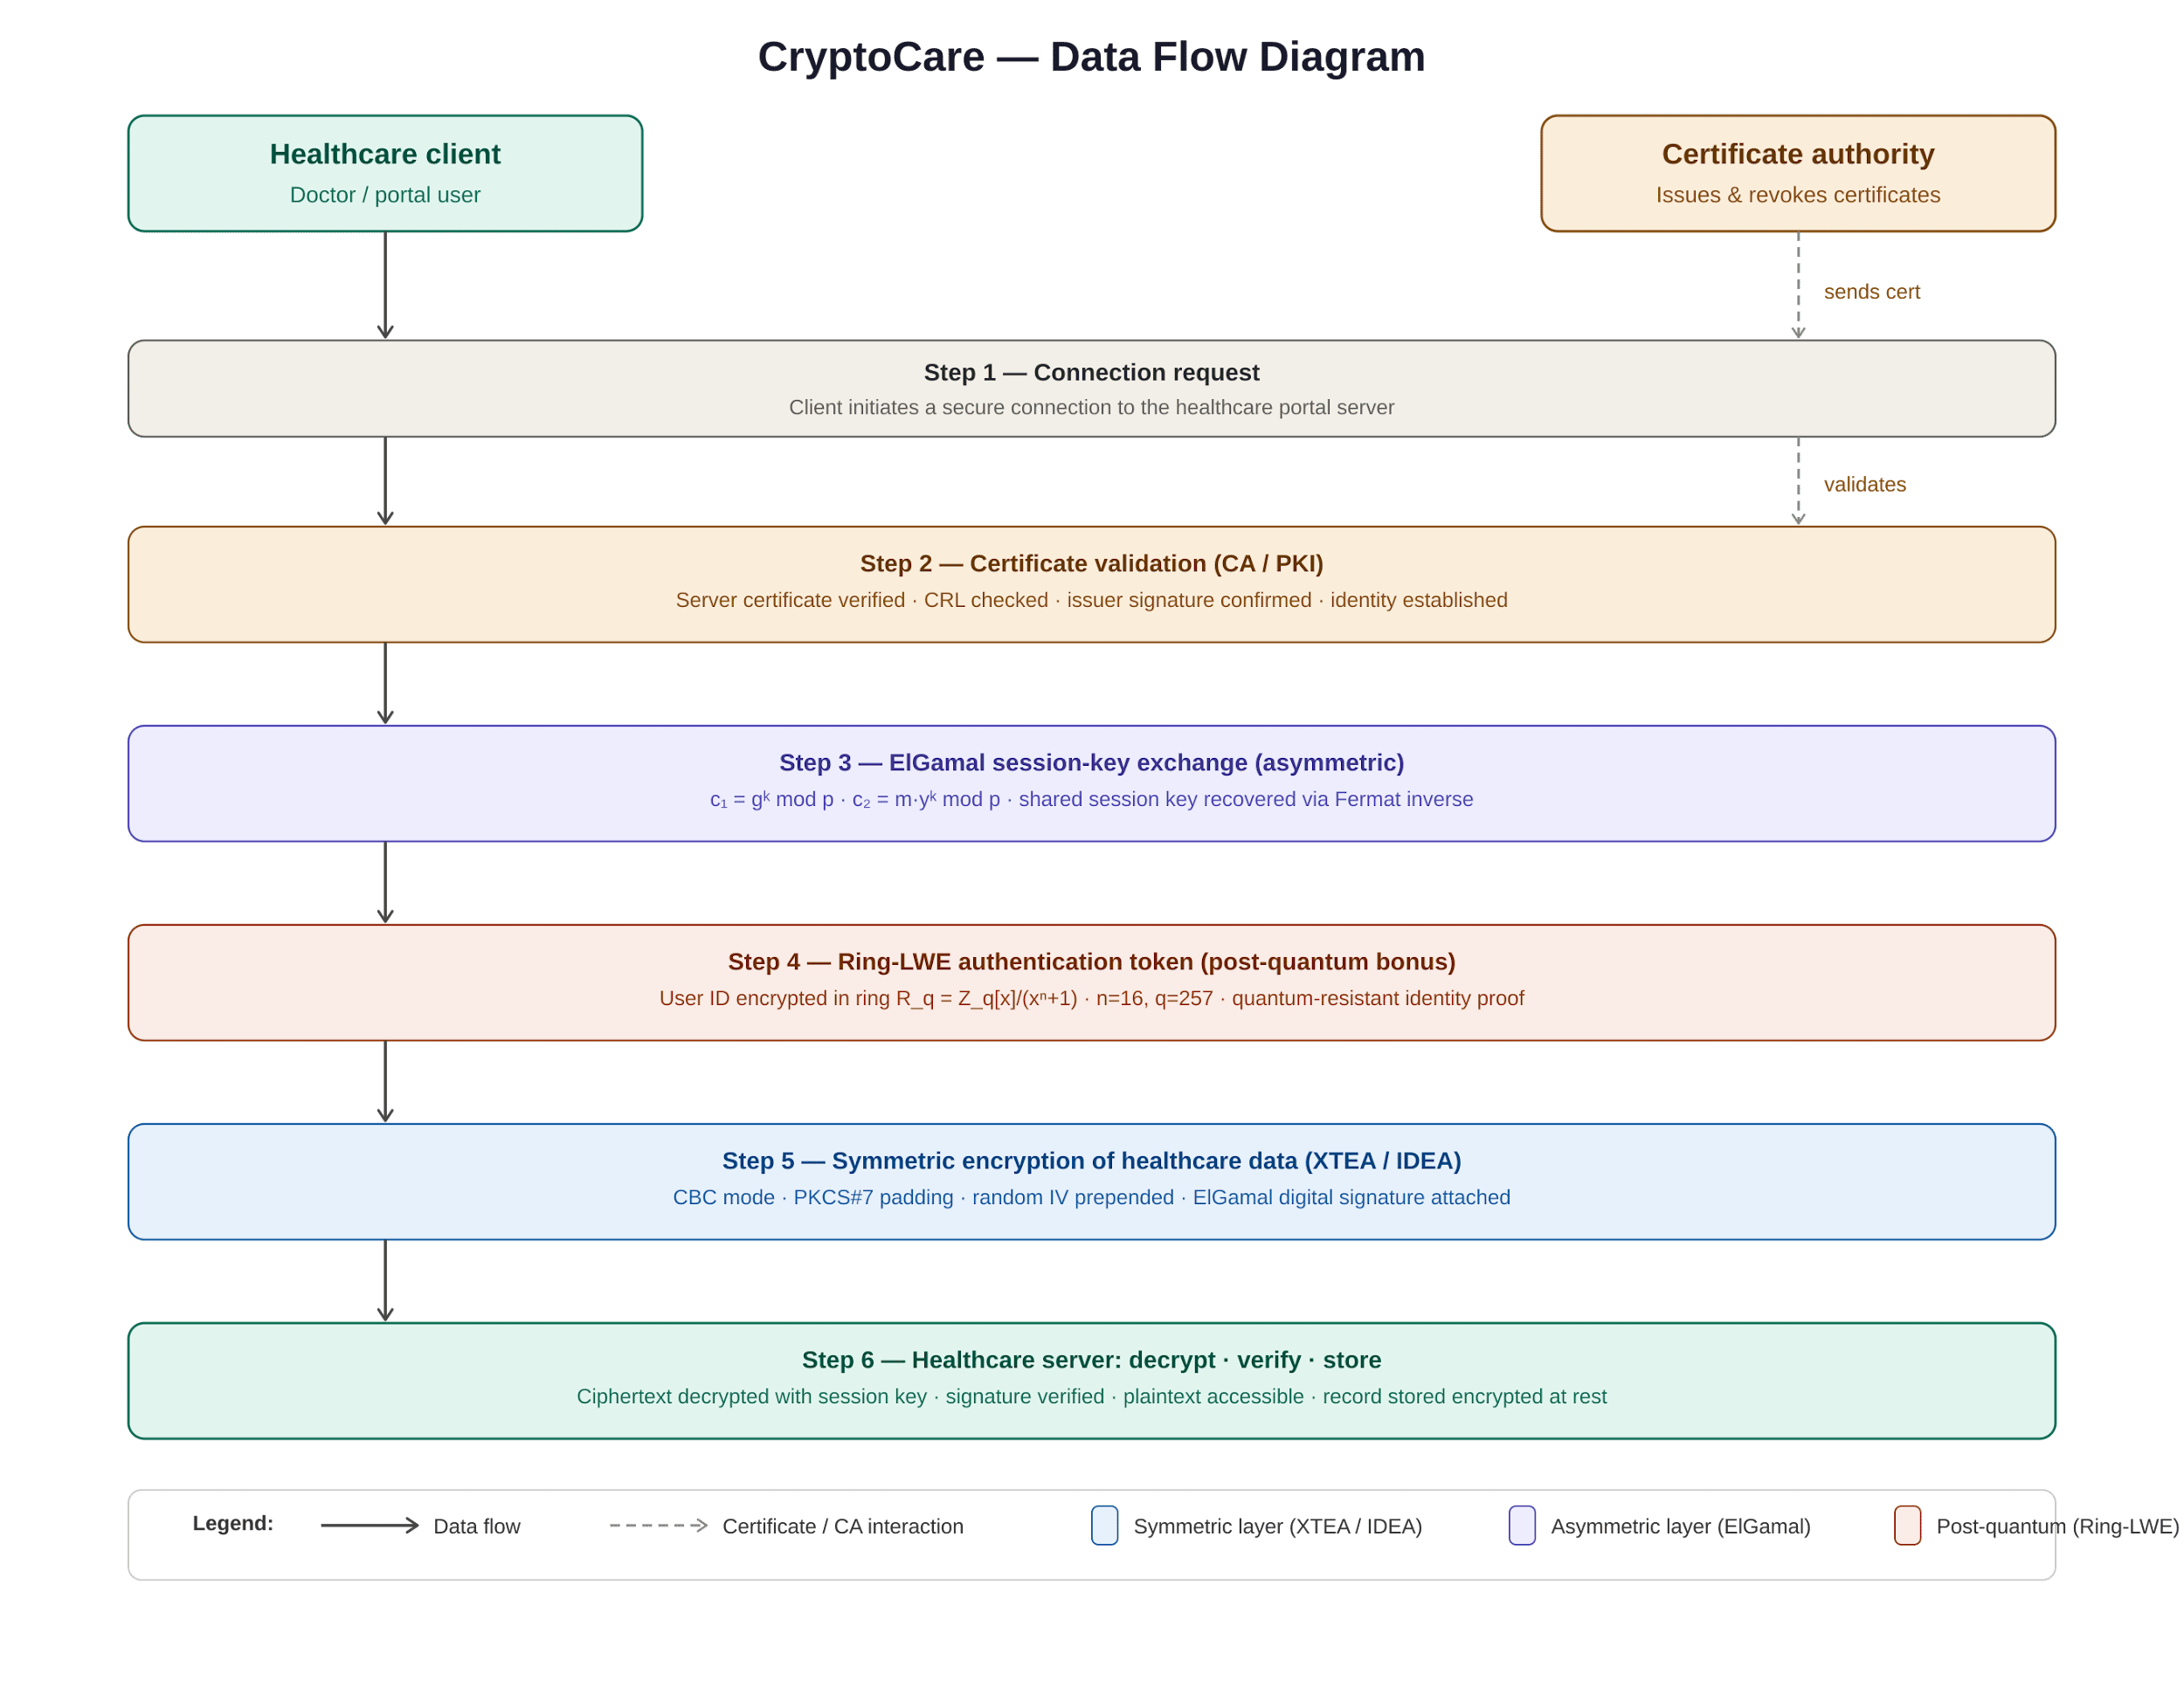
The Certificate Authority module is responsible for issuing and validating digital certificates. During authentication, the client verifies the server certificate before trusting the communication channel. This process prevents unauthorized entities from impersonating legitimate servers and reduces the risk of man-in-the-middle attacks.

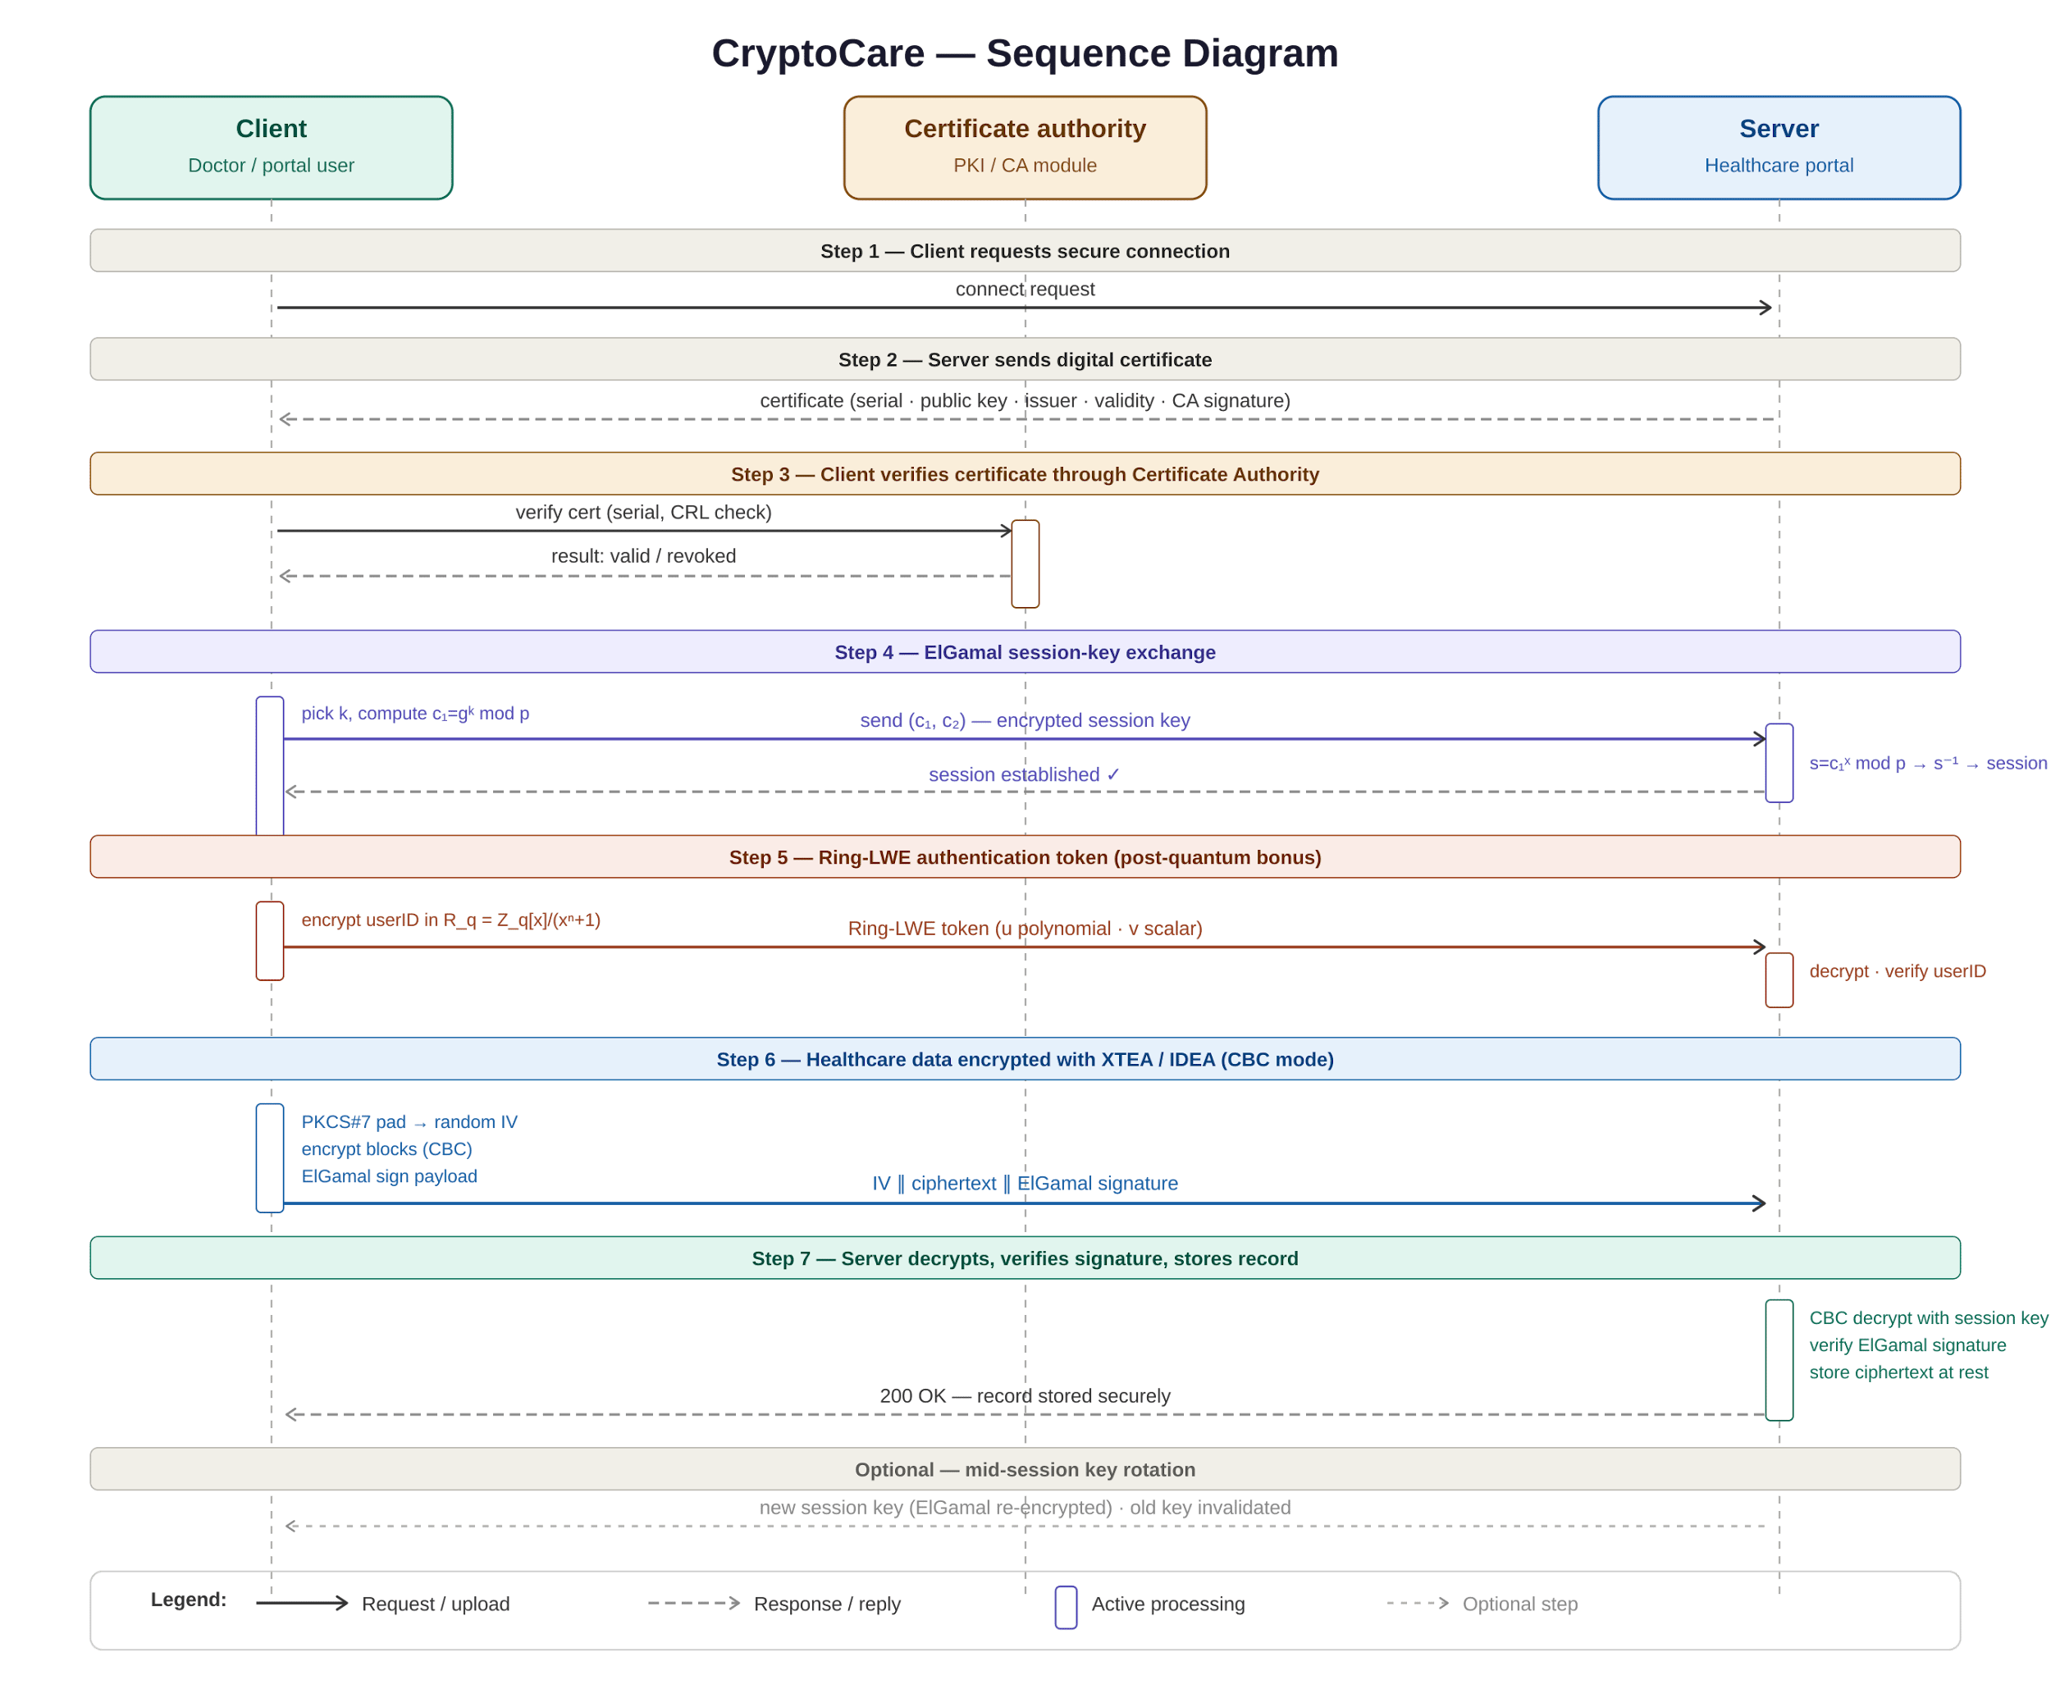

5. Conclusion

Building CryptoCare from scratch proved more rewarding than expected. Implementing XTEA, IDEA, ElGamal, a certificate authority, and a Ring-LWE module all without external libraries forced us to grasp every mathematical step instead of relying on prebuilt functions. That depth of understanding could not have been gained otherwise.
The system’s hybrid design keeps it practical. XTEA and IDEA encrypt bulk patient records efficiently in CBC mode, while ElGamal is reserved for session-key exchange and physician signatures, avoiding asymmetric overhead. The CA layer ensures verified identities, and session-key rotation limits damage from compromise. The Ring-LWE module, though using toy parameters, demonstrates awareness of post-quantum directions.
To conclude, CryptoCare shows that a secure, multi-layered communication system for healthcare data can be built from first principles. Scaling to production would require larger ElGamal primes and replacing Ring-LWE with CRYSTALS-Kyber, but the architecture already anticipates those upgrades.

