Cairo University Faculty of Computers and Artificial Intelligence



**Advanced SE**

**Software design specification document**

**2022**

**Project Team**

|  |  |  |
| --- | --- | --- |
| **ID** | **Name** | **Email** |
| 20200204 | Ziad Mohamed Samir | ziadmohamed997@gmail.com |
| 20200082 | Islam Yasser Tamer | Islamyasser950@gmail.com |
| 20200018 | Ahmed Sayed Mansour | ahmed.sa.mns@gmail.com |

Contents

Instructions[To be removed] 2

Class diagram design 2

Class diagram Explanation 3

Sequence diagram design 3

Github repository link 4

# Class diagram design

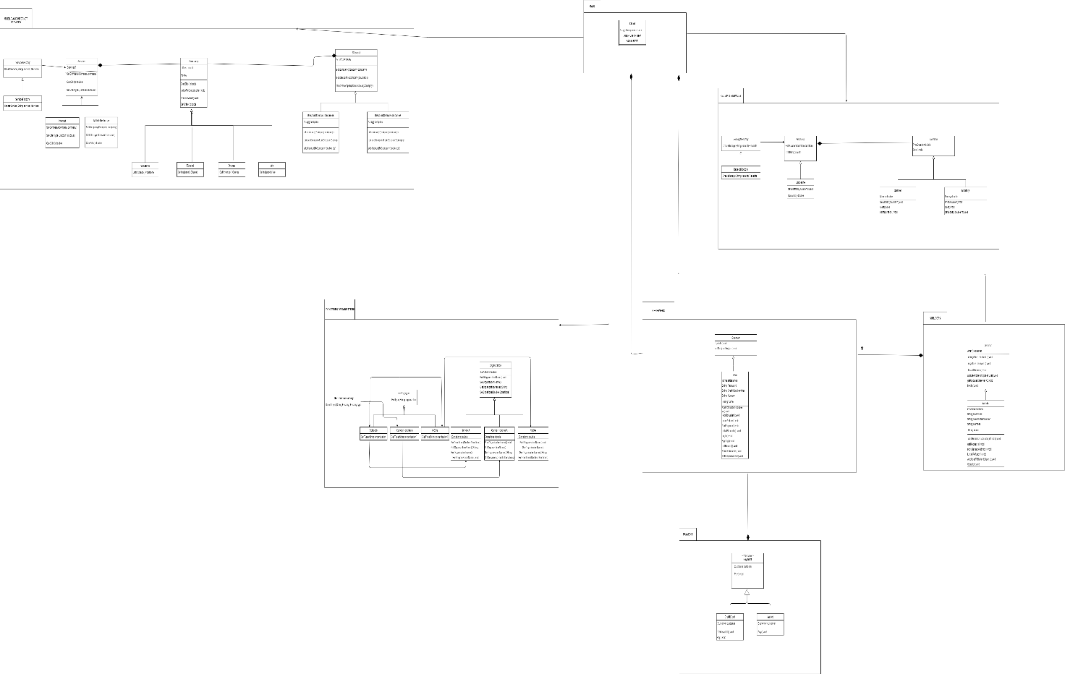

# Class diagram Explanation

|  |  |  |  |  |
| --- | --- | --- | --- | --- |
| **Design Patterns** | **Factory pattern** | **Abstract factory** | **Strategy pattern** | **Observer pattern** |
| **Classes** | **[1)ServiceFactory**  **2)Service**  **3)IServiceFactory**  **4)InternetServices**  **5)mobileCharge]**  **[1) Reciept**  **2)IRecieptFactory**  **3)RecieptFactory**  **4)Receipts**  **5)Landline]** | **[1) GetDonationFactory:**  **2)FactoryType:**  **3)Schools:**  **4)cancerhospitals:**  **5)NGOS:**  **6)Organization:**  **7)SchoolA:**  **8) cancerHospitalA:**  **9) NGOA:]** | **[1)Companies**  **2)Vodafone**  **3)Etisalat**  **4)Orange**  **5)We**  **6)MobileCharge**  **7)InternetService]**  **[1)Discount**  **2)SpecialDiscount**  **3)OverallDiscount**  **4)Companies**  **]** | **[1)Admin**  **2)User**  **]** |
| **Justifications** | **[IServiceFactory: interface that ease the addition or removal of service.**  **ServiceFactory: implements IserviceFactory.**  **Service: Abstract class that implemented by mobileRecharge class and InternetServices class]**  **[IRecieptFactory:interface that ease the addition or removal of receipts as landline or gas or water receipt.**  **RecieptFactory:implements IReciptFactory to ease the creation of object.**  **Landline:type of service that work on reciepts** | **[1) GetDonationFactory:concrete**  **2)FactoryType:interface**  **3)Schools:concrete implement factorytype**  **4)cancerhospitals: concrete implement factorytype**  **5)NGOS: concrete implement factorytype**  **6)Organization:abstrsct class**  **7)SchoolA:concrete class extends organization and created from Schools class**  **8) cancerHospitalA:concrete class extends organization and created from cancerHospital class**  **9) NGOA:concrete class extends organization and created from NGOs class** | **[As companies:interface that Vodafone, Etisalat, Orange, We implement it.**  **And InternetServices and MobileRecharge has an instance of companies to ease the choose of behaviors that are the company type.]**  **[As Discount:interface that specialDiscount and OverallDiscount implement it.**  **And companies class has an instance from Discount to add Discount to every service provider.]** | **User requests a refund so the refund request is sent to admin and the admin accept pr refuse the request and notify the user with the update he done as he accept or not.** |

# Sequence diagram design

1. Add new Discount

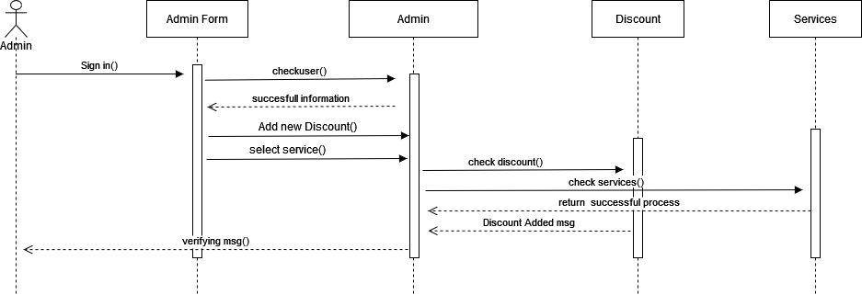

1. User Refund Request

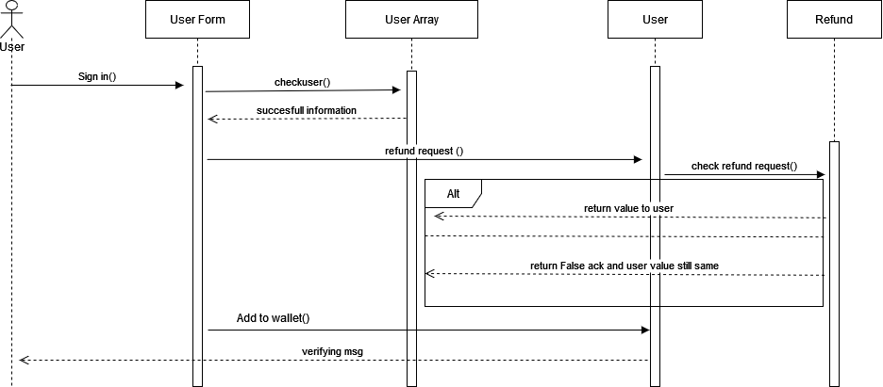

1. Admin Accept Request

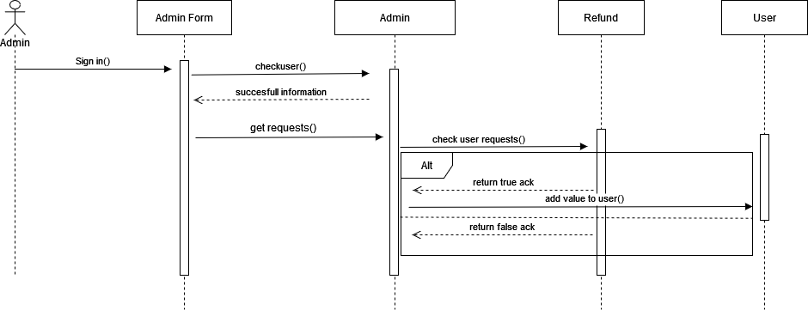

1. User adds to wallet

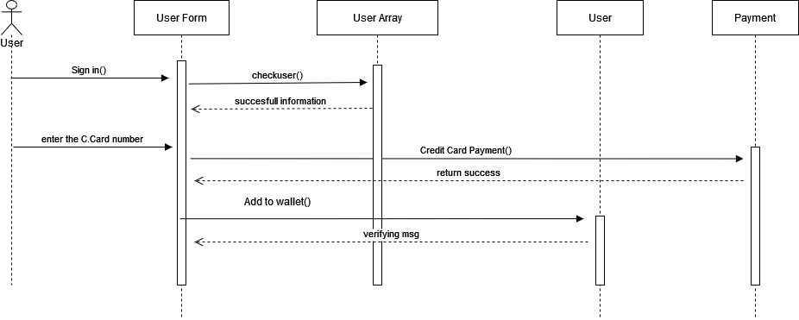

1. User check Discount

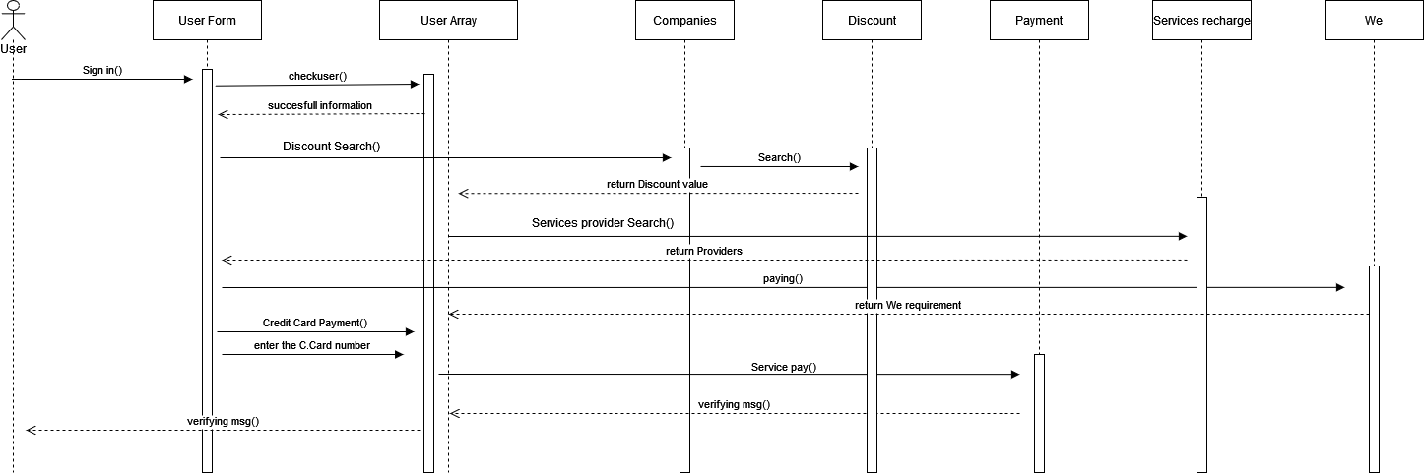

1. User choose Service

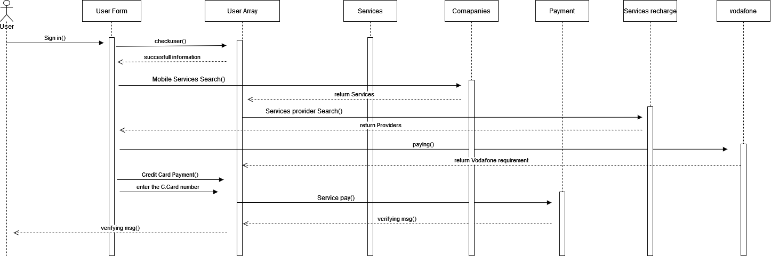

# Github repository link

https://github.com/ZiadSamir99/Eda3ly-Service-Project.git