|  |  |
| --- | --- |
| ***Super Function in python*** | *This project explores how Python’s super function handles multiple inheritance. super function avoids redundancy and improves code clarity.*  Ziad Nasser |

**Introduction:**In Python, the super function is used to call methods from a parent. Its importance becomes especially clear in the context of multiple inheritance, where multiple classes are involved. The primary goal of super function is to maintain a well-defined and predictable order of method resolution.

**Multiple Inheritance:**

Multiple inheritance allows the class to inherit from more than one parent class. This can create ambiguity in method calls if more than one parent class implements the same method.

**Example without super function:**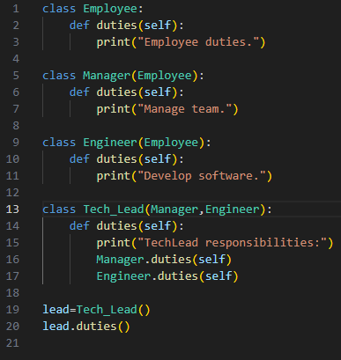

**Output:**

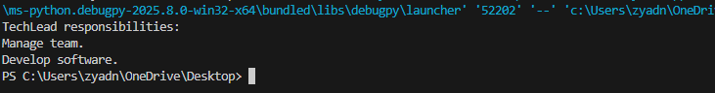

In the above example, Manager.duties() and Engineer. duties () are called explicitly, which is not scalable or maintainable, especially when the hierarchy grows.

**Example with super function:**

Python uses the C3 linearization algorithm (MRO) to find the order of method calls. Super function respects this order and allows each class to take part in the chain properly.

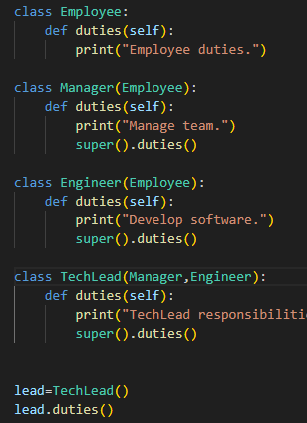

**Output:**

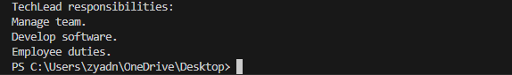

**Advantage of super function in muti inheritance:**

1. Avoid duplicate calls by the same method.
2. Follows MRO, which is deterministic and consistent.
3. Extensibility, new classes can be inserted into the hierarchy without changing existing code.

***Conclusion***

The super function is a powerful feature in Python that elegantly manages multiple inheritance by using the Method Resolution Order (MRO). It ensures clean and predictable behavior across class hierarchies, making it essential for building scalable and maintainable object-oriented systems.