

Communication Assignment 1



Ziad Sherif Muhammed BN:27 Sec:1

Abdelrahman Muhammed Hamza BN:37 Sec:1

Introduction

This report describes the implementation of uniform scalar quantizer and de-quantizer functions. The quantizer function accepts an input signal, number of bits, and range of the quantizer as inputs, and quantizes the input signal using uniform quantization. The de-quantizer function reverses the quantization process and reconstructs the original signal. The functions are tested on deterministic and random input signals, and their performance is evaluated in terms of signal-to-noise ratio (SNR) for different number of bits.

Implementation:

1. Quantizer:

The uniform scalar quantizer function is implemented with the header. q_ind = UniformQuantizer(in_val, n_bits, xmax, m). The input signal is quantized using uniform quantization, where the range of the quantizer is defined by xmax and m, and the number of bits is defined by n_bits. The width of each quantization interval is calculated using the formula Δ = 2 × xmax/L, where L is the number of quantization intervals. The mean (or offset) of the quantizer reconstruction levels is defined by m. The function returns the index of the chosen quantization level in q_ind.

1. De-Quantizer:

The uniform scalar dequantizer function is implemented with the header deq_val=UniformDequantizer(q_ind,n_bits,xmax,m). The function dequantizes the input signal by reversing the quantization process and reconstructing the original signal. The function parameters (i.e., n_bits,xmax,m) are the same as in the quantizer function.

Req 3:

functions are tested on a deterministic input signal, which is a ramp signal x=-6:0.01:6. The input signal is quantized and dequantized assuming that n_bits=3 and xmax=6, and the reconstructed signal is plotted on the same graph as the input signal for m=0 and m=1.

Screenshots:

|  |  |
| --- | --- |
|  |  |
|  |  |

Req 4:

The functions are tested on a random input signal, which is a sequence of 10,000 independent and identically distributed (i.i.d) continuous uniform random variables between -5 and 5. Each sample of the input signal is passed through the quantizer and de-quantizer functions, and the quantization error is calculated using xmax=5 and m=0. The SNR is then calculated as E(input^2)/E(quantization error^2) for different number of bits (n_bits=2:1:8), and the simulation and theoretical SNR (in dB) are plotted on the same graph.

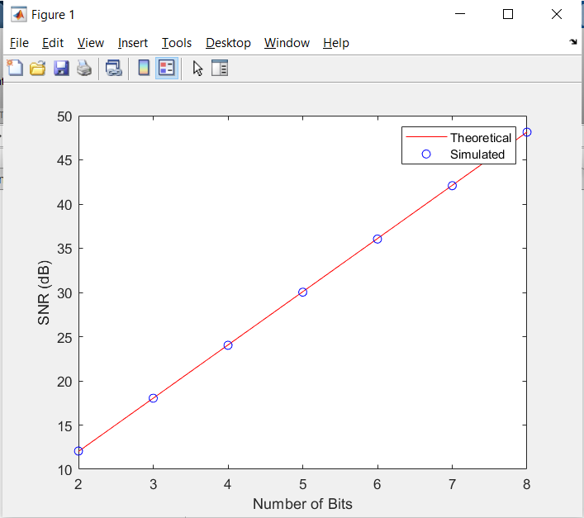Screenshots:

Req 5:

The uniform scalar quantizer was tested on a non-uniform random input signal in this task. The input signal was created by multiplying a sequence of random variables with an exponential distribution by another sequence of random polarity using the sign function in MATLAB. The resulting signal was quantized and dequantized. The quantization parameters were set to n_bits = 3 and xmax = 5. The quantization process was repeated for both midrise and midtread reconstruction by setting m = 0 and m = 1.

The quantization error and signal-to-noise ratio (SNR) were calculated for each value of m. The SNR, which is the ratio of the input signal power to the quantization error power in dB, decreased as the number of bits used for quantization decreased. This is because reducing the number of bits used for quantization increases the quantization error, resulting in a lower SNR.

Screenshots:

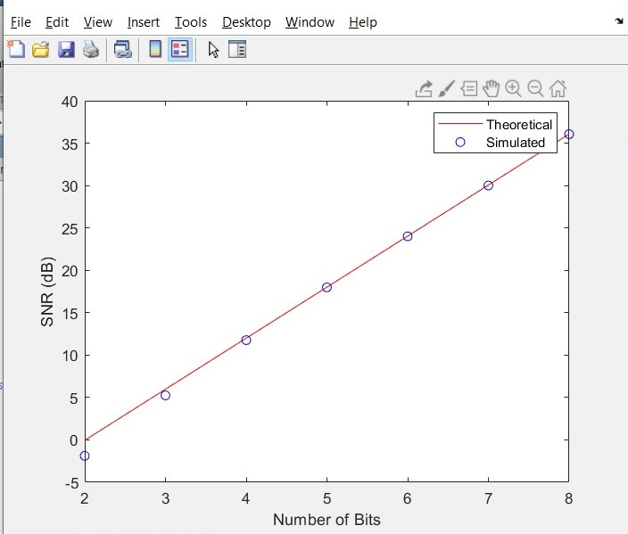

Req 6:

Finally, the uniform quantizer is tested on a non-uniform random input signal, which has a random polarity and follows an exponential distribution with PDF f(x)=e^(-x). The input signal is quantized using a non-uniform 𝝁 law quantizer for different values of 𝜇 (𝜇=0, 5, 100, 200), and the performance is evaluated in terms of SNR.

Screenshots:

Conclusion

In this assignment, we implemented uniform scalar quantizer and de-quantizer functions and tested them on deterministic and random input signals. The performance of the functions was evaluated in terms of SNR for different number of bits and for non-uniform random input signals. The results show that the uniform quantizer and de-quantizer functions perform well for uniform and non-uniform random input signals, and the performance improves with increasing number of bits.