

Communication Assignment 2

**Ziad Sherif Muhammed**

**Sec:1 Code: 9202586**

**Abdelrahman Muhammed Hamza**

**Sec:1 Code: 9202793**

Part ||

2) // **To-do** MATLAB

1. Add code.
2. Add simulation.

3) // **To-do** some of plots here

Linear

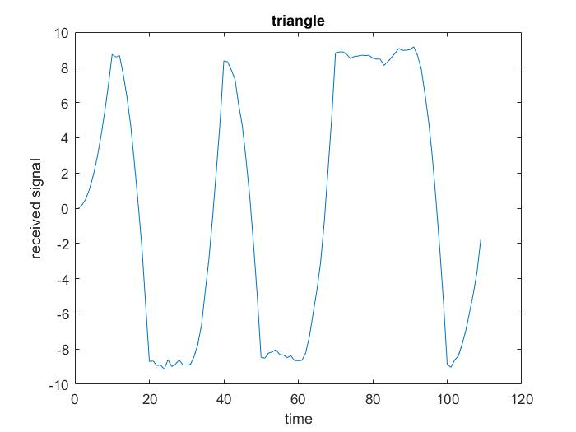

Matched

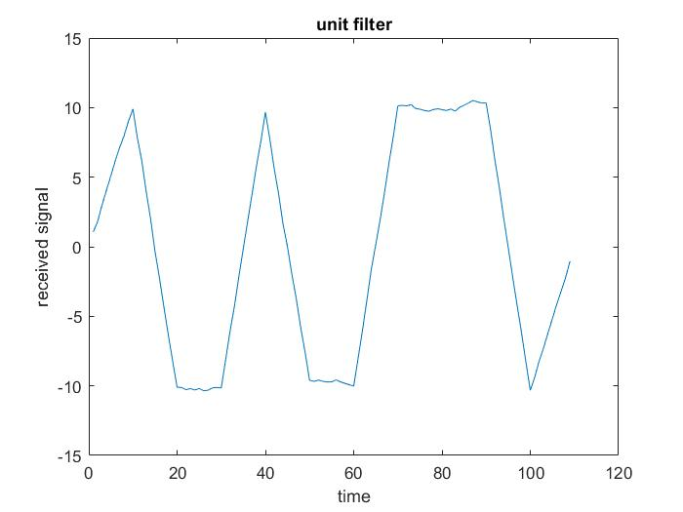

Pulse

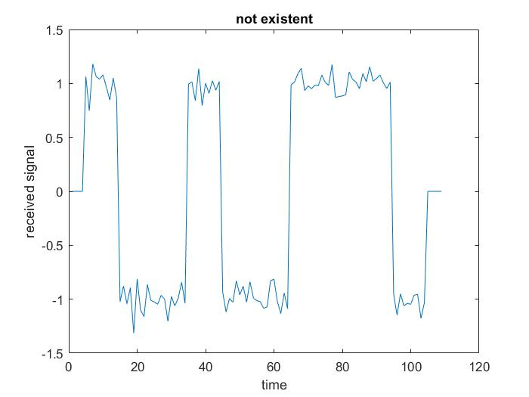

4) // **To-do** some of plots here

BER

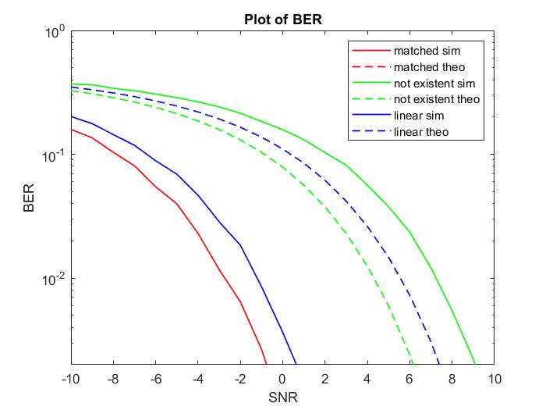

5) BER is decreasing as a function E/No. due to:

1. Increasing the ratio of signal energy per bit (E) to power spectral density of noise (No), which is denoted as **E/No**, leads to a **decrease** in No and const (E). This decrease in No reduces the standard deviation (sigma) of **the added noise** since sigma = sqrt (No/2), which means that the added AWGN involves less variation and corresponds to smaller values **close to zero**. Consequently, which **it doesn`t affect the input signal** that much, therefore **BER decreases**.
2. As in the theoretical expression and knowing that Q is a decreasing function, it’s clear that Q (a * sqrt(E/No)).

**for all the cases above. Hence, BER is a decreasing function of E/No (noting that sqrt is an increasing function)**

6) The matched filter case is the one with lowest BER since it uses a filter matched to the pulse to **minimize** the probability of error. To accomplish this, it equivalently **maximizes** the peak pulse SNR at the sampling instant.