Neural Network & Deep Learning Documentation
Project: 7- Car Type Classification
ElZowzat +2 Team
This document provides a comprehensive comparison between four neural network architectures used in this project: VGG19 (trained from scratch), MobileNet V1 (trained from scratch), ResNet50 (fine-tuned), and Inception V1 (fine-tuned). It analyzes their performance metrics, discusses their advantages and limitations, and outlines planned future models.

1. VGG19 (Trained From Scratch)

Overview
VGG-19 is a deep Convolutional Neural Network (CNN) model developed by the Visual Geometry Group (VGG) at the University of Oxford. It is well known for its simple and uniform architecture, where very small convolution filters (3×3) are stacked deeply to increase the network’s ability to learn complex visual features. VGG-19 contains 19 learnable layers (16 convolutional layers + 3 fully connected layers) and was originally trained on the ImageNet dataset for large-scale image classification. Its main strength lies in showing that depth alone, with a consistent design, can significantly improve performance in image recognition tasks.
Structure of VGG-19
The architecture of VGG-19 is organized into 5 convolutional blocks, followed by fully connected layers:
- Input Layer
  - Input image size: 224 × 224 × 3 (RGB image).
- Convolutional Blocks (Feature Extraction)
  - Each block uses 3×3 convolution filters, stride = 1, padding = “same”.
  - ReLU activation is applied after every convolution.
  - Each block ends with a Max Pooling layer (2×2) to reduce spatial dimensions.
  - Block 1: 2 convolution layers (64 filters) + max pooling
  - Block 2: 2 convolution layers (128 filters) + max pooling
  - Block 3: 4 convolution layers (256 filters) + max pooling
  - Block 4: 4 convolution layers (512 filters) + max pooling
  - Block 5: 4 convolution layers (512 filters) + max pooling
- Fully Connected Layers (Classification)
  - Flatten layer
  - FC layer with 4096 neurons + ReLU
  - FC layer with 4096 neurons + ReLU
  - Output layer with Softmax (number of neurons depends on number of classes)
Steps of Working (How VGG-19 Works)
- Input Image is resized to 224×224 and normalized.
- Convolution Layers extract low-level features (edges, textures) in early layers and high-level features (shapes, objects) in deeper layers.
- ReLU Activation introduces non-linearity, allowing the network to learn complex patterns.
- Max Pooling reduces feature map size, lowers computation, and helps prevent overfitting.
- Flattening converts 2D feature maps into a 1D vector.
- Fully Connected Layers learn global relationships between features.
- Softmax Layer outputs class probabilities for classification.
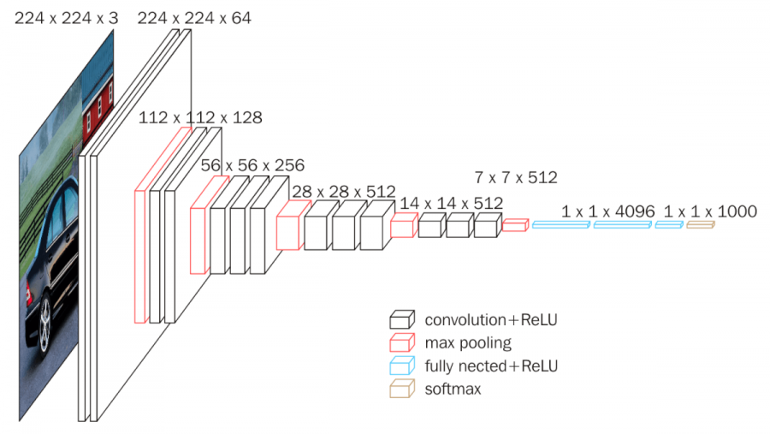
Figure : Architecture of VGG 19

Performance Metrics
Metric | Value
Top-1 Accuracy | 0.82%
Top-5 Accuracy | 3.11%
Precision | 0.01%
Recall | 0.82%
F1-Score | 0.01%
Log Loss | 5.2726
AUC-ROC (Macro) | 0.5000
AUC-ROC (Weighted) | 0.5000

Advantages
- Educational Value: Highlights the practical difficulties of training deep convolutional networks from random initialization on limited datasets.
- Full Architectural Control: All learned representations are derived exclusively from the task-specific data.

Limitations
- Extremely Poor Performance: The model failed to converge and produced results close to random guessing.
- High Computational Cost: Training deep models from scratch requires substantially more data, epochs, and compute resources.
- Optimization Challenges: The absence of residual connections makes very deep networks prone to vanishing gradients.

2. ResNet50 (Fine-Tuned)

Overview
ResNet (Residual Network) is a deep Convolutional Neural Network introduced by Microsoft Research to solve the problem of vanishing and exploding gradients that occurs when networks become very deep. Its key idea is the use of residual (skip) connections, which allow the network to learn the residual of a function instead of the full mapping.
Structure of ResNet
ResNet is built from repeating units called residual blocks, rather than plain stacked convolution layers.
Residual Blocks (Core of ResNet)
  - Each block contains:
    - Convolution layers (usually 3×3)
    - Batch Normalization
    - ReLU activation
    - Skip (shortcut) connection that adds the input of the block directly to its output
Steps of Working (How ResNet Works)
- Input image is resized and normalized.
- Early convolution layers extract basic features such as edges and textures.
- Residual blocks learn feature transformations while
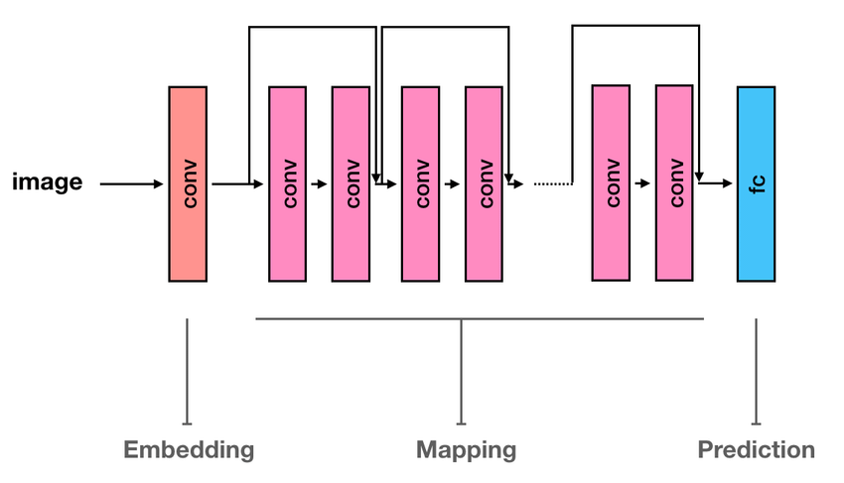
Figure : Architecture of ResNet

Performance Metrics
Metric | Value
Top-1 Accuracy | 85.60%
Top-5 Accuracy | 96.64%
Precision | 86.88%
Recall | 85.60%
F1-Score | 85.32%
Log Loss | 0.5033
AUC-ROC (Macro) | 0.9986
AUC-ROC (Weighted) | 0.9986

Advantages
- Strong Predictive Performance: Achieved high Top-1 and Top-5 accuracy, indicating effective classification.
- Training Efficiency: Converged rapidly due to the reuse of robust pre-trained feature extractors.
- Excellent Class Separation: Near-perfect AUC-ROC values demonstrate strong discrimination between classes.

Limitations
- Dependency on Pre-Trained Weights: Performance relies on the availability and quality of external datasets such as ImageNet.

3. InceptionV1
Inception V1 (GoogLeNet) is a deep Convolutional Neural Network developed by Google that focuses on efficient computation and multi-scale feature extraction. Instead of using a single filter size per layer, Inception V1 processes the input using multiple convolution filters of different sizes in parallel, allowing the network to capture both local and global features at the same time. Despite being deep (22 layers), it has far fewer parameters than models like VGG, making it faster and more memory-efficient. It achieved top performance on the ImageNet challenge.
Structure of Inception V1
The architecture of Inception V1 is built around the Inception module, which is the core building block of the network.
- Inception Modules (Main Feature Extractor)
  - Each Inception module has parallel paths:
    - 1×1 convolution (for dimensionality reduction)
    - 3×3 convolution
    - 5×5 convolution
    - 3×3 max pooling
  - Outputs from all paths are concatenated along the depth dimension.
  - 1×1 convolutions are used before 3×3 and 5×5 filters to reduce computation cost.
- Auxiliary Classifiers
  - Two auxiliary classifiers are added in intermediate layers.
  - They help improve gradient flow and act as regularizers during training.
- Final Layers
  - Global Average Pooling
  - Fully Connected layer
  - Softmax output layer
In our implementation we utilized pre-trained weights, ones trained on ImageNet, as a base, then ran a fine-tuning phase to introduce the model to the dataset. This allowed it to leverage its pre-existing general knowledge to achieve great performance in this specific task.

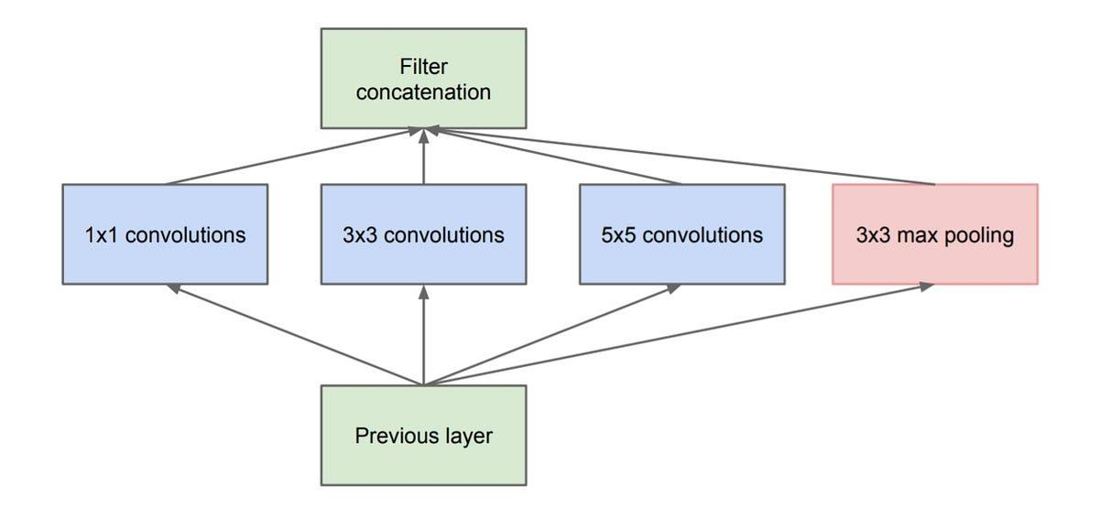
Figure 3: Architecture of Inception V1

Performance Metrics

Metric | Value
Top-1 Accuracy | 82.90%
Top-5 Accuracy | 96.15%
Precision | 85.26%
Recall | 82.90%
F1-Score | 82.51%
Log Loss | 0.6708
AUC-ROC (Macro) | 0.9980
AUC-ROC (Weighted) | 0.9979

4. MobileNet
The main feature of this model is Depthwise separable convolutions. These factorize standard convolutions into depthwise and pointwise operations, dramatically reducing computational cost and parameters while maintaining reasonable accuracy. This architectural choice makes the model highly efficient for resource-constrained environments.
Depthwise Separable Convolution Blocks
Each block consists of:
  - Depthwise Convolution
    - Applies a single filter to each input channel separately
    - Extracts spatial features
  - Pointwise Convolution (1×1)
    - Combines outputs from depthwise convolution
    - Controls the number of output channels
  - Batch Normalization + ReLU activation after each step
In our implementation we trained the weights from scratch, this forced the model. Under this setup, the model was required to learn all feature representations solely from the provided dataset.
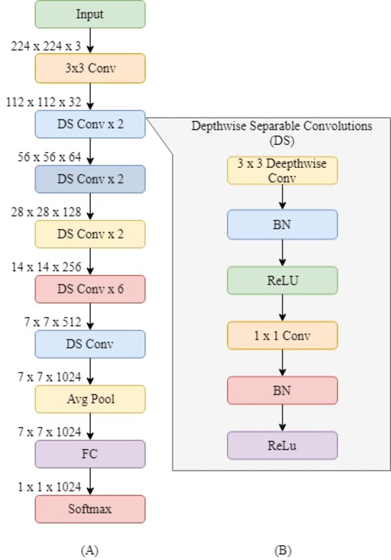
Figure : Architecture of Mobilenet

Performance Metrics

Metric | Value
Top-1 Accuracy | 62.11%
Top-5 Accuracy | 85.43%
Precision | 63.82%
Recall | 62.11%
F1-Score | 61.59%
Log Loss | 1.5188
AUC-ROC (Macro) | 0.9892
AUC-ROC (Weighted) | 0.9890

3. Comparative Analysis
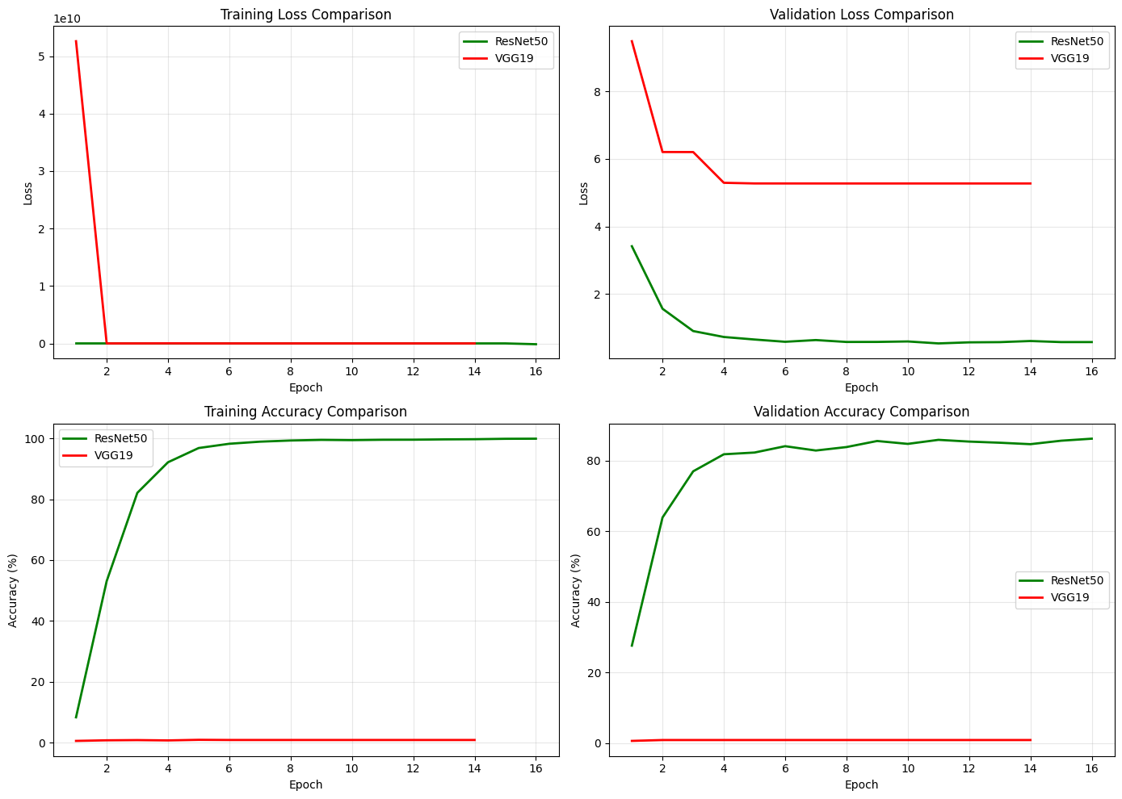
The table below presents a direct comparison between all the models.
Metric | ResNet50 (Fine-Tuned) | VGG19 (From Scratch) | MobileNet (from scratch) | Inception V1 (fine-tuned) | Better Model
Top-1 Accuracy (%) | 85.60 | 0.82 | 62.11 | 82.90% | ResNet50
Top-5 Accuracy (%) | 96.64 | 3.11 | 85.43 | 96.15% | ResNet50
Precision (%) | 86.88 | 0.01 | 63.82 | 85.26% | ResNet50
Recall (%) | 85.60 | 0.82 | 62.11 | 82.90% | ResNet50
F1-Score (%) | 85.32 | 0.01 | 61.59 | 82.51% | ResNet50
Log Loss | 0.5033 | 5.2726 | 1.5188 | 0.6708 | ResNet50
AUC-ROC (Macro) | 0.9986 | 0.5000 | 0.9892 | 0.9980 | ResNet50
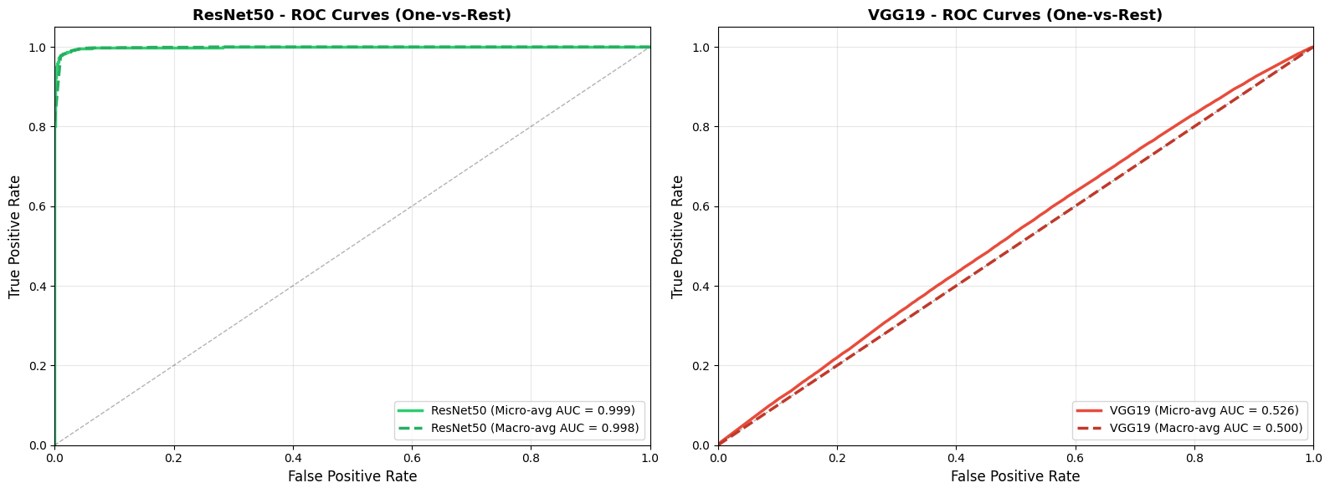

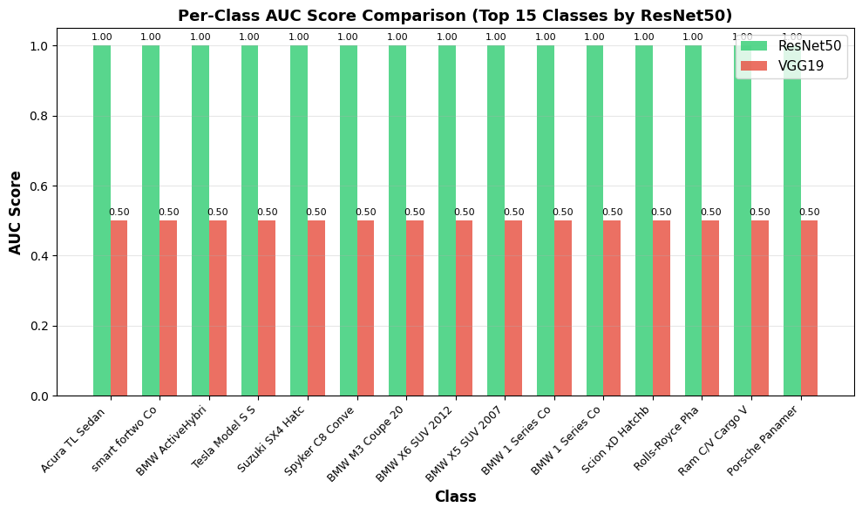

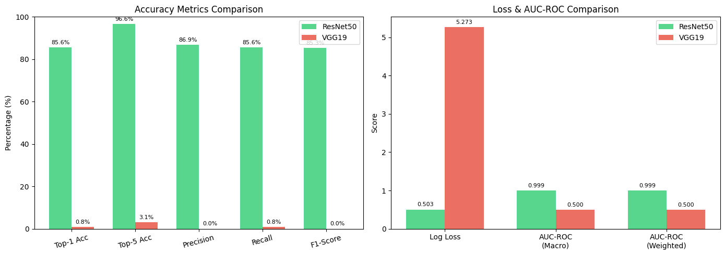

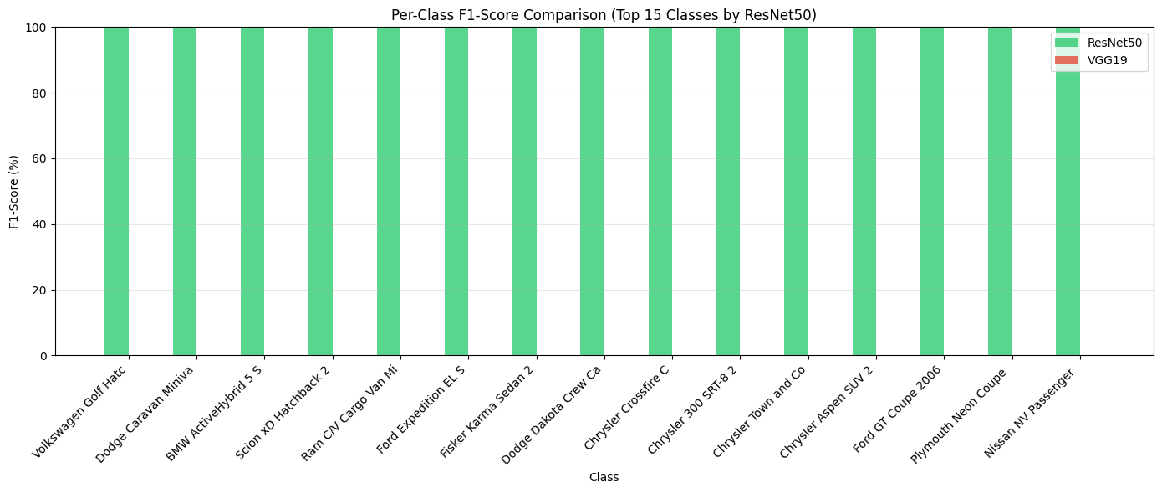

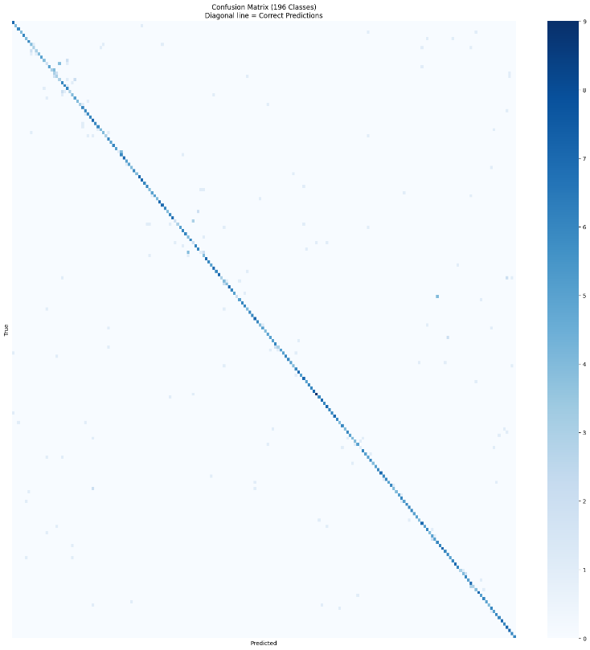
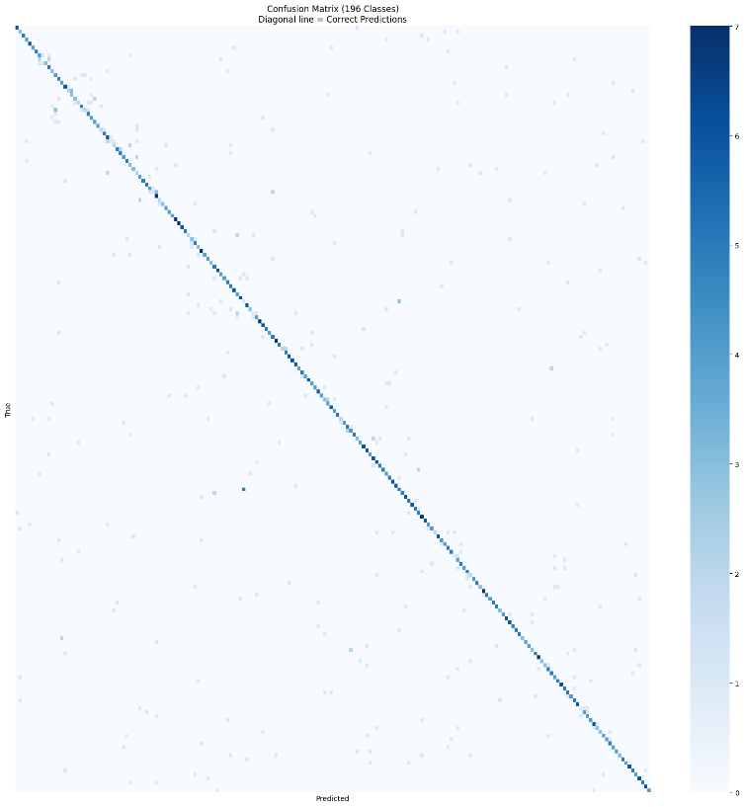
Confusion Matrix VGG19 and Resnet
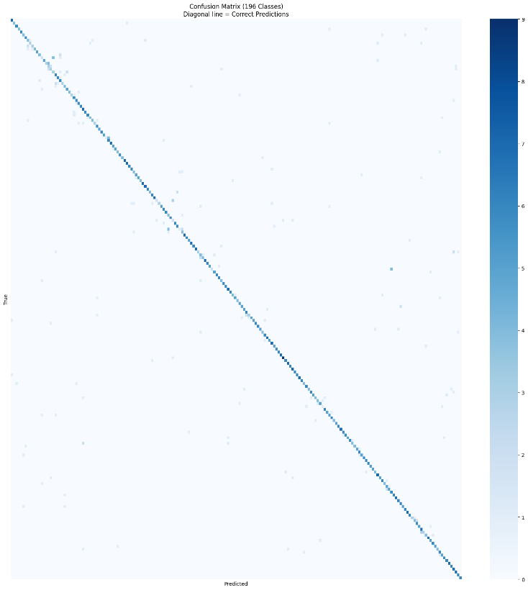
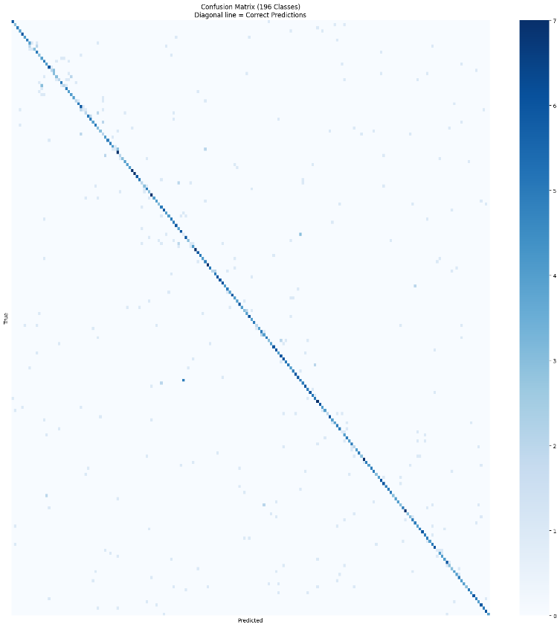

Confusion Matrix Inception V1 and Mobile net

Inception V1 ROC:

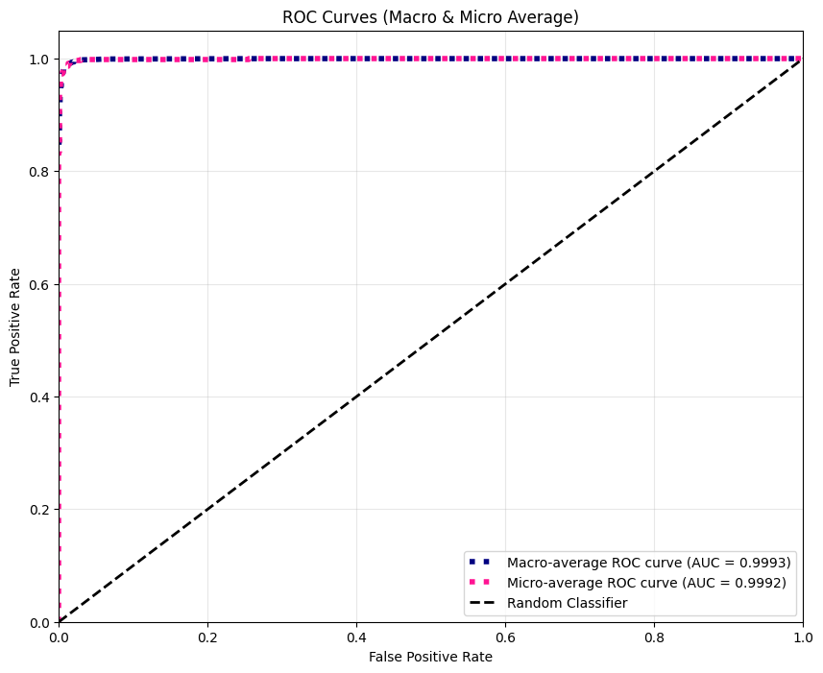

MobileNet ROC:
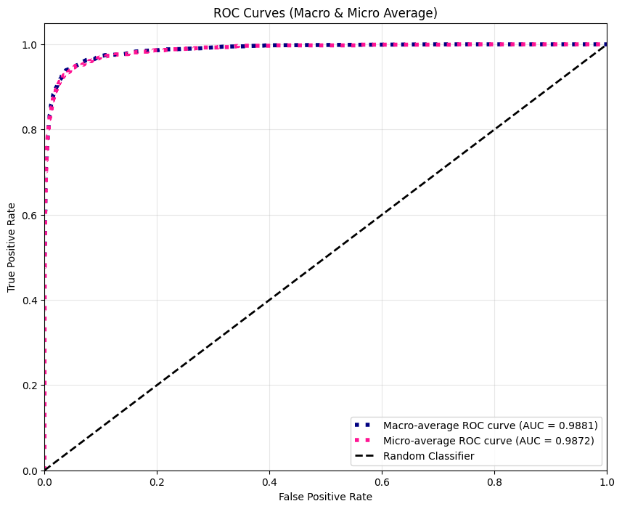

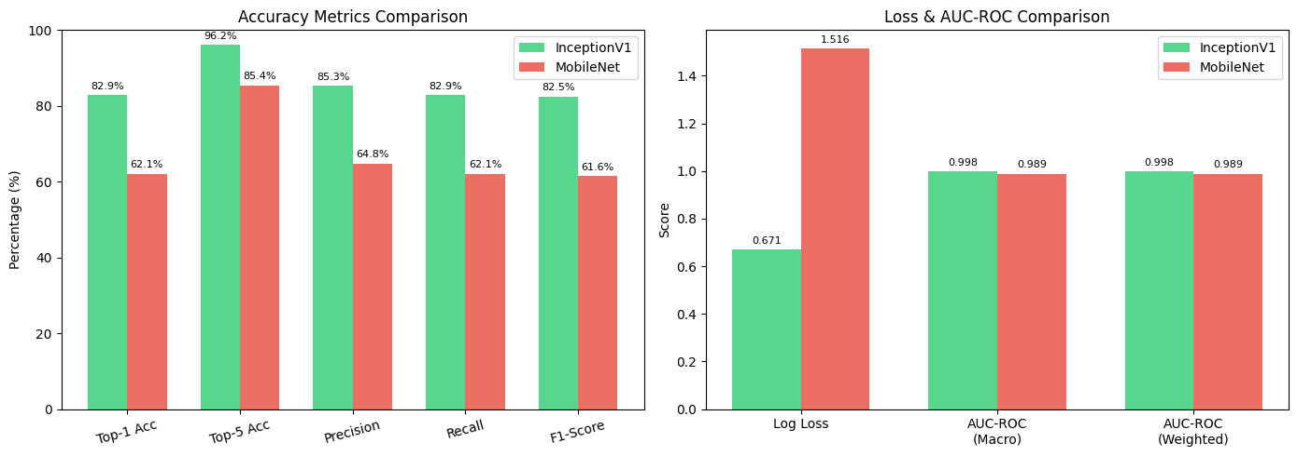

4. Conclusion
The (Fine-Tuned) ResNet50 model is the clear choice for deployment in this project. Its superior accuracy, stability, and convergence behavior significantly outperform the from scratch models and slightly edges Inception V1. These results strongly support the use of pre-trained models when working with limited datasets.

5. Citations
- ResNet (He et al., 2015):
He, K., Zhang, X., Ren, S., & Sun, J. (2016). Deep Residual Learning for Image Recognition. Proceedings of the IEEE Conference on Computer Vision and Pattern Recognition (CVPR), 770–778. https://doi.org/10.48550/arXiv.1512.03385
- VGG19 (Simonyan & Zisserman, 2014):
Simonyan, K., & Zisserman, A. (2015). Very Deep Convolutional Networks for Large-Scale Image Recognition. International Conference on Learning Representations (ICLR). https://doi.org/10.48550/arXiv.1409.1556
- Inception v1 C. Szegedy et al., "Going deeper with convolutions," in 2015 IEEE Conference on Computer Vision and Pattern Recognition (CVPR), Boston, MA, USA, 2015, pp. 1-9, doi: 10.1109/CVPR.2015.7298594.
- MobileNet v1 A. G. Howard et al., "MobileNets: Efficient convolutional neural networks for mobile vision applications," arXiv preprint arXiv:1704.04861, 2017.

