Documentation
This document provides a comprehensive comparison between two neural network architectures used in this project: VGG19 (trained from scratch) and ResNet50 (fine-tuned). It analyzes their performance metrics, discusses their advantages and limitations, and outlines planned future models.

1. VGG19 (Trained From Scratch)

Overview
The VGG19 model was trained from scratch without using any pre-trained weights. Under this setup, the model was required to learn all feature representations solely from the provided dataset.

Performance Metrics
Metric | Value
Top-1 Accuracy | 0.82%
Top-5 Accuracy | 3.11%
Precision | 0.01%
Recall | 0.82%
F1-Score | 0.01%
Log Loss | 5.2726
AUC-ROC (Macro) | 0.5000
AUC-ROC (Weighted) | 0.5000

Advantages
- Educational Value: Highlights the practical difficulties of training deep convolutional networks from random initialization on limited datasets.
- Full Architectural Control: All learned representations are derived exclusively from the task-specific data.

Limitations
- Extremely Poor Performance: The model failed to converge and produced results close to random guessing.
- High Computational Cost: Training deep models from scratch requires substantially more data, epochs, and compute resources.
- Optimization Challenges: The absence of residual connections makes very deep networks prone to vanishing gradients.

2. ResNet50 (Fine-Tuned)

Overview
The ResNet50 model employed transfer learning, starting from ImageNet pre-trained weights and fine-tuning them on the target dataset. This allowed the model to leverage previously learned visual features.

Performance Metrics
Metric | Value
Top-1 Accuracy | 85.60%
Top-5 Accuracy | 96.64%
Precision | 86.88%
Recall | 85.60%
F1-Score | 85.32%
Log Loss | 0.5033
AUC-ROC (Macro) | 0.9986
AUC-ROC (Weighted) | 0.9986

Advantages
- Strong Predictive Performance: Achieved high Top-1 and Top-5 accuracy, indicating effective classification.
- Training Efficiency: Converged rapidly due to the reuse of robust pre-trained feature extractors.
- Excellent Class Separation: Near-perfect AUC-ROC values demonstrate strong discrimination between classes.

Limitations
- Dependency on Pre-Trained Weights: Performance relies on the availability and quality of external datasets such as ImageNet.

Future Model 1: InceptionV1

Future Model 2: MobileNet

3. Comparative Analysis
The table below presents a direct comparison between VGG19 (from scratch) and ResNet50 (fine-tuned).
Metric | ResNet50 (Fine-Tuned) | VGG19 (From Scratch) | Better Model
Top-1 Accuracy (%) | 85.60 | 0.82 | ResNet50
Top-5 Accuracy (%) | 96.64 | 3.11 | ResNet50
Precision (%) | 86.88 | 0.01 | ResNet50
Recall (%) | 85.60 | 0.82 | ResNet50
F1-Score (%) | 85.32 | 0.01 | ResNet50
Log Loss | 0.5033 | 5.2726 | ResNet50
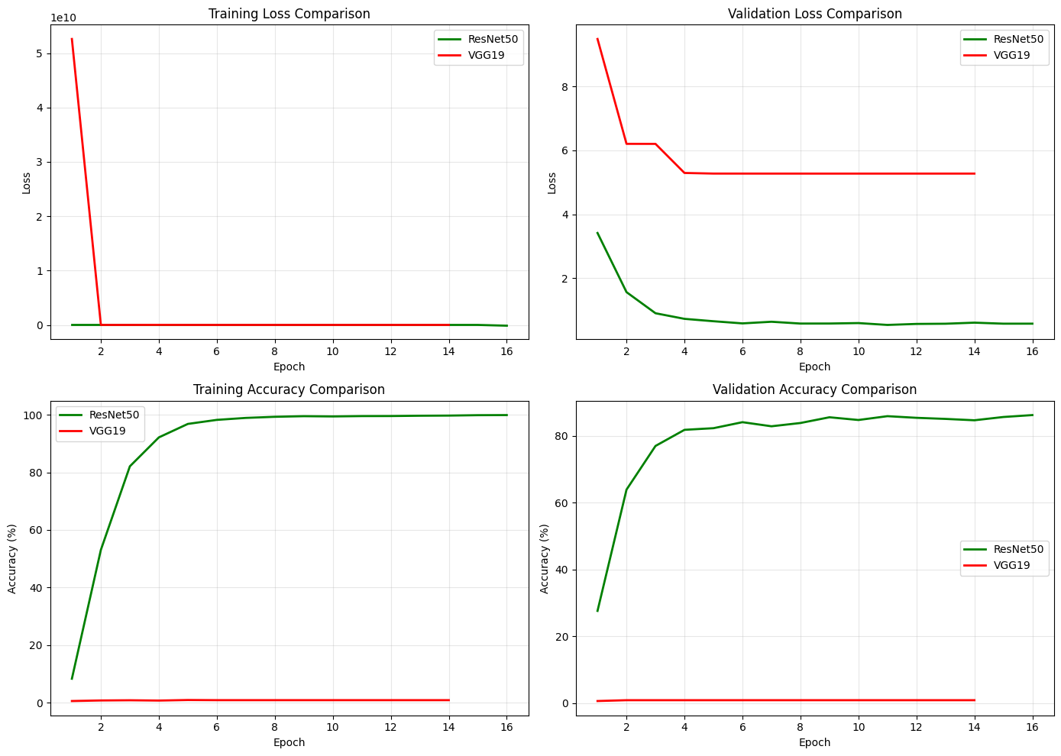  AUC-ROC (Macro) | 0.9986 | 0.5000 | ResNet50
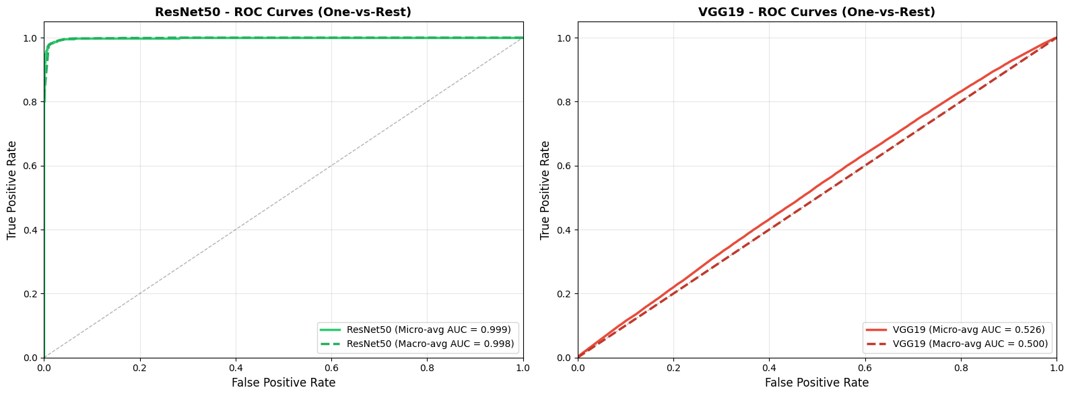

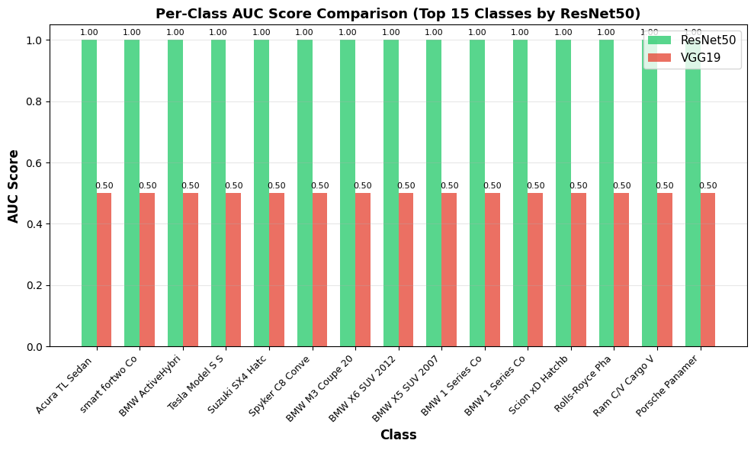

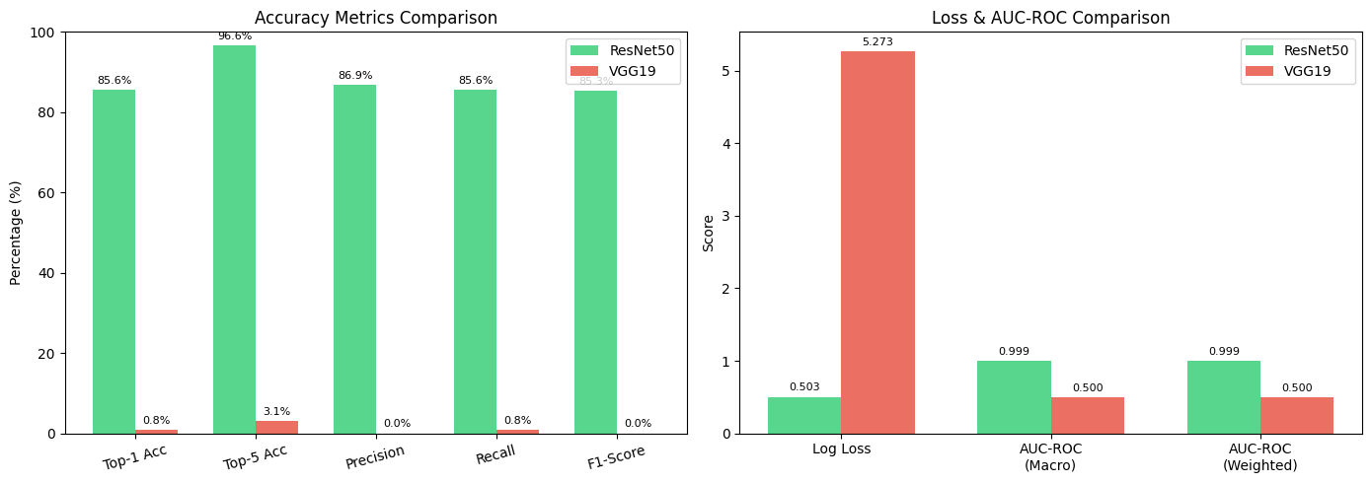

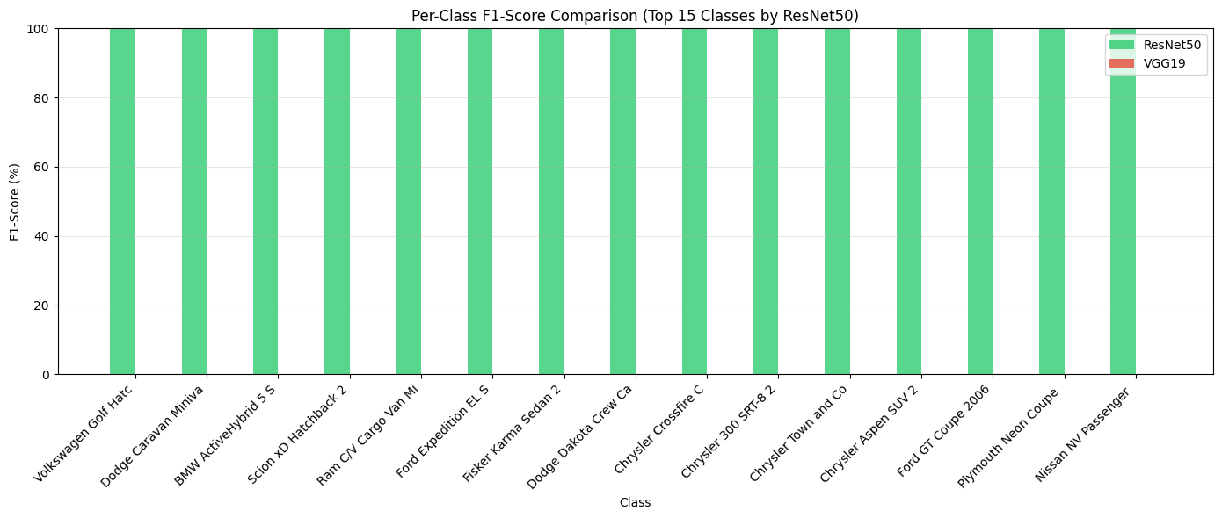

4. Conclusion
The (Fine-Tuned) ResNet50 model is the clear choice for deployment in this project. Its superior accuracy, stability, and convergence behavior significantly outperform the VGG19 model trained from scratch. These results strongly support the use of pre-trained models when working with limited datasets.

5. Citations
- ResNet (He et al., 2015):
He, K., Zhang, X., Ren, S., & Sun, J. (2016). Deep Residual Learning for Image Recognition. Proceedings of the IEEE Conference on Computer Vision and Pattern Recognition (CVPR), 770–778. https://doi.org/10.48550/arXiv.1512.03385
- VGG19 (Simonyan & Zisserman, 2014):
Simonyan, K., & Zisserman, A. (2015). Very Deep Convolutional Networks for Large-Scale Image Recognition. International Conference on Learning Representations (ICLR). https://doi.org/10.48550/arXiv.1409.1556

