CMPS458 – Reinforcement Learning
Assignment 2: Policy Iteration on a Custom 5 × 5 Grid Maze
Karim Tarek Abdalla
Ziad Abdelraouf Hassan

Experiment setup and results
I trained the agent using Policy Iteration on one fixed maze layout. The goal gives a reward of +1, an obstacle gives -1, and a normal move gives 0. These are the actual results saved in the notebook for seed 38.
Maze / seed | 5 × 5 / 38
Goal | (2, 1)
Obstacles | (1, 3) and (1, 0)
Gamma / theta | 0.95 / 1e-10
Policy iterations | 4
Evaluation sweeps | 495, including the final evaluation
Success rate | 22/22 starting cells (100%)
Average / maximum steps | 2.73 / 5
All recorded results refer to this layout. Changing the maze layout can change the convergence count and performance.

Assignment questions and answers

1. What is the state-space size of the 5 × 5 maze?
There are 25 possible positions in the maze. One is the goal and two are bad cells, so the agent can start from the remaining 22 positions. I used 25 positional states because the maze layout stays fixed during training.

2. How can Policy Iteration be optimized?
I used in-place updates during policy evaluation, so new values could be used immediately in the same sweep. I also reused the value estimates from the previous policy instead of starting from zero every time. Evaluation stops when the largest change is below theta, and Policy Iteration stops when the policy no longer changes.

3. How many iterations did it take to reach a stable policy?
The policy became stable after 4 iterations. The notebook also recorded 495 policy-evaluation sweeps in total, including the final evaluation. These numbers are specific to the maze generated with seed 38.

4. What would happen if the maze had multiple goals?
The agent would compare the expected return from reaching each goal and choose the better path. If both goals gave the same reward, the shorter safe path would usually be preferred because the reward is received sooner. A farther goal could still be better if its reward were higher.

5. Can Policy Iteration work on a 100 × 100 maze?
Yes, but the computation becomes more expensive. A 100 × 100 maze has 10,000 positional states, compared with only 25 in this assignment. We would need more time to evaluate the states and more memory to store the transition information.

6. Can it work with a continuous state space?
Not directly with the tabular implementation used here. A continuous space has infinitely many possible positions, so we cannot keep a separate table entry for every state. We would need to divide the space into a finite grid or approximate the value function.

7. What if the bad cells were moving, like ghosts in Pac-Man?
The state would have to include the positions of the moving obstacles, not just the agent’s position. We would also need a transition model that describes how the obstacles move. Policy Iteration could still be applied if this model were known, although the state space would be much larger.

Learned policy map
The following policy map is the one produced by the notebook. Each arrow shows the selected action from that cell, G is the goal, and X marks a bad cell.
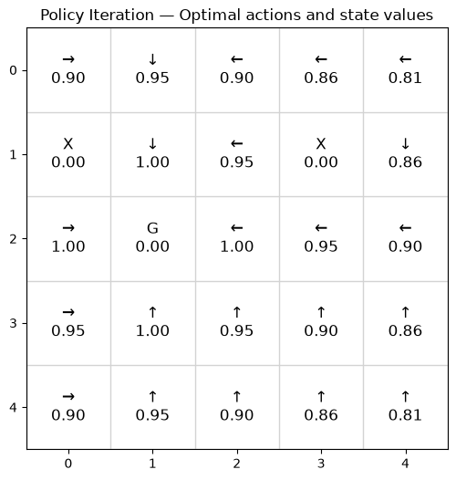

Recorded episode screenshots
The images below were taken from the recorded runs. They show the agent moving in the same fixed maze layout.
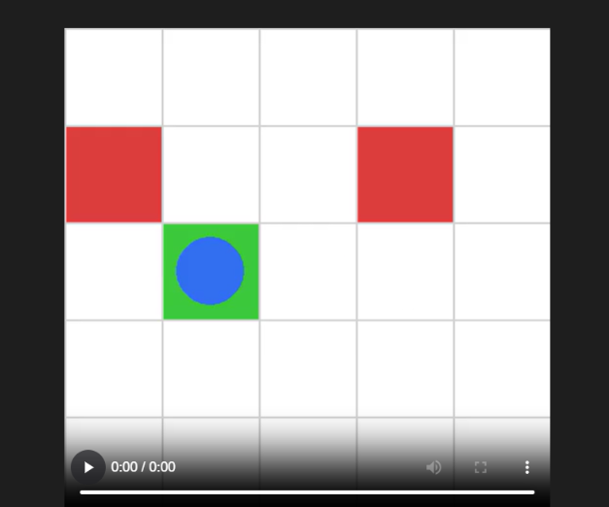  Episode 0 | 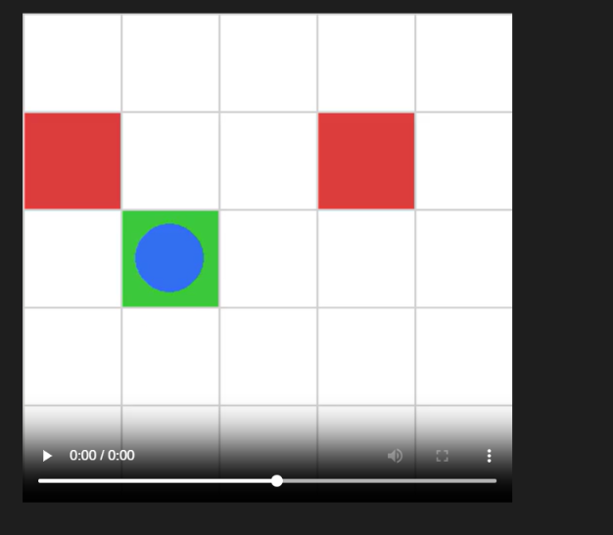  Episode 1
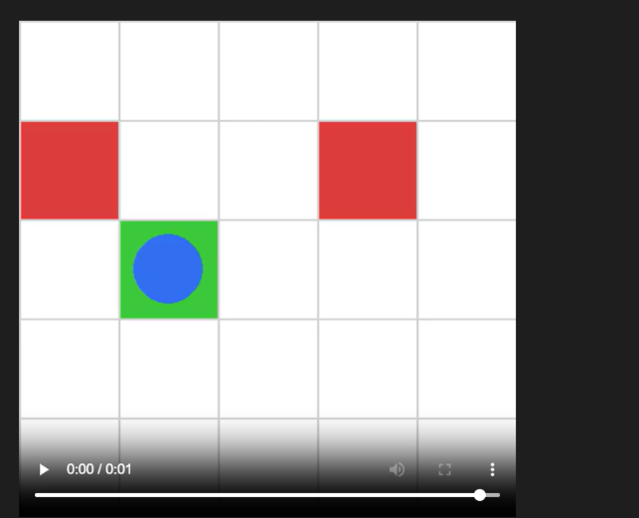  Episode 2 | 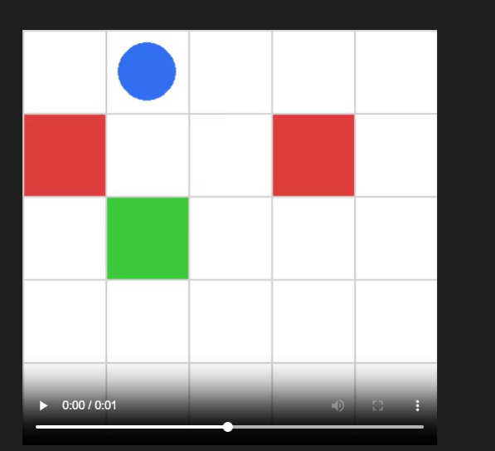  Episode 2 — additional frame
The three recorded episodes took 2, 1, and 3 steps, respectively. Each episode ended at the goal with a final reward of +1.

