Telecom Egypt (WE) - Customer Billing Dispute & Refund Policy
Comprehensive Operations Manual for Customer Dispute Mediation, Fee Waivers & Bill Adjustments
Effective: 2026 | Document ID: DOCX-BILL-2026-REV3

Section 1: Scope & Regulatory Framework
This operational policy applies to all Customer Service Representatives, Billing Supervisors, and Branch Specialists handling payment inquiries across Home Internet (ADSL/VDSL/FTTH), Postpaid Indigo Mobile, and Fixed Landline accounts. WE operates in strict accordance with the National Telecommunications Regulatory Authority (NTRA) consumer protection directives, ensuring fair, transparent, and prompt billing dispute resolution within 48 hours of complaint submission.

Section 2: One-Time Annual Courtesy Late Fee Waiver Policy
WE values long-term customer relationships. Customers who incur a Late Payment Administrative Fee (15 EGP for home internet or 25 EGP for postpaid mobile) are eligible for an immediate, no-questions-asked courtesy waiver once every 12 rolling months, provided that:
1. The customer account has been active for at least 6 consecutive months.
2. No more than 1 late payment fee waiver has been applied in the prior 365 calendar days.
3. The past-due balance is paid in full at the time of waiver application.
CSRs are authorized to apply this credit directly in CRM using reason code 'COURTESY_ANNUAL_WAIVER_LATE_FEE' without escalation.

Section 3: Double-Charge & Payment Gateway Timeout Mediation
When a customer attempts online bill payment or wallet top-up via Credit Card, Debit Card, WE Pay, or electronic aggregator (Fawry, Aman, Masary) and experiences an error where funds are debited twice or debited without account credit:
- Gateway Reconciliation Timeline: Automated settlement occurs within 24 hours.
- Immediate Credit Guarantee: If the customer provides the bank transaction reference or SMS receipt, the CSR must issue an immediate temporary service extension token for 72 hours to prevent line disconnection while the financial reconciliation is finalized.
- Direct Bank Refund: Card debits are refunded to the issuing bank card within 5 to 14 business days.

Section 4: Service Outage Billing Credits & Prorated Adjustments
In the event of documented technical broadband or fixed voice service disruptions exceeding 24 continuous hours not caused by customer home wiring:
- Customers are entitled to a prorated billing credit for the exact duration of the outage.
- Outages exceeding 72 hours automatically grant the customer an additional 20% courtesy credit applied to the subsequent billing cycle.
- Formula: Credit Amount = (Monthly Subscription Fee / 30) * Outage Days * 1.20.

Section 5: Disputed Value-Added Service (VAS) Subscriptions
Where a customer disputes unauthorized subscription to third-party SMS entertainment, gaming, or content portals:
- The CSR must immediately cancel all active VAS subscriptions.
- Apply a full credit refund for the preceding 2 billing cycles.
- Place an active VAS Barring flag on the subscriber profile to prevent recurring subscriptions.

Section 6: Security Deposit Return & Account Termination Refunds
Upon official termination of postpaid Indigo lines or fiber internet subscriptions:
- All customer hardware (routers, ONTs) returned in operable condition within 14 business days will have security deposits refunded in full.
- Cash refunds up to 1,000 EGP are payable instantly across all official WE stores.
- Refund balances exceeding 1,000 EGP are transferred via WE Pay digital wallet, InstaPay, or bank wire within 7 business days.

Section 7: Tiered Authorization Matrix for Billing Adjustments
Financial credit adjustment approval thresholds are strictly regulated by employee role:
- Frontline CSR: Up to 100 EGP per transaction.
- Senior CSR / Team Leader: Up to 350 EGP per transaction.
- Operations Supervisor: Up to 1,000 EGP per transaction.
- Branch / Regional Operations Manager: Above 1,000 EGP with audit documentation.

Section 8: Fraudulent International Call Dispute Procedures
Customers reporting unexpected international toll charges resulting from PBX hacking or malware:
- Flag line for immediate Fraud Investigation Team review.
- Halt collection activity on disputed amount for up to 30 days pending CDR call detail record forensic analysis.

Section 9: Prorated Migration Adjustments
When migrating between package tiers (e.g. Super 140GB to Mega 250GB mid-cycle):
- The existing plan quota and fee are calculated on a prorated daily basis.
- Any unused days are credited against the newly initiated plan billing invoice.

Section 10: Special Considerations for Corporate & SOHO Accounts
Small Office / Home Office (SOHO) customers enjoy consolidated multi-line billing. Disputed charges on a single mobile line will not cause suspension of the primary company data leased line.

Section 11: Billing Operational Flowchart & Financial Ledger (Part 1)
Standard operating procedure for financial reconciliations, payment dispute management, and CSR courtesy waiver verifications under audit schedule #1.
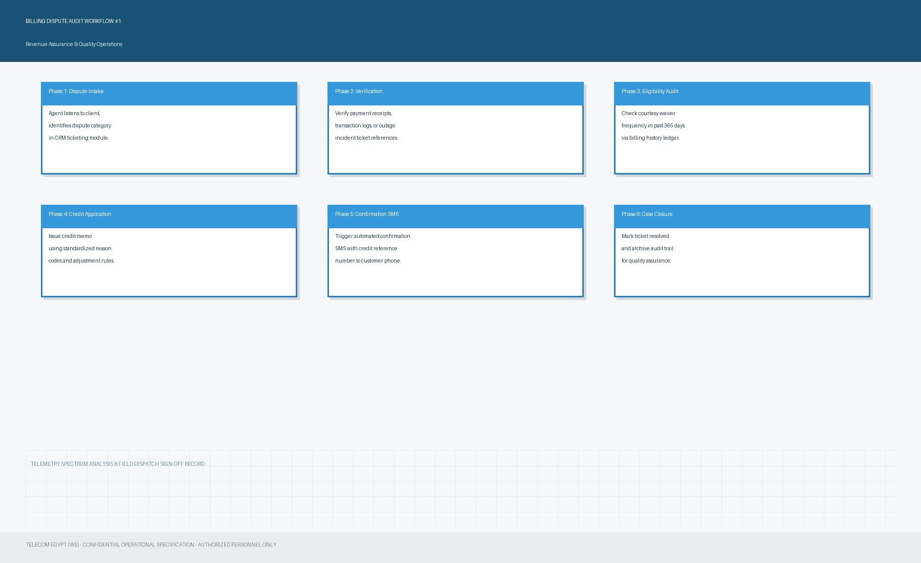

Section 12: Billing Operational Flowchart & Financial Ledger (Part 2)
Standard operating procedure for financial reconciliations, payment dispute management, and CSR courtesy waiver verifications under audit schedule #2.
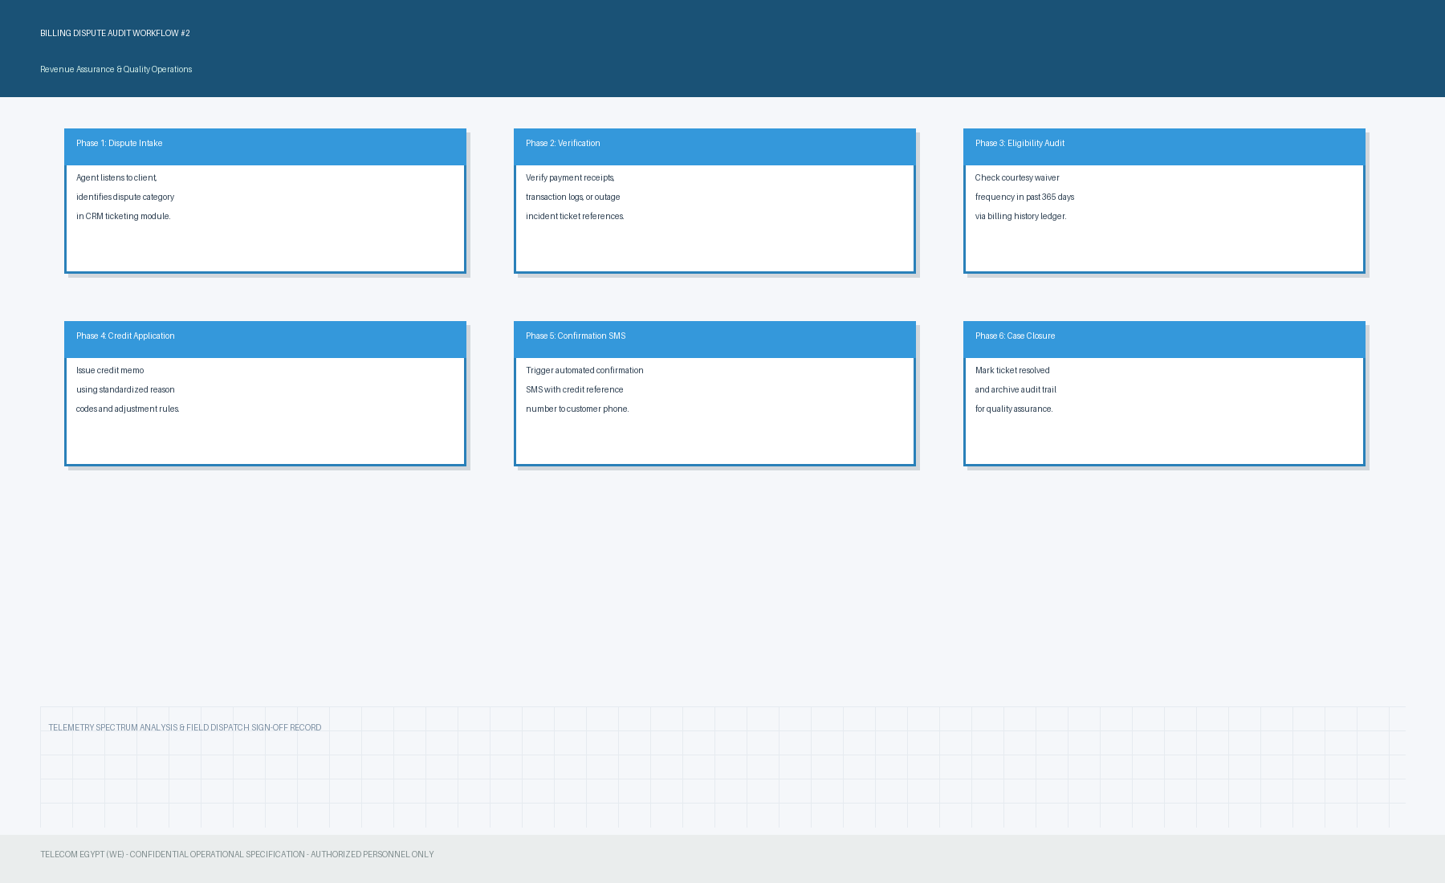

Section 13: Billing Operational Flowchart & Financial Ledger (Part 3)
Standard operating procedure for financial reconciliations, payment dispute management, and CSR courtesy waiver verifications under audit schedule #3.
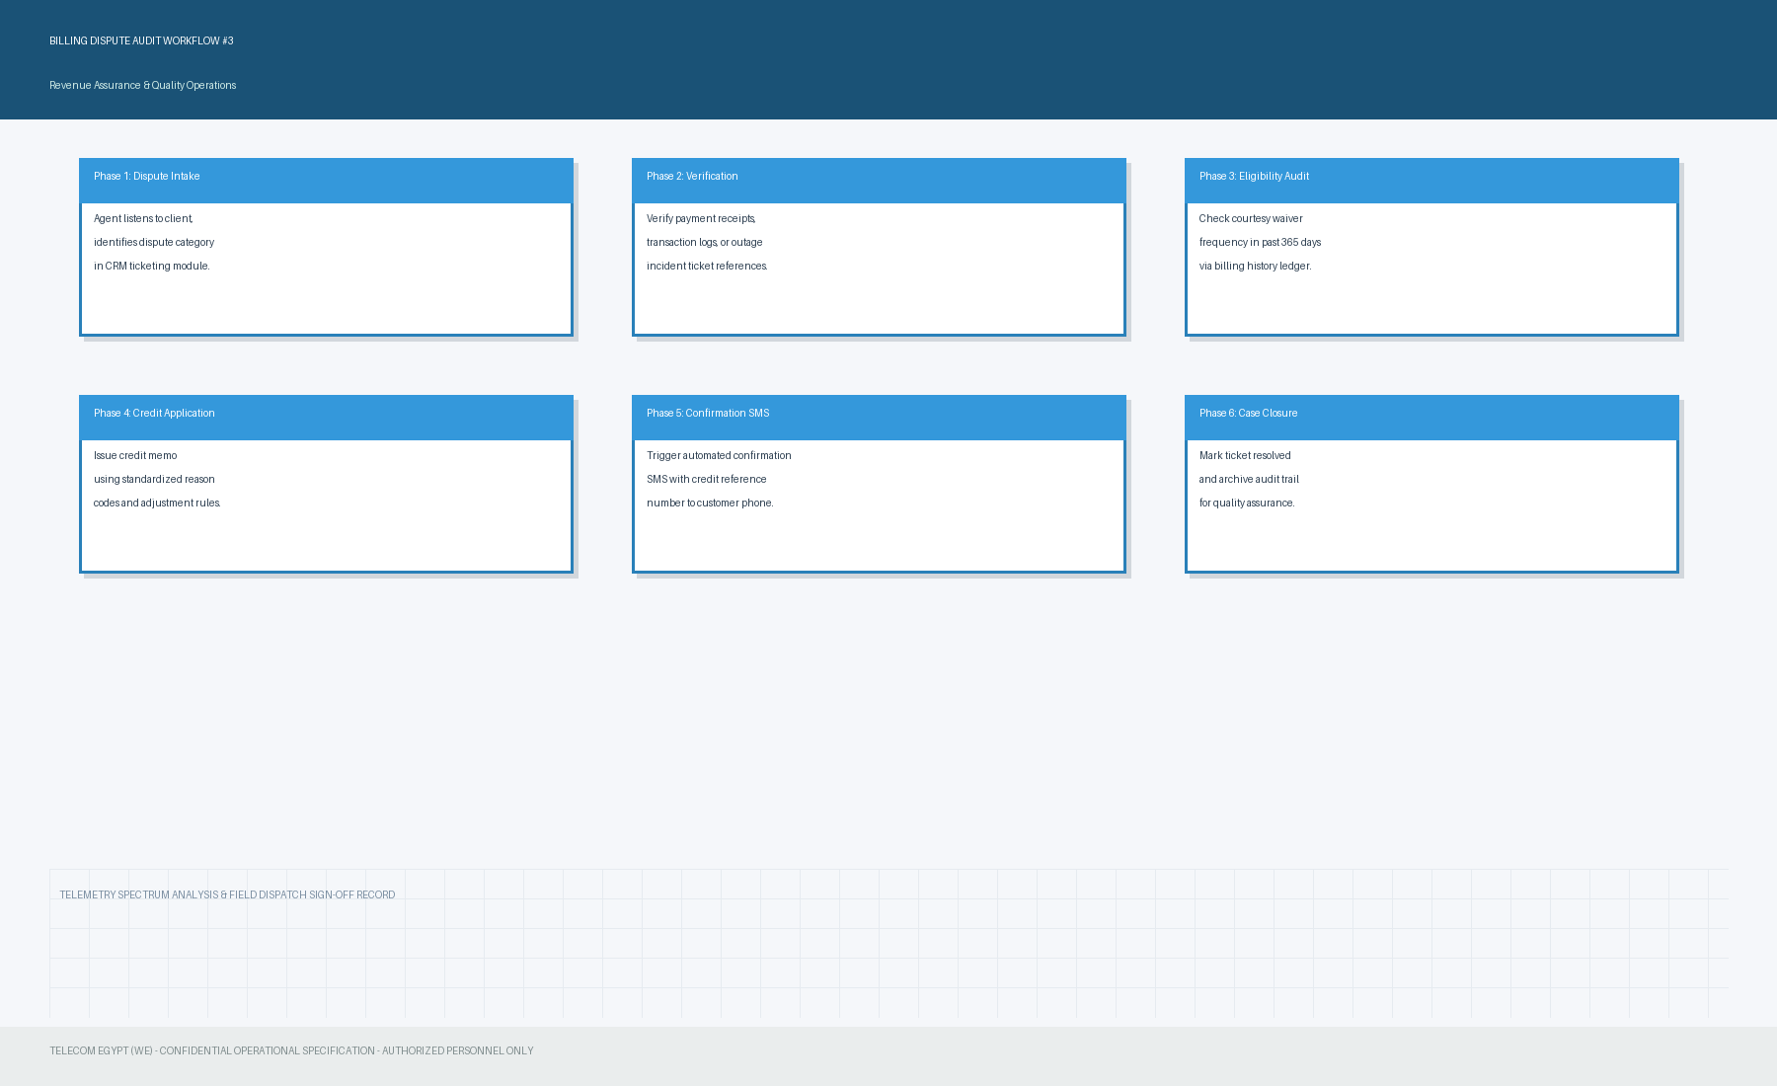

Section 14: Billing Operational Flowchart & Financial Ledger (Part 4)
Standard operating procedure for financial reconciliations, payment dispute management, and CSR courtesy waiver verifications under audit schedule #4.
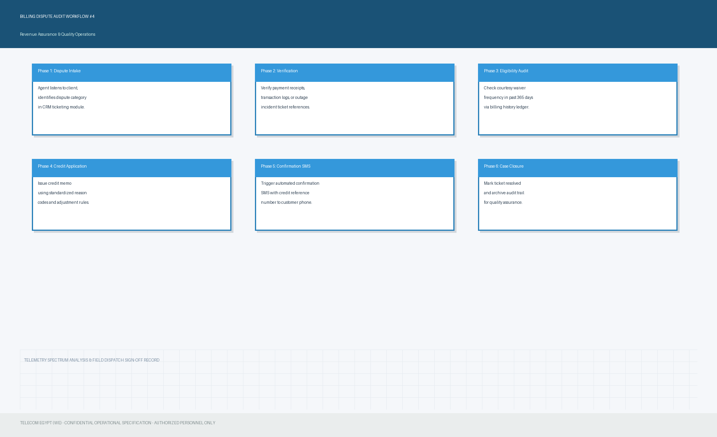

Section 15: Billing Operational Flowchart & Financial Ledger (Part 5)
Standard operating procedure for financial reconciliations, payment dispute management, and CSR courtesy waiver verifications under audit schedule #5.
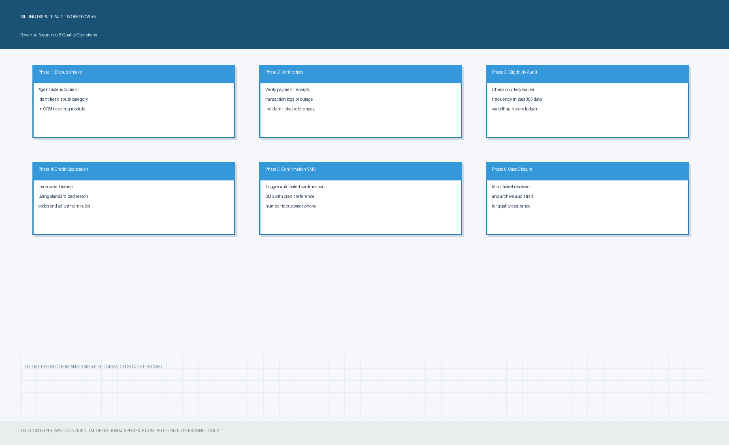

Section 16: Billing Operational Flowchart & Financial Ledger (Part 6)
Standard operating procedure for financial reconciliations, payment dispute management, and CSR courtesy waiver verifications under audit schedule #6.
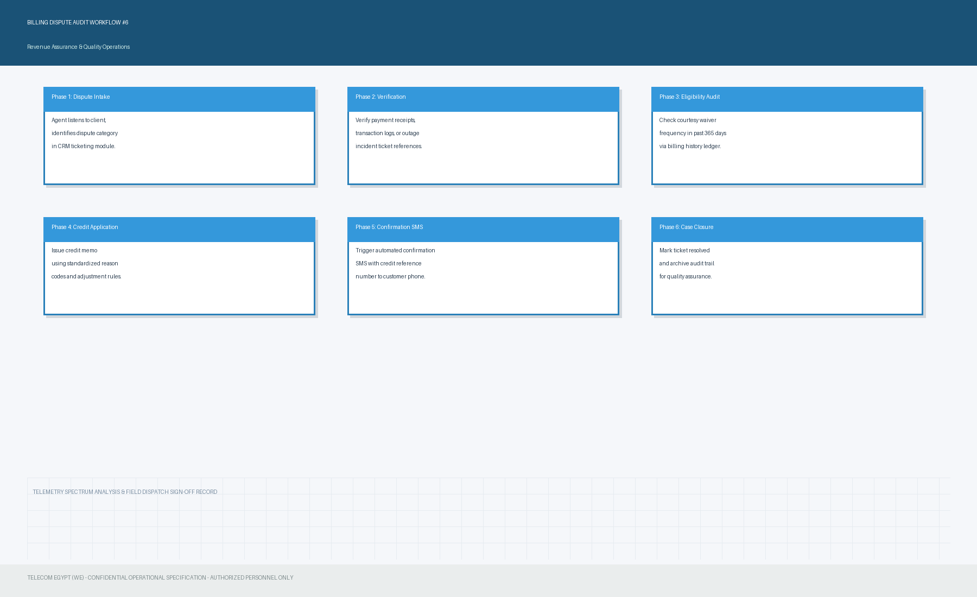

Section 17: Billing Operational Flowchart & Financial Ledger (Part 7)
Standard operating procedure for financial reconciliations, payment dispute management, and CSR courtesy waiver verifications under audit schedule #7.
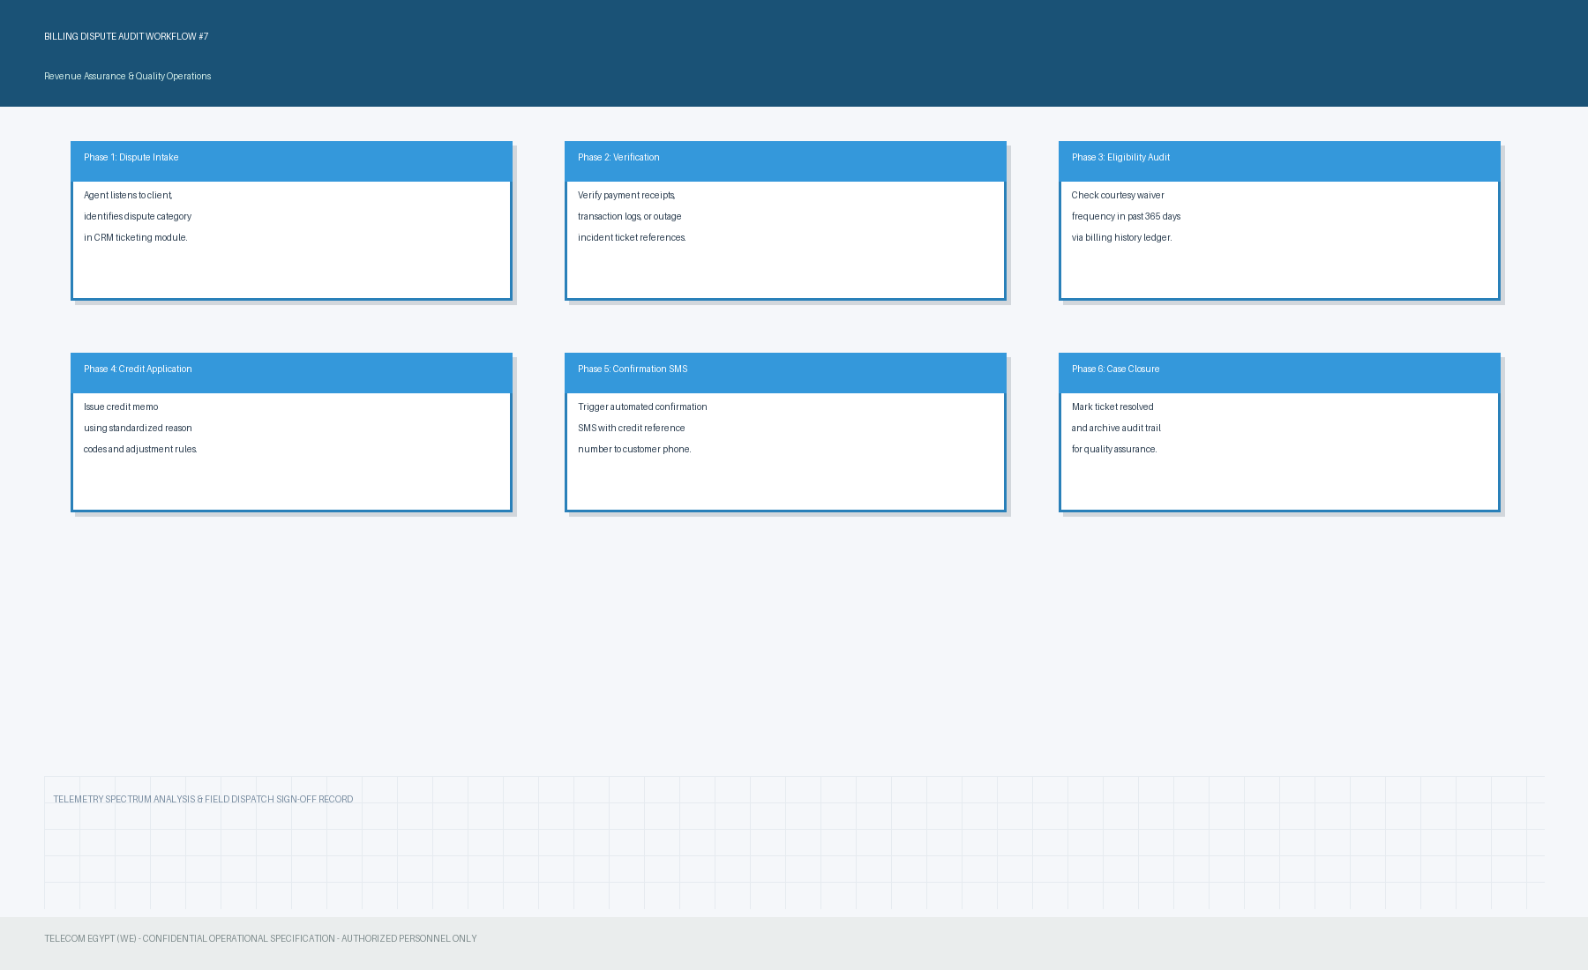

Section 18: Billing Operational Flowchart & Financial Ledger (Part 8)
Standard operating procedure for financial reconciliations, payment dispute management, and CSR courtesy waiver verifications under audit schedule #8.
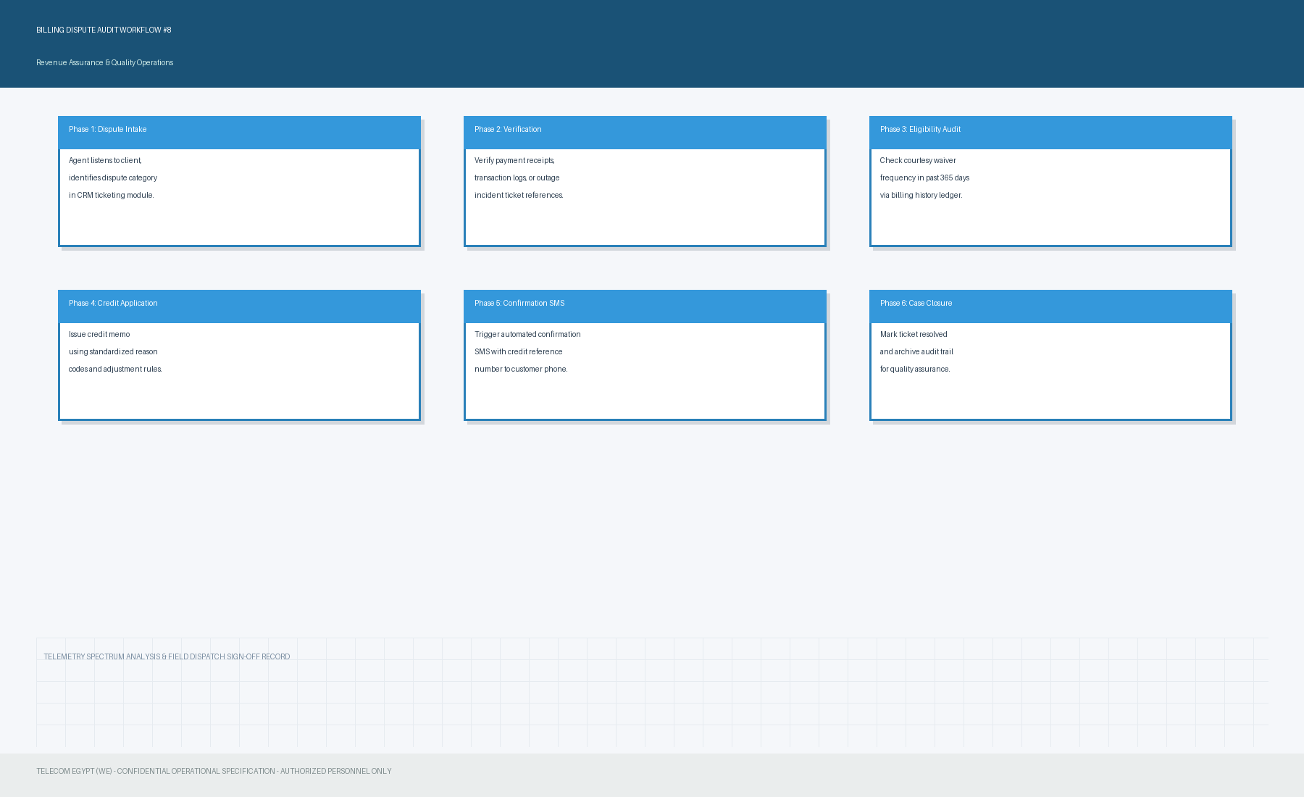

Section 19: Billing Operational Flowchart & Financial Ledger (Part 9)
Standard operating procedure for financial reconciliations, payment dispute management, and CSR courtesy waiver verifications under audit schedule #9.
