Telecom Egypt (WE) - FTTH Fiber Optic Installation & Attenuation Standards
دليل التركيبات الفنية للألياف الضوئية FTTH وقياسات الإشارة الضوئية

Section 1: Scope of Home Fiber Installations (نطاق أعمال التركيبات)
This operational and technical manual specifies mandatory standards for all Fiber-to-the-Home (FTTH) installations, drop-cable routing, optical power testing, and indoor Optical Network Terminal (ONT) setup across Egypt. Ensures zero signal degradation and stable gigabit-speed connectivity for residential and commercial customers.
يحدد هذا الدليل المعايير القياسية الإلزامية لفرق التركيبات الميدانية والفنيين لضمان جودة توصيل كابلات الألياف الضوئية من كبائن التوزيع FAT وحتى جهاز الراوتر المنزلي.

Section 2: Optical Power Budget & Attenuation Thresholds (مستويات الإشارة الضوئية dBm)
Technicians must measure optical power levels using an Optical Power Meter (OPM) calibrated at 1490nm (downstream) and 1310nm (upstream) prior to customer sign-off:
- Optimal Signal Range: -15.0 dBm to -24.0 dBm (Green Status - Perfect Transmission).
- Acceptable Signal Range: -24.1 dBm to -27.0 dBm (Yellow Status - Marginal, requires cable inspection).
- Defective / Critical Signal: Worse than -27.1 dBm or below -30 dBm (Red Status - Service will experience frequent dropouts; FAT box re-splicing required immediately).
- Over-saturation Warning: Stronger than -8.0 dBm may damage ONT optical receiver diode.

Section 3: FAT Box Splicing & Drop Cable Standards (مواصفات التوصيل وكابل السحب)
1. Fiber Distribution Box (FAT): Ensure waterproof IP67 sealing of FAT closure.
2. Drop Cable: Use G.657.A2 bend-insensitive optical drop cable for residential routing.
3. Minimum Bending Radius: Never bend optical drop cable at a radius smaller than 15mm to avoid macro-bending light loss.
4. Optical Wall Outlet (ATB): Mount the Access Terminal Box inside the customer premises at least 30cm above floor level away from direct heat sources.

Section 4: Indoor ONT Setup & Wi-Fi Coverage Optimization (ضبط جهاز الراوتر والواي فاي)
1. Connect SC/APC green-colored optical patch cord securely into the ONT PON port until a distinct mechanical click is heard.
2. Configure Wi-Fi Dual-Band operation (2.4GHz for range, 5GHz for maximum bandwidth).
3. Default SSID: Set to 'WE_Fiber_XXXXXX' with WPA3/WPA2-PSK mixed security.
4. Perform automated speed test to confirm contract speed (e.g. Ultra 100Mbps or Max 200Mbps) with ping latency under 10ms to local WE gateway.

Section 5: Fiber Field Diagnostics & Splice Quality Matrix (Part 1)
Technical standard reference for optical OTDR trace analysis, connector cleaning with isopropyl alcohol wipes, and attenuation troubleshooting for GPON / XGS-PON splitters. Case 1.
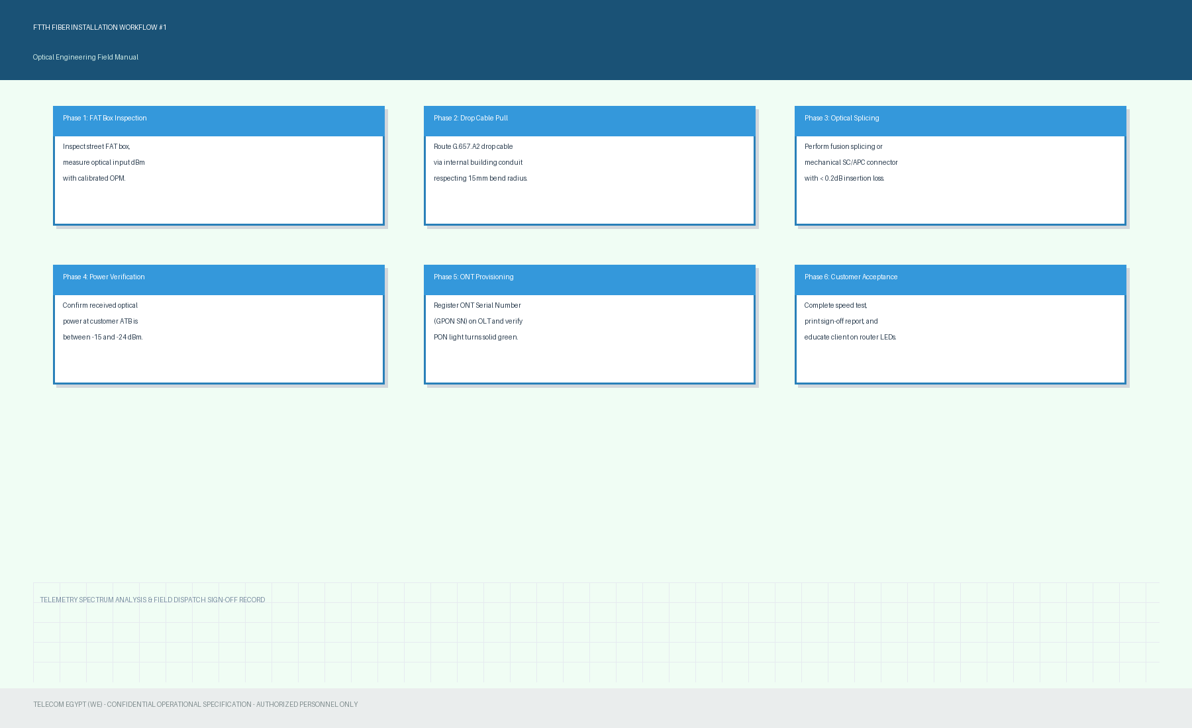

Section 6: Fiber Field Diagnostics & Splice Quality Matrix (Part 2)
Technical standard reference for optical OTDR trace analysis, connector cleaning with isopropyl alcohol wipes, and attenuation troubleshooting for GPON / XGS-PON splitters. Case 2.
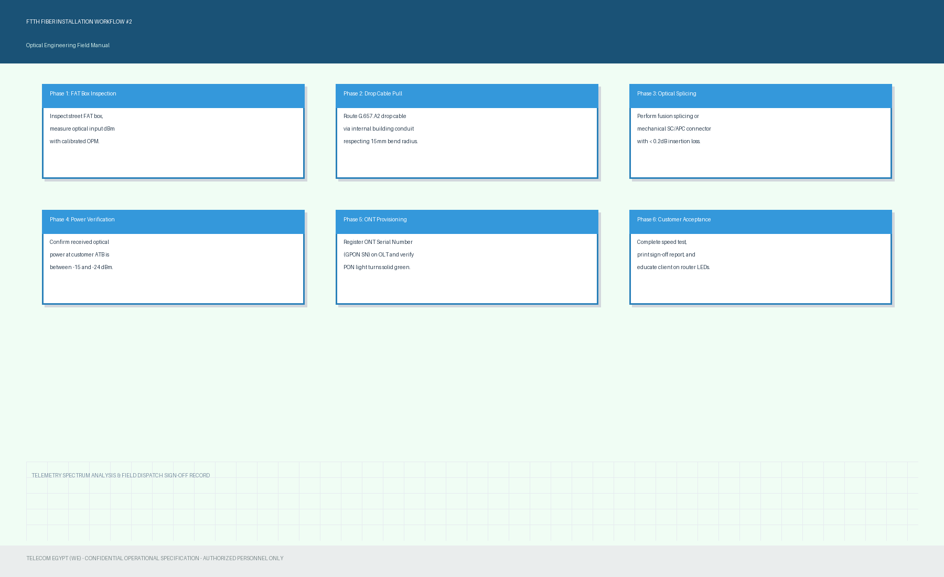

Section 7: Fiber Field Diagnostics & Splice Quality Matrix (Part 3)
Technical standard reference for optical OTDR trace analysis, connector cleaning with isopropyl alcohol wipes, and attenuation troubleshooting for GPON / XGS-PON splitters. Case 3.
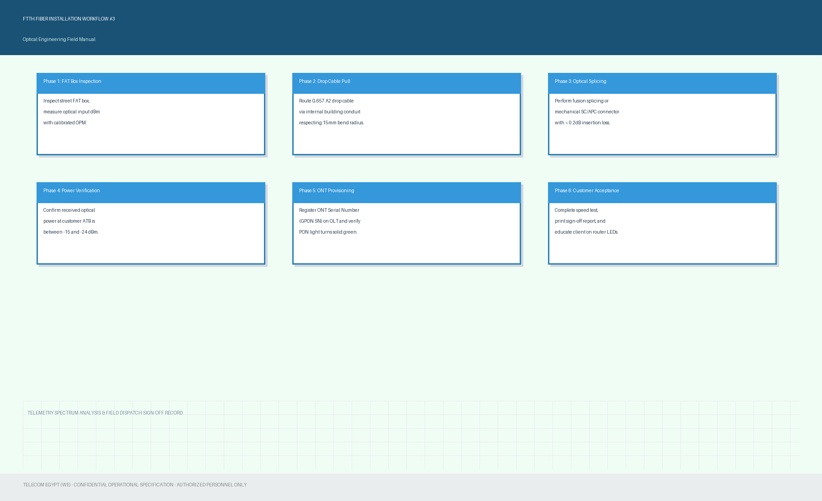

Section 8: Fiber Field Diagnostics & Splice Quality Matrix (Part 4)
Technical standard reference for optical OTDR trace analysis, connector cleaning with isopropyl alcohol wipes, and attenuation troubleshooting for GPON / XGS-PON splitters. Case 4.
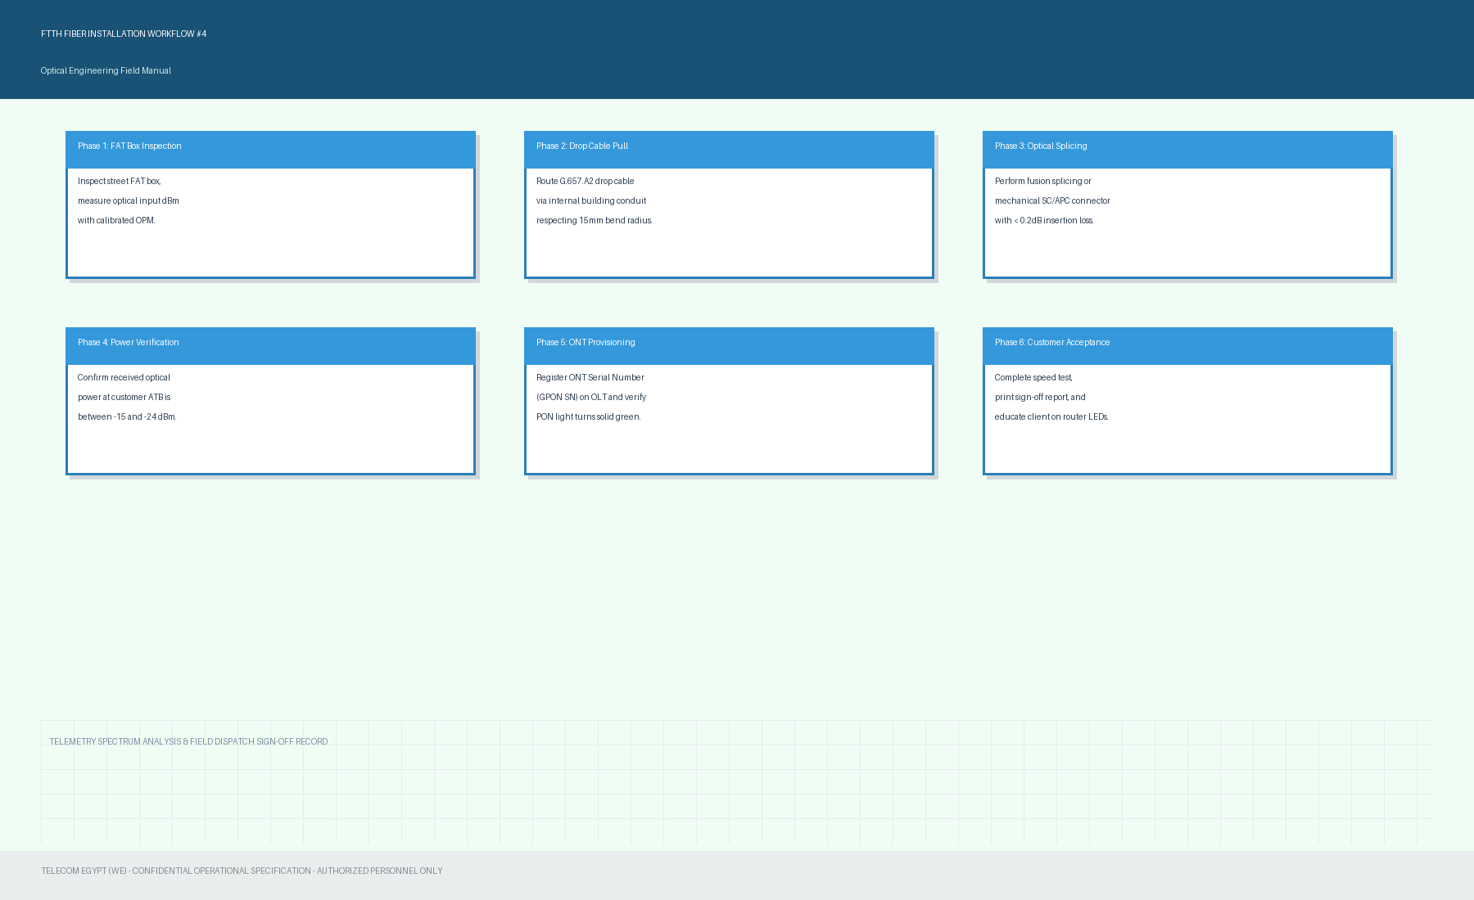

Section 9: Fiber Field Diagnostics & Splice Quality Matrix (Part 5)
Technical standard reference for optical OTDR trace analysis, connector cleaning with isopropyl alcohol wipes, and attenuation troubleshooting for GPON / XGS-PON splitters. Case 5.
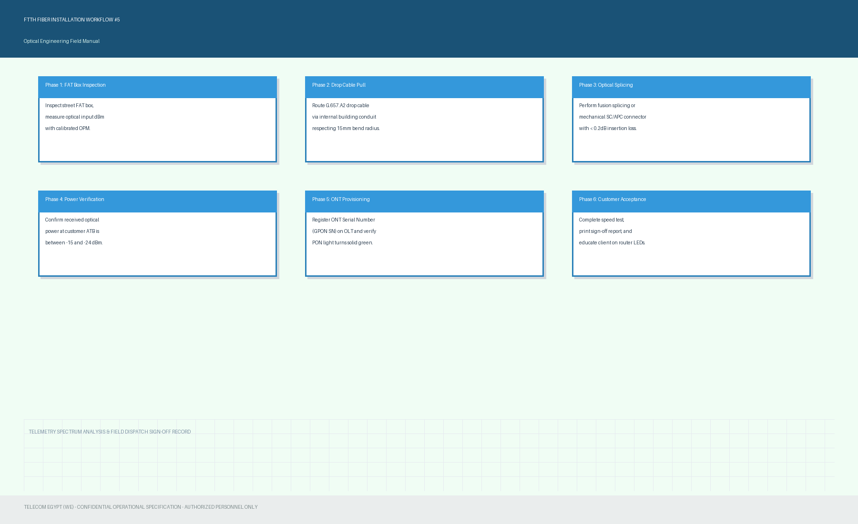

Section 10: Fiber Field Diagnostics & Splice Quality Matrix (Part 6)
Technical standard reference for optical OTDR trace analysis, connector cleaning with isopropyl alcohol wipes, and attenuation troubleshooting for GPON / XGS-PON splitters. Case 6.
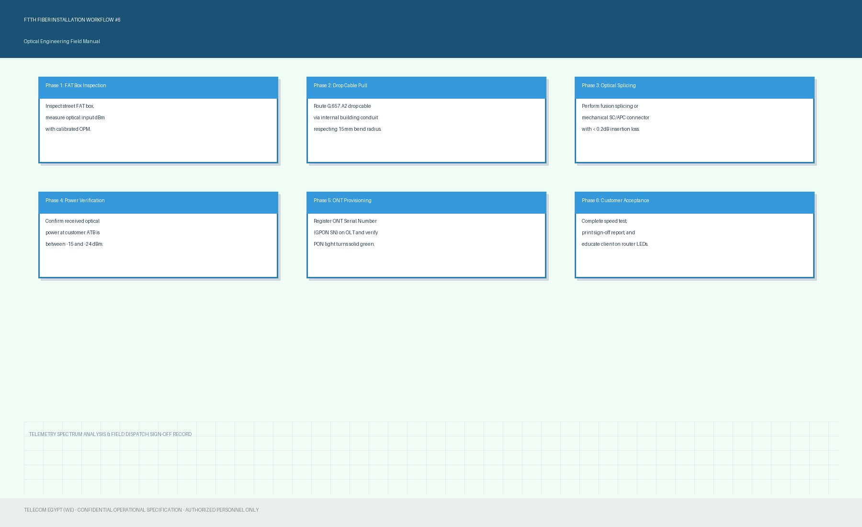

Section 11: Fiber Field Diagnostics & Splice Quality Matrix (Part 7)
Technical standard reference for optical OTDR trace analysis, connector cleaning with isopropyl alcohol wipes, and attenuation troubleshooting for GPON / XGS-PON splitters. Case 7.
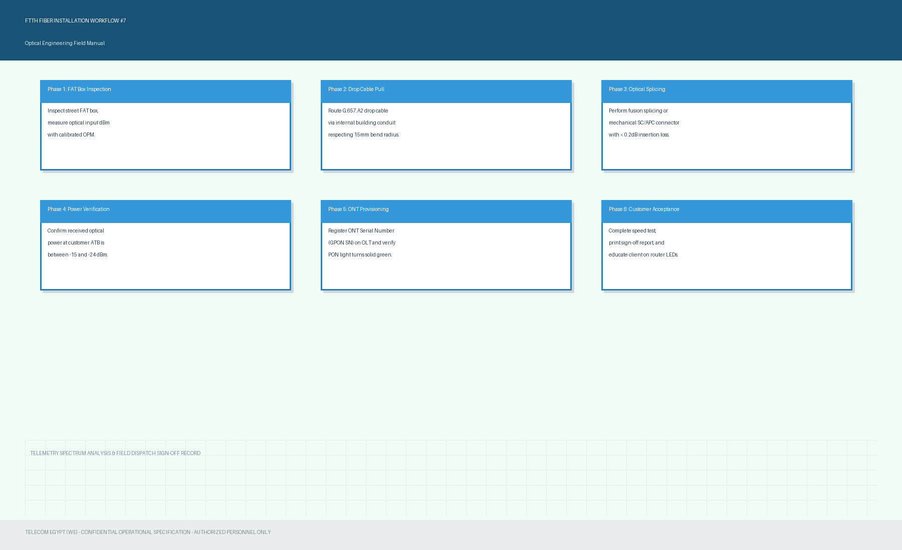

Section 12: Fiber Field Diagnostics & Splice Quality Matrix (Part 8)
Technical standard reference for optical OTDR trace analysis, connector cleaning with isopropyl alcohol wipes, and attenuation troubleshooting for GPON / XGS-PON splitters. Case 8.
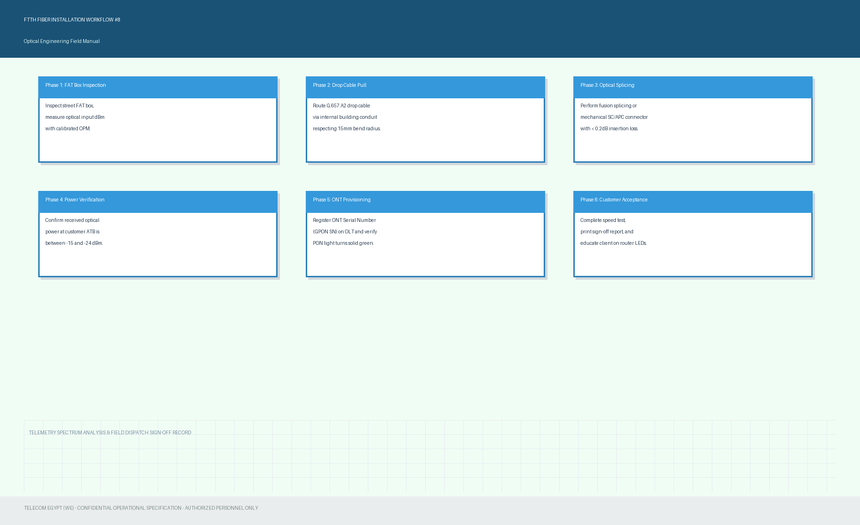

Section 13: Fiber Field Diagnostics & Splice Quality Matrix (Part 9)
Technical standard reference for optical OTDR trace analysis, connector cleaning with isopropyl alcohol wipes, and attenuation troubleshooting for GPON / XGS-PON splitters. Case 9.
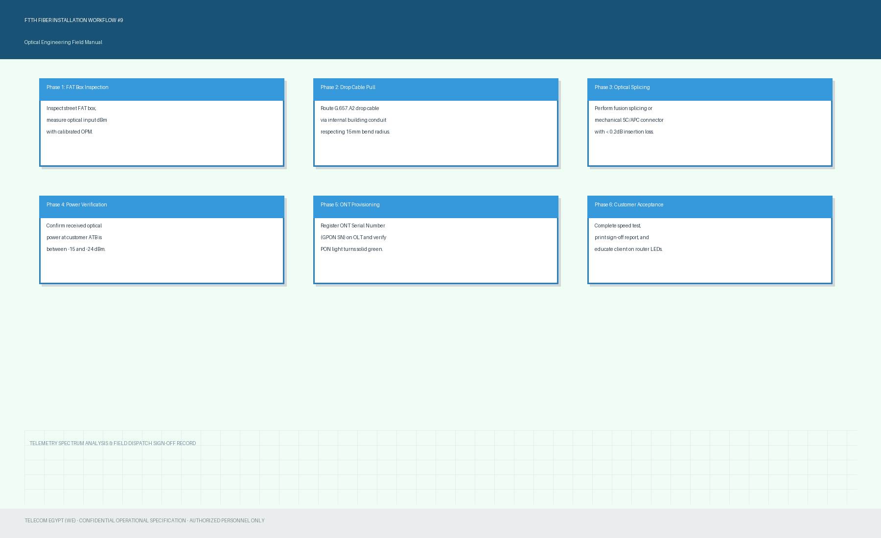

Section 14: Fiber Field Diagnostics & Splice Quality Matrix (Part 10)
Technical standard reference for optical OTDR trace analysis, connector cleaning with isopropyl alcohol wipes, and attenuation troubleshooting for GPON / XGS-PON splitters. Case 10.
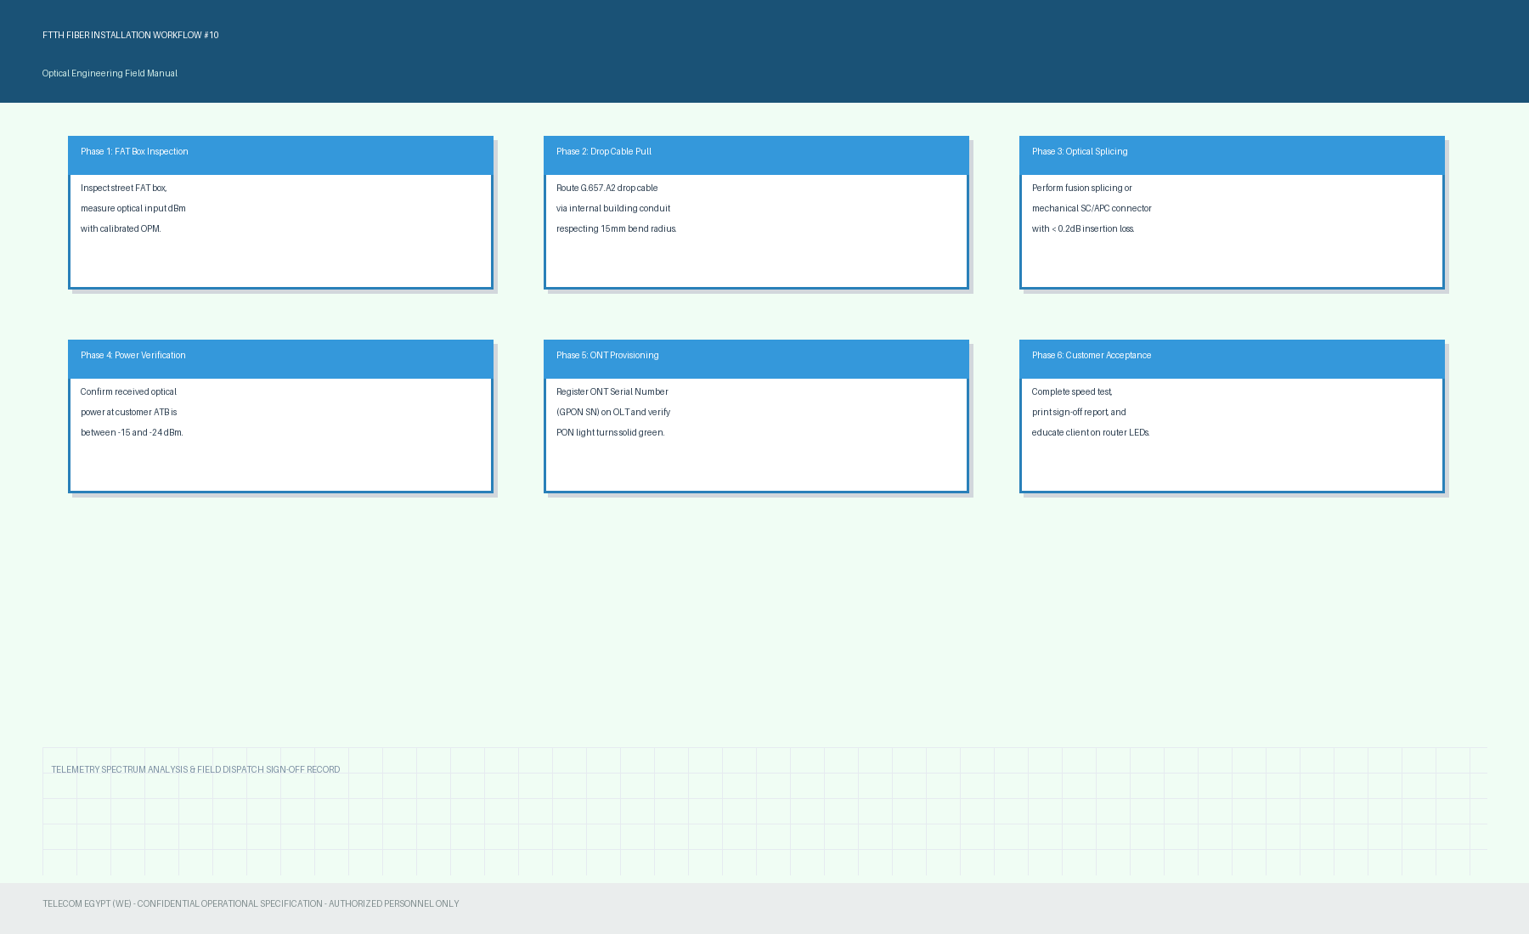

Section 15: Fiber Field Diagnostics & Splice Quality Matrix (Part 11)
Technical standard reference for optical OTDR trace analysis, connector cleaning with isopropyl alcohol wipes, and attenuation troubleshooting for GPON / XGS-PON splitters. Case 11.
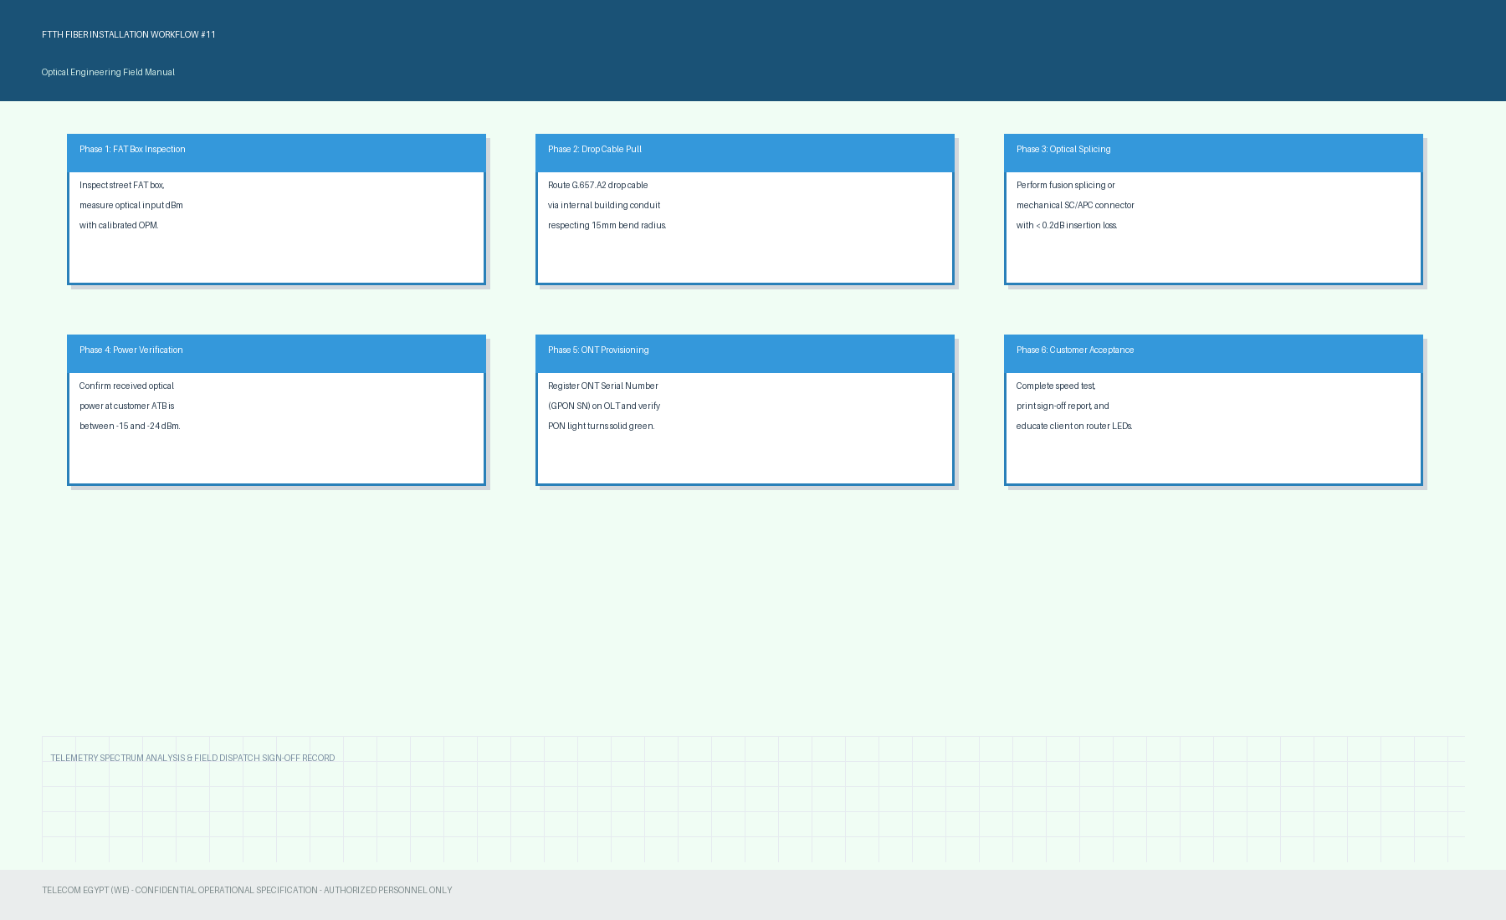

Section 16: Fiber Field Diagnostics & Splice Quality Matrix (Part 12)
Technical standard reference for optical OTDR trace analysis, connector cleaning with isopropyl alcohol wipes, and attenuation troubleshooting for GPON / XGS-PON splitters. Case 12.
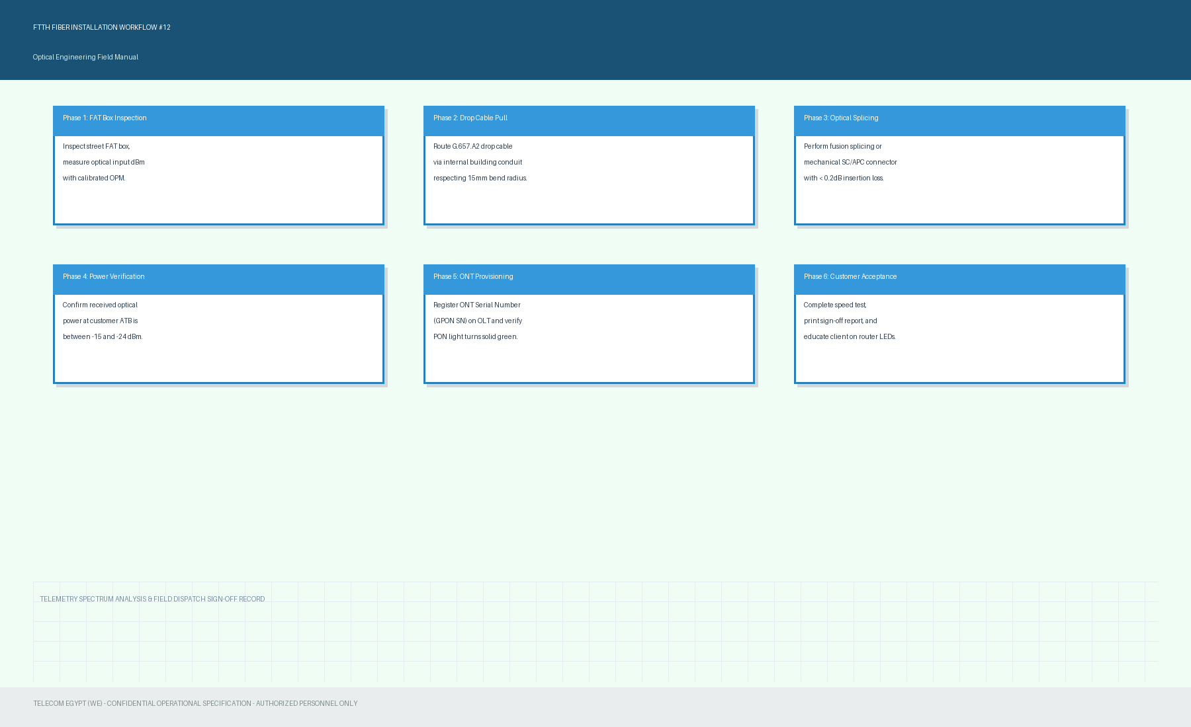

Section 17: Fiber Field Diagnostics & Splice Quality Matrix (Part 13)
Technical standard reference for optical OTDR trace analysis, connector cleaning with isopropyl alcohol wipes, and attenuation troubleshooting for GPON / XGS-PON splitters. Case 13.
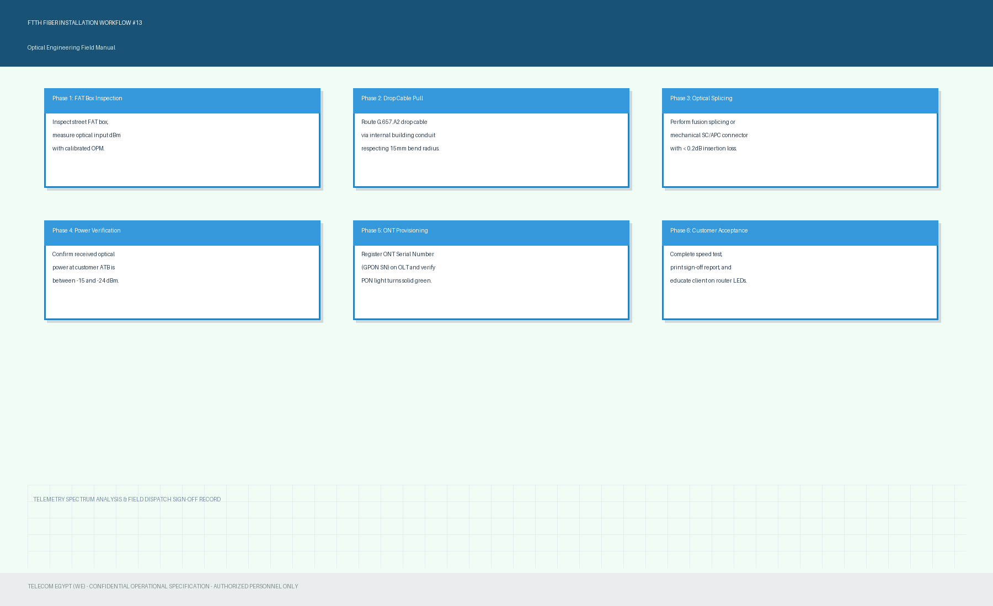

Section 18: Fiber Field Diagnostics & Splice Quality Matrix (Part 14)
Technical standard reference for optical OTDR trace analysis, connector cleaning with isopropyl alcohol wipes, and attenuation troubleshooting for GPON / XGS-PON splitters. Case 14.
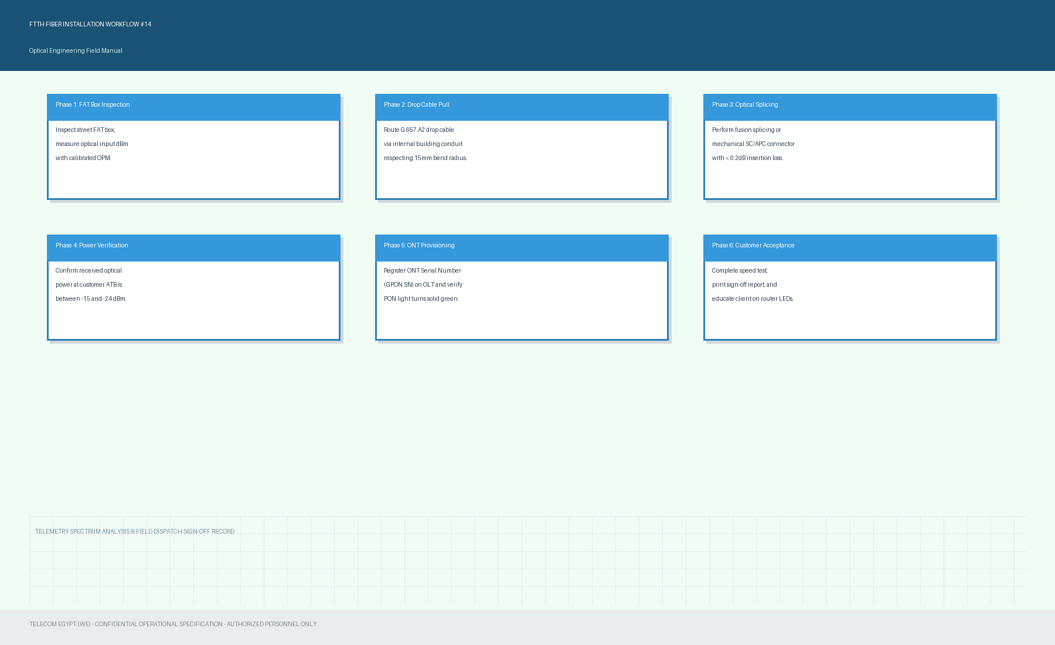

Section 19: Fiber Field Diagnostics & Splice Quality Matrix (Part 15)
Technical standard reference for optical OTDR trace analysis, connector cleaning with isopropyl alcohol wipes, and attenuation troubleshooting for GPON / XGS-PON splitters. Case 15.
