**CMPS450 – Pattern Recognition and Artificial Neural Networks**

**Project Report**

**Submitted by:**

|  |  |
| --- | --- |
| Name | ID |
| Ahmed Emad Reda | 1190180 |
| Hla Hany Mohamed | 1190344 |
| Nada Tarek | 1180504 |
| Ziad Ahmed Hamed | 4200002 |

**Due Date:**

15 May 2024

**Table of Contents**

Problem Description 3

Project Pipeline 4

Data Loading & Splitting 4

Preprocessing Module 5

Feature Extraction and Selection Modules 6

Performance Analysis 7

Model Architecture 7

Unsuccessful Trials 8

Workload Distribution 9

# Problem Description

**Objective:**

Develop a system to classify Arabic paragraphs into four font categories based on input images.

**Challenges:**

Characterizing unique font features; handling variations in writing styles, spacing, and noise.

# Project Pipeline

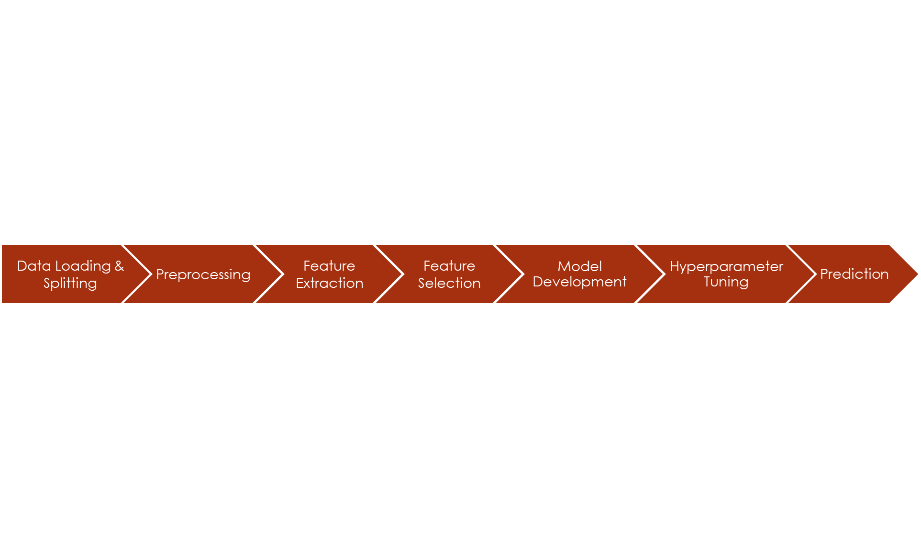

# Data Loading & Splitting

* Load the dataset into memory.
* Split the dataset into training and validation sets to evaluate model performance.
* The validation set is used to tune model hyperparameters to find the best model state.

# Preprocessing Module

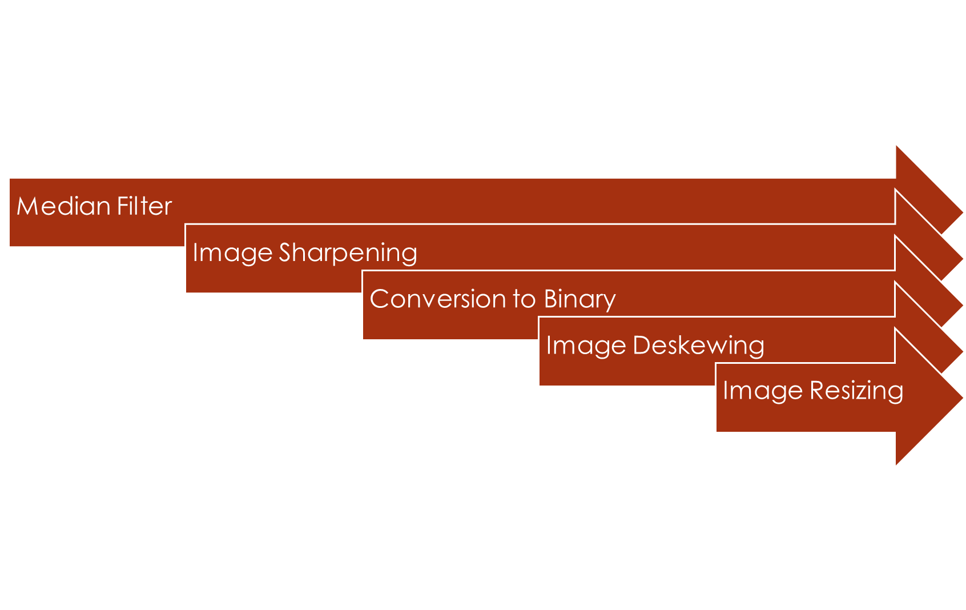

**Steps:**

1. Median blur filter: to remove salt and pepper noise.
2. Filter2D: to sharpen the image.
3. cv2 Threshold: to convert the image to binary.
4. Image deskewing:

* We want to detect any skew present in the image, which means if the image is slanted or tilted.
* We try different angles (0°, 45°, 90°, etc.) to check for skew.
* For each angle tested, we compute a score based on how much the histogram of the image changes.
* A higher score means more skew corrections are needed.
* We choose the best angle that gives us the highest score, indicating the most significant skew.
* With the best angle identified, we rotate the image in the opposite direction to counteract the skew.
* The rotation fills any remaining empty spaces with a white color to maintain the image's rectangular shape.

1. Image resizing.

# Feature Extraction and Selection Modules

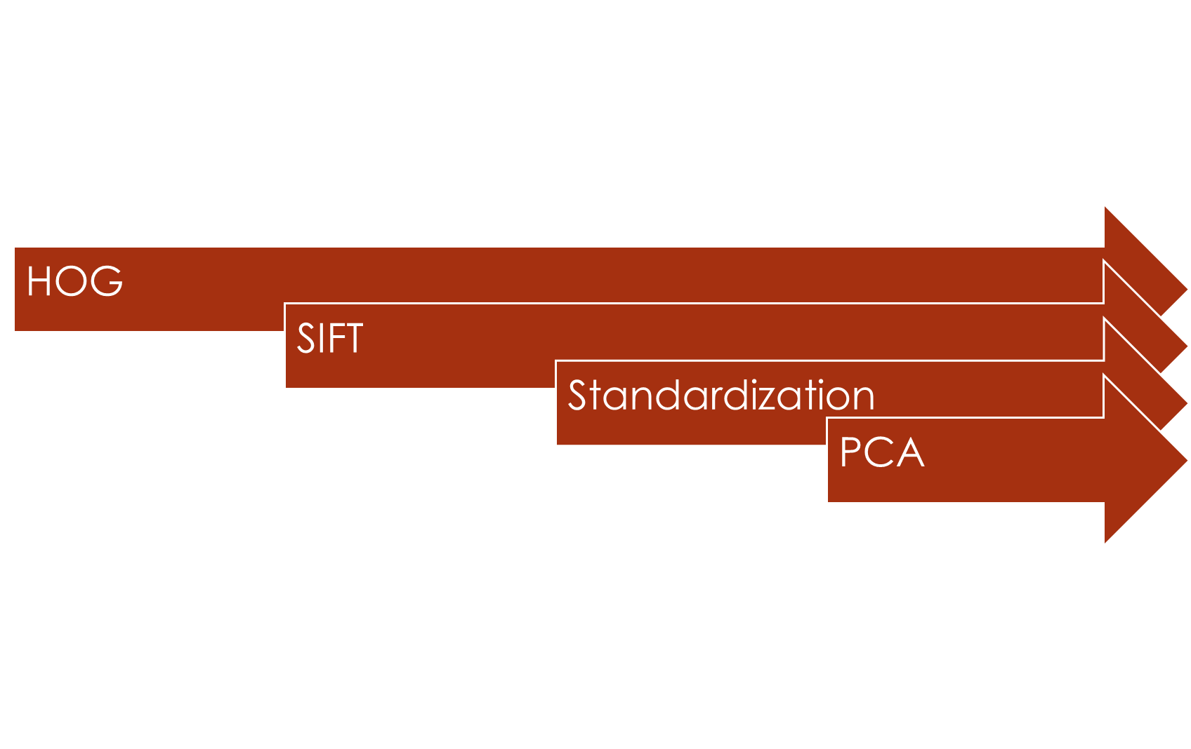

**Steps:**

* **Histogram of Oriented Gradients (HOG):**

Extract features from images to describe their shapes and textures.

* **Scale-Invariant Feature Transform (SIFT):**
* Detect and describe key points in images to help recognize objects or scenes.
* Pad SIFT descriptors to make sure all SIFT feature sets are of the same length for consistency in analysis.
* **Standardization:**

Adjusts the scale of features to ensure fair comparison.

* **Principal Component Analysis (PCA):**

Transform the data into a lower-dimensional space while preserving the most important information.

# Performance Analysis

|  |  |
| --- | --- |
| Model | Accuracy |
| PyTorch Neural Network | 96.5% |
| Stacking Classifier | 96% |
| Logistic Regression | 95.5% |
| MLP Classifier | 92.75% |
| SVM | 91.25% |

# Model Architecture

* Input layer processes feature vectors.
* 2 hidden layers learn complex patterns with ReLU activation.
* Output layer generates class probabilities with softmax activation.

**Accuracy obtained:** 96.5%

# Unsuccessful Trials

1. **Edge Direction Matrix (EDM):**

**Features from EDM1 & EDM2:**

* Edges Direction
* Homogeneity
* Pixel Regularity
* Edges Regularity

**Accuracy obtained:** 85%

1. **Segmentation technique (inspired by Variance Threshold by scikit-learn)**

# Workload Distribution

|  |  |
| --- | --- |
| Team member | Tasks |
| Ahmed Emad | Preprocessing, Model Development, API |
| Hla Hany | EDM, Model Development, Deployment |
| Nada Tarek | HOG, SIFT, PCA |
| Ziad Ahmed | Preprocessing, Model Development, API |