### How to run it？

1. Download lexer.l and parser.y file then use the following commands in order:
2. flex lexer.l
3. bison -d parser.y
4. gcc lex.yy.c parser.tab.c
5. a.exe
6. Well-formed program:

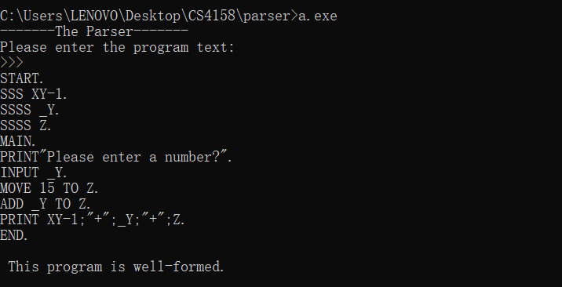

1. If a program tried to ‘MOVE 500000 TO _Y’ a warning flag should be raised (as _Y is only declared as ‘SSSS’) :

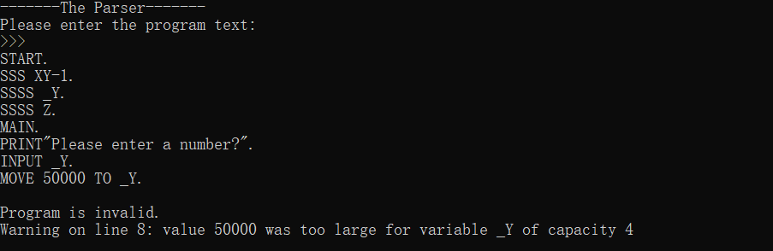



The parser can detect if, when you move a value from an identifier 1 to an identifier 2, identifier 1 is declared to be larger than identifier 2 and issue a warning. (in the example above 'MOVE Z to XY-1' should cause this).

