Tutorial 3 | Waves, pixels & 2D FFT filtering in ImageJ

Part A | 1D waves and spectra
1. Open the 1D Fourier Lab. Under Wave basics, set amplitude = 1, harmonic = 1 and phase = 0°. Compare harmonics 1 and 4, changing only the harmonic number.
2. Under Addition & phase, use two equal-amplitude waves with the SAME harmonic number. Try relative phase 0°, 90° and 180°.
3. Under Harmonics & spectrum, create a signal with only harmonic 1 and harmonic 3 non-zero. Compare the waveform and discrete amplitude spectrum.
A1. What changes when the harmonic number increases? What changes when only amplitude increases?
__________________________________________________________________________________________
A2. Why do two equal-amplitude, same-frequency waves cancel when 180° out of phase?
__________________________________________________________________________________________
A3. Which graph identifies the frequency components present, and what does each bar mean?
__________________________________________________________________________________________

Part B | One image: matrix, pixel size and grey levels
4. Download Blobs_Lines_Mixed_256.png. Open in ImageJ (File → Open). Use Image → Show Info or the image title to confirm 256 columns × 256 rows and 8-bit intensity coding.
5. Assume the supplied FOV is 160 mm horizontally and 160 mm vertically. The PNG does not contain physical FOV metadata. Follow the worked example:
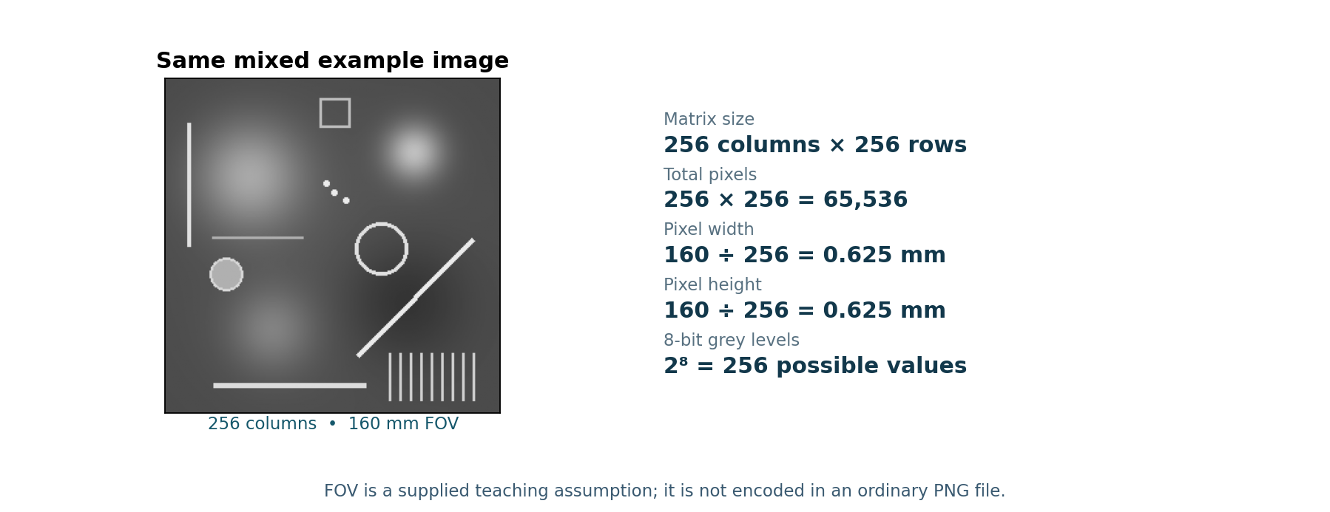
B1. For 512 columns × 384 rows and FOV 240 × 180 mm, calculate total pixels and horizontal/vertical pixel sizes. Quick checks: (a) If a square image has 256 pixels TOTAL, how many per side? (b) For 50 × 50 mm FOV and 0.5 mm pixels, how many columns and rows?
__________________________________________________________________________________________
6. In the Pixel & Quantisation Lab (browser), compare the SAME image with 256, 16 and 4 possible grey levels. Observe changes in the smooth blobs. The 2D FFT experiments use ImageJ, not the browser lab.
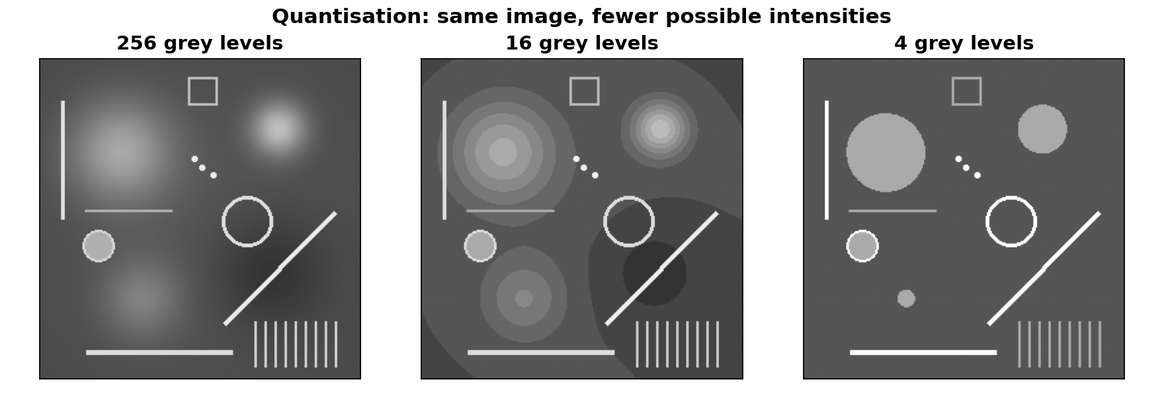
B2. How many grey levels are possible with 2-, 4- and 8-bit coding? Which version has the strongest posterisation, and why do we quantise intensities?
__________________________________________________________________________________________Part C | 2D FFT filtering with ImageJ (18 min)
7. Select the ORIGINAL Blobs_Lines_Mixed_256.png image in ImageJ. Choose Process → FFT → FFT. The new “FFT of ...” window is a picture of the image’s frequency content, not a map of where its blobs are. The centre represents zero/very low frequency; points farther out represent higher spatial frequencies.
Why are there matching patterns on opposite sides? An ordinary grayscale image has equal-strength frequency partners in opposite directions. Their matching brightness makes the displayed FFT magnitude look symmetric around its centre. This does NOT mean that the original image is symmetric.
Before filtering: click the FFT spectrum window (not the original image). For reliable black masks, check Edit → Options → Colors… and set the Background colour to BLACK. Select the rectangle tool. Do not choose “Clear Outside” in the first experiment.
8. REMOVE LOW FREQUENCIES (high-pass experiment): draw a SMALL square, about 20 × 20 pixels, centred on the bright middle of the FFT. Select Edit → Clear to blacken ONLY the central square. Then choose Process → FFT → Inverse FFT. Compare with the original: what happened to the smooth blobs/background and the sharp lines?
9. REMOVE HIGH FREQUENCIES (low-pass experiment): reopen Blobs_Lines_Mixed_256.png from File → Open to start fresh. Choose Process → FFT → FFT again. Draw a LARGER square, roughly 64 × 64 pixels, centred on the FFT middle. Now select Edit → Clear Outside: everything OUTSIDE this square should turn black, leaving just the central frequencies. Choose Process → FFT → Inverse FFT. What happened to the thin lines and edges?
Important: Clear removes what is INSIDE your selection; Clear Outside removes what is OUTSIDE it. Apply these commands to the FFT WINDOW. To compare fairly, use Image → Adjust → Brightness/Contrast on a COPY of the reconstructed image only if needed for viewing; this can alter its display, not restore removed frequencies.
C1. After clearing the small CENTRAL region and applying Inverse FFT, which image features are reduced? Which features remain relatively noticeable? Explain briefly.
___________________________________________________________________________________
C2. After clearing everything OUTSIDE the larger central region and applying Inverse FFT, does the image look sharper or blurrier? Why?
___________________________________________________________________________________

Exit ticket & take-home messages (3 min)
Quick check: 256 × 256 = ______ total pixels; pixel width = ______ mm; clearing the FFT centre removes ______ frequencies; keeping only the centre removes ______ frequencies.
- Amplitude changes a wave’s height; frequency changes how rapidly it oscillates. Relative phase determines whether equal-frequency waves reinforce or cancel.
- An amplitude spectrum tells which frequencies are present and their strengths; the waveform describes how a signal varies with position or time.
- Pixel size = FOV ÷ pixels along that direction. A 256 × 256 matrix has 65,536 pixels. More available grey levels reduce quantisation banding.
- In a 2D FFT, the centre contains zero/low spatial frequencies (broad, smooth changes) and the outer regions contain higher frequencies (fine detail/edges). Removing central frequencies suppresses broad background variations; removing outer frequencies blurs fine details. The magnitude spectrum has matching opposite-side features for real grayscale images.
Answers can be revealed on the Canvas page after attempting the questions.

