Tutorial 4 | Image contrast, LUTs & noise

Part A | Display contrast & histograms (20 min)
1. Open Windowing_phantom_256.png in ImageJ. Choose Image → Duplicate to preserve the starting image.
2. Use Image → Adjust → Brightness/Contrast. Compare Auto with Reset. Then choose Image → Adjust → Window/Level. Narrow the width, then move the level while holding width approximately fixed.
3. On the unchanged original, select Analyze → Histogram. Distinguish a histogram of STORED pixel intensities from how a LUT/window displays them.
A1. What changes visually when window width becomes narrower? What does window level do?
___________________________________________________________________________________
A2. If stored pixel values shift towards smaller numbers, and display mapping stays fixed, what happens to the histogram and appearance?
___________________________________________________________________________________

Part B | Look-up tables (15 min)
4. Duplicate the original phantom again. Choose Image → Lookup Tables → Invert LUT. Look at the original and the LUT-inverted image side by side.
5. Compare Analyze → Histogram between the original and LUT-inverted image. Invert LUT is primarily a display change, not automatically a rewrite of every stored pixel.
B1. Write a clear definition of a LUT. Does Invert LUT necessarily change the stored histogram?
___________________________________________________________________________________

Part C | Noise & standard deviation (15 min)
6. Open Noise_low_256.png and Noise_high_256.png. These are synthetic and contain Gaussian random fluctuations, not a photon-counting simulation.
7. Select Analyze → Measurement → Results → Set Measurements: tick Mean gray value and Standard deviation. Draw the same-sized rectangular ROI (about 100 × 100 px) near the centre of each image.
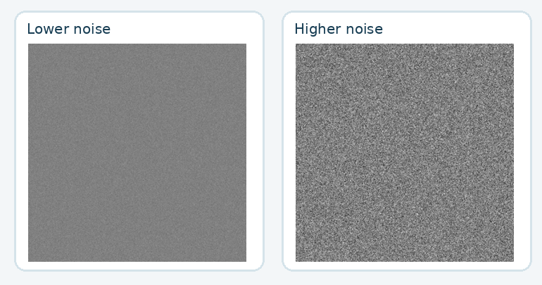
Measurement | Lower-noise PNG | Higher-noise PNG
Mean | ________________ | ________________
Std dev. | ________________ | ________________

C1. Which image has greater noise? Why does standard deviation measure noise better than mean intensity in a uniform region?
___________________________________________________________________________________
C2. Explain why quantum mottle can make faint details harder to see in a radiograph.
___________________________________________________________________________________

DICOM, exit ticket & take-home messages (5 min)
DICOM (Digital Imaging and Communications in Medicine) standardises medical imaging formats, metadata and communication between compatible systems.
D1. How does DICOM help imaging devices and software from different manufacturers work together?
___________________________________________________________________________________
- Window width controls the displayed intensity span; window level selects its centre. Display adjustments do not necessarily alter the stored pixel values.
- LUTs map stored intensity values to displayed values; a display inversion is different from rewriting the underlying pixel array.
- Standard deviation in a uniform area is a simple noise measure. Higher noise can obscure faint image details.
- DICOM defines imaging formats, metadata and communication for interoperable medical imaging workflows.

