Game Design Document for:

Smart Shopper

A fun way to manage your money and learn numeracy skills!

Copyright © GET Pte. Ltd.

Written by Group 6

Version # 1.00

Current Date

**Table of Contents**

**1** **Design History**

1.1 Version 1.10

1.2 Version 2.00

1.3 Version 2.10

**2** **Game Overview**

2.1 Introduction/Summary

2.2 Common Questions

2.2.1 What is the game?

2.2.2 Why create this game?

2.2.3 Where does the game take place?

2.2.4 What do I control?

2.2.5 What is the main focus?

2.2.6 What's different?

**3** **Feature Set**

3.1 General Features

3.2 Multi-Player Features

3.3 Game-Play

**4** **The Game World**

4.1 Overview

4.2 Key World Features

4.3 The Physical World

4.4 Graphics

4.4.1 Overview

4.4.2 2D/3D Rendering

4.4.3 Art Style

4.4.4 Animation

4.4.5 Camera

4.4.6 Lighting Style

4.5 Other Technical Features

4.5.1 Sound

4.5.2 Physics

4.5.3 Collision Detection

4.5.4 A.I.

4.6 Game Engine

4.6.1 Overview / Requirements

4.6.2 Engine Short-list

4.6.3 Chosen Engine

**5** **The World Layout**

5.1 Overview

5.2 World Layout Details

**6** **Game Characters**

6.1 Overview

6.2 Creating a Character

6.3 Hero/Heroes

6.4 Friends

6.5 Enemies & Monsters

6.6 Bystanders

**7** **User Interface**

7.1 Overview

7.2 In-Game Control System

7.3 Front-end and Menus

**8** **Weapons**

8.1 Overview

8.2 Weapon Details

**9** **Vehicles**

9.1 Overview

9.2 Vehicle Details

**10** **Musical Scores and Sound Effects**

10.1 Overview

10.2 Sound Design

10.3 Musical Scores

10.4 Sound Effects

**11** **Single-Player Game**

11.1 Overview

11.2 Key Features

11.3 Story

11.4 Hours of Game play

11.5 Victory Conditions

11.6 Saving and Loading

**12** **Multi-Player Game**

12.1 Overview

12.2 Max Players

12.3 Server-Style

12.4 Internet

12.5 Persistence

12.6 Saving and Loading

**13** **Tools**

13.1 External Software to use

13.2 World Editing

13.3 Character Creation

13.4 Internal Tools

# **Design History**

This is where the changes for the design document will be in.

## ***Version 1.***00

This is the only version of the complied design documents.

# **Game Overview**

## ***Introduction/Summary***

Smart shopper is an educational financial literacy game hoping to develop these financial literacy skills within our special needs target audience which has the developmental age of 7–12 year olds. The player will be tasked with navigating a supermarket to find the intended ingredients for a recipe and will be tasked with paying for it afterwards depending on the total price. This will not only develop their financial literacy skills however it will improve their self-independent navigation skills as well as their self-control to not purchase unnecessary items. There are not many games like it, especially in a Singaporean context as it is a stage-based shopping game which include both shopping and paying, most game developers would only focus on either shopping or paying however Smart Shopper includes both.

**Title**: Smart Shopper

**Genre**: Educational

**Platform**: Tablet/Web-browser

**Mode(s)**: Single Player

**Number of Player(s)**: 1

**Target Audience**: Special Needs with the mental age of children

**Age Range**: 7-12 years old

**High Concept**:

A financial literacy educational game looking to replicate and simulate the real life experience of shopping and paying to develop financial literacy skill and navigation skills within our special need target audience.

achieve victory, using strategy and tactics.

## ***Common Questions***

### **What is the game?**

Smart Shopper is an educational game looking to simulate a shopping experience

### **Why create this game?**

In order to simulate real-world shopping, we created this game to allow players to train their financial decisions for when they shop in real life.

### **Where does the game take place?**

The game takes place in a supermarket where they can walk around to find ingredients.

### **What do I control?**

A male of female character that is chosen by the player.

### **What is the main focus?**

The focus of Smart shopper is to obtain all the ingredients needed for the level and pay for it. This will be win or loss objective if the player is able to succeed/fail to pay for it or if they made a poor decision that leads to a game over scene.

### **What's different?**

Unlike other games, most developers focus only on one part of the game, which is either shopping or paying. Smart shopper focuses on both aspects of it.

# **Feature Set**

## ***General Features***

2D Supermarket

Large variety of items on shelves

15 Levels

Fun cashier system

## ***Multi-Player Features***

No multiplayer features.

## ***Game-Play***

The movement of the characters can be controlled with 2 on-screen buttons. They can walk through the entire level endlessly to find their required ingredients or they can use the map feature and go to the aisle quickly.

When the players move close to the food shelves, a pop-up appears, showing them the food name, and price, giving them an option to add it to the cart. If the players accidentally added it to the cart, they can open up the cart panel, where they can see the objective of the level, what they added to the cart and their budget. If the players would want to remove the item, they could also do it here.

Going around the level, the player might stumble upon someone. This person might be there to help the player or try to take the player's money! It is up to them if they fall into their scams or see if they are a good person.

# **The Game World**

## ***Overview***

The game world is set in a sprawling modern supermarket.

## ***Key World Features***

The different contrasting ingredients on the shelves make it more enticing to purchase.

The different shelves also make each aisle feel different.

## ***The Physical World***

**Overview**

The world starts in a supermarket, with a span of 9 different aisles and a variety of items in these aisles.

**Key Locations** – Supermarket

**Travel** – By Walking around

**Scale** – NA

**Objects** –Items in the supermarket that you buy which unlocks the cashier for payment.

**Weather** – Its Indoors

**Day and Night** – Its Indoors

**Time –** N/A

## ***Graphics***

### **Overview**

The graphics are leaning more towards cartoon style in 2.5D.

### **2D/3D Rendering**

2D flat for movement, character and backgrounds. 2.5D for items and shelves to give it depth.

### **Art Style**

The art style will be cartoony and simple, as it is targeted towards audiences with special needs so we went for a simpler yet attractive style of art.

### **Animation**

The animation is frame by frame using the Unity animator.

### **Camera**

Camera is centred on the player character and will follow the character as it walks around the level.

### **Lighting Style**

Smart shopper utilizes ‘lighting’ by brightening an element and darkening the rest to highlight important features of the game during the explanation. These highlight feature acts as a pointer to grab the player’s attention.

## ***Other Technical Features***

### **Sound**

Smart Shopper utilizes sounds as a clear indicator for our special needs audience that the button is a clickable item or just as a clear indicator that they have clicked on it. Additionally, Smart Shopper also uses music as background music to enhance the shopping experience and to fill up the empty noises while traversing the level. Different scenes will be using different music to develop a familiarity with music being associated with a certain scene or alternative to indicate that they are traversing into a new scene.

### **Physics**

N/A

### **Collision Detection**

Collision Detection to check if the player is in a certain aisle in the supermarket along with checking if the player is next to an item.

### **A.I.**

N/A

## ***Game Engine***

### **Overview / Requirements**

Unity

### **Engine Short-list**

Taking into account budget restraints and requirements, what engines are we considering and why.

Unity Engine

Steam source Engine

### **Chosen Engine**

Unity Engine. It is because it is a game engine that we are familiar with and we are trained with. It also provides a multi-platform support which means we can play from either platforms.

# **The World Layout**

## ***Overview***

The game begins in a Supermarket, which would technically be our game world. The supermarket will have 9 aisles to walk through and an on screen cashier system.

## ***World Layout Details***

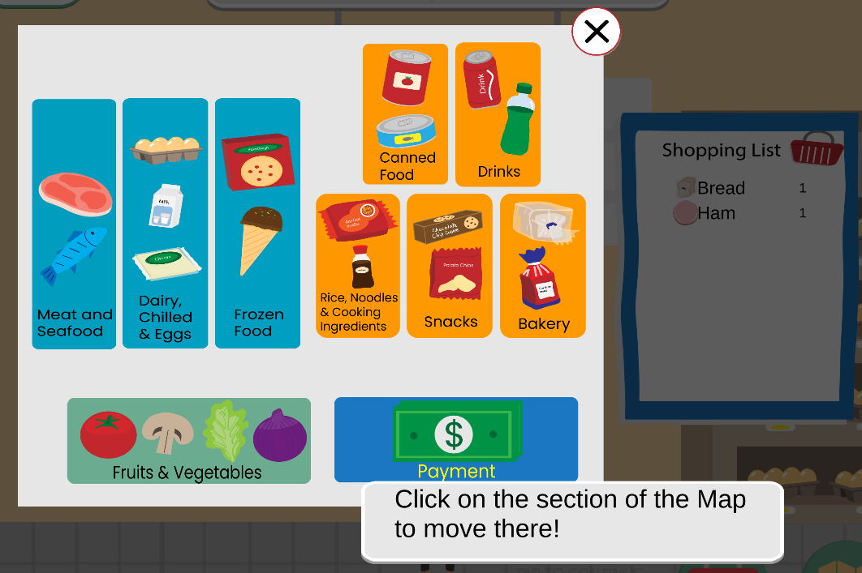

The map layout will indeed change with the map navigation being reordered every difficulty tweak. However the level too will get tweaked by having the aisle placed in different orders

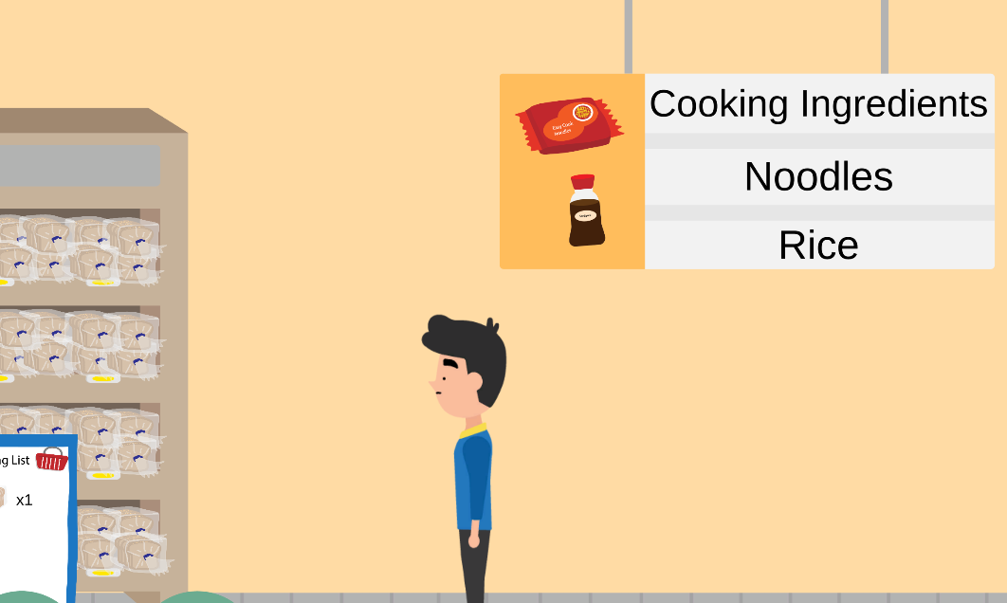

As seen the bread aisle is followed up by the cooking ingredients aisle.

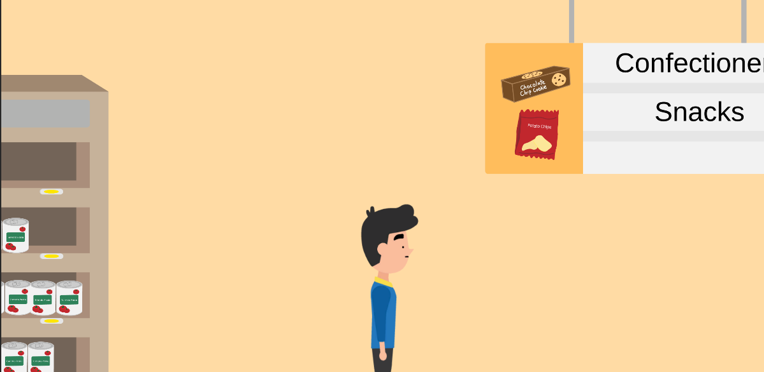

However, different levels could show the canned food aisle instead.

# **Game Characters**

## ***Overview***

There are 2 different player characters (male or female) to choose from, and some randomized NPCs when roaming the aisles.

## ***Creating a Character***

Starting the game, the player can choose between 2 models.  


## ***Hero/Heroes***

The “Heroes” of our story is the main character the player chooses. Either female or male character. They are tasked with getting groceries.

## ***Friends***

The player is able to stumble across a Supermarket Worker that will assist the player in finding the item they seek in the market.



## ***Enemies & Monsters***

There are 7 unfriendly NPCs who try to trick the player. All 7 of them try to scam the player’s money, but in different scenarios. Only one enemy NPC has been implemented so far, with the rest to be worked on in the continuation project.



## ***Bystanders***

N/A

# **User Interface**

## ***Overview***

The UI will be simplistic and bigger than usual so as to cater to our special needs audience. It will be brighter and contrasted from the environment so as to stand out and capture their attention, emphasizing importance to the buttons. The game will include timers for the guardian attending to the player to keep track of the progress of the player.

## ***In-Game Control System***

We control the cash register by using a drag-and-drop system. It is required to drag the money and coins towards the cashier. It will require a mouse if you are using a PC and touch controls if you are using an ipad.

## ***Front-end and Menus***

Users can only enter the game by clicking on “Start Game” in the Main Menu screen. After clicking Start Game, players can select a level in the Level Select screen which leads them to the Level Confirmation screen.

There is also a Pause Menu in the game. While shopping, there is also the option to open the Map Menu to teleport. Lastly, there is the Game Over menu which allows them to retry the level or go to the Main Menu.

# **Weapons**

## ***Overview***

Not applicable.

## ***Weapon Details***

Not applicable.

# **Vehicles**

## ***Overview***

Not applicable.

## ***Vehicle Details***

Not applicable.

# **Musical Scores and Sound Effects**

## ***Overview***

Music added to provide audio feedback and to make the game feel more alive.

## ***Sound Design***

Smart Shopper is aiming to replicate and use a cartoonish style of sound to match the non-serious aspect of the game.

## ***Musical Scores***

The music in the game is played in the background. There are 2 different music for the background, one for the menu and one for the levels. The menu is more chilled so that the player can take their time while the music for the levels is more upbeat to signal to the players that they should speed up.

## ***Sound Effects***

Sound effects on buttons to give an audio feedback to the player.

# **Single-Player Game**

## ***Overview***

It will be a stage based game where different levels are offered with differing difficulty. Single Player is a core aspect of the game as our target audience is special needs, they would need to play the game at their own pace as all of them have different learning paces.

## ***Key Features***

Free roam, players can go anywhere they want.

Many items to choose from.

Fun cashier system where they can calculate the total amount with money given (notes and coins!).

## ***Story***

The player is tasked to buy ingredients from the supermarket. As a growing adult, they are tasked to do it alone.

## ***Hours of Game play***

Total time for all 15 levels should take around 45 mins to 1 hour.

## ***Victory Conditions***

The player is able to complete the game by finding all the ingredients and successfully paying it for it. The game is rather flexible allowing some mistakes to be made for the player taking in consideration of their different needs. Therefore, the player is able to complete the game however they may not score the best outcomes. Smart shopper calculate the star tally by checking the remaining change needed to pay. If the player pays too little or too much, they will receive a lower rating.

The player can lose the game by making poor decision choices at the NPC Interaction meaning that if they decide to agree with an evil NPC, they will receive a bad ending which means a loss. The player can also lose if they pay way too much which they will receive a 0 rating.

## ***Saving and Loading***

No saving and loading as it is web-based.

# **Multi-Player Game**

## ***Overview***

Not applicable.

## ***Max Players***

Not applicable.

## ***Server-Style***

Not applicable.

## ***Internet***

Not applicable.

## ***Persistence***

Not applicable.

## ***Saving and Loading***

Not applicable.

# **Tools**

## ***External Software to use***

Used Adobe Illustrator to make the art assets.

## ***World Editing***

World is created in Unity 2D. Designers can go into the unity file and edit the world however they want without any help from programmers or artists.

## ***Character Creation***

The designers are the driver when it comes to character creation as it does not impact the game too significantly, The characters are mostly a preference section and will not impact gameplay however it will just allow the player to relate to their character.

## ***Internal Tools***

Not applicable.