

ANALYSIS OF AN E-COMMERCE SALES BUSINESS

A SMALL DATA ANALYSIS DONE TO ANSWER SOME QUESTIONS RELATED TO THE SALES DATA.



# INTRODUCTION

This report offers the firm sales insights based on order data from the previous year. The collection includes information on 128,975 orders, such as quantity, items, dates, and client location. We may find patterns and possibilities to boost sales and marketing by examining this data.

## QUESTIONS TO BE ANSWERED

What is the average sales per month?

Which market(state) generated the most sales on average?

Which category of products sells the best?

When are the best and worst selling periods?

What is the Average Order Value for each product category?

What is the average sales per month?

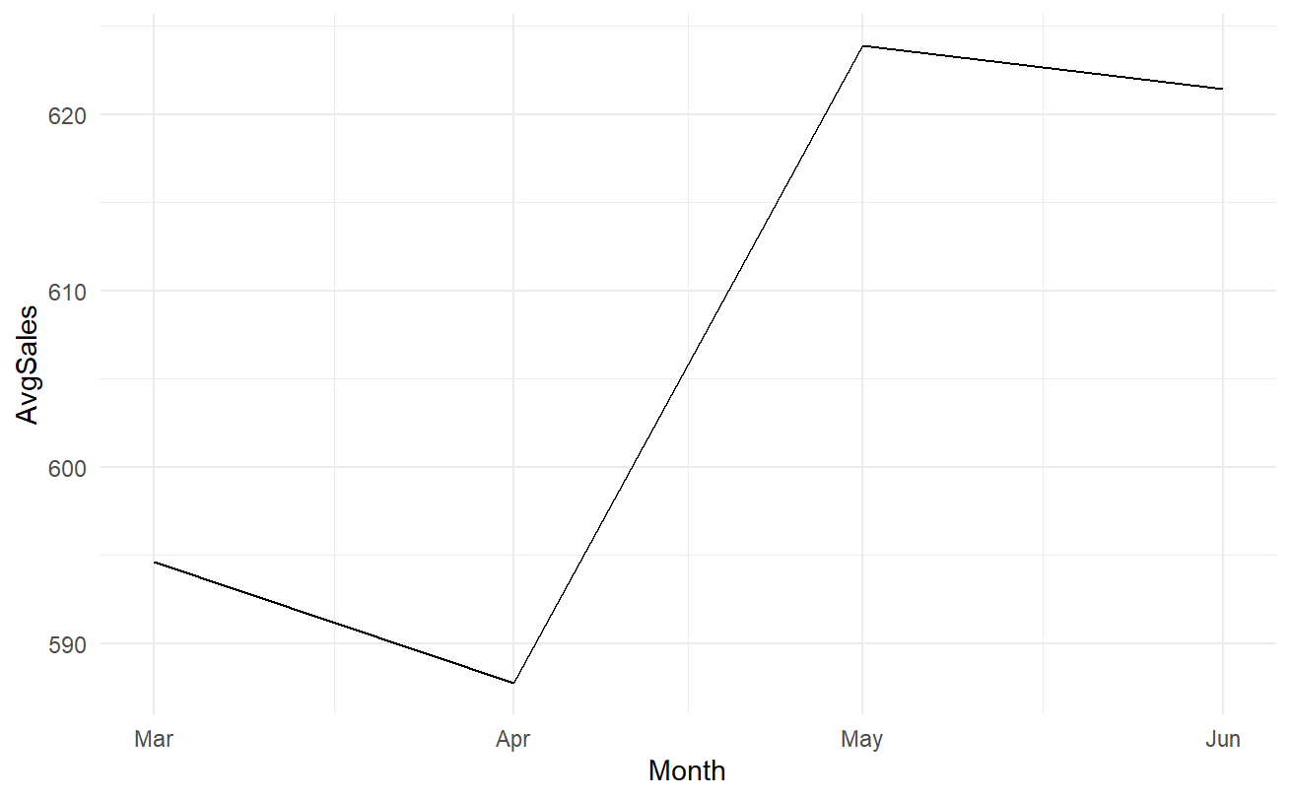The output shows that the average sales for the month of March are the lowest, with a steady increase from April to May. The average sales for the month of March are 595, while the monthly average sales for the month of May are 624, which is the highest.

The heatmap of the average sales of the product with respect to the months is shown below.

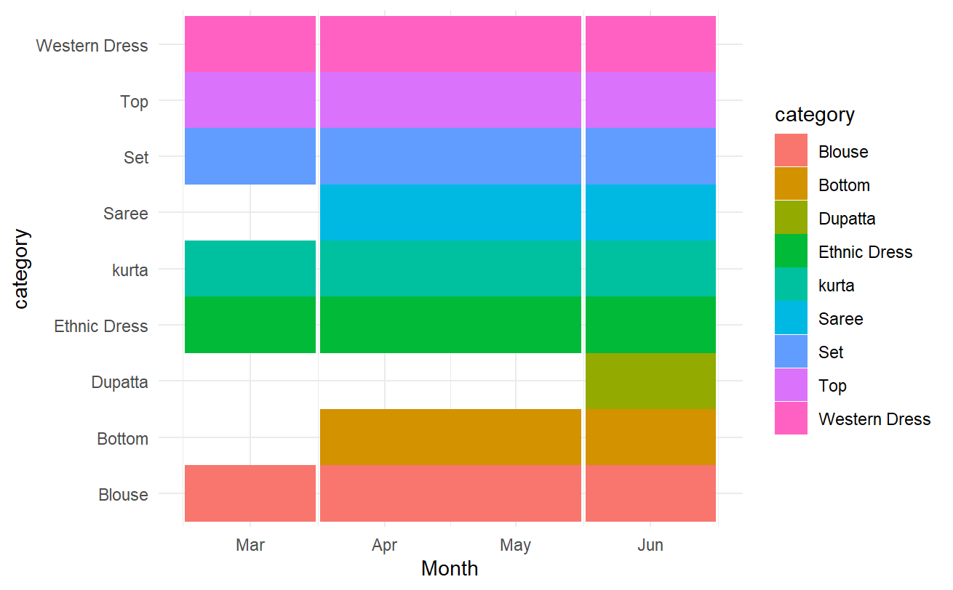

Which market(state) generated the most sales on average?

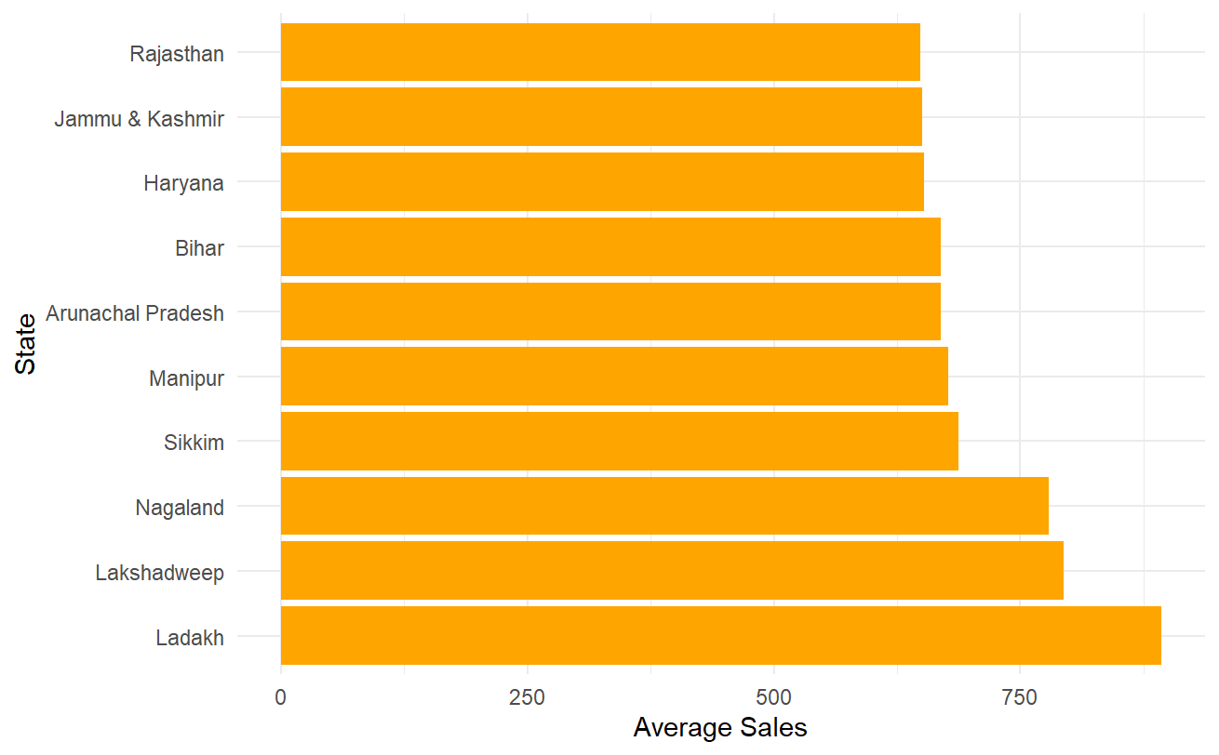The chart below shows that the state of Ladakh fared well in average sales, with Lakshadweep coming in second. The least-performing marketplaces or states are Rajasthan along with Jammu and Kashmir.

Which category of products sells the best?

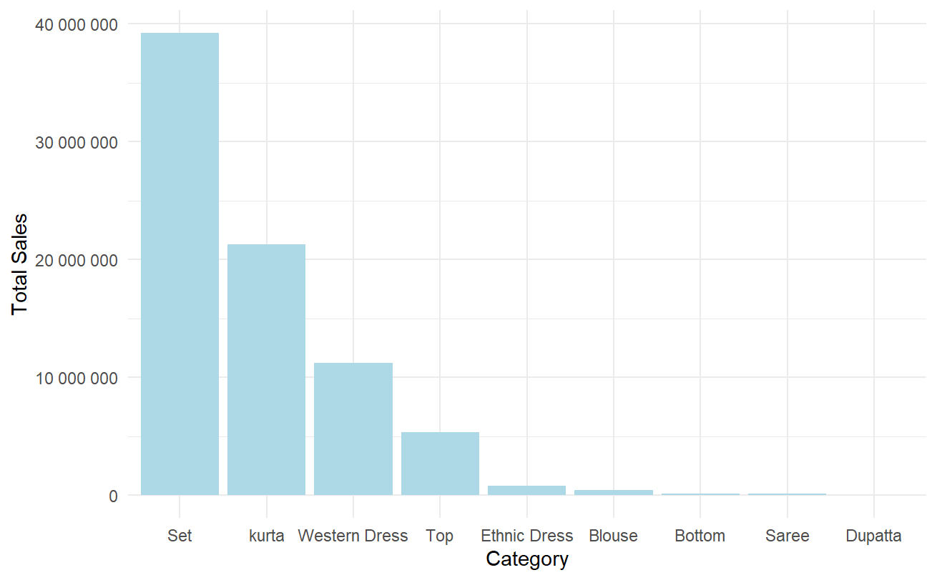The Category 'set' performed exceptionally well in comparison to the majority of the states, with 39195176 rupees in sales, while the Category 'Dupatta' performed poorly, with just 915 rupees in sales.

When are the best and worst selling periods?

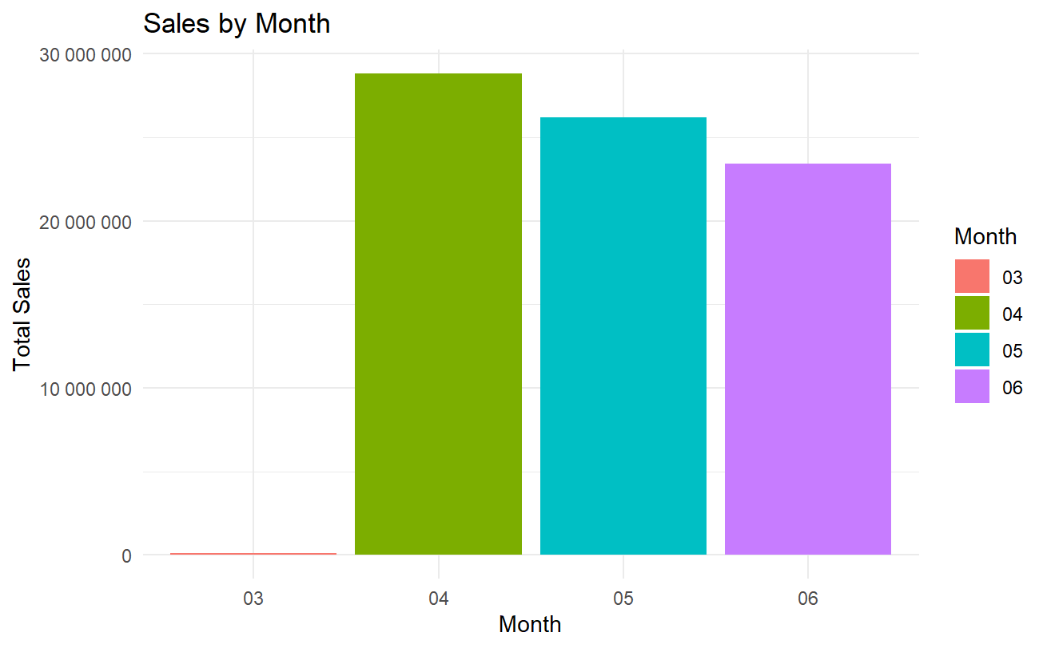According to the graph, the best selling month is April, while the lowest selling month is March. We can also observe that there isn't much of an uptick in sales beyond April, and that it really decreases as we move into May and June.

What is the Average Order Value for each product category?

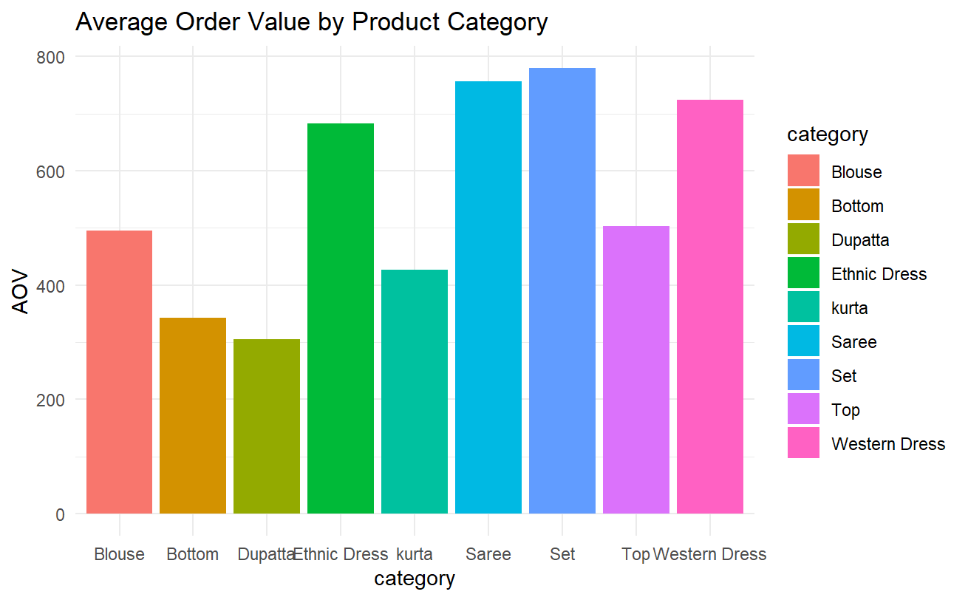The bar plot shows that the category 'Set' has the highest Average Order Value (AOV), followed by the category 'Saree', while the category 'Dupatta' has the lowest AOV.

# CONCLUSION



Finally, this e-commerce sales data analysis delivers useful information. The average monthly sales indicate March as the lowest selling month and April as the highest. Ladakh had the highest average sales per state, while Rajasthan had the lowest. The product category 'Set' had the greatest sales and average order value, while the product category 'Dupatta' had the lowest. According to the sales data, the peak sales season is April, with a fall in May and June. Additional elements might be investigated in order to enhance marketing and increase total sales.