Supplementary Material
Directional Hybrid-Work Misfit and Job Dissatisfaction: Implications for Socially Sustainable Hybrid-Work Design
Zidong Zhou, Rudzi Munap and Yue Meng
This file contains Supplementary Figures S1–S2 and an index to the complete spreadsheet tables. Tables S1–S43 and Additional Tables A1–A3 are provided in Supplementary File S2. Detailed variable definitions, model specifications, and robustness results are reported in those tables. Source CSV files are provided in Supplementary File S3.
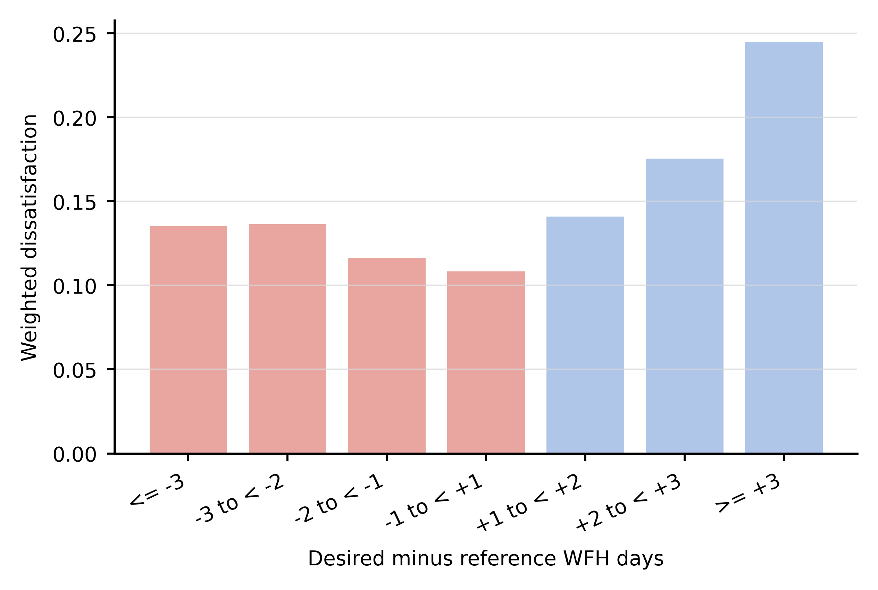
Figure S1. Job dissatisfaction across signed planned-reference misfit bins. Positive values indicate that desired WFH exceeds employer-planned WFH.
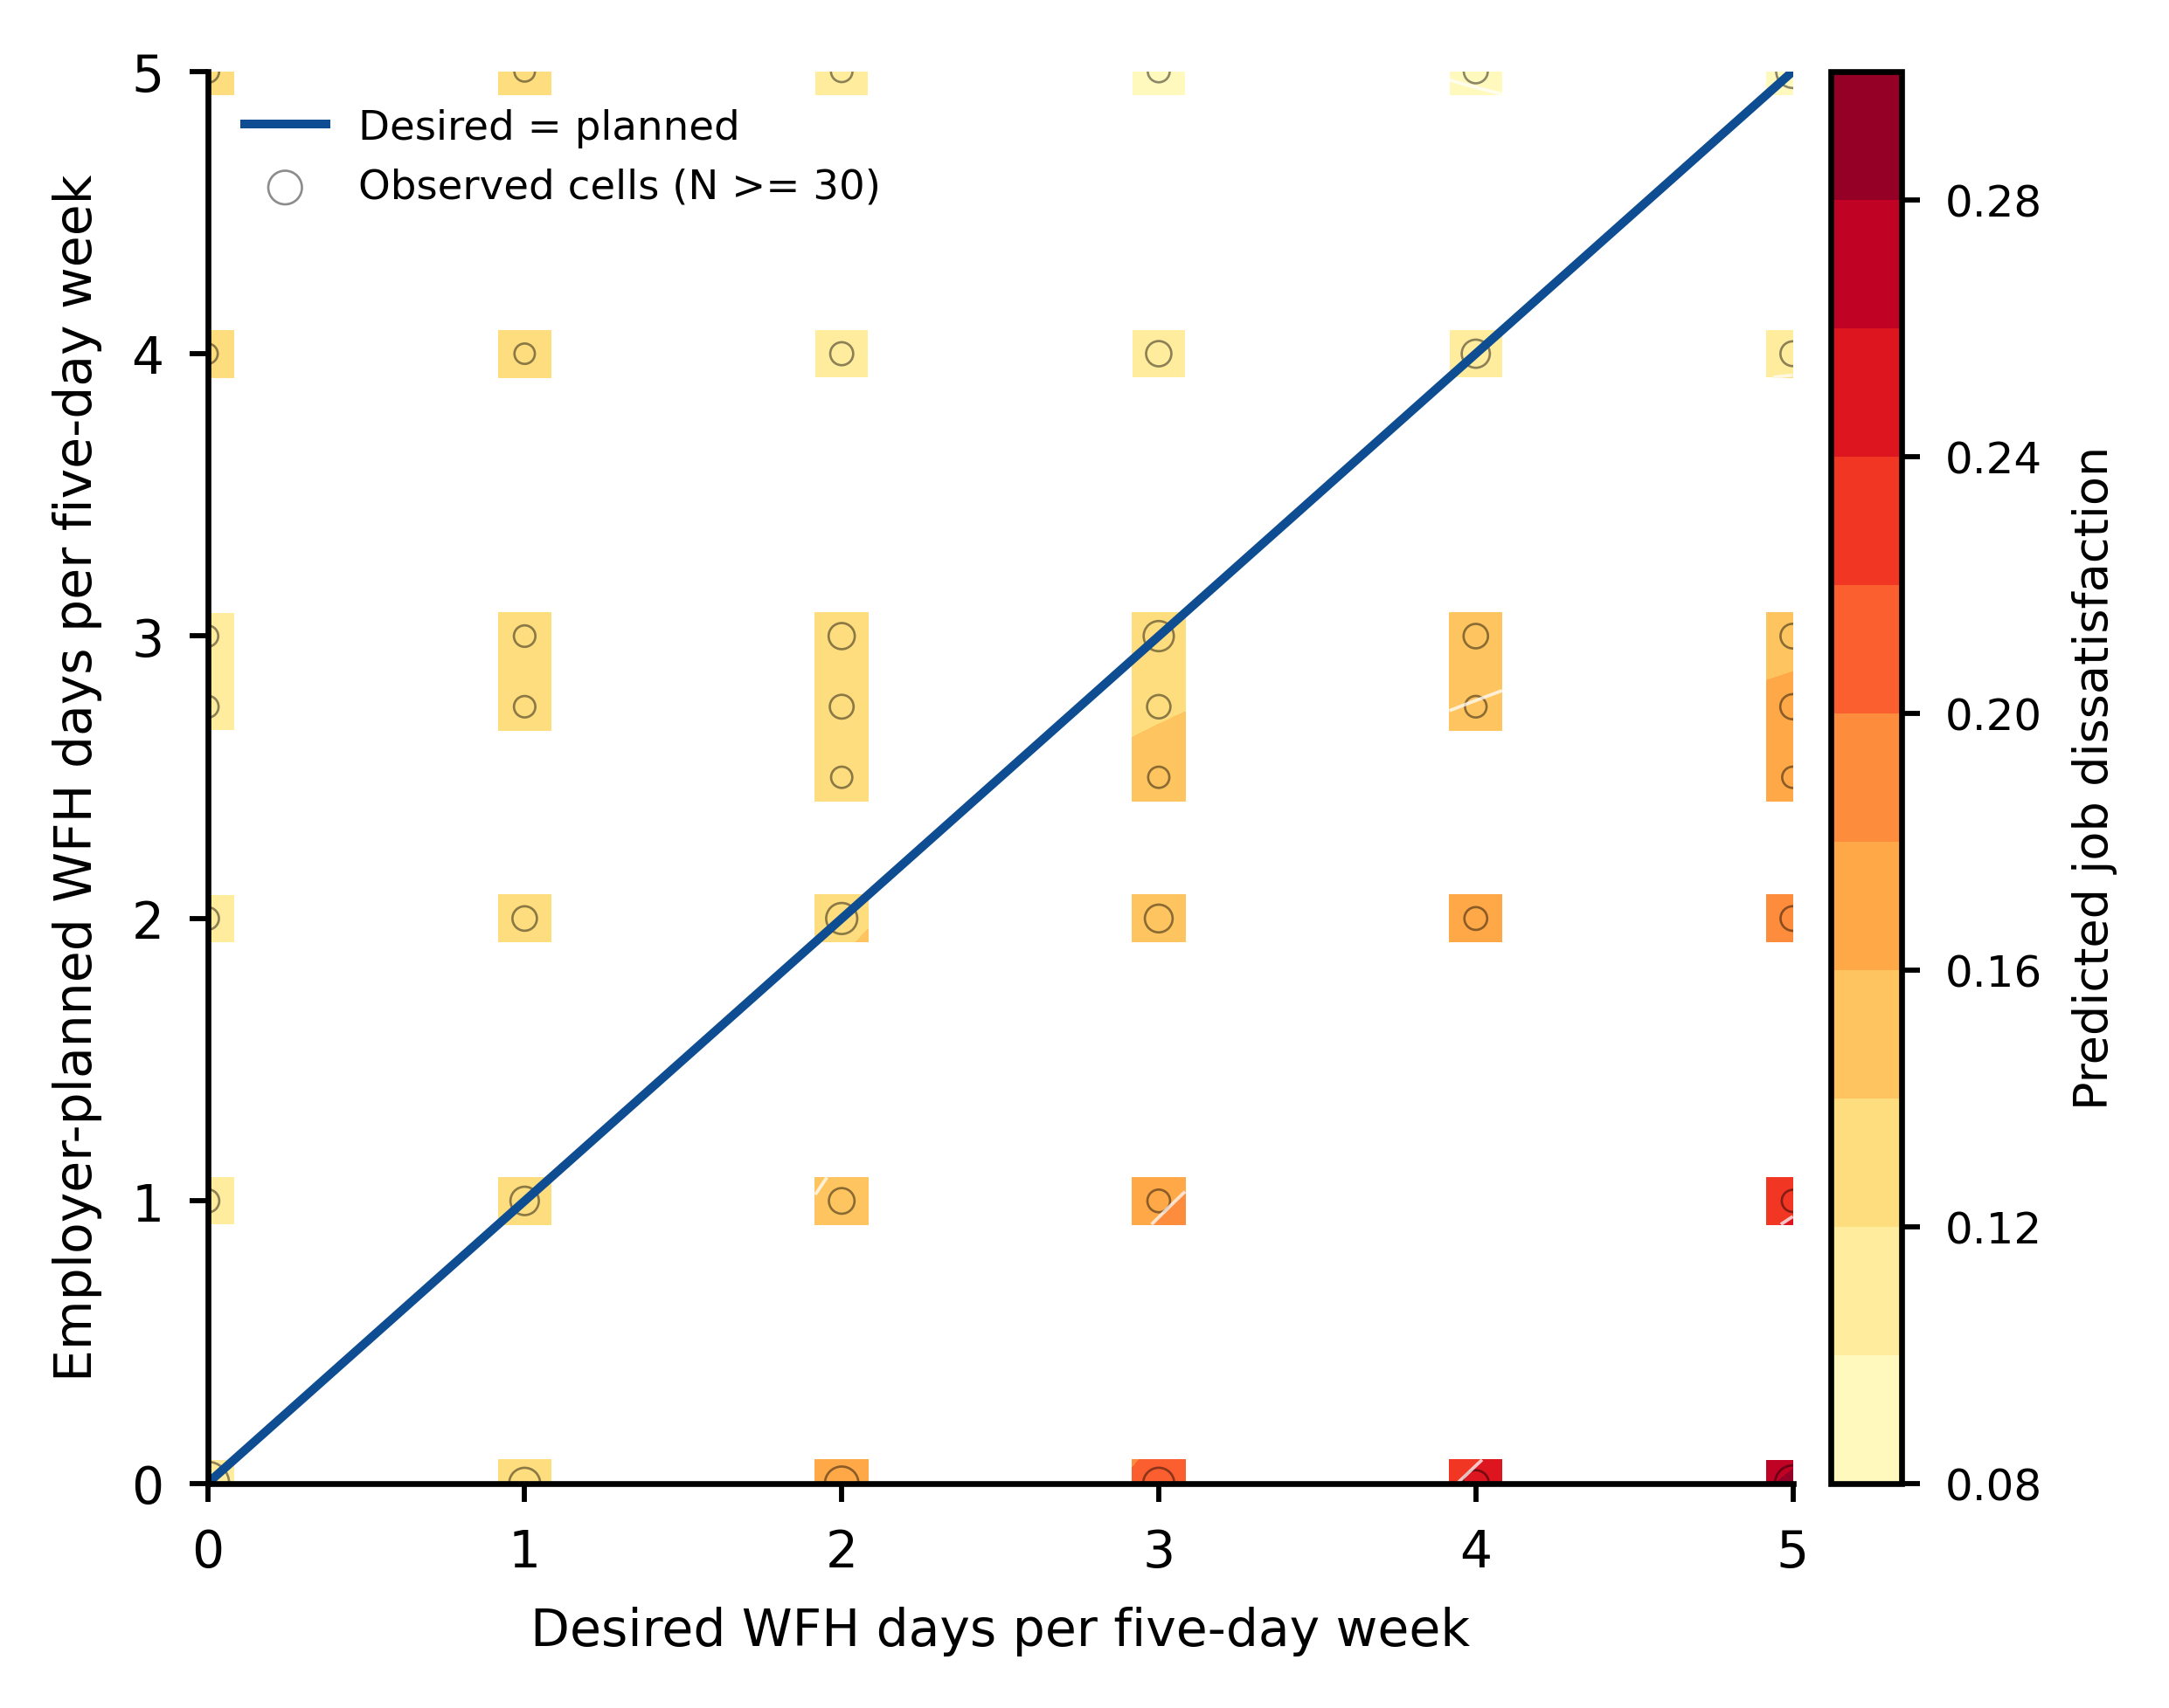
Figure S2. Planned-only response surface. Desired and employer-planned WFH are centered at the common 2.5-day midpoint. Predictions are masked where the nearest quarter-day cell contains fewer than 30 observations; point size represents local support.
Supplementary table index.
Supplementary item | CSV source
Table S1. Sample construction flow | revision_sample_construction_flow.csv
Table S2. Weighted descriptive statistics by misfit group | revision_table1_descriptives_by_misfit.csv
Table S3. Full weighted/unweighted association models | revision_weighted_unweighted_association.csv
Table S4. Association model grid with controls | revision_association_model_grid.csv
Table S5. Single-imputation and missingness-indicator association robustness | revision_imputed_association_robustness.csv
Table S6. Threshold and reference-arrangement robustness | revision_threshold_reference_lpm_robustness.csv
Table S7. Reference construction summary | revision_reference_construction_summary.csv
Table S8. Outcome-definition and misfit-definition robustness | revision_outcome_misfit_definition_robustness.csv
Table S9. Five-category satisfaction-score robustness | revision_satisfaction_score_robustness.csv
Table S10. Planned-WFH missingness profile | revision_planned_wfh_missingness_profile.csv
Table S11. Weight-trimming robustness | revision_weight_trimming_lpm.csv
Table S12. Month-cluster robust uncertainty for the M4 model | revision_wave_clustered_lpm.csv
Table S13. Temporal-holdout feature ablation | revision_ablation_temporal_performance.csv
Table S14. Directly interpretable rule definitions | revision_rule_definitions.csv
Table S15. Paired-bootstrap temporal-holdout comparisons | revision_paired_bootstrap_vs_rules.csv
Table S16. Calibration correction metrics | revision_calibration_correction.csv
Table S17. Top-k subgroup audit | revision_topk_subgroup_audit.csv
Table S18. Weighted top-k sensitivity | revision_weighted_topk_sensitivity.csv
Table S19. Heterogeneity interaction results | revision_heterogeneity_interactions.csv
Table S20. Reverse-causality sensitivity checks | revision_reverse_causality_sensitivity.csv
Table S21. Supplementary dissatisfaction-related outcomes | revision_supplementary_outcomes_summary.csv
Table S22. Outcome coding audit | revision_outcome_coding_audit.csv
Table S23. Model tuning and preprocessing details | revision_model_tuning_details.csv
Table S24. Practical ranking simulation | revision_practical_ranking_simulation.csv
Table S25. Permutation importance | revision_permutation_importance.csv
Table S26. Continuous directional-misfit robustness | revision_continuous_misfit_lpm.csv
Table S27. Complete-case inverse-probability weighting sensitivity | revision_ipw_complete_case_sensitivity.csv
Table S28. January-February 2026 temporal-holdout check | revision_temporal_stability_validation.csv
Table S29. Raw-score group-wise calibration diagnostics | revision_groupwise_calibration.csv
Table S30. Planned-only feature ablation | revision_sensitive_variable_ablation.csv
Table S31. Tie-robust top-k sensitivity | revision_tie_robust_topk.csv
Table S32. Calibrated subgroup audit | revision_groupwise_calibrated_subgroup_audit.csv
Table S33. Remoteability moderation and stratification | revision_remoteability_moderation.csv
Table S34. Signed misfit-bin prevalence | revision_misfit_bin_prevalence.csv
Table S35. Complete-case balance | revision_complete_case_balance.csv
Table S36. Planned-WFH missingness model | revision_planned_missingness_model.csv
Table S37. SWAA weight distribution by analytic sample | revision_weight_distribution.csv
Table S38. Planned-only ranking validation | revision_planned_only_ranking_validation.csv
Table S39. Month-by-month January-February 2026 validation | revision_monthly_2026q1_validation.csv
Table S40. Weighted-training sensitivity | revision_weighted_training_sensitivity.csv
Table S41. Ranking-model governance summary | revision_ranking_model_governance_summary.csv
Table S42. Subgroup safeguard simulation | revision_subgroup_safeguard_simulation.csv
Table S43. Planned-only polynomial response-surface analysis | revision_response_surface_planned_only.csv
Additional Table A1. Temporal calibration sensitivity | revision_temporal_calibration_sensitivity.csv
Additional Table A2. Calibration-bin source data | revision_calibration_bins.csv
Additional Table A3. Primary association sample by survey month | revision_association_sample_months.csv
Note: The spreadsheet workbook contains one formatted worksheet per listed table.

