

**PROJECT**

**“Car Rental System using Python”**

Arranged by : Group 4

|  |  |
| --- | --- |
| 1. Gafrilatif Aviandi Putra Adnanta | (2120010053) |
| 2. Muhamad Farhan Budiana | (2120010203) |
| 3. Muhammad Zidan Satrio | (2120010105) |

Faculty :

Riza Muhammad Nurman

**Continuing Education Program Center for Computing and Information Technology**

**Faculty of Engineering, University of Indonesia**

**2021**

**PROJECT ON**  
CAR RENTAL SYSTEM USING C++

Developed by

Name : Gafrilatif Aviandi Putra Adnanta

Muhamad Farhan Budiana

Muhammad Zidan Satrio

Faculty : Riza Muhammad Nurman



**CAR RENTAL SYSTEM USING Python**

Batch Code : 2ISA3

Start Date : 12 Aprill 2022

End Date : 21 Aprill 2022

Name of the Coordinator : Riza Muhammad Nurman

Name of Developer : Gafrilatif Aviandi Putra Adnanta

Muhammd Farhan Budiana

Muhammad Zidan Satrio

Date of Submission : 21 Aprill 2022



**CERTIFICATE**

This is to certify that this report, titled *CAR RENTAL SYSTEM USING C++,* embodies the original work done by *Gafrilatif Aviandi Putra Adnanta, Muhammd Farhan Budiana, and Muhammad Zidan Satrio* in partial fulfillment of his/her cource requirement at NIIT.

Coordinator :

*Riza Muhammad Nurman*

**ACKNOWLEDGEMENT**

Thank you, the author wishes to God the Almighty for His blessings and grace, we can complete this project task both in the form of presentation and paper in a timely manner.

The author also delivers him gratitude to Mr. Riza Muhammad Nurman faculty and other faculty for all guidance to complete it. Thank you to fellow students who have supported, and also thank you to fellow workers in the education at CCIT FT UI. The Project paper entitled “ Car Rental System using C++ ” the author submits as a requirement for the Project assignment in 2022.

Finally, the authors hope this paper can be useful for all and also gain a better insight into the operating system. The author realizes that it is still imperfect. Therefore, the authors really expect all suggestions and criticisms from readers who are constructive in order for the perfection of this paper. Hopefully, this paper can provide many benefits for the readers.

**SYSTEM ANALYSIS**

The development of existing programming methods is growing so rapidly, it is marked by the many new programming methods aimed at making it easier for programmers to do programming and various purposes. because the development of the program is getting faster, there are many system changes where many fields have been digitized, coupled with the covid-19 pandemic, making everything turn online and programmed.

This problem will not been resolved until everything is digitized in order to compete and survive in this era of development. One example is the problem of public services in car rental and other fields. In order to speed up service and maintain health protocols where we are required to change our service system to be completely digital

Therefore, we created a simple program based on object oriented programming about a car rental system as an example of a solution so that people can survive and compete in today's conditions where everything is connected to each other by the internet. In this project we created a car rental system using C++ language, and we created a simple menu where customers can rent a car easily just by going through this program without having to meet face to face.

**FLOWCHART MAIN MENU**

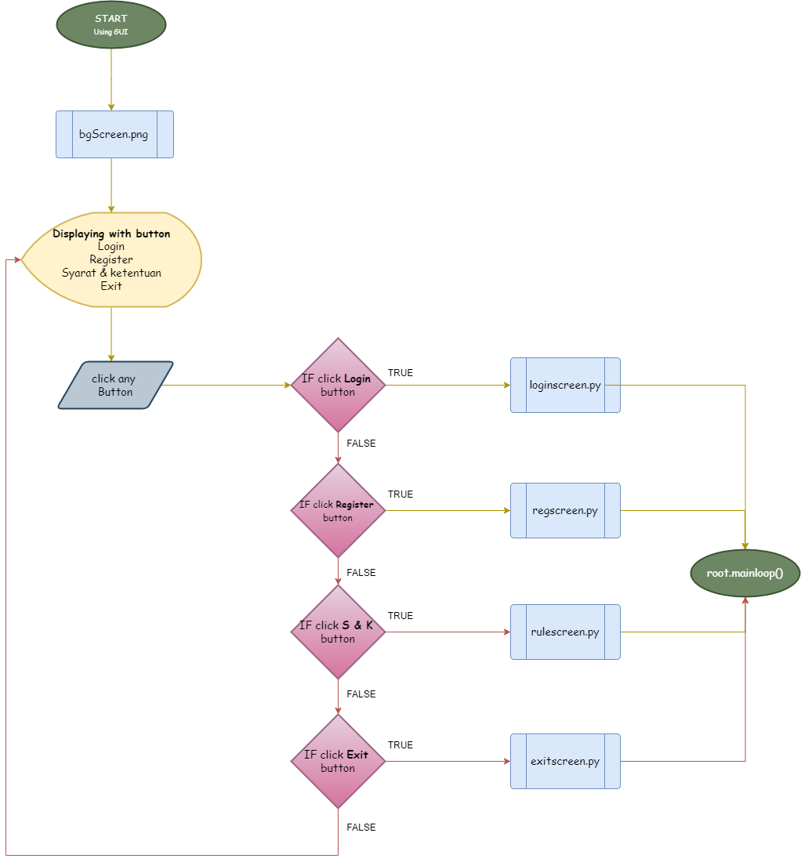

**FLOWCHART LOGIN SCREEN**

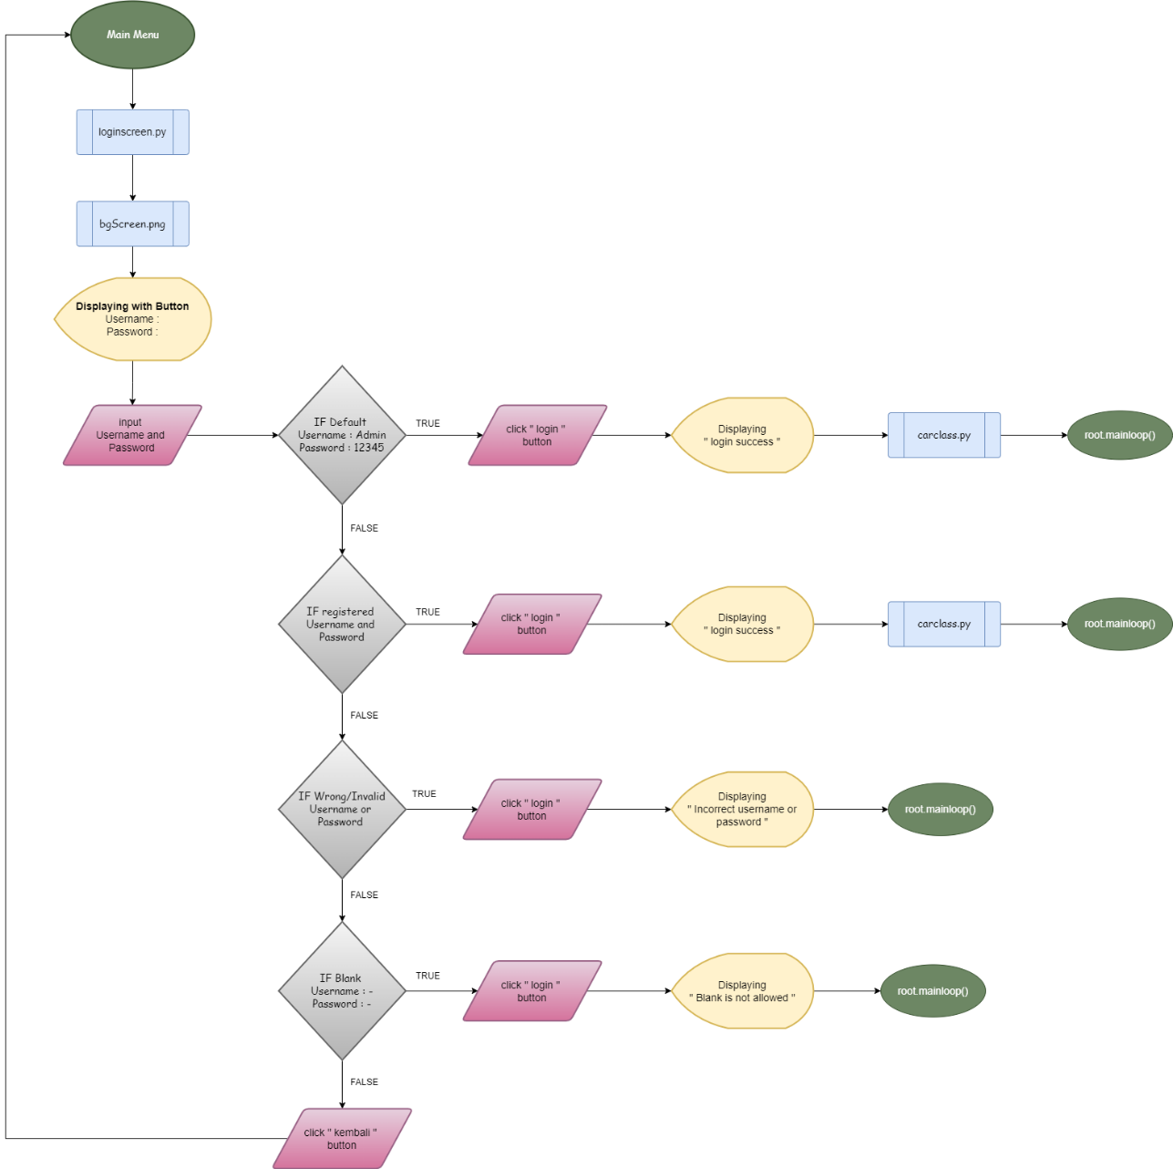

**FLOWCHART REGISTER**

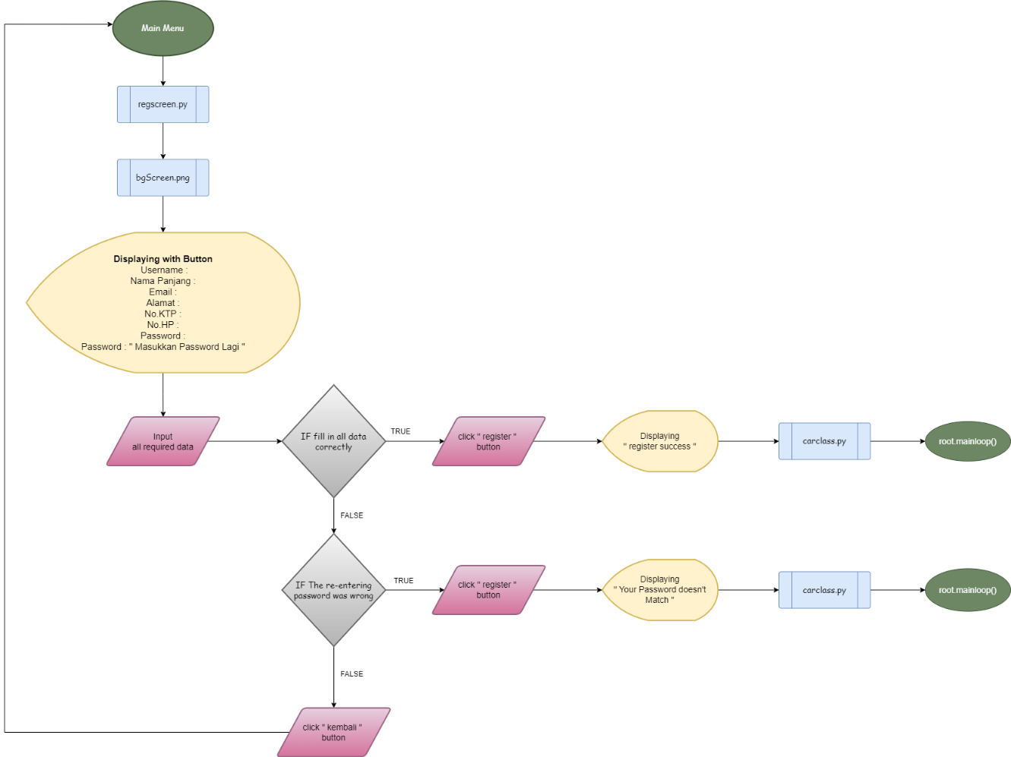

**FLOWCHART RULES**

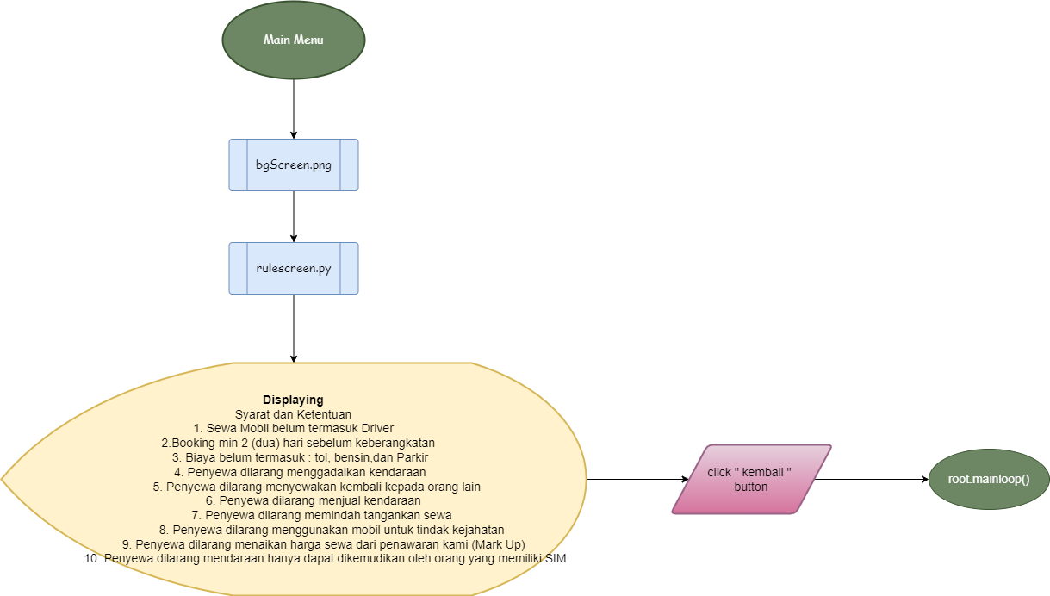

**FLOWCHART MPV CAR**

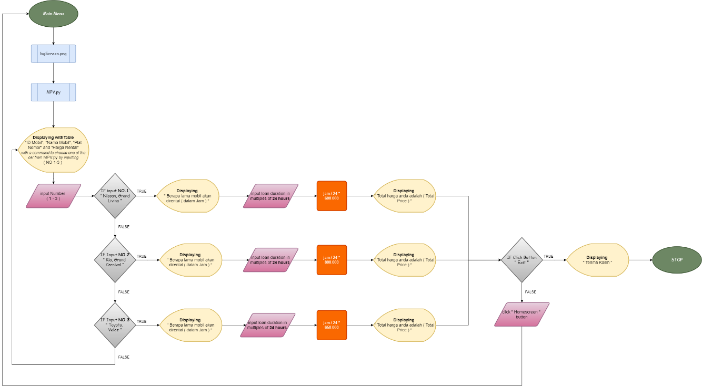

**FLOWCHART SUV CAR**

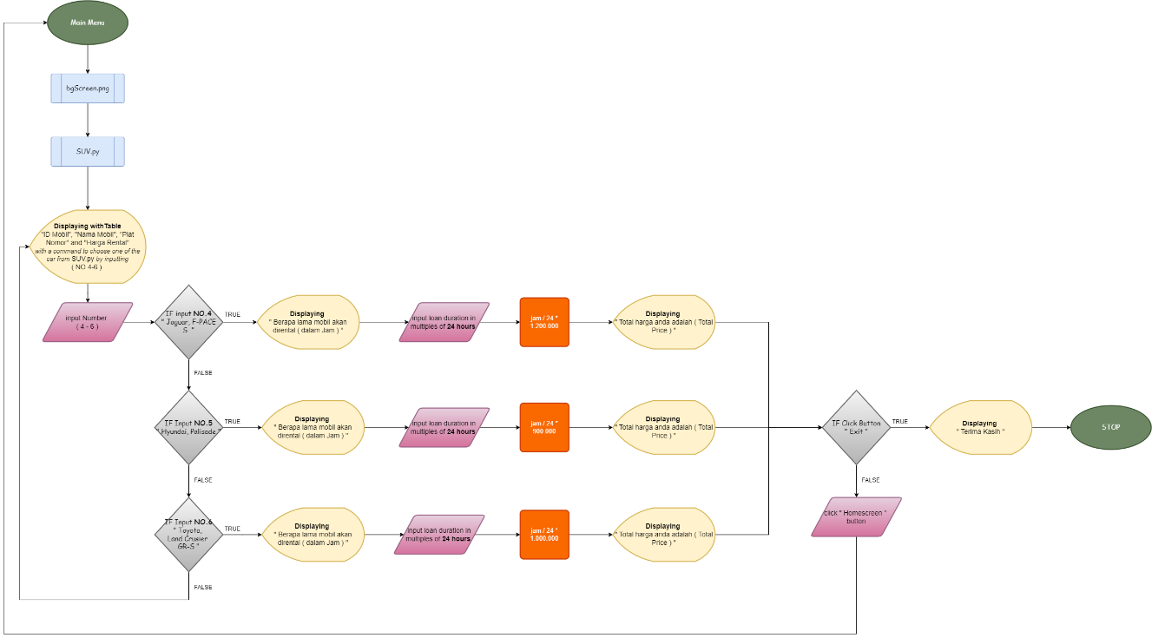

**FLOWCHART SPORT CAR**

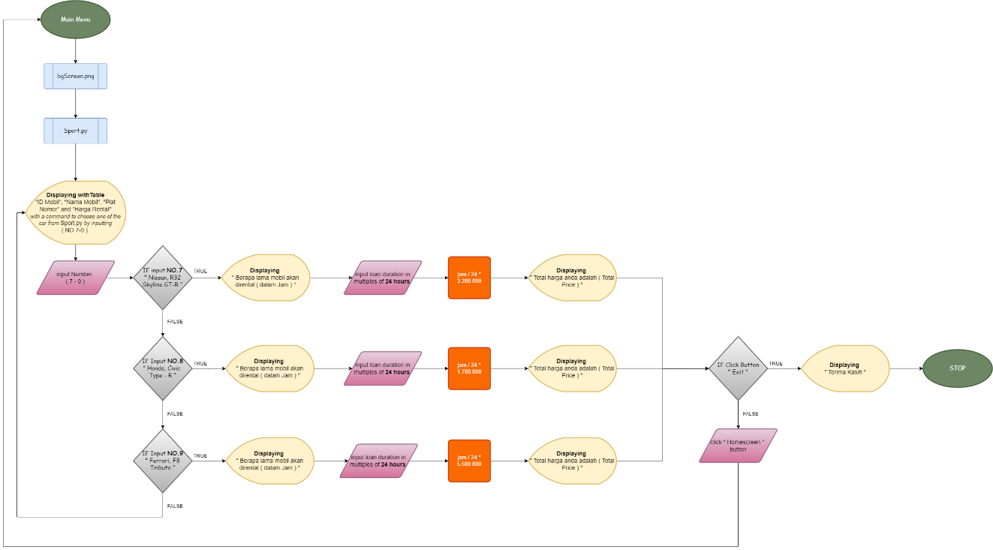

**FLOWCHART EXIT**

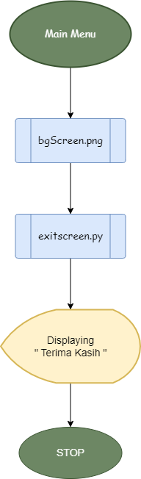

from tkinter import *  
import tkinter.font as font  
  
root = Tk()  
root.title("Main menu")  
root.state('zoomed')  
  
# Button Commands  
def login():  
 root.destroy()  
 import loginscreen  
  
def register():  
 root.destroy()  
 import regscreen  
  
def rules():  
 root.destroy()  
 import rulescreen  
  
def exit():  
 root.destroy()  
 import exitscreen  
  
bg = PhotoImage(file =r"C:\Users\user\Downloads\BGCARRENTAL1.png")  
  
# Create Canvas  
canvas1 = Canvas(root, width=800,  
 height=600)  
  
canvas1.pack(fill="both", expand=True)  
  
# Display image  
canvas1.create_image(0, 0, image=bg,  
 anchor="nw")  
  
# Add Text  
canvas1.create_text(767, 80, text="ZEN CAR RENTAL", fill='red3', anchor='center', font=("Helvetica", "30", "bold italic"))  
  
# define font  
myFont = font.Font(size=18)  
  
# Create Buttons  
button1 = Button(root, text="Login", fg='red3', bg='azure2', command=login)  
button2 = Button(root, text="Register", fg='red3', bg='azure2', command=register)  
button3 = Button(root, text="Syarat dan ketentuan", fg='red3', bg='azure2', command=rules)  
button4 = Button(root, text="Exit", fg='red3', bg='azure2', command=exit)  
  
# apply font to the button label  
button1['font'] = myFont  
button2['font'] = myFont  
button3['font'] = myFont  
button4['font'] = myFont  
  
# Display Buttons  
button1_canvas = canvas1.create_window(400, 150, height= 40, width=100,  
 anchor="nw",  
 window=button1)  
button1.place(relx=0.5, rely=0.30, anchor='center')  
  
button2_canvas = canvas1.create_window(400, 200, height= 40, width=130,  
 anchor="nw",  
 window=button2)  
button2.place(relx=0.5, rely=0.40, anchor='center')  
  
button3_canvas = canvas1.create_window(400, 250, height= 40, width=250,anchor="nw",  
 window=button3)  
button3.place(relx=0.5, rely=0.50, anchor='center')  
  
button4_canvas = canvas1.create_window(400, 300, height= 40, width=85, anchor="nw",  
 window=button4)  
button4.place(relx=0.5, rely=0.60, anchor='center')  
  
  
# Execute tkinter  
root.mainloop()