S K U N K W O R K S
OPERATOR MANUAL
Organized by application tab and workspace
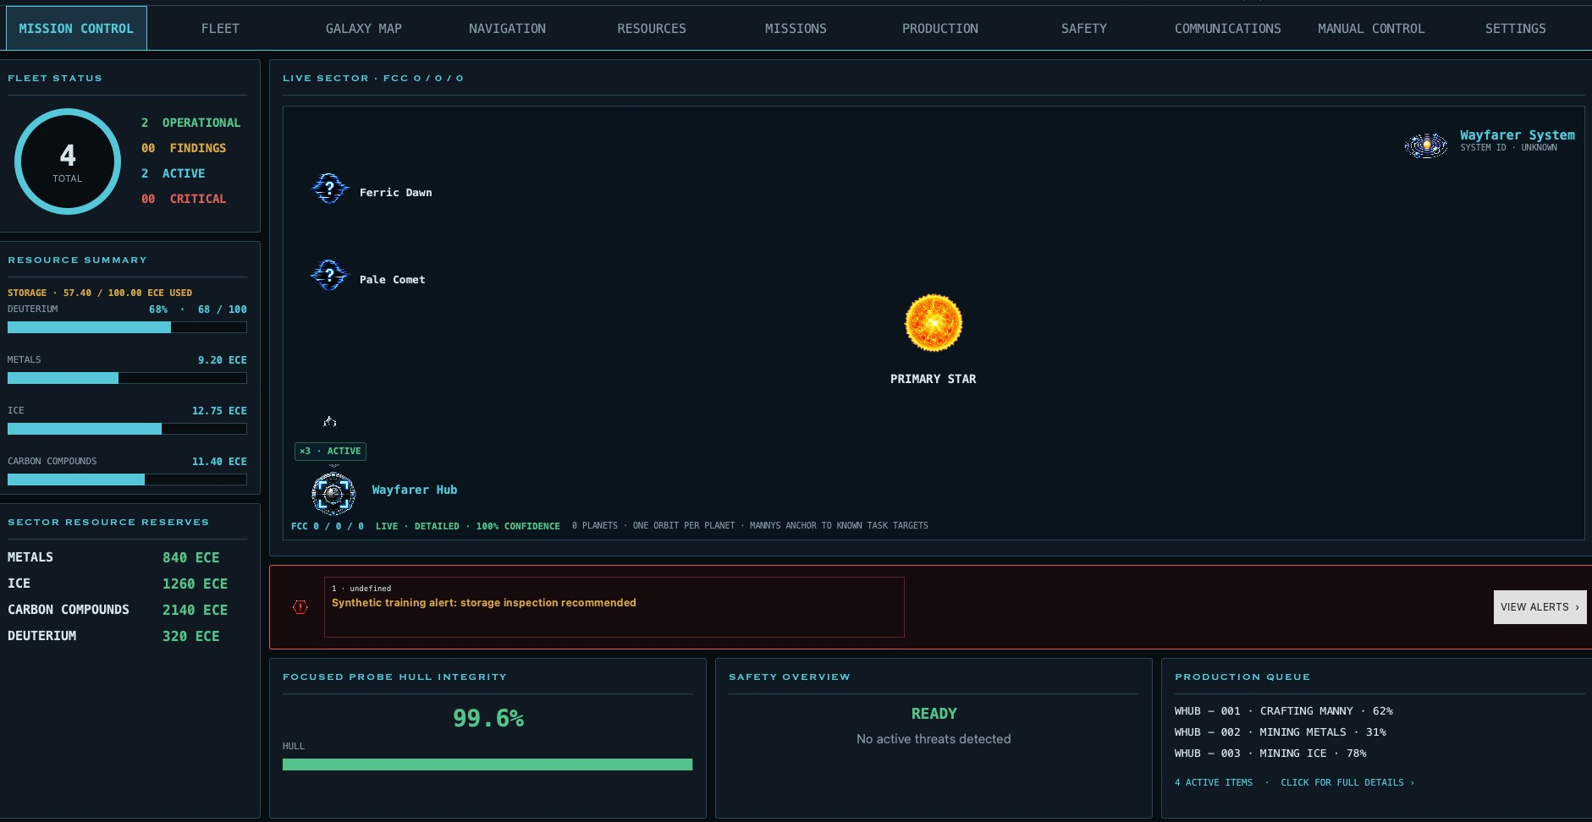
Mission Control: live fleet, sector, resources, safety, alerts, and production at a glance.
EDITION Version 0.5 follows the application's navigation hierarchy. Each top-level tab is one section; its sub-tabs, instructions, and supplied screenshots remain together.

Contents
The manual follows the application from left to right. Page ranges include every subsection and screenshot belonging to that top-level tab.
Section | Application area | Pages
1 | Getting Started | 3
2 | Mission Control | 4
3 | Fleet | 5
4 | Galaxy Map | 6
5 | Navigation | 7–9
6 | Resources | 10
7 | Missions | 11
8 | Production | 12
9 | Safety | 13
10 | Communications | 14
11 | Manual Control | 15–21
12 | Settings | 22–31
13 | Troubleshooting and Glossary | 32
 | Manny Warranty Redemption Form | 33

1. Getting Started
Skunkworks is a command-and-awareness layer for Von Neumann Game. The focused probe supplies the operational context shown throughout the application.
COMMAND AUTHORITY Observe Only never sends orders. Approval requires confirmation. Automatic can send allowlisted orders when live execution is enabled. Emergency Stop overrides every mode.

First launch
- Open Settings and securely save the game API key.
- Test the connection and confirm Connected appears in the header.
- Select each probe and verify its name, role, sector, fuel, and inventory.
- Keep automation in Observe Only until the proposed queue matches your intent.

Reading the header
- System Status summarizes readiness.
- Focused Probe changes the context for every probe-specific tab.
- Refresh reloads live account data.
- Stop immediately prevents automated orders.

2. Mission Control
Mission Control is the at-a-glance dashboard for the focused probe. It combines fleet posture, accessible resources, the current sector, alerts, hull integrity, safety, and active production without replacing the detailed tabs.

Figure 2-1. Mission Control dashboard and primary navigation.
No. | Control | Purpose
1 | System status | Overall readiness and current findings.
2 | Focused probe | Selects which probe supplies sector, resource, navigation, and fleet context.
3 | Primary navigation | Opens Mission Control, Fleet, Galaxy Map, Navigation, Resources, Missions, Production, Safety, Logbook, and Settings.
4 | Live sector view | Star-centered schematic with planets, asteroids, probes, relays, and grouped Manny activity.
5 | Fleet status | Fleet totals and operational/active/critical posture.
6 | Resource summary | Focused-probe fuel percentage and accessible resource quantities.
7 | Safety overview | Highest-priority safety state and plain-language reason.
8 | Active alerts | Warnings and critical conditions; open the full Safety view for details.
9 | Active missions | A compact summary; click for the full mission list.
10 | Production queue | Current crafting, assembly, and mining work; click for full details.

3. Fleet
Fleet contains probe identity and fleet-wide selection. Rename probes, choose the default probe when reachable, configure Manny naming for the focused probe, and select a probe card to change context.

Probe and Manny naming
- The {probe} field inserts the focused probe name.
- The {number} field inserts the selected numeric or letter sequence.
- Apply to Existing Mannys performs an immediate bulk rename for the focused probe.
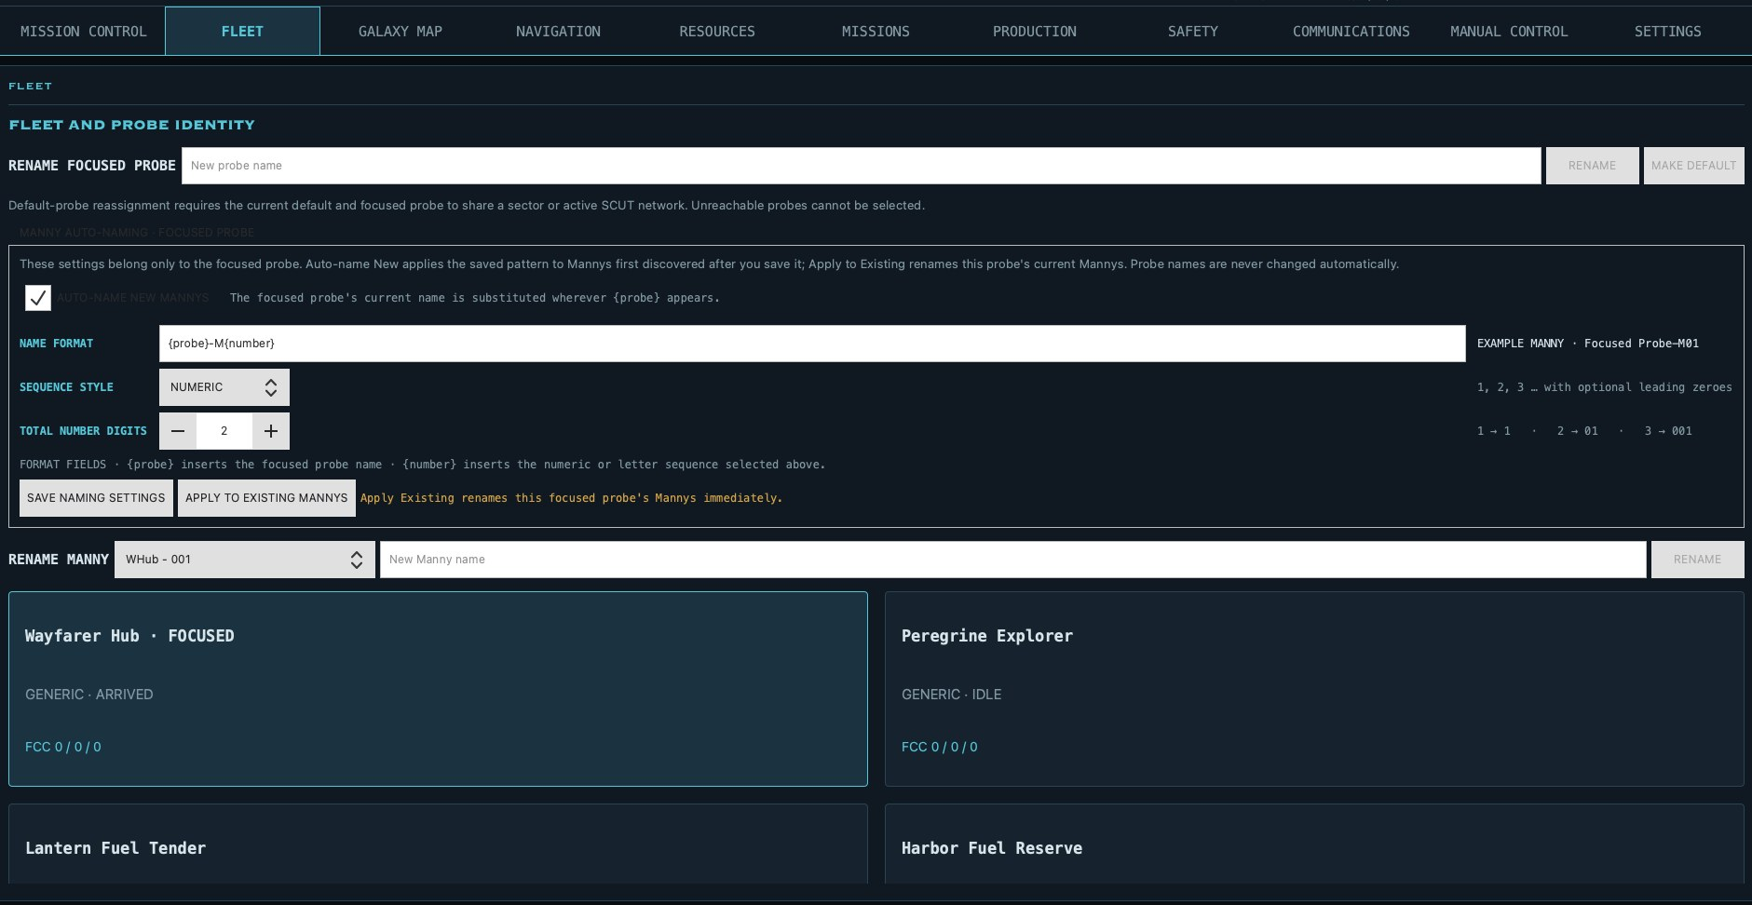
Figure 3-1. Probe identity, Manny auto-naming, direct Manny rename, and fleet cards.

4. Galaxy Map
Galaxy Map presents the locally known FCC network. Drag to orbit or pan, use the wheel to zoom, and use the view buttons for precise orientation. Verified lines represent neighboring-sector relationships.

Filters and sector details
- Filter by discovery state, resource, hazard, dropped container, focused-probe trail, or SCUT coverage.
- Select a node to read its coordinates, observations, objects, confidence, and last visit.
- Scan/Refresh requests current knowledge when the selected sector is reachable by the API.
LOCAL KNOWLEDGE Detailed history persists after scans, but Skunkworks never invents information the game API did not expose.

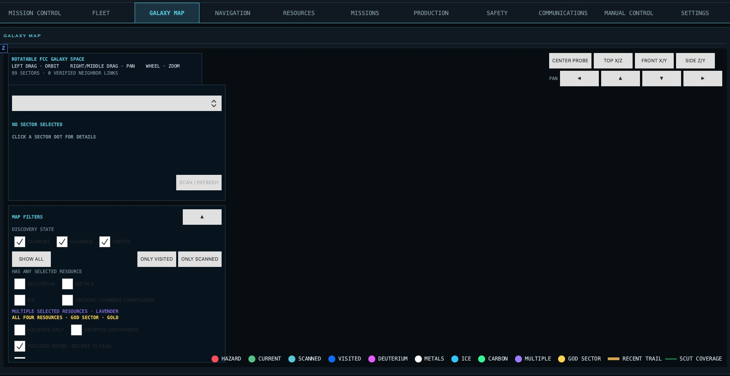
Figure 4-1. Rotatable FCC galaxy view, sector inspector, filters, trail, and SCUT coverage.

5. Navigation

Manual Travel
Manual Travel prepares one movement command for the focused probe. Enter an FCC directly or choose Use for Manual Travel beside a neighboring scan, then select the route strategy and preview before anything is sent.
- Confirm the focused probe and current FCC in the header.
- Enter the destination X, Y, and Z coordinates.
- Choose the segmented route strategy and select Preview Route.
- Review every segment, deuterium requirement, fuel reserve, cargo-detachment warning, and refueling dependency.
- Use Confirm One-Time Travel Command only for this trip.
ONE-TIME ORDER Manual confirmation does not create a repeating route. Movement still requires the command allowlist and live execution authority.

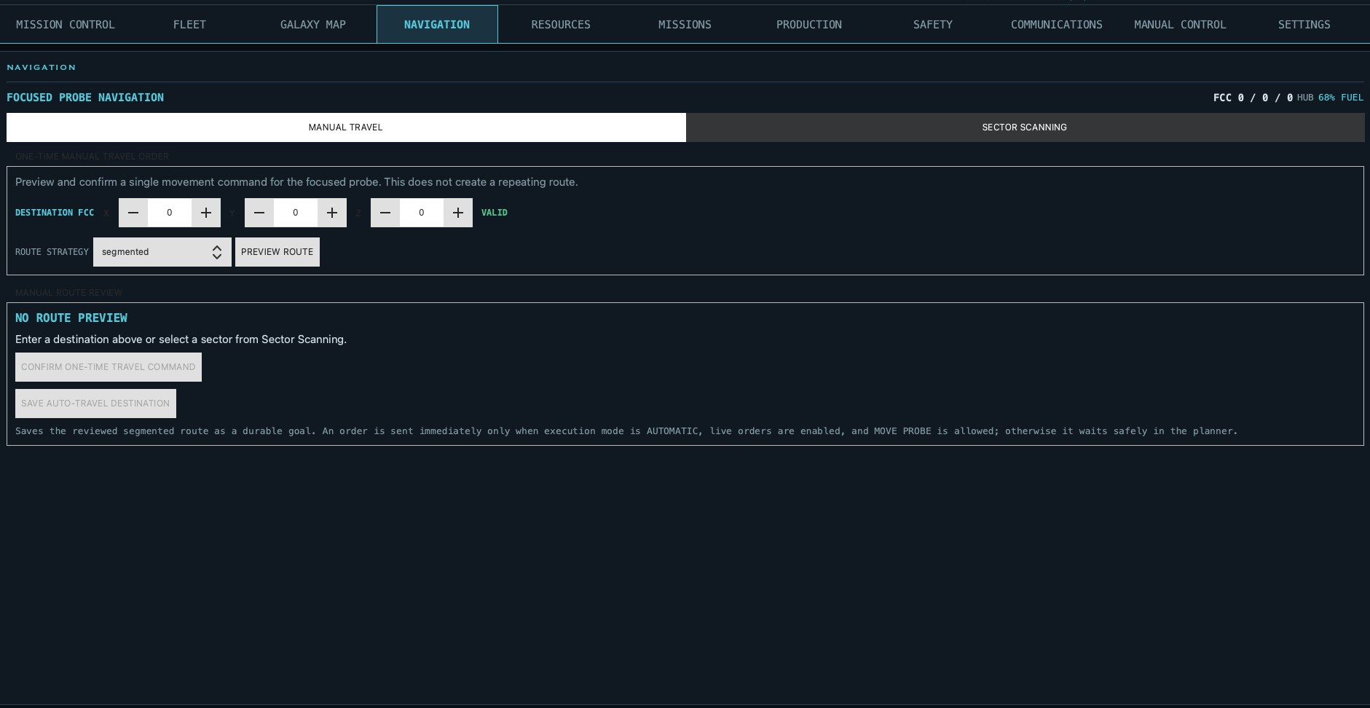
Figure 5-1. Manual Travel keeps destination, preview, warnings, and confirmation together.

Automatic Travel
After a segmented route has been previewed, Save Auto-Travel Destination stores that reviewed destination as a durable planner goal. It is not an unconditional launch button: the planner waits until Automatic mode, live orders, and Move Probe permission are all enabled.
- The saved goal remains associated with the focused probe.
- The planner sends one safe segment at a time and rechecks the live probe state after refresh.
- Fuel and safety floors continue to apply before every departure.
- Recurring pickup-and-delivery loops are configured separately under Settings → Probe Role Settings → Transport or Deuterium Tanker.

Figure 5-2. The same reviewed route can be saved as an automatic destination from Manual Travel.

Sector Scanning
Sector Scanning lists the twelve valid FCC neighbors around the focused probe. Each row identifies its knowledge level, estimated contents, and SCUT coverage.
- Scan requests current data for one neighbor.
- Scan All 12 Neighboring Sectors refreshes the complete neighborhood.
- Details opens the retained observation for that FCC.
- Use for Manual Travel copies the selected FCC into the travel form.
- Detailed and Neighbor Scan labels distinguish authoritative observations from lower-detail estimates.
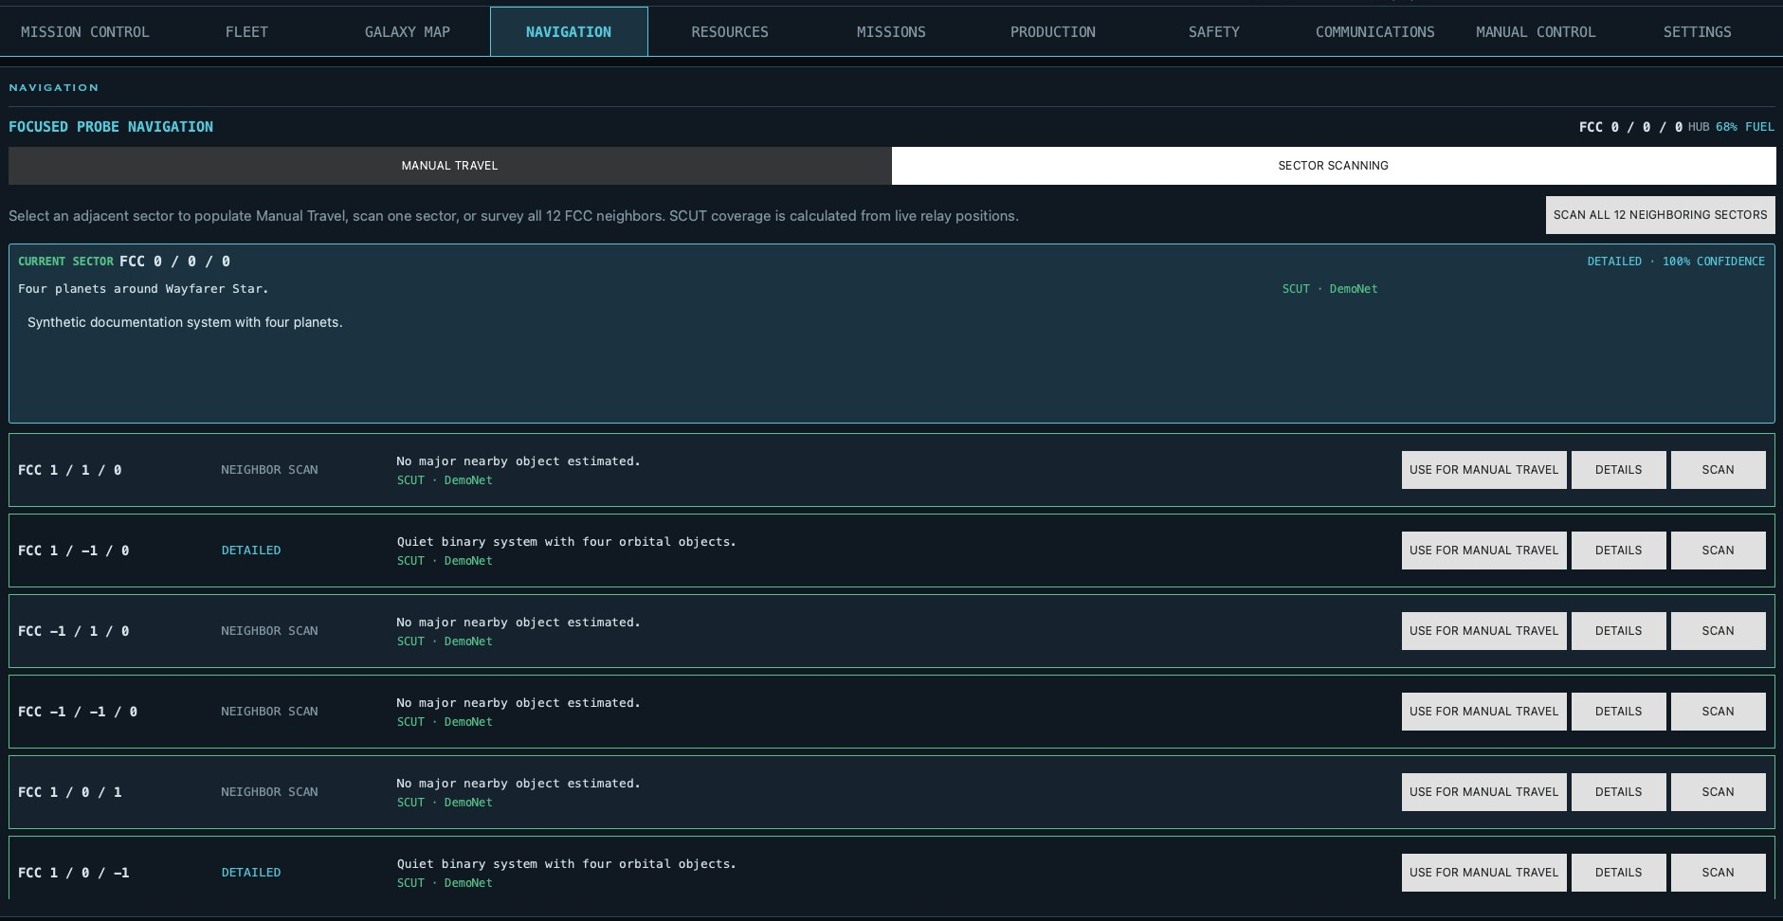
Figure 5-3. Sector Scanning actions and knowledge states.

6. Resources
Resources groups probe storage, containers, drifting objects, and the latest observed asteroid reserves. Quantities retain their source location so users can distinguish accessible cargo from remote or detached stock.

Reading inventory
- Probe deuterium is displayed as a percentage of tank capacity.
- Bulk resources use ECE quantities and retain their containing probe or container.
- Asteroid quantities are the latest recorded scan, not a prediction of current stock.
- Unknown or unavailable container contents remain explicitly labeled.
RELATED CONTROLS Resource movement, jettison, container routing, deployment, and recovery are operator commands under Manual Control → Cargo and Transfers. They are documented there with their actual screenshots.

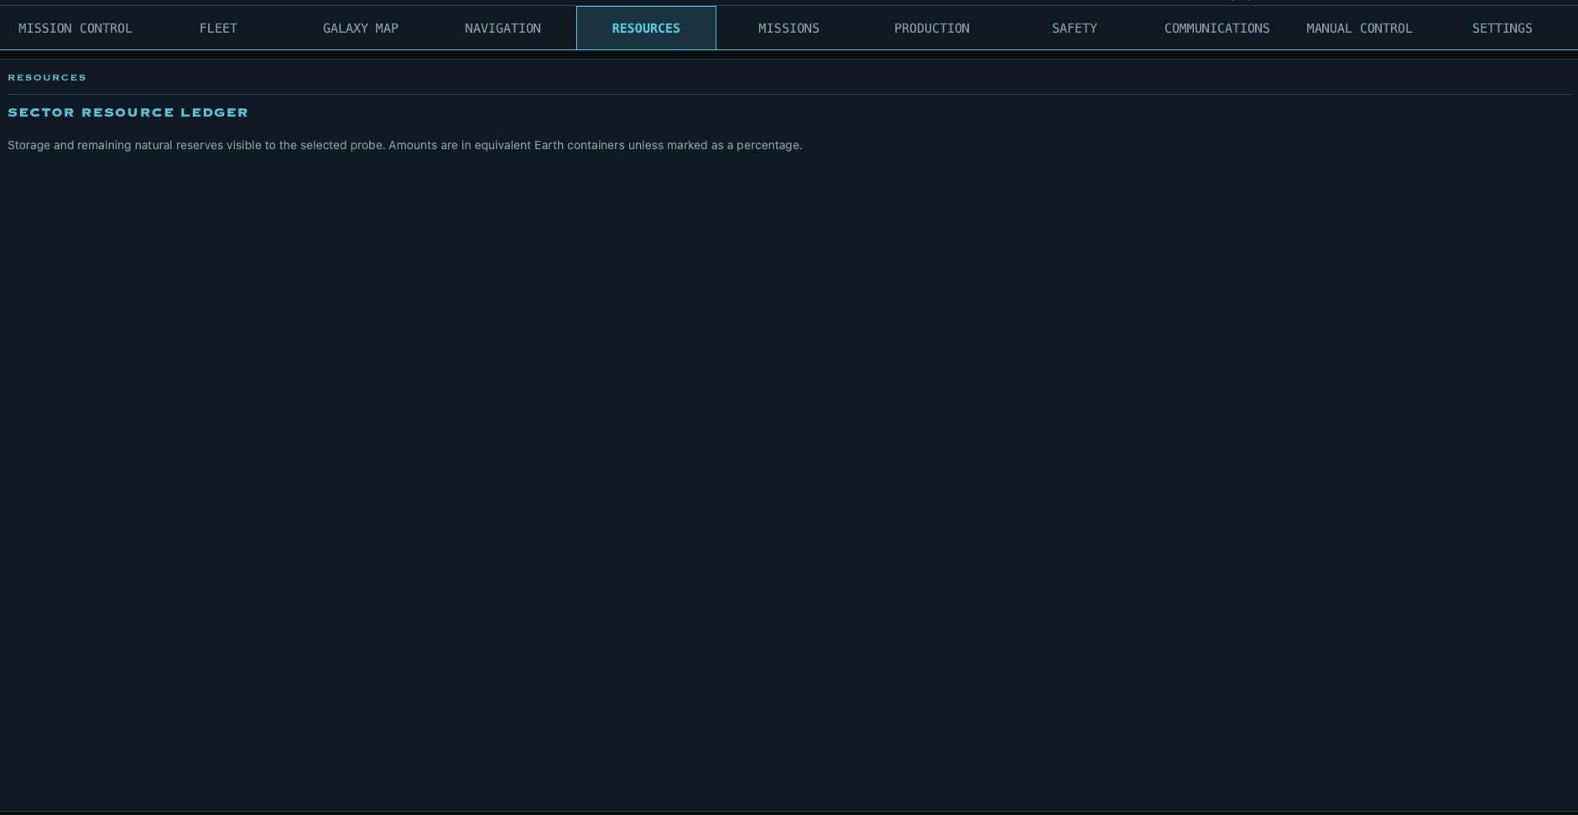
Figure 6-1. Resource ledger groups probe storage, containers, detached cargo, and observed natural reserves.

7. Missions
Missions lists objectives and progress exposed by the game. Select an entry to review its description, current state, progress, and any requirements supplied by the API. Refresh after completing mission work elsewhere so the displayed state is authoritative.
- The mission list is account context, while probe-specific requirements still depend on the focused probe.
- Skunkworks does not infer hidden objectives or undisclosed completion conditions.
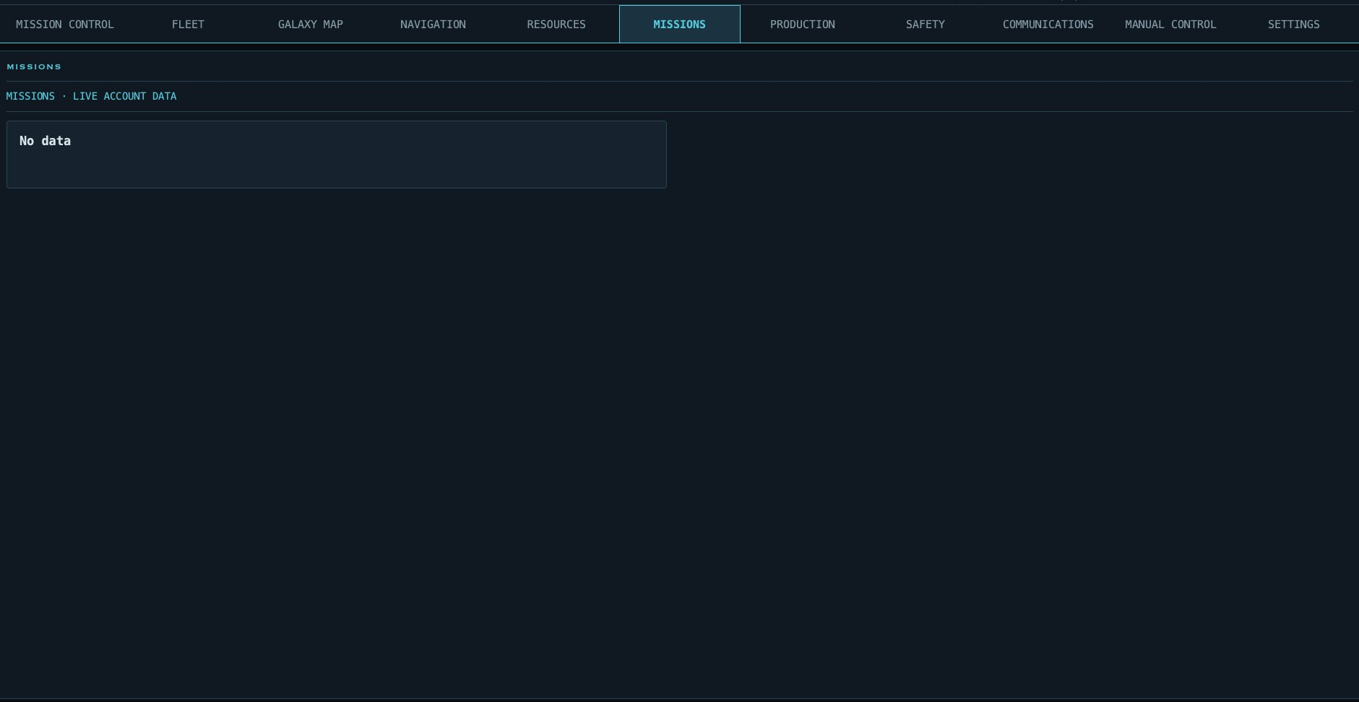
Figure 7-1. Missions lists objectives and progress exposed by the game API.

8. Production
Production displays every Manny and printer, including idle workers. Active cards show the task, target, progress, local completion time, countdown, delivery behavior, and the reason automation dispatched the order.
- Sort Mannys by name, status, or remaining time.
- Idle Ready means the Manny can receive a valid order.
- Recall cancels the current task subject to game rules.
- Mining cards show their target object, resource, amount, and delivery commitment.
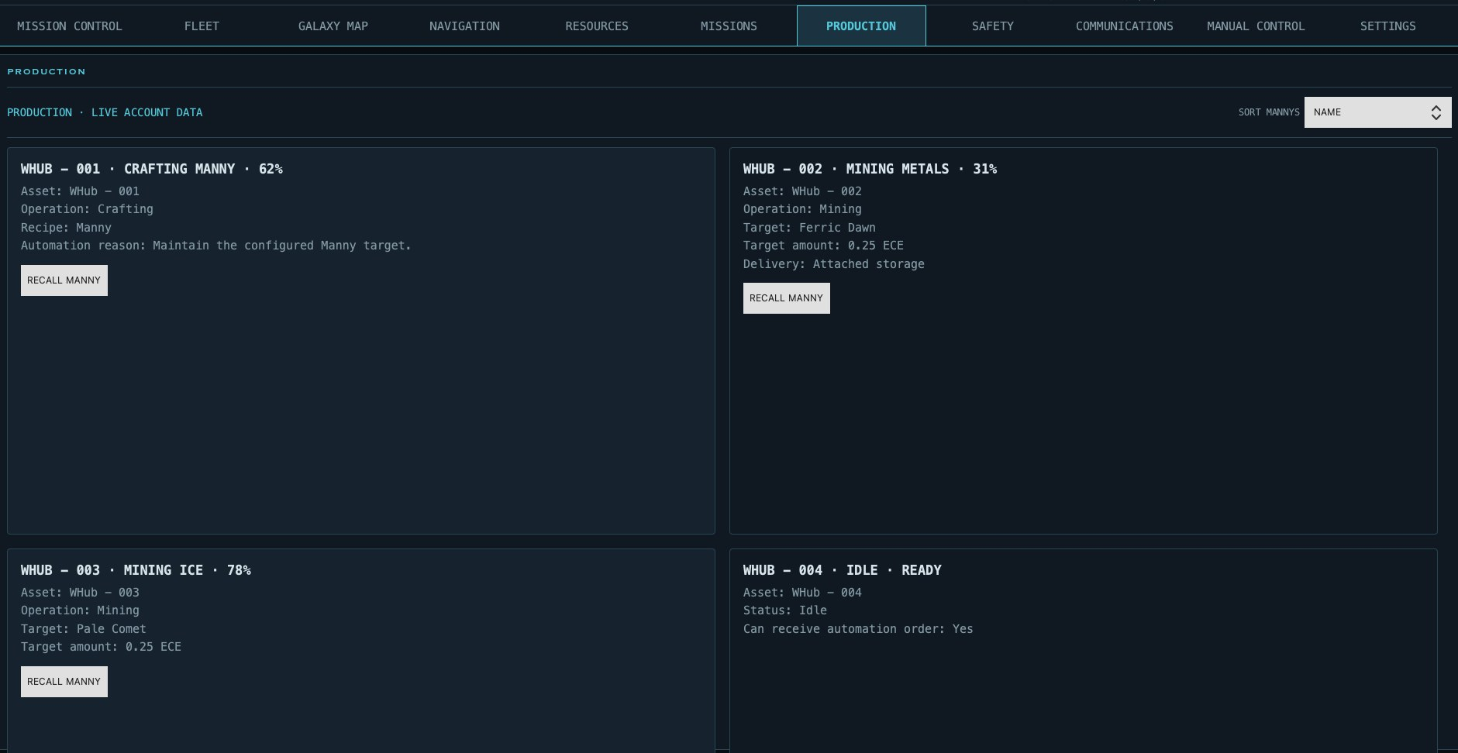
Figure 8-1. Live Manny production, crafting, mining, countdowns, and recall controls.

9. Safety
Safety centralizes operational findings. Readiness distinguishes advisory notices from warning and critical conditions; a busy fleet can remain healthy even when no Manny is currently available.
- Travel risk considers distance, fuel, return options, and destination refueling.
- Cargo warnings identify detachment risk at five or more containers.
- Resource depletion warns before local mining sources are exhausted.
- Emergency Stop prevents automation until explicitly cleared.
EVIDENCE Some hazards are observed game behavior rather than formal API guarantees. The application identifies uncertainty and keeps configurable thresholds where appropriate.

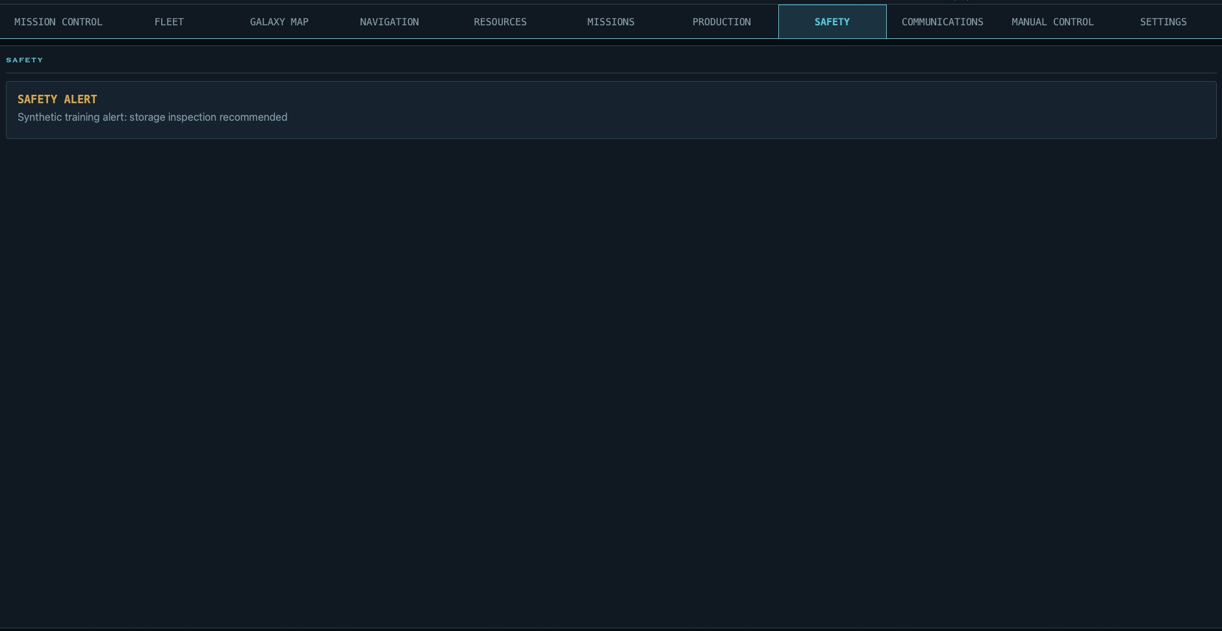
Figure 9-1. Safety groups current findings, severity, and available recovery actions.

10. Communications

Messaging
Messaging contains account communications and unread state exposed by the game API. Messages remain separate from operational alerts and safety findings.

Logbook
Logbook pages belong to the focused probe. Create, edit, and delete operator notes independently of automatic reporting. Routine refreshes are not logged as events.

Optional Automatic Reports
Automatic daily role reports and major-discovery reports are an opt-in feature controlled by the Auto-Log Daily Role Reports and Major Discoveries checkbox in the Logbook sub-tab. The checkbox is off by default and is stored as an account-wide preference rather than a separate setting for each probe.
- When enabled, the first eligible refresh after 17:00 local time creates one due role-specific report for each owned probe.
- A report summarizes the previous reporting window using retained Skunkworks telemetry and commands accepted by the game; unavailable activity is not inferred.
- Major-discovery pages are also created only while this checkbox is enabled.
- Unchecking the option prevents future automatic reports but does not delete pages already created.
- Manual logbook pages remain available whether automatic reporting is enabled or disabled.
PRIVACY Automatic reports are written into the game's probe logbooks. Review their contents before sharing screenshots or diagnostic material because reports can contain probe names, sectors, inventory activity, and operational history.

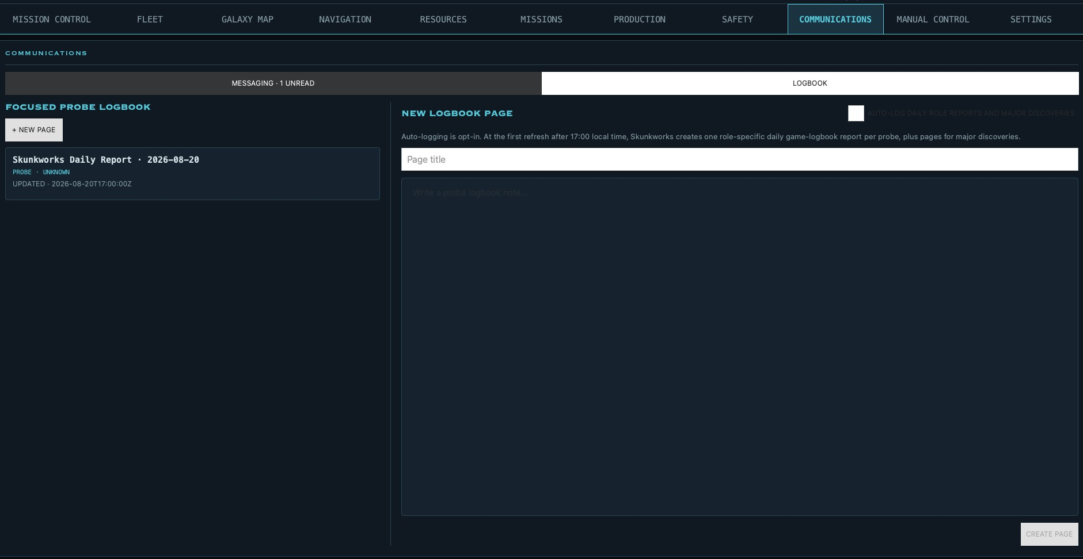
Figure 10-1. Messaging/Logbook sub-tabs, page list, editor, and automatic daily reports.

11. Manual Control
Manual Control contains one-time operator orders. Every command remains subject to live validation, confirmation, reservations, and Manny availability.
REVIEW BEFORE SENDING Buttons labeled Review open a confirmation summary. Disabled controls indicate that a required Manny, item, object, blueprint, destination, or API capability is unavailable.

Production and Assembly
This sub-tab starts a single recipe or assembles one probe without creating an automation target. Manual Build Order needs a recipe and a compatible idle fabricator. Manual Probe Assembly needs a model, an assembly Manny, two distinct empty containers, and every listed model component.
- Queue Build submits one finished item using the game's exposed recipe.
- The crafting reference expands ordinary recipes into the total raw resources for one finished item.
- Probe Assembly Requirements lists the physical crafted components consumed by each probe model.
- Review Probe Assembly rechecks the selected containers, assembly Manny, and components before confirmation.
- The assembly Manny is installed aboard the completed probe and is no longer available on the source probe.
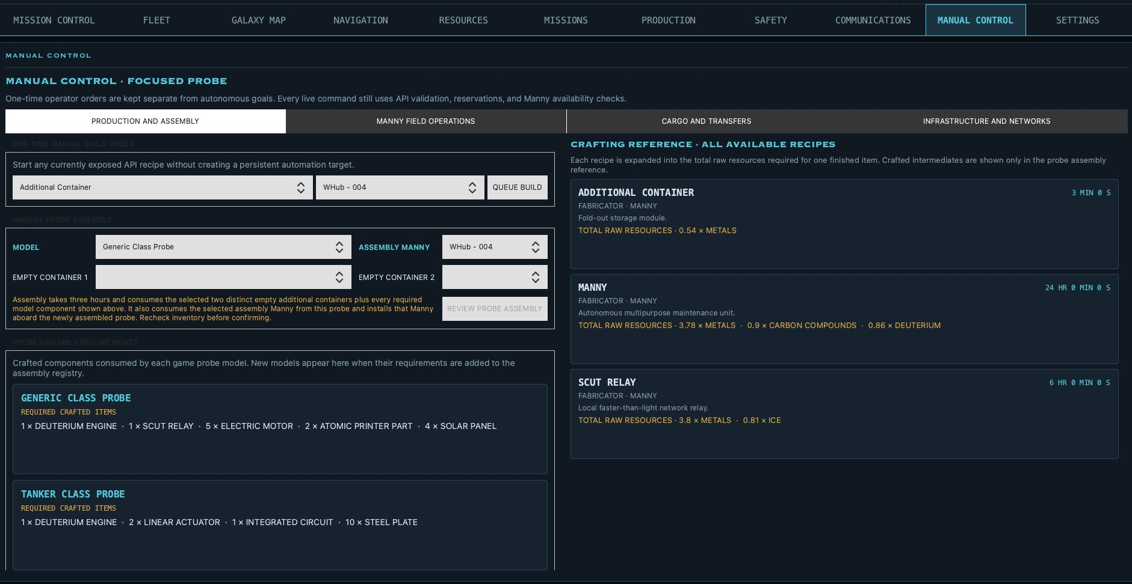
Figure 11-1. Production and Assembly inputs, model requirements, and recipe reference.

Manny Field Operations
This sub-tab operates directly on the focused probe and its same-sector neighbors.
- Manual Probe Repair selects an idle Manny and a repair percentage; the order remains unavailable when no Manny can act.
- Manual Probe Upgrade lists only unlocked, unfinished upgrades supported by the current owner and probe.
- Manual Mining Order selects the Manny, mineable object, resource, ECE amount, and delivery destination. The amount is capped by Max per Manny Mining Order.
- Same-Sector Probe Transfers can send deuterium or a Manny to an arrived target probe.
- Transferring a busy Manny cancels that Manny's current task; moving probes are excluded until both probes arrive.
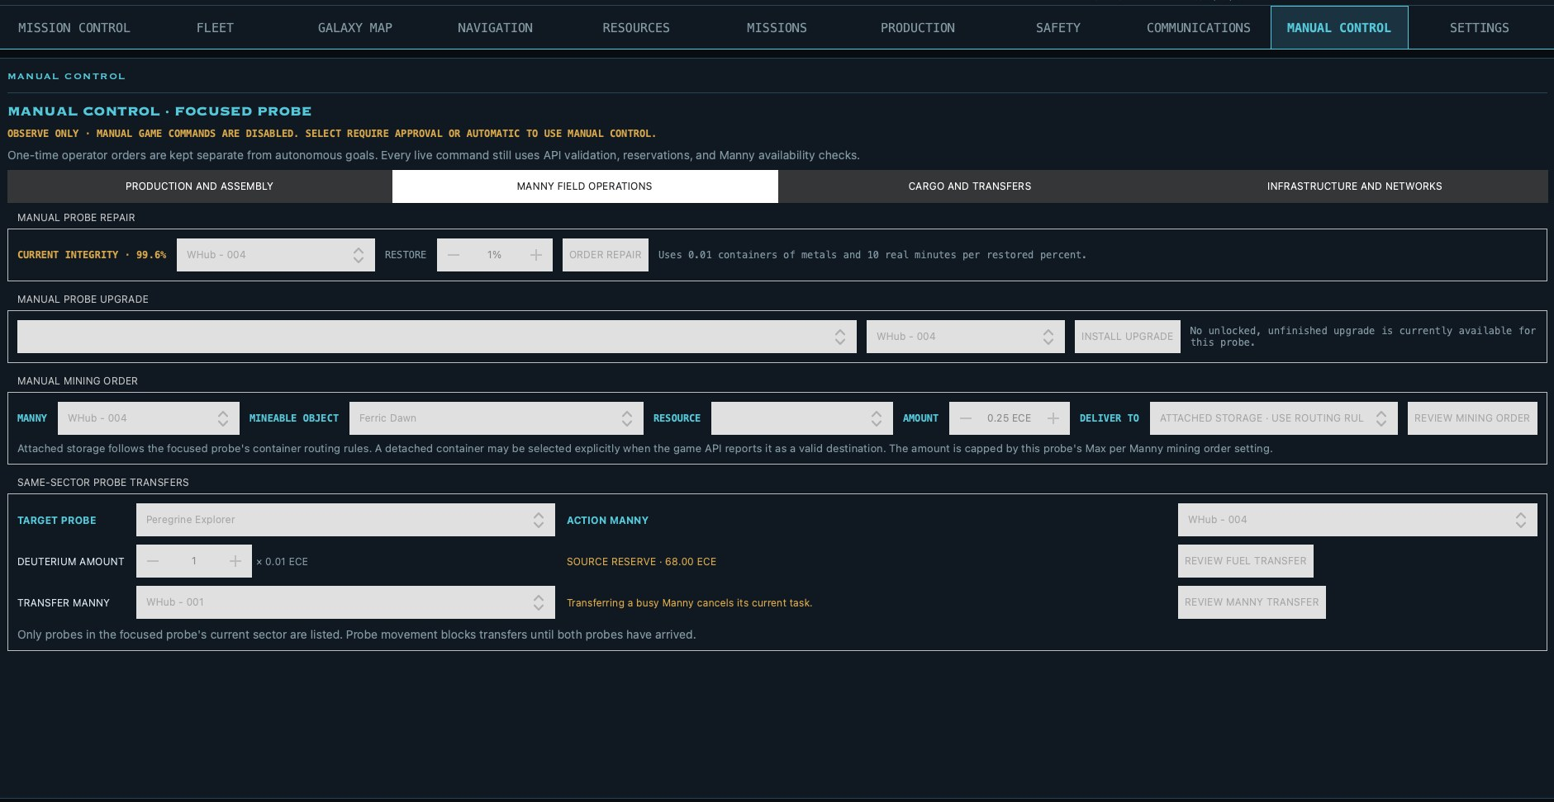
Figure 11-2. Repair, upgrade, mining, deuterium transfer, and Manny reassignment.

Cargo and Transfers
Inventory and Container Control moves or releases cargo from the focused probe. Every transfer requires an available onboard Manny and confirmation.
- Move Stock selects resource or item, amount, source container, and destination container.
- Manual Jettison creates a recoverable sector object; another same-sector probe can recover it for an item handoff.
- SCUT Relay Deployment uses a stored relay, an idle Manny, an Integrated Circuit for activation, and a SCUT Transit Beacon for transit support.
- Inspect Object records object detail without starting mining; Bookmark Target installs a named reference.
- Waiting Cargo emergency re-dock permanently discards resource cargo but returns recoverable objects to the sector.
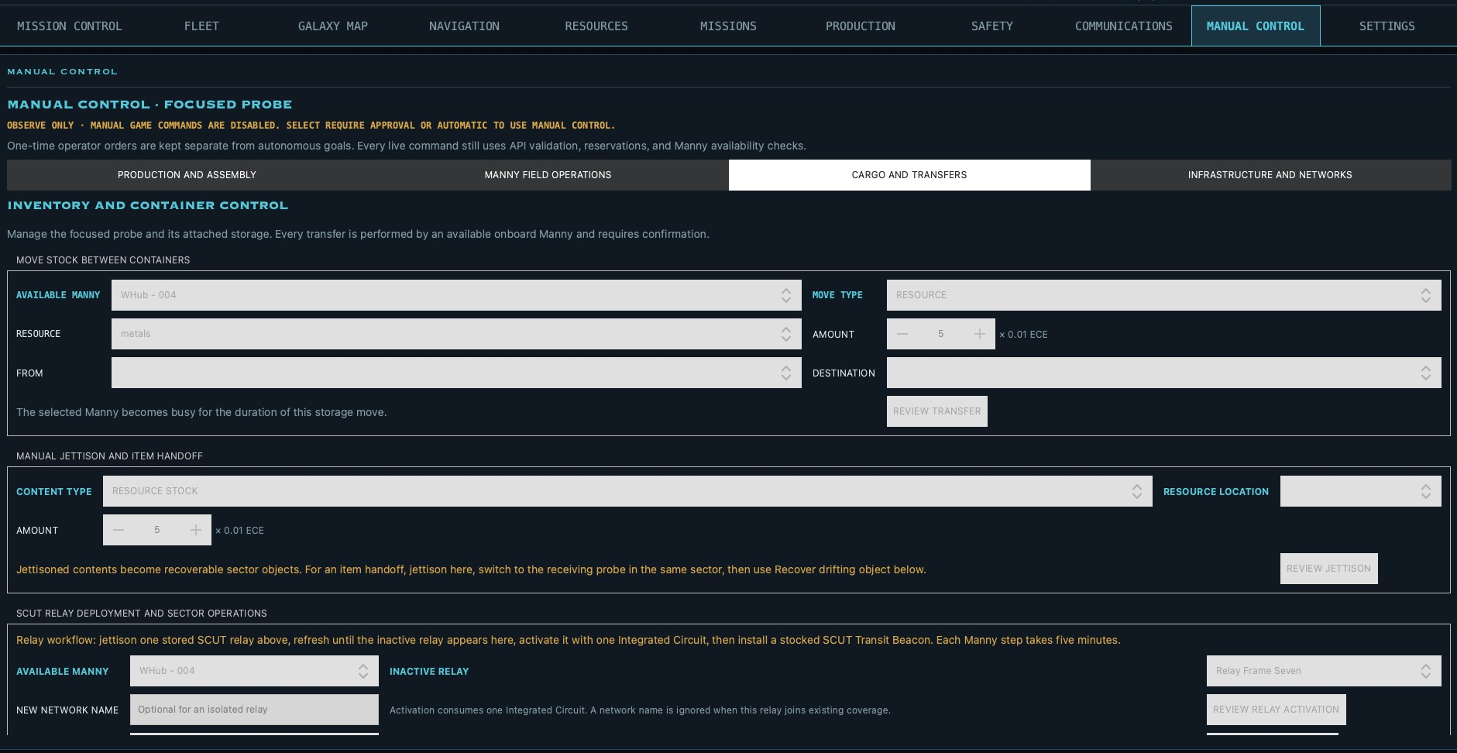
Figure 11-3. Stock movement, jettison, relay deployment, inspection, and waiting cargo.

Container Deployment, Recovery, and Routing
Deploy one attached container to space, an asteroid, a planet, or another supported destination, then recover a visible drifting object with a Manny. Routing rules control where newly received content is placed.
- Choose Available Manny, Attached Container, and Destination before Review Deployment.
- Choose Recovery Manny and Drifting Object before Review Recovery.
- Rename gives each storage location an operational label.
- Preferred Contents reserves normal routing for one resource type or allows any contents.
- Reassign Craft Reservations moves active output reservations only when all reserved output fits elsewhere; otherwise nothing changes.
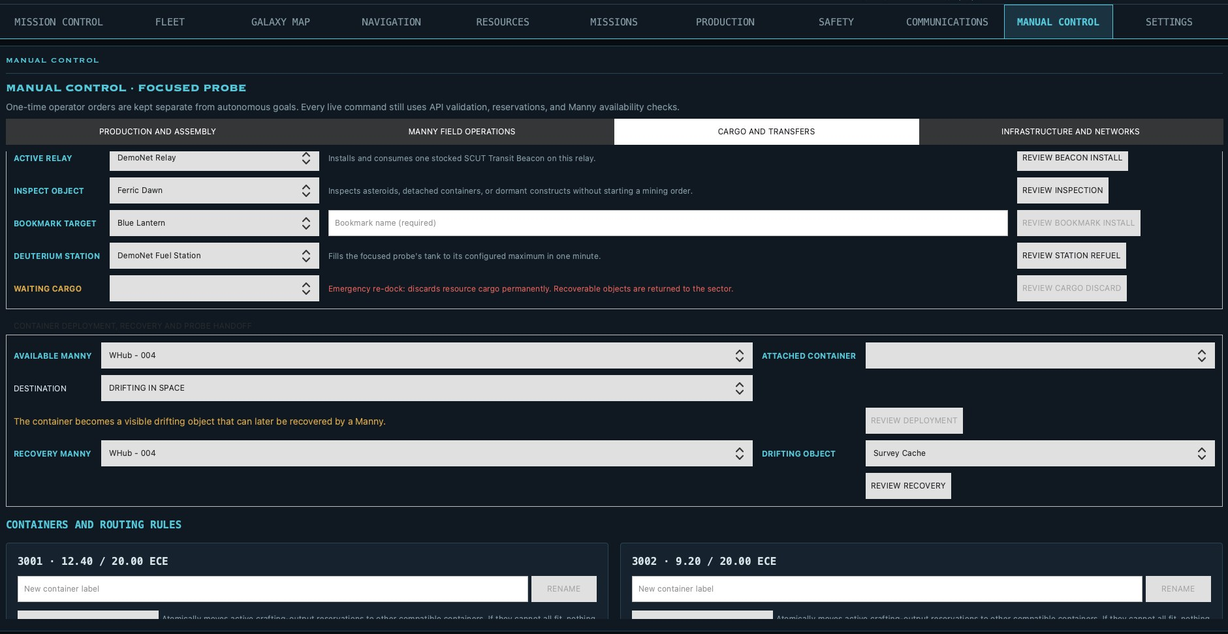
Figure 11-4. Container deployment, recovery, naming, routing, and reservation reassignment.

Infrastructure and Networks
Infrastructure controls create and use persistent network objects. The relay workflow is sequential: jettison a stored SCUT Relay, refresh until it appears as inactive, activate it with an Integrated Circuit, then install a stocked SCUT Transit Beacon.
- Each Manny relay step takes five minutes.
- Inspect Object and Bookmark Target work on visible sector objects.
- Station Refuel requires a visible deuterium station.
- Share Improvement Blueprint requires a known blueprint, recipient probe, and shared coverage from the selected active SCUT network.
- Repeating a completed blueprint share is idempotent and does not duplicate the recipient alert.
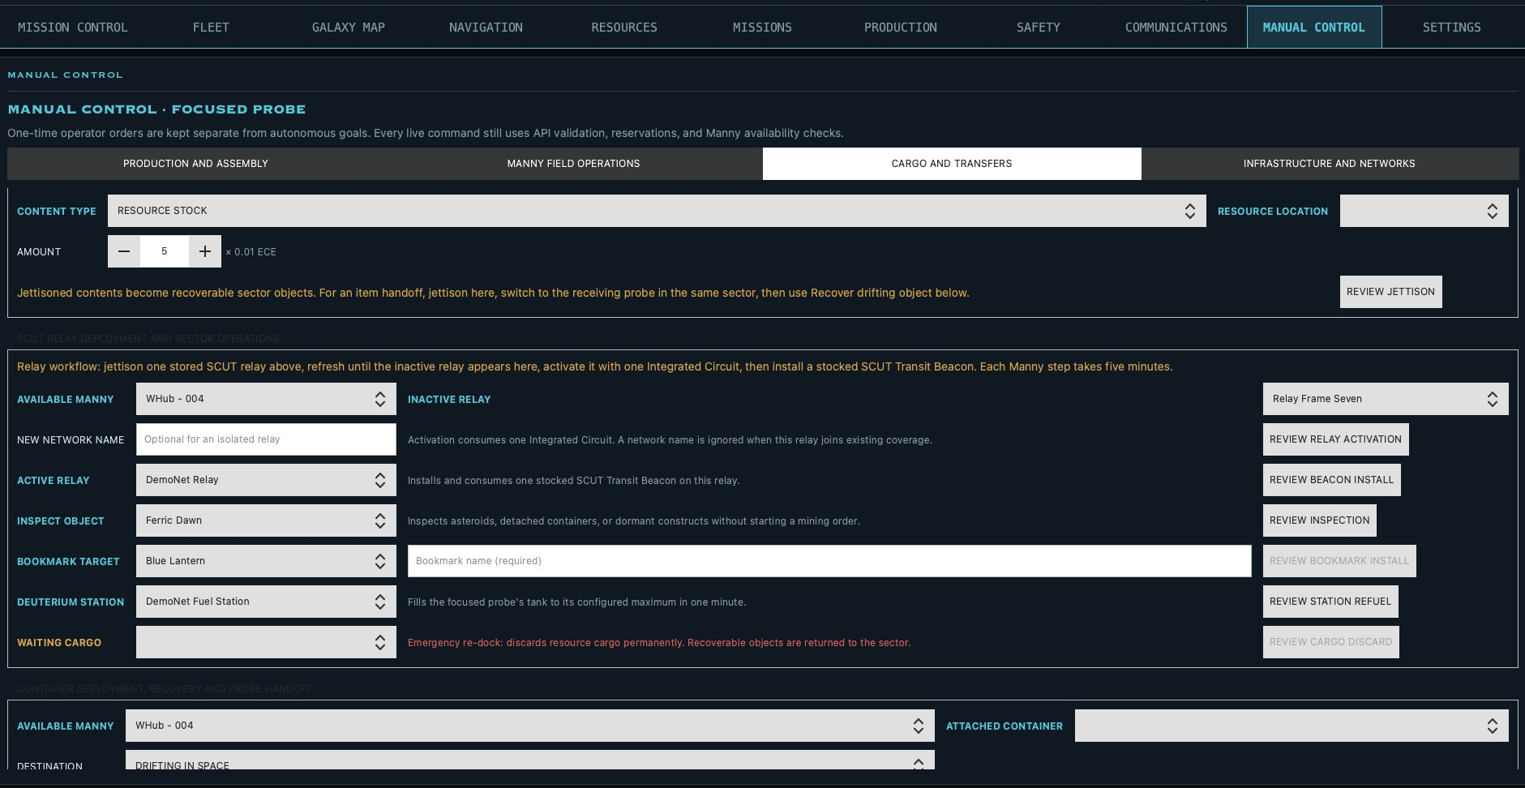
Figure 11-5. Relay workflow, inspection, bookmarks, refueling, waiting cargo, and blueprint sharing.

Motorized Asteroid Operations
These are direct, high-impact asteroid commands. Controls stay locked until the required owner capability or blueprint is known.
- Install Asteroid Propulsion selects an idle Manny and asteroid; the game immediately consumes the listed engine, steel, and deuterium inputs.
- Refuel Motorized Asteroid selects the motorized asteroid and a valid source.
- Launch selects the asteroid, movement mode, and a directly neighboring FCC. Transfer advances one sector per 24 hours and cannot be cancelled through the current API.
- Sculpt Anatiform Asteroid requires the corresponding blueprint and performs the documented two-day operation.
- Detected Active Trajectories lists movement currently visible in the detailed sector scan.
IRREVERSIBLE REVIEW Read the destination and resource summary carefully before confirming installation or launch.

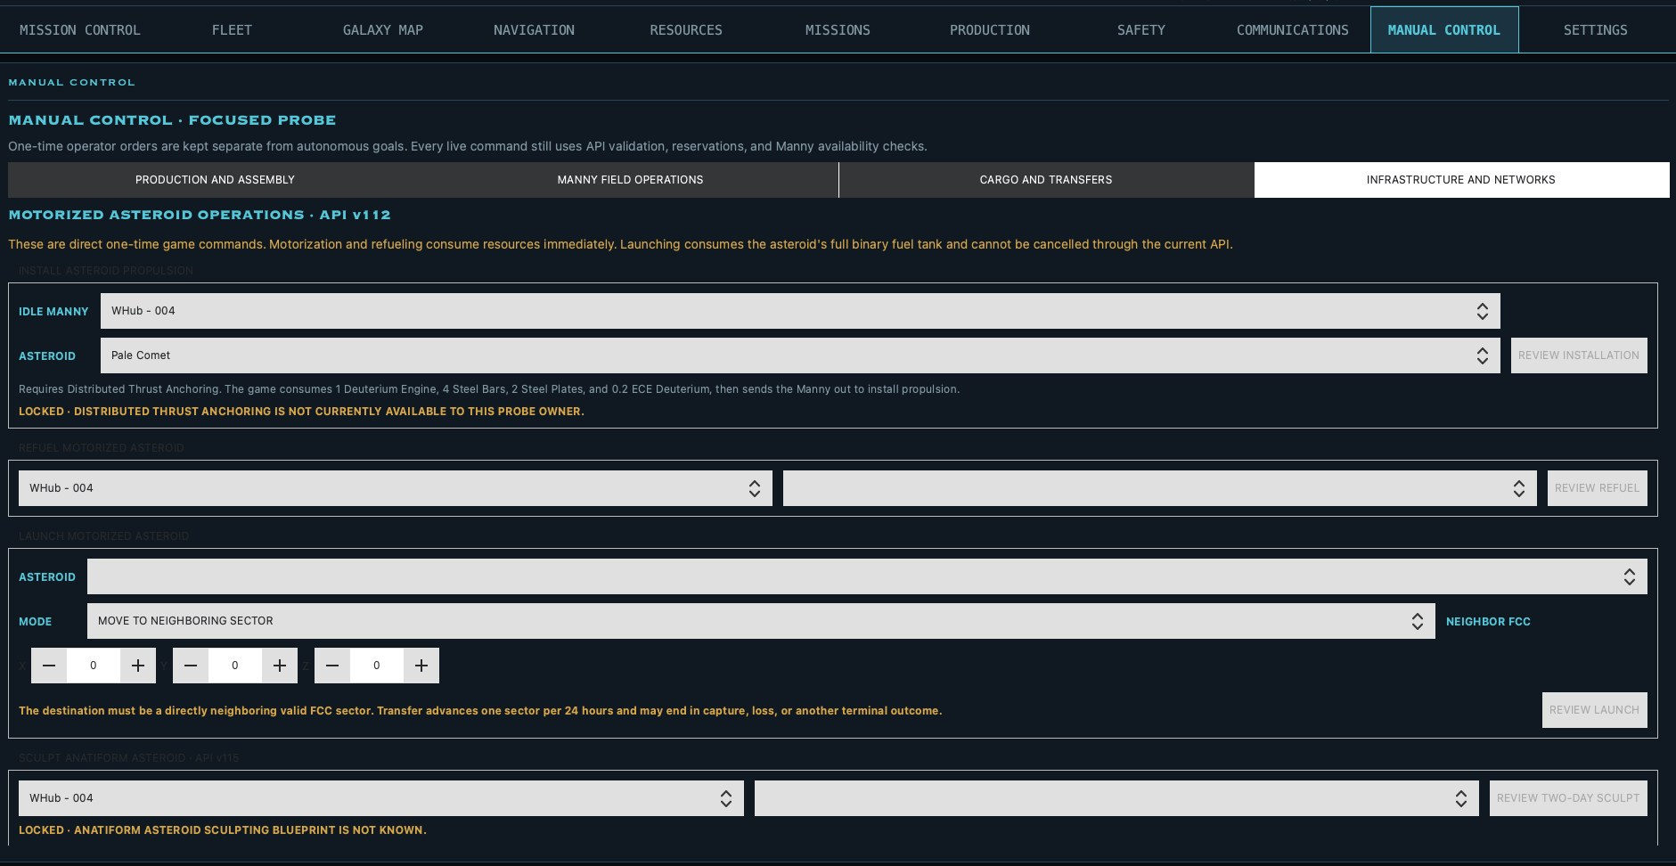
Figure 11-6. Propulsion installation, refueling, launch, sculpting, locks, and trajectories.

12. Settings

General Automation
General Automation owns the focused probe's account connection, audio, execution authority, desired state, safety floors, planner status, and diagnostics.

Account, Audio, and Execution Policy
- The API key is stored in the operating-system credential vault and is not written into settings or logs.
- Test Connection verifies access; Remove deletes the saved credential.
- Audio separately controls background music, interface effects, hover sounds, and volumes.
- Execution Mode selects Observe Only, Approval, or Automatic.
- Allow Skunkworks to Send Game Orders is the master live-order permission.
- Command Allowlist limits crafting/assembly, mining, travel, deuterium transfer, and repair families.
- Max Orders per 1-Minute Cycle limits the number of commands sent in one automatic cycle.
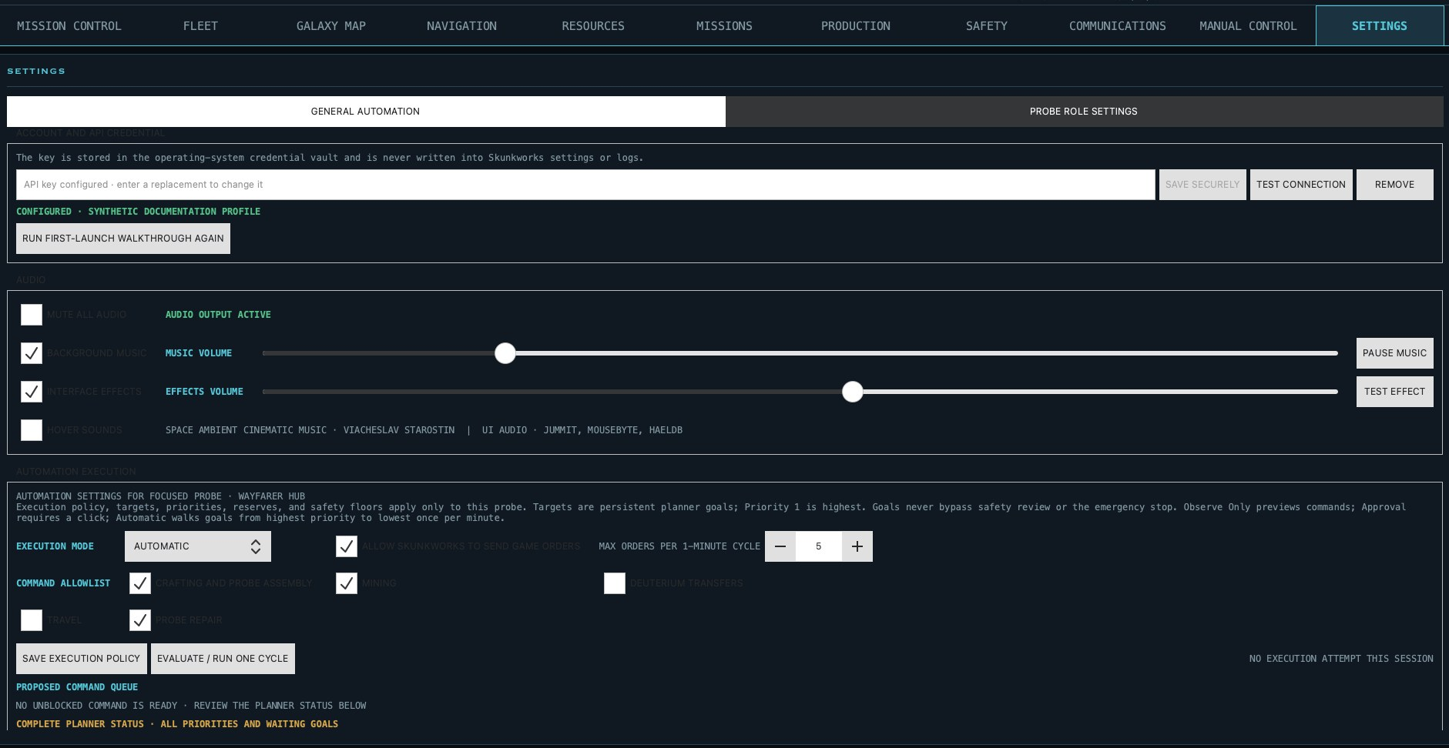
Figure 12-1. Credentials, audio, execution authority, allowlist, cycle limit, and command queue.

Targets and Priorities
Fleet Assembly Targets and Production Targets define persistent desired quantities. A target counts stored output plus output already active or allocated.
- Desired Quantity is the completed quantity to maintain, not a one-time batch size.
- Priority 1 is highest; 10 is lowest.
- Higher-priority goals claim current raw resources and required stored components before lower-priority goals.
- Equal-priority goals use stable target order and are reconsidered after each planning cycle.
- Ordinary crafts use the game's direct recipe and reserve only the next unit's raw inputs; probe assembly reserves its required physical components.
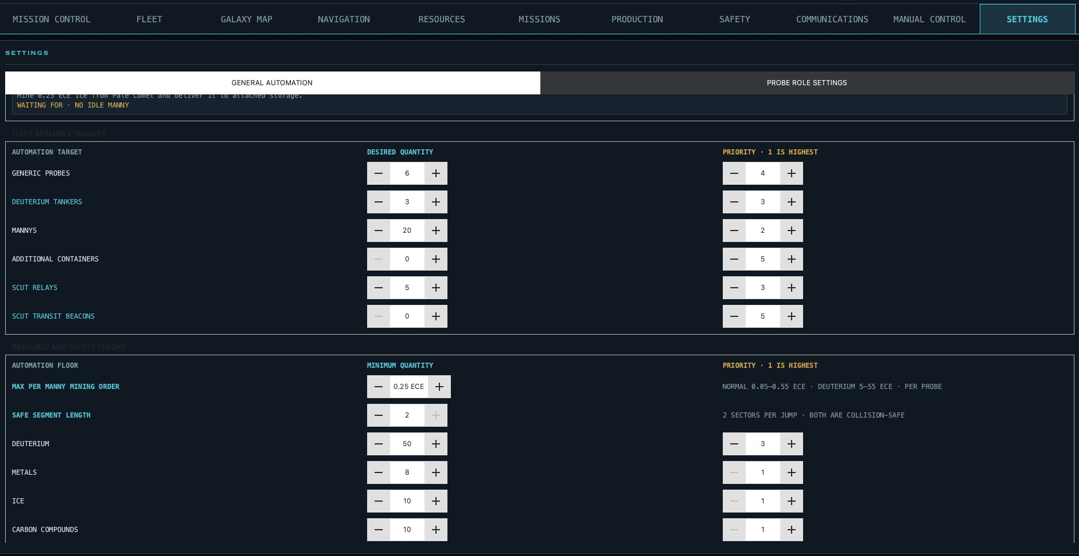
Figure 12-2. Persistent fleet and production targets with independent priorities.

Resource and Safety Floors
- Max per Manny Mining Order caps one continuous mining campaign from 0.05–0.55 ECE.
- Safe Segment Length limits how many collision-safe sectors one planned travel segment may span.
- Deuterium, Metals, Ice, and Carbon Compounds define minimum onboard reserves and independent priorities.
- Fuel Floor protects the percentage required before normal work or departure.
- Min Free Capacity keeps storage available for incoming work.
- Auto Repair At / Below and Repair Target define when automatic repair begins and where it stops.
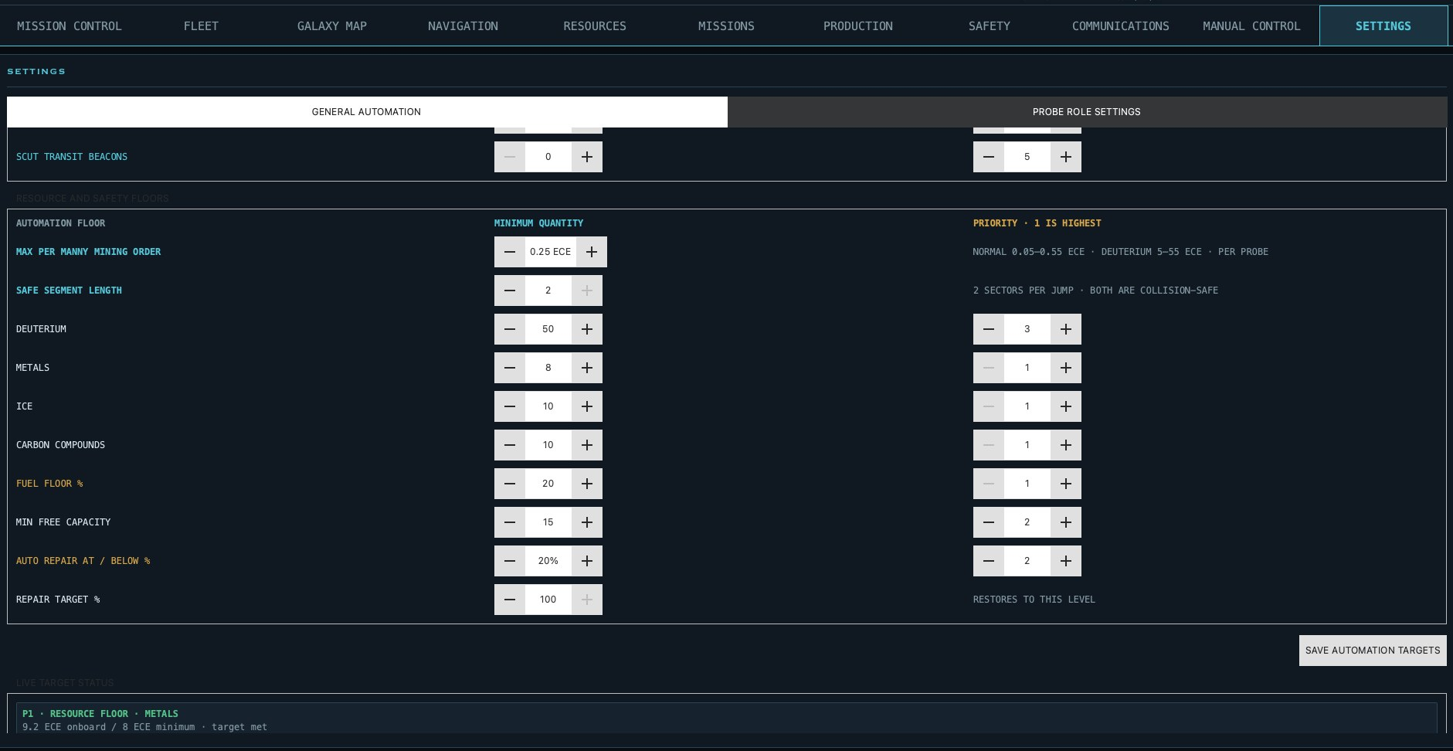
Figure 12-3. Mining size, travel, resource, fuel, capacity, and repair floors.

Live Target Status and Planner
Live Target Status is the compact desired-state summary. Each row shows current or active quantity, target, remaining work, and priority color. Refresh Diagnostics identifies the slowest refresh stages.
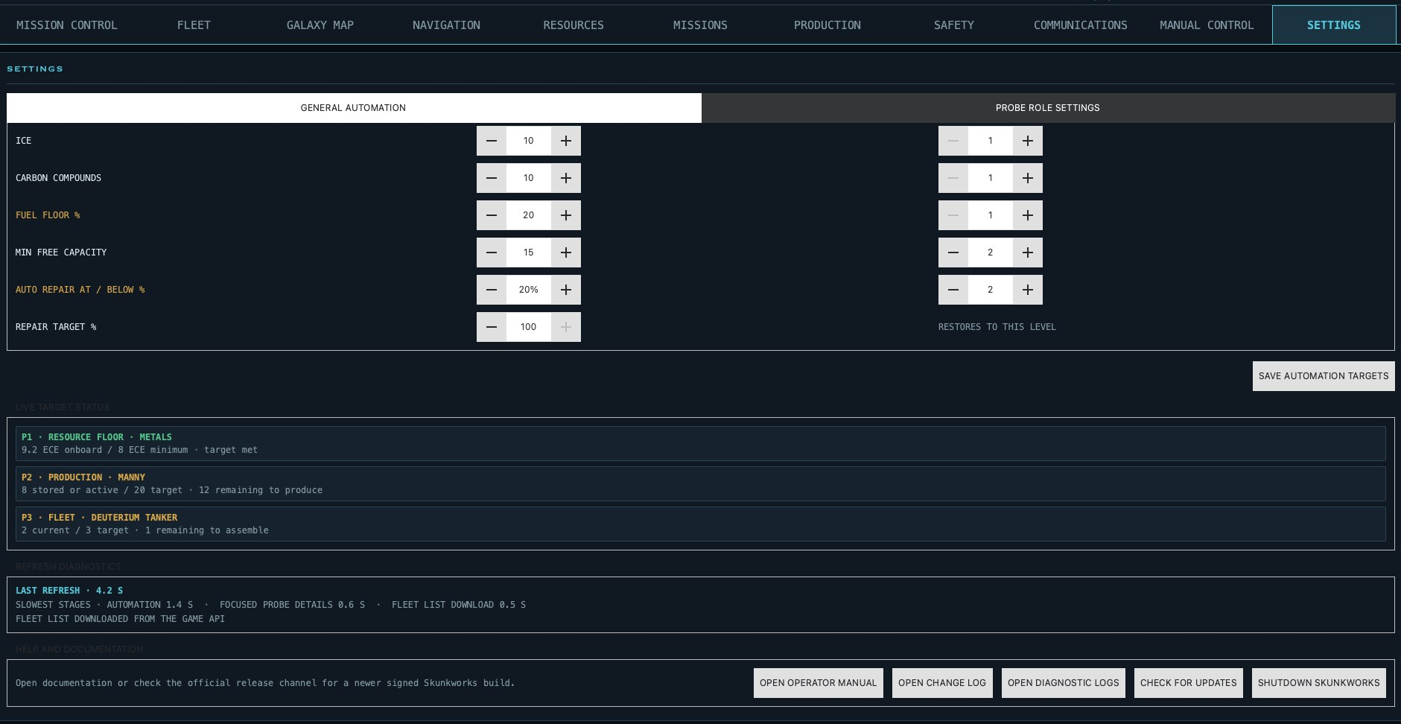
Figure 12-4. Live Target Status, remaining work, and refresh diagnostics.

Complete Planner Status
When no command is ready, the planner still lists every goal. Read each row from the intended output through its next-unit requirements and Waiting For reasons.
- Missing Resources shows the exact uncovered raw quantity after onboard and inbound stock.
- Fabricator Unavailable means the required worker type is occupied or absent.
- No Idle Manny prevents work that specifically requires a Manny.
- Fleet Role Assignment Not Automated identifies a role dependency that must be configured by the operator.
- Higher-priority reservations remain visible so lower-priority work is not mistaken for forgotten work.
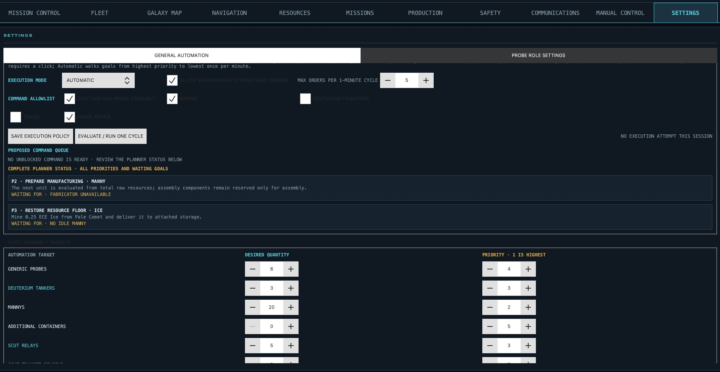
Figure 12-5. Planner requirements, allocations, uncovered resources, and named blockers.

Probe Role Settings
Probe roles are configured together in this sub-tab. The default probe assigns one role to each owned probe. Selecting a role-bearing probe then exposes that role's own controls; roles without settings clearly say that no probe-specific controls are available yet.

Role Assignment
- Hub marks the main coordination probe.
- Explorer supports travel and scanning workflows.
- Transport carries a selected resource between configured endpoints.
- Deuterium Tanker carries fuel using an absolute tank target.
- Deuterium Reserve monitors and replenishes a selected downstream probe or tanker.
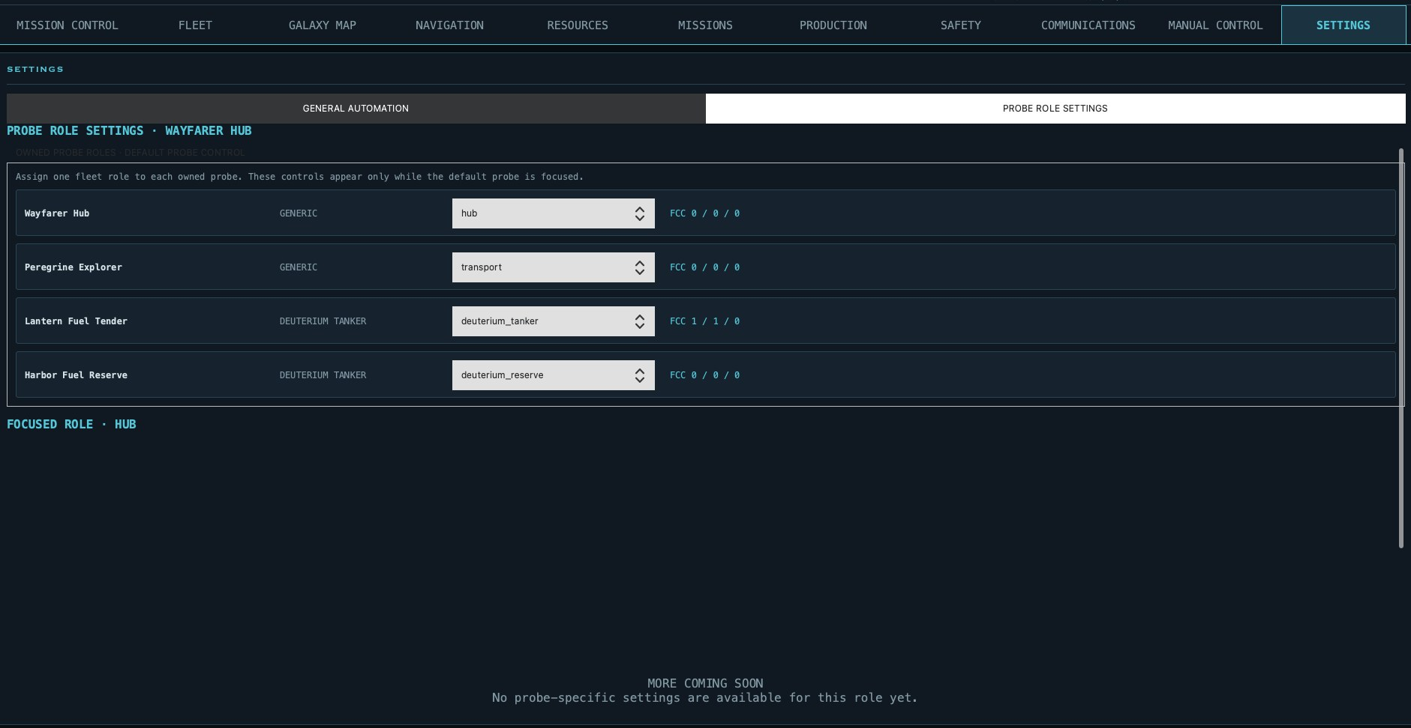
Figure 12-6. Fleet-wide role assignment from the default probe.

Deuterium Reserve
Select Monitor and Refill Probe to identify the next link in the reserve chain. Protected Source Reserve is the ECE the reserve tanker must retain before it can forward fuel. Multiple reserve tankers can be chained by selecting another tanker as the monitored consumer.
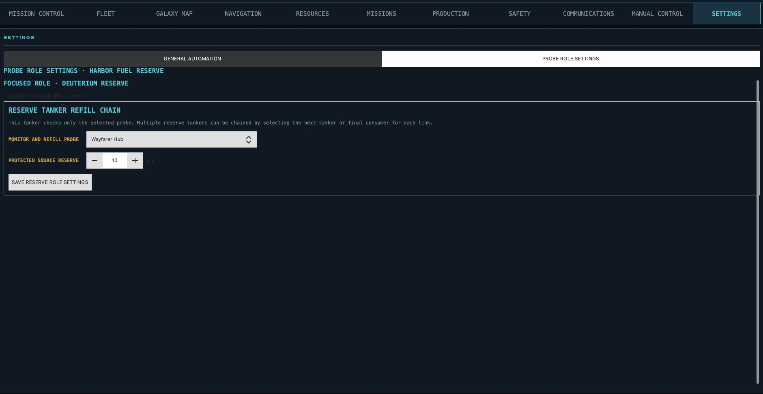
Figure 12-7. Reserve-chain consumer and protected source reserve.

Transport and Deuterium Tanker
Both recurring roles use Loading Sector, Unloading Sector, Return Point, source/destination probes, repetition, protected deuterium, contingency hops, and an optional verified refuel stop.
- Transport selects a resource, loads until a cargo percentage, and unloads until a percentage remains.
- Deuterium Tanker always carries deuterium and loads the tank to an absolute ECE target.
- Repeat Until Paused makes the saved operation recurring.
- Route Depends on Refueling requires the selected intermediate FCC and minimum source quantity to be verified.
- Review validates the current route; Pause Route stops future departures without deleting the saved plan.
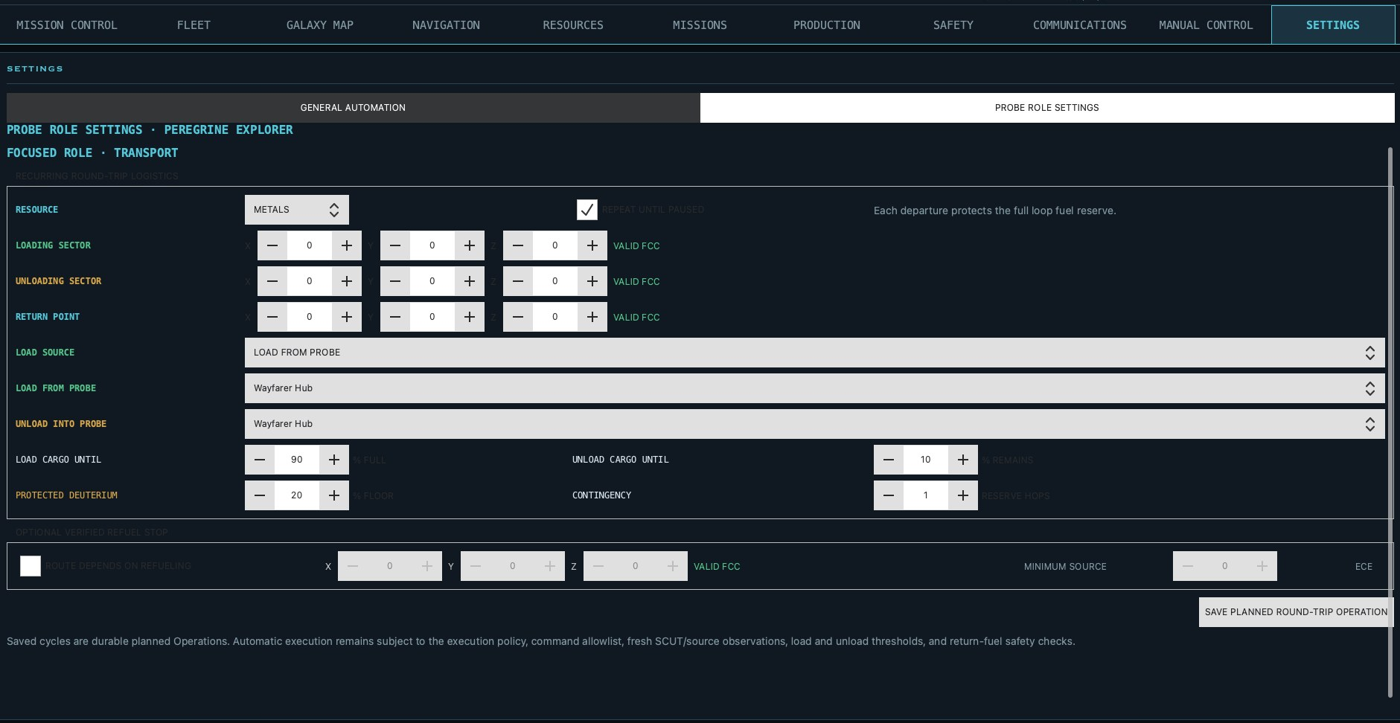
Figure 12-8. General Transport round-trip configuration.

Deuterium Tanker
Tanker mode replaces percentage cargo loading with Load Tank To ECE while preserving the protected fuel floor and contingency reserve for the complete loop.
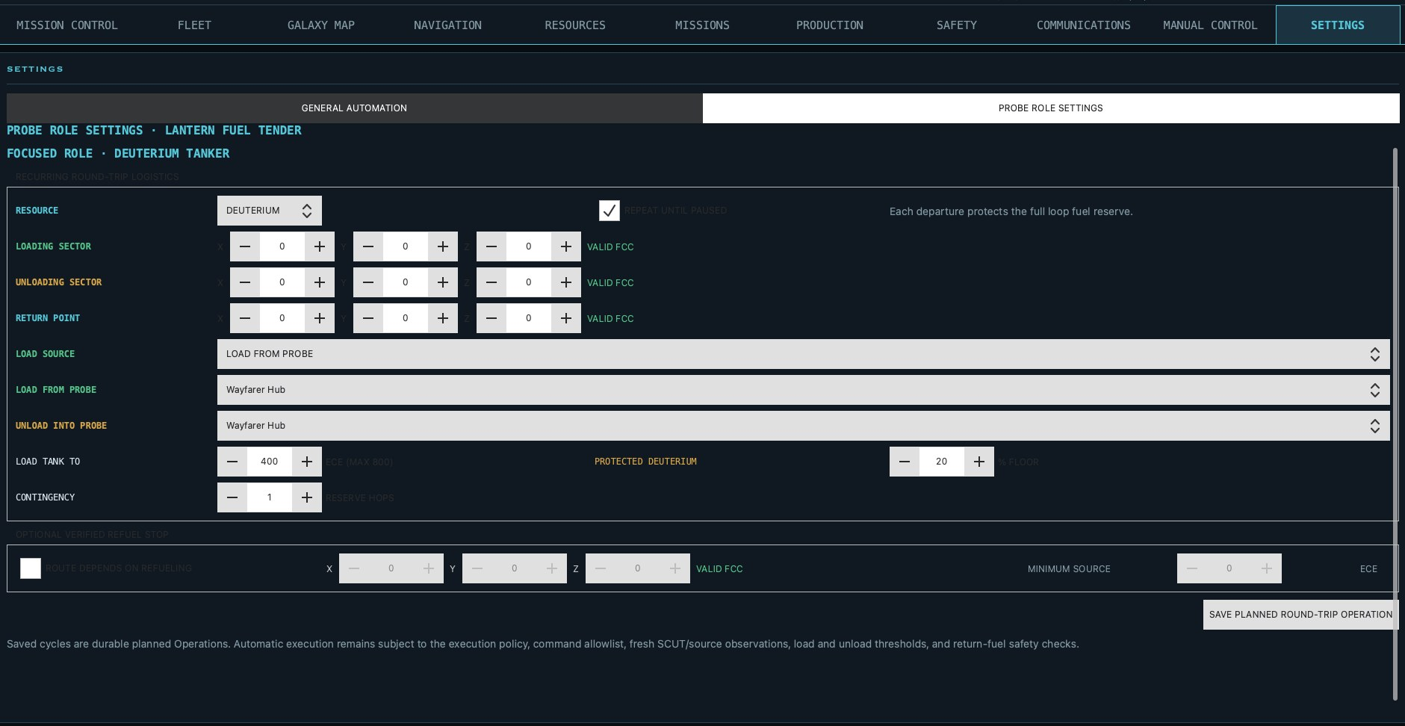
Figure 12-9. Deuterium Tanker absolute fuel-load configuration.

13. Troubleshooting and Glossary
Symptom | Check | Action
Wrong sector after probe selection | Focused Probe and FCC after refresh | Wait for the authoritative snapshot before acting.
No automation command | Planner blockers, inventory, allowlist, safety | Read Complete Planner Status and resolve the named prerequisite.
Idle Manny receives no work | Queue, raw resources, fabricator, reservations | Confirm a command is unblocked and the required worker type is available.
Refresh is slow | Refresh Diagnostics slowest stages | Capture diagnostic logs; galaxy refreshes are expected to be the heaviest.
Map lacks detail | Knowledge level and last scan | Scan the sector or its neighbors.

Glossary
ECE. Resource and capacity quantity unit.
FCC. Three-dimensional sector coordinates.
Manny. Autonomous construction and mining unit.
SCUT relay. Communication relay in a discovered network.
Desired state. The quantities and priorities automation maintains.
Focused probe. The probe supplying the current workspace context.

MANNY LIMITED INTERSTELLAR WARRANTY
SERVICE JOB FLYER / REDEMPTION FORM MW-3000-ECE
Submit to the nearest imaginary Skunkworks Warranty Department. Processing: three to five business orbits, excluding relativistic delays, black holes, and lunch.
CLAIMANT AND UNIT IDENTIFICATION  Operator / probe owner: __________________________________  Probe name: ______________________________________________  Manny designation: ________________________________________  Serial / task ID: __________________________________________  ECE mined since last imaginary oil change: _________________  Current sector (FCC): ________ / ________ / ________  SERVICE REQUEST - CHECK ALL THAT APPLY  [ ] Sympathetic nod after avoidable fuel-floor warning  [ ] 3,000-ECE oil change (oil port location unknown)  [ ] Cargo-detachment logistics counseling  [ ] Sensor head points at things judgmentally  [ ] Arm makes noise best described as 'expensive'  [ ] Return-trip definition requires arbitration  [ ] Other: ___________________________________________ | 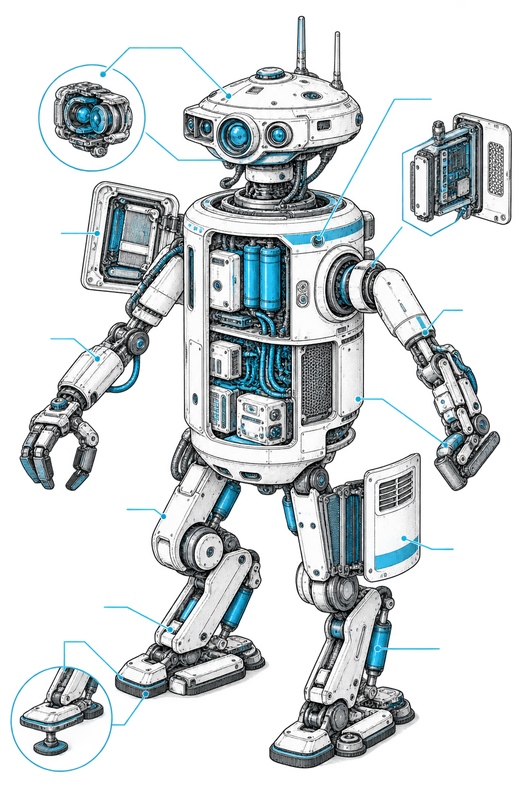  MANNY FIELD-INSPECTION DIAGRAM  A. Sensor head - sees warning; cannot make operator read it  B. Utility arm - rated for tools, cargo, and expressive shrugging  C. Service bay - oil port still not found  D. Mobility assembly - warranty void where gravity disagrees

Description of alleged defect
________________________________________________________________________________
________________________________________________________________________________

Warranty adjuster checklist
[ ] Fuel floor reviewed—or claimant has prepared a convincing story.
[ ] Emergency Stop treated as a control, not decorative lighting.
[ ] Five-container detachment recorded as an unscheduled logistics exercise.
[ ] No black-hole travel affecting the probe or the definition of 'return trip.'
ACTUAL TERMS Skunkworks is an independent community tool. The game server remains authoritative, and no joke on this page overrides safety warnings, the software license, or game rules.
Operator signature: __________________________ Date / local orbit: __________________

