Alex Ziegenhorn

Design Document

**Class Diagram/Text Description**

***Server Program***

*Functions:*

* ReceiveRequest()

Listens for a request for a specific filename, checks to make sure it is a valid filename, sends a response back, and prints detailed info on what was received.

* SplitFile()

Retrieve file from the local data storage, and break it into suitable segments.

* SendSegment()

After the requested file has been broken up into suitable segments, we initiate the transfer of specified file. Also checks for packet loss using Alternating Bit and Selective Repeat protocols.

***Client Program***

*Functions:*

* SendFileRequest()

Sends request for file with specified filename, prints detailed info on what was sent.

* ReceiveSegment()

Listens for a segment to be sent over from the server, receives the data segment, prints detailed info on what was received. Also checks for packet loss using Alternating Bit and Selective Repeat protocols.

The following are diagrams (from the book) of how both the server and client programs are going to be carrying out Alternating Bit Protocol.

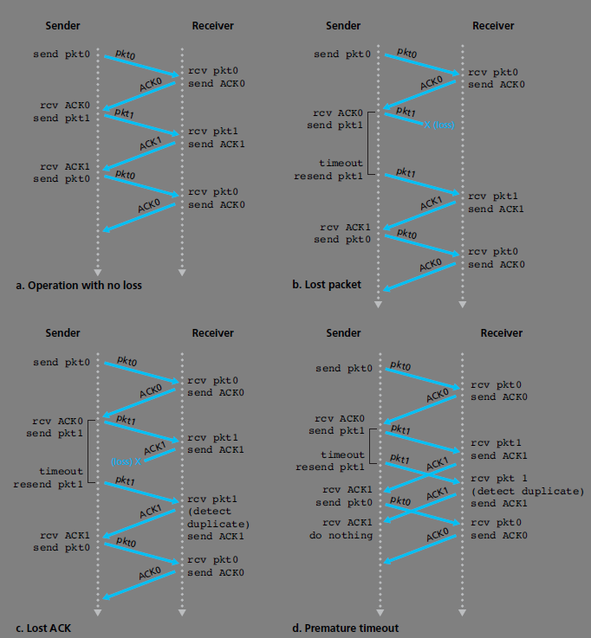

The following are diagrams (from the book) of how both the server and client programs are going to be carrying out Selective Repeat Protocol.

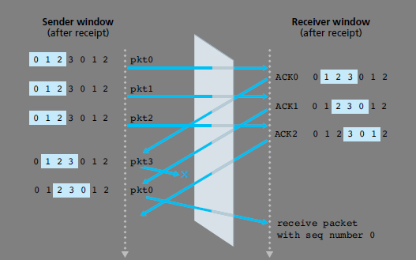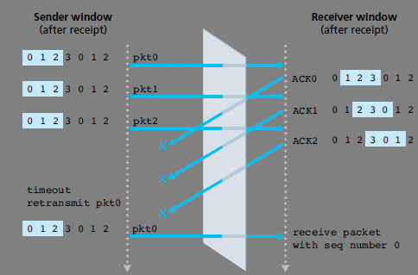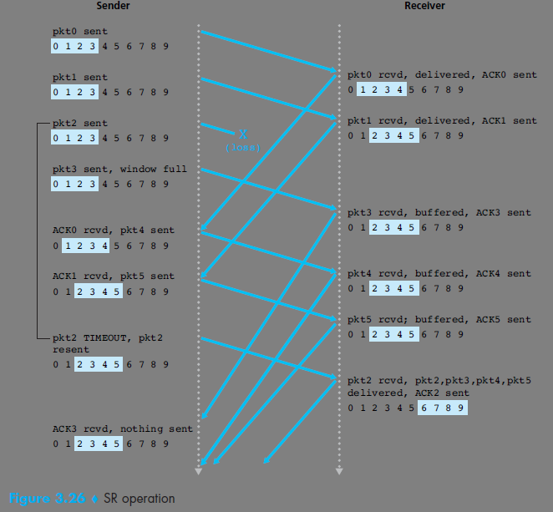

The following image is a rough State Diagram of how the two programs are going to be interacting.

