# Use Case Tables

## Sell Regular Ticket

|  |  |
| --- | --- |
| Requests to sell a regular ticket |  |
|  | Asks for qty of tickets to sell |
| Gives a number |  |
|  | Asks for the customer id of the buyer |
| Gives the id |  |
|  | Asks for the credit card number to use |
| Gives a credit card number |  |
|  | Asks for the date of the showing |
| Gives a date |  |
|  | If there are no conflicts sells the tickets to the customer and adds half the price of the ticket to the balance of the client who is performing the play. |
|  | Shows success message if successful. If not, show an error message and asks if they would like to try again. |
| If shown an error message and asked if the user wants to try again, the user answers yes or no. |  |
|  | If yes skip back to the step that asks for qty of tickets to sell |

## Sell Advance Ticket

|  |  |
| --- | --- |
| Requests to sell an advance ticket |  |
|  | Asks for qty of tickets to sell |
| Gives a number |  |
|  | Asks for the customer id of the buyer |
| Gives the id |  |
|  | Asks for the credit card number to use |
| Gives a credit card number |  |
|  | Asks for the date of the showing |
| Gives a date |  |
|  | If there are no conflicts sells the tickets to the customer and adds half the price of the ticket to the balance of the client who is performing the play. |
|  | Shows success message if successful. If not, show an error message and asks if they would like to try again. |
| If shown an error message and asked if the user wants to try again, the user answers yes or no. |  |
|  | If yes skip back to the step that asks for qty of tickets to sell |

## Sell Student Advance Ticket

|  |  |
| --- | --- |
| Requests to sell a student advance ticket |  |
|  | Asks for qty of tickets to sell |
| Gives a number |  |
|  | Asks for the customer id of the buyer |
| Gives the id |  |
|  | Asks for the credit card number to use |
| Gives a credit card number |  |
|  | Asks for the date of the showing |
| Gives a date |  |
|  | If there are no conflicts sells the tickets to the customer and adds half the price of the ticket to the balance of the client who is performing the play. |
|  | Shows success message if successful. If not, show an error message and asks if they would like to try again. |
| If shown an error message and asked if the user wants to try again, the user answers yes or no. |  |
|  | If yes skip back to the step that asks for qty of tickets to sell |

# Sequence Diagrams

## Sell Regular Ticket

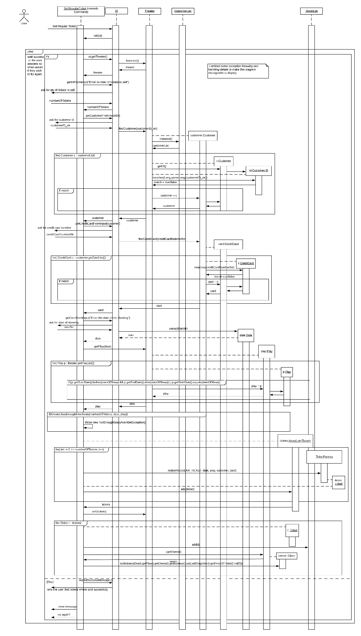

## Sell Advance Ticket

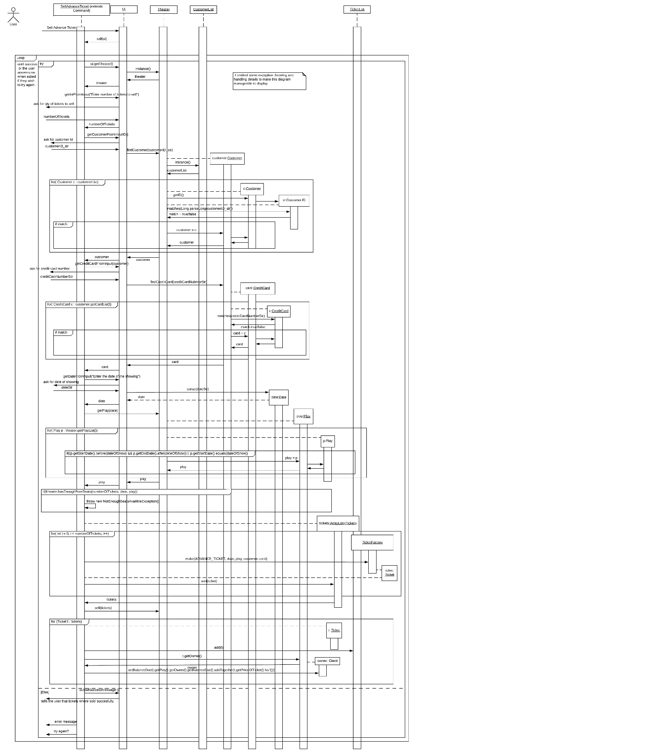

## Sell Student Advance Ticket

