**暹罗猫** Siamese cat

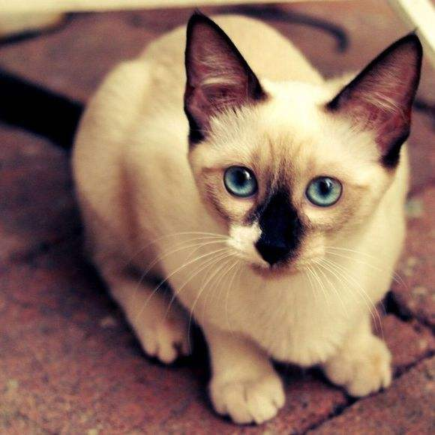

Siamese cat, also known as Thai cats, originating in Thailand, is a short-type. First kept in the Thai royal family and the monastery, once the outside world little-known palace "Mibao." Siamese cats are sleek, slender, well-proportioned limbs, torso, neck and tail. Siamese cat nature lively, clever, agile, elegant temperament, looks extraordinary. Siamese cats are currently the most popular purebred short hair cat representatives. Siamese cats are perhaps the most famous of all pedigrees. At the end of the 19th century, Siamese cats as a diplomatic gift were sent to Britain and the United States by the Royal Thai Parliament. Its upbringing has aroused public interest, and the number has been growing. Siamese cat, also known as West mother cat, Thai cat, is the world famous short-haired cat, short hair cat is the representative species.

Price: 1000-4000 yuan

Hair length: Short hair

Country of Origin: Thailand

Size: Medium

**波斯猫** Persian

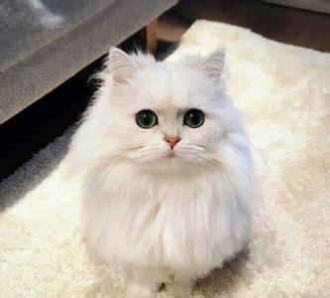

Persian, Persia is the ancient name of Iran. Persian cats are the most common and typical species. Persian cats are actually based on Afghan long-haired cats and Angolan long-haired cats from Turkey or Armenia, breeding in the UK for more than 100 years, breeding in 1860 The birth of a variety. Persian cat has a pleasant face, long and gorgeous coat, elegant manners, it is "the prince in the cat," "princess," said, and therefore worth. A purebred Persian cat up to thousands of dollars, the cat is one of the world's favorite cat. Persian cat in the aristocratic, gentle temperament, smart and agile, understanding, less moving and quiet, Jiaojiao Sophie soft, love spoiled.

Price: 5000-8000 yuan

Hair length: Long hair

Country of Origin: United Kingdom

Size: Medium

**[美国短毛猫](http://www.ichong123.com/maomao/mgdmm" \o "美国短毛猫)** American Shorthair

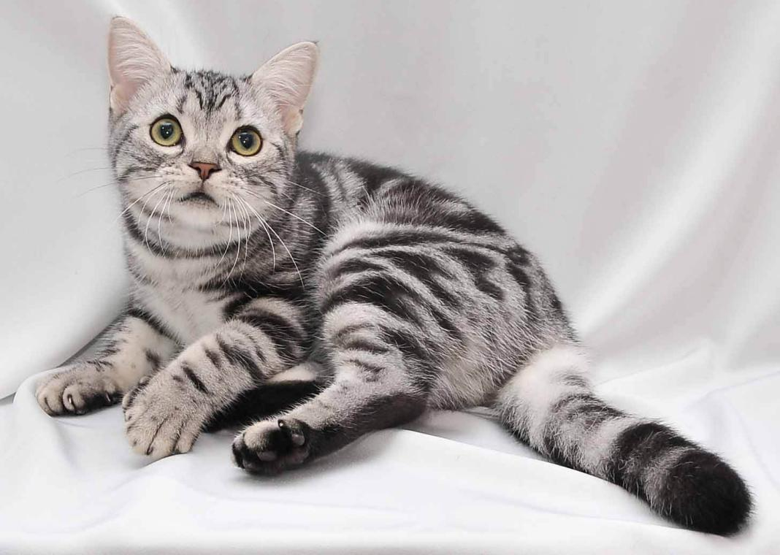

American Shorthair is a United States origin of a cat, the ancestors of the early immigrants to Europe to North America cat species, and the British Shorthair and European Shorthair. According to records, Mayflower number to carry a cat to help deratization. The breed of cats is collected in the streets of cats among the selected species, and imported varieties such as the British Shorthair, Burmese cats and Persian cat hybridization. American Shorthair is rare in Europe, but popular in Japan, in the United States is also more popular. American short-haired cat to physique, skeletal stout, muscular, intelligent nature, docile and well-known, is a short-haired cat in large-scale varieties. Coat thick, color up to more than 30 species, including silver stripes is particularly valuable species

Price: 2000-4000 yuan

Hair length: Short hair

Country of Origin: United States

Size: Medium

**布偶猫** Puppet cat

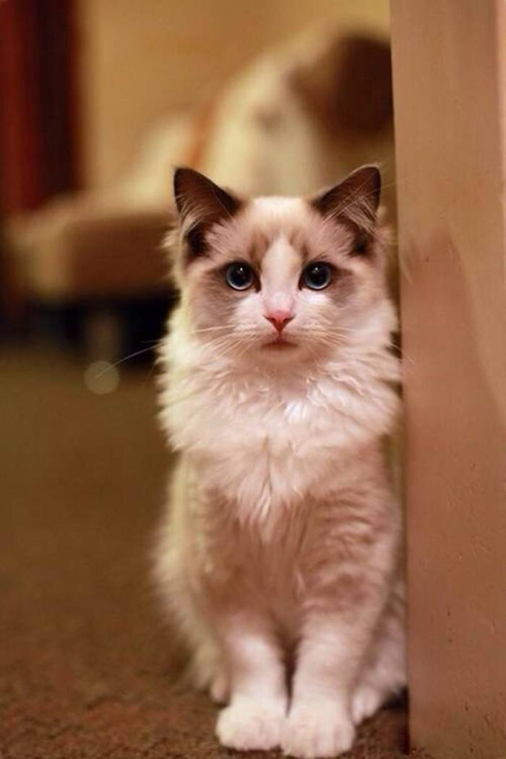

Puppet cat, also known as Braduoer cat, cat is the largest body weight and a cat. Puppet cat character gentle and quiet, very friendly to people, patience, and often mistaken for a lack of pain, Puppet cat can tolerate the child because of the catch, the most suitable for children with family rearing. Its head was V-shaped, large round eyes, rich coat, limbs, thick, tail length, soft body, mostly three-color or two-color cat. Its origin is the United States, through trade communication, most of the world's more economically developed countries are distributed. Puppet cat, the English name Ragdoll, common name alias doll cat. Puppet cat is the origin of the United States, also known as Braddell cat, by the California women Amber (Ann Baker) breed out of the cat species.

Price: 8000-15000 yuan

Hair length: Long hair

Country of Origin: United States

Size: Large

**曼岛无尾猫** Hayman Island cat

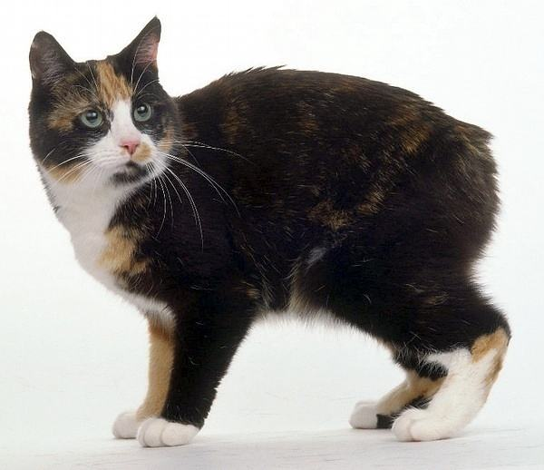

Hayman Island cat, also known as Man Island cat, Mancus cat, Manx cat, Man Island tail without a cat. The most prominent feature of the cat is no tail or short tail, followed by round head, round mouth, round eyes, round ears, small and sharp face, Oriental slim body, beak, filamentous single coat, waist thin , Arm thin. The cat because of the developed limbs, peculiar steps such as rabbit jump, so there are rabbit cats. Isle of Man Cat originating in the United Kingdom and Northern Ireland between the Isle of Man, has a long history. As early as 1901 in the United Kingdom will have the Isle of Man Cat Club, it is said that the King of Edward VII was raising a few Man Island cat. Hayman Island cat temperament docile, clever, easy to train, good at climbing a tree. Hayman Island cats are one of the lively cats, they can throw toys like a dog.

Price: 1000-5000 yuan

Hair length: Short hair

Country of Origin: British Isles

Size: Small

**埃及猫** Egyptian cat

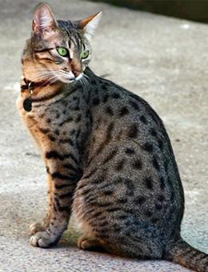

Egyptian cat is an ancient species, in ancient Egypt was regarded as a god cat, smart personality, friendly, lively and playful, but more sensitive, such as careless, easy to escape. Egyptian cats thousands of years ago in ancient Egypt tombstones and scrolls have their graphics and written records. Egyptian cat with spots, to form a fixed species originated in the 19th century Mediterranean region, a princess, she is very fond of a cat introduced from Cairo, it and an Italian cat mating. Later, the descendants of the cat was brought to the United States and the next year in the United States registered for the first time exhibitors, by the US family generally welcomed. Origin of Egypt, the 1950s from Egypt into the United States and Britain. Egyptian skull slightly rounded, oval face.

Price: 5000-12000 yuan

Hair length: Short hair

Country of Origin: Egypt

Size: Medium

**缅甸猫** Maine cats

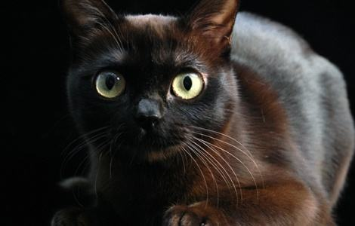

Maine cats are the first naturally occurring long-haired cat breeds in North America, native to the East Coast of Maine near the United States. Maine cat is the cat species which "cat mouth" the most species, in addition to its intelligent and lively well known, its unique large size is also unforgettable. At the cat show in New York in 1895, the Maine cat became the first native cat show in the United States. Maine Coon cat hunting skills, and thus make this native born in the United States of America Maine long hair cat people know. Through the unique breeding program, the cat developed into a strong body, especially suitable for living in the rich winter and different seasons. The beautiful appearance of the Maine Coon cat is often admired. Purebred Maine cat must have the characteristics are: eye socket, lips and paw pads must be black.

Price: 1000-15000 yuan

Hair length: Long hair

Country of Origin: Maine, United States

Size: Large

**巴厘猫** Balinese cats

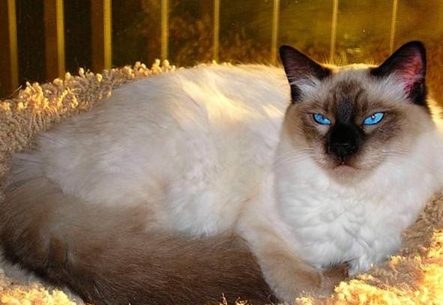

Balinese cats are a long-haired variant of the Havana cats that evolved from the naturally long-haired individuals of American-born Siamese cats. Balinese cats sleek beautiful, elegant body, animal experts because of the cat's graceful shape and graceful movements, think of Bali, Indonesia, the attitude of indigenous dancers to give the name, in fact, and no geographical relationship with Bali . Balinese cats, also known as Balinese cats, Javanese cats, are naturally mutated by Siamese cats or are genetically trait-producing, and were originally called long-haired Siamese cats. Bali cat originating in the United States, it is the beginning of this century in the United States of New York state Beilunmiesi Madame breed of crocodile found in the offspring of long-haired mutant, through a series of breeding, purification, breeding made.

Price: 2000-5000 yuan

Hair length: Long hair

Country of Origin: United States

Size: Medium

**折耳猫** Scottish Fold

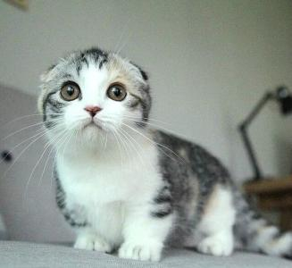

Scottish Fold (Scottish Fold) in the purebred cat family is a relatively young breed, in the breeding process, due to the British Shorthair and American Shorthair Cat mating, so inherited the above two cats physically strong, lively Cute, the advantages of strong disease resistance, as a relatively easy to breed purebred cats. And it is lively, intelligent, like the character close to people, almost any cat like a person will love it. Fold the cat without too much care daily, but due to ear droop will affect the air flow inside the ear, causing bacterial growth, prone to ear disease, it is best to regularly clean it inside the ear. Folded cat has a solid color, stripes, color, hawksbill and other hair color, but the focus color and champagne is not recognized.

Price: 500-10000 yuan

Hair length: Short hair

Country of Origin: United Kingdom

Size: Small