Girma Dingeto
Suresh Shrestha
Samuel Sidzyik
CSD-460
10/23/26
Git Repo
Zigget/CSD-460: Capstone
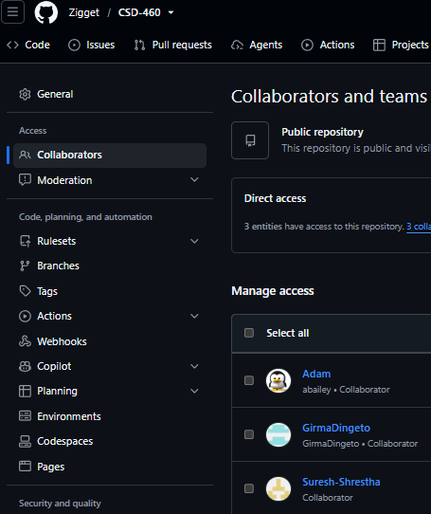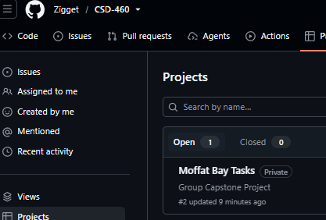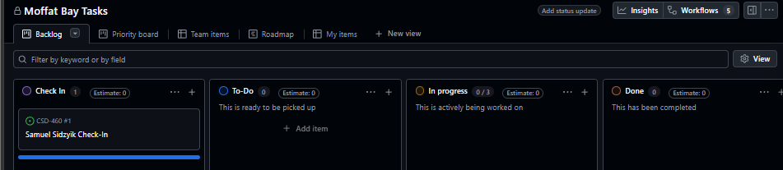
Group Convo Initiated.
