Samuel Sidzyik
Module 4.2 Assignment
01/26/2026

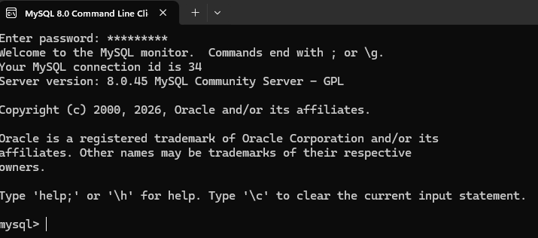
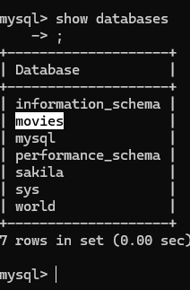

Sakila is a fake imdb database I learned to query with in my last class. I’ll use it if I don’t have instruction to use another. The assignment is the first foray into db’s. I would assume the first things we are looking for are [‘Select’, ‘From’, ‘Where’, ‘Order By’, ‘Group by’]. But you are asking for functions. I understand ‘functions’ to be [‘Count()’, ‘Sum()’, ‘Min()’, ‘Max()’, ‘Average()’, ‘Upper()’] and Google agreed. The reading doesn't really call out functions so we know what to look for, so I hope this is what you are looking for. I may have misunderstood!

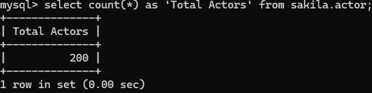
count(*) is an effective measuring stick when getting information from tables. This is used to find total actors, but it can be more meaningful when queries have conditions to show how many X have Y after Date.

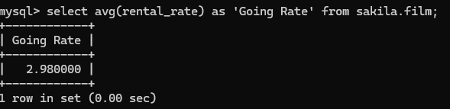
avg() gathers the average. Another method for measuring data contained in tables.

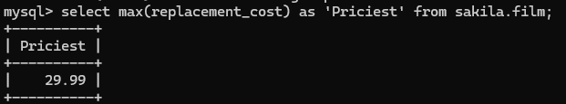
I’m not great with SQL. I wanted to get a list of titles where their price matched to max price. I’m sure it takes like a subquery or something.

