Samuel Sidzyik
Module 8.2
2/23/26
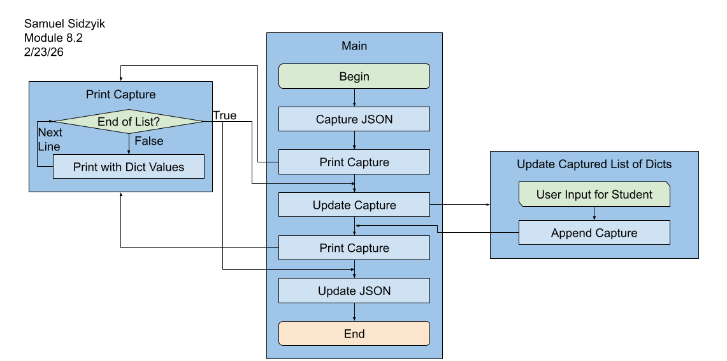
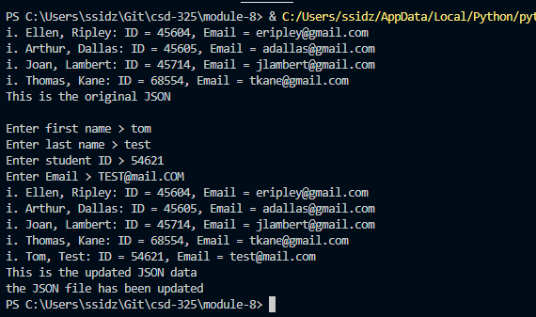
I must have missed something because my program writes to the JSON without the pop-up of are you sure you wish to save. So I can’t get that screenshot.

