Girma Dingeto, CSD380 Module4.2 Assignment

Project: | Todo Application Functional Test Plan
Course: | CSD430 – Server-Side Development
Description: | Functional test plan validating core business requirements of the Todo web application
Date: | 2026/09/03

TABLE OF CONTENTS
Test 1 – Website Loads Successfully
Test 2 – Add a New Todo Item
Test 3 – Mark Todo Item as Complete
Test 4 – Delete a Todo Item
Test 5 – List Updates After Actions

Test 1 | Website Loads Successfully
 | Test Objective: Verify the Todo application loads through a standard URL and refreshes without errors | Developer: Girma  Date tested: 2026/09/03 | Peer tester: Sam Sidzyik  Date tested: 2026/09/06
Step | Action | Expected Results | Developer pass/fail | Tester pass/fail  + Screenshot
1 | Navigate to https://buwebdev.github.io/todo/ | Page loads without errors | Yes | Yes
2 | Observe the homepage | Todo list UI displays correctly | Yes | Yes
3 | Refresh the browser | Page reloads successfully | Yes | Yes
4 | Verify no console errors | No errors appear in browser console | Yes | Yes
5 | Verify UI elements | Input field and Add button are visible | Yes | Yes
Comments | The application loaded correctly and behaved as expected during refresh. The UI elements appeared without delay, and no console errors were detected. Overall, the loading functionality meets the business requirement for standard URL access.  WebApp launches and run fine.

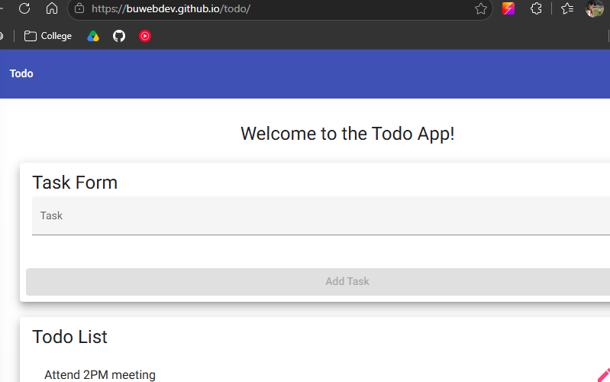Webpage URL works
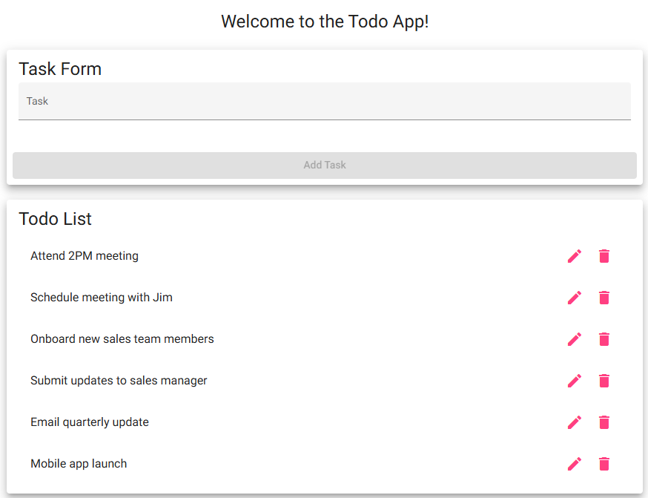 UI Looks Good
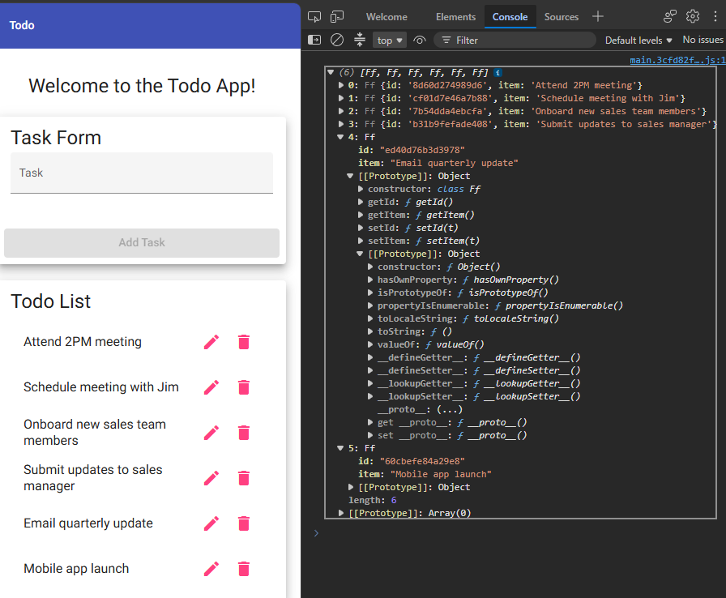Console has no errors.

Test 2 | Add a New Todo Item
 | Test Objective: Verify users can add a new todo item | Developer: Girma  Date tested: 2026/09/03 | Peer tester: Sam Sidzyik  Date tested: 2026/09/06
Step | Action | Expected results: | Developer pass/fail | Tester pass/fail
1 | Locate the input field | Input field is visible | Yes | Yes
2 | Type “Buy groceries” | Text appears in input field | Yes | Yes
3 | Click the Add button | Item appears in the list | Yes | Yes
4 | Verify item placement | Item appears at bottom of list | Yes | Yes
5 | Verify no errors | No errors appear in console | yes | Yes
Comments | The add functionality worked smoothly. The new item appeared instantly and was properly formatted. This confirms the application meets the requirement for adding new todo items.  Adding items works just fine.

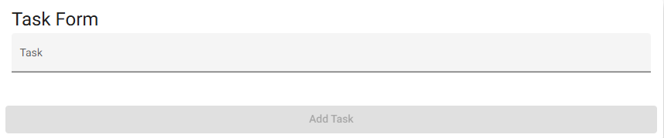 Input Field
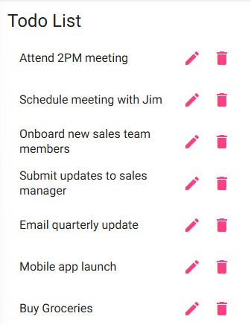 Buy Groceries added fine
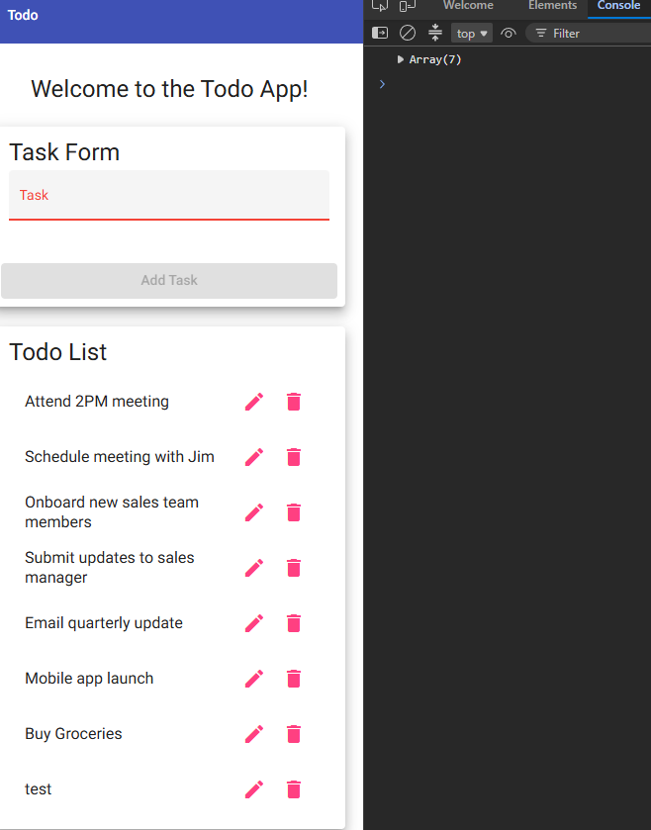 No Console Errors

Test 3 | Mark Todo Item as Complete
 | Test Objective: Verify users can mark an item as completed | Developer: Girma  Date tested:  2026/09/03 | Peer tester: Sam Sidzyik  Date tested: 2026/09/06
Step | Action | Expected results: | Developer pass/fail | Tester pass/fail
1 | Add a new item | Item appears in list | Yes | Yes
2 | Click the checkbox next to item | Checkbox becomes checked | Yes | No  Checkbox??
3 | Observe item styling | Item shows completed styling (strikethrough) | Yes | No
4 | Refresh page | Completed state persists | Yes | No
5 | Verify no errors | No console errors | Yes | Yes
Comments | Marking items complete worked as expected. The visual change was clear and persisted after refreshing, demonstrating proper state handling. This meets the business requirement for marking tasks complete.  Did I miss something? These are not working on my machine. I don’t have checkboxes, finish task options and refreshing pages resets to default values.

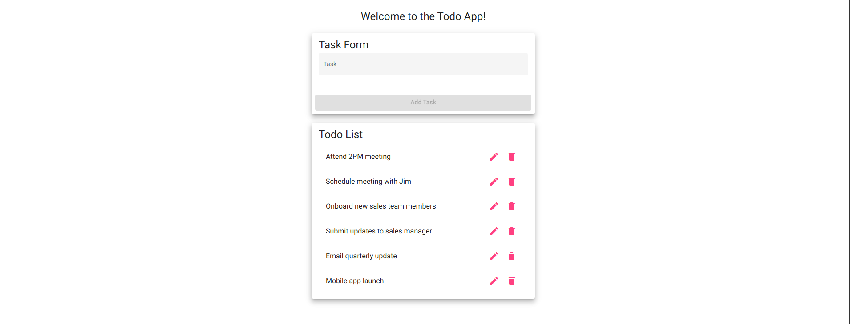Checkbox? Strikethrough? Refresh clears everything…
Test 4 | Delete a Todo Item
 | Test Objective: Verify users can delete an existing todo item | Developer: Girma  Date tested: 2026/09/03 | Peer tester: Sam Sidzyik  Date tested: 2026/09/06
Step | Action | Expected Results | Developer pass/fail | Tester pass/fail  + Screenshot
1 | Add a new item | Item appears in list | Yes | Yes
2 | Click the delete icon | Item disappears from list | Yes | Yes
3 | Verify list updates | Remaining items shift correctly | Yes | Yes
4 | Refresh page | Deleted items do not reappear | Yes | No
5 | Verify no errors | No console errors | Yes | Yes
Comments | The delete function behaved correctly and removed the item instantly. The list updated without glitches, and the deleted item did not return after refresh. This confirms compliance with deletion requirements.  Refreshes clear work. Otherwise, deleting works just fine.

Task added
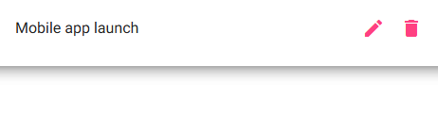 Task deleted

Test 5 | List Updates After Actions
 | Test Objective:  Verify the list updates correctly after adding, complete, and delete actions | Developer:Girma  Date tested: 2026/09/04 | Peer tester: Sam Sidzyik  Date tested: 2026/09/06
Step | Action | Expected Results | Developer pass/fail | Tester pass/fail  + Screenshot
1 | Add “Test update behavior” | Item appears in list | Yes | Yes
2 | Mark item complete | Item shows completed styling | Yes | No
3 | Delete item | Item is removed | Yes | Yes
4 | Verify list refresh | List updates instantly | Yes | Yes
5 | Refresh page | List reflects final state | Yes | No
Comments | The list updated correctly after each action, demonstrating stable UI behavior. The application handled multiple sequential operations without errors, confirming strong functional reliability.  Missing the completed styling feature and persistent state.

