Samuel Sidzyik
07/19/2026
Module 9.2

https://netbeans.apache.org/front/main/download/nb30/
https://www.codelerity.com/netbeans/
https://dev.mysql.com/downloads/file/?id=523570
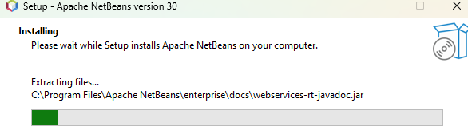
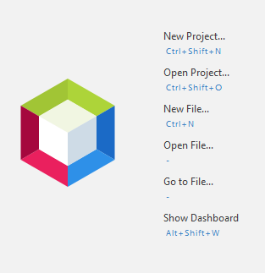
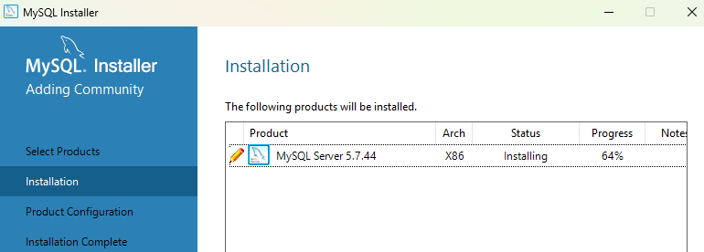
I forgot my password to mysql from our course earlier. Didn’t know how to reset that. Google had me turn off the mysql service and enter a few commands to reset but wasn’t able to get that to work… Temporary password didn’t log me in? idk. Spent a good deal of time yesterday troubleshooting. Today I went through my memory bank of recent passwords and lucked out.
