Samuel Sidzyik
CSD-430
10/11/26
Creating Custom Tags
Custom tags play an important role in modern web development by allowing developers to extend the capabilities of server-side technologies and create reusable, expressive components. In environments like what we’ve gone over with JSPs, custom tags provide a way to encapsulate logic, simplify page structure, and promote a cleaner separation between business logic and presentation. Understanding how custom tags work, why they are used, and what is required to build them effectively is essential for any developer working with component-based web frameworks.
One of the primary advantages of custom tags is reusability. When there are patterns or repeated logic across multiple pages, custom tags offer a way to package that functionality into a single, maintainable unit. I wish we could utilize this in my position because when one piece of logic needs to be updated, you are tasked with making the same update multiple times, and if you miss one business area, they insist that everything needs to be tested from scratch. Instead of duplicating code, a custom tag can be used with a simple, readable syntax. This reduces redundancy and makes future updates significantly easier. If a change is needed, it can be made in one place rather than across dozens of JSP files.
Another advantage is improved readability and maintainability. JSP pages can become cluttered when they contain large blocks of Java code mixed with HTML. While our project was fairly simple, it is clear how quickly it can become cumbersome. Custom tags help solve this by hiding complex logic behind a clean, declarative interface. A page that uses custom tags is easier for designers, junior developers, or future maintainers to understand because the tags describe what should happen rather than how it happens. This separation aligns with the Model-View-Controller (MVC) philosophy and encourages better architectural discipline.
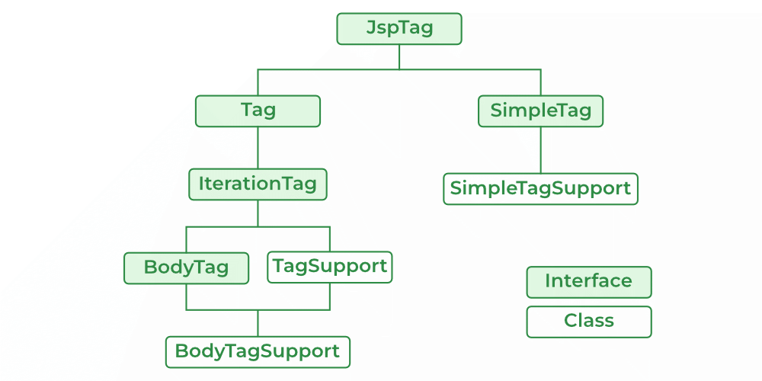
package customtags;

import java.io.IOException;
import java.time.LocalTime;
import jakarta.servlet.jsp.tagext.SimpleTagSupport;
import jakarta.servlet.jsp.JspException;
import jakarta.servlet.jsp.JspWriter;

public class GreetingTag extends SimpleTagSupport {

@Override
public void doTag() throws JspException, IOException {
JspWriter out = getJspContext().getOut();

LocalTime now = LocalTime.now();
String message;

if (now.isBefore(LocalTime.NOON)) {
message = "Good morning!";
} else if (now.isBefore(LocalTime.of(17, 0))) {
message = "Good afternoon!";
} else {
message = "Good evening!";
}

out.write("<p class='greeting'>" + message + "</p>");
}
}
*Image from GeeksForGeeks source and code built by me using their code as examples
Custom tags also support abstraction and encapsulation. By encapsulating logic inside a tag, developers can enforce consistent behavior and reduce errors caused by copy-and-paste coding. Tags can accept attributes, perform validation, and generate dynamic output, all while keeping the JSP page clean and focused on layout.
Getting into the cons includes something I regularly bring up in discussion posts. You have to use the right tool for the job and with JSP Custom tags one challenge is the initial development cost.
Custom Tags are a powerful tool when used thoughtfully. I always appreciate cleaner code and reducing duplication. However, I also believe custom tags should be used selectively. Not every piece of logic deserves its own tag, and overusing them can create unnecessary abstraction. I prefer custom tags when they genuinely simplify the page or cover frequently reused behavior. When they are used only to hide small pieces of logic, they can make the codebase harder to navigate.
Sources:
Good info on Custom Tags with JSP along with coding examples. This does mention that this reduces scriplets and we used that quite a bit this course. I mostly just used this source and riffed on it. I’ll add a couple extra sources that jive with what I wrote.
https://www.geeksforgeeks.org/java/custom-tags-in-jsp/

This shows how to implement Custom Tags in JSP.
https://www.tutorialspoint.com/jsp/jsp_custom_tags.htm

Source information
https://docs.oracle.com/cd/E11035_01/wls100/taglib/quickstart.html

