Samuel Sidzyik
CSD-430
Module 3.2
8/30/26

I chose the Job Application form
Results before running form Results after (I did the css after this screenshot)
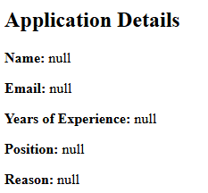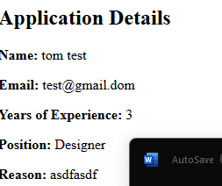
This included the CSS. It is the form
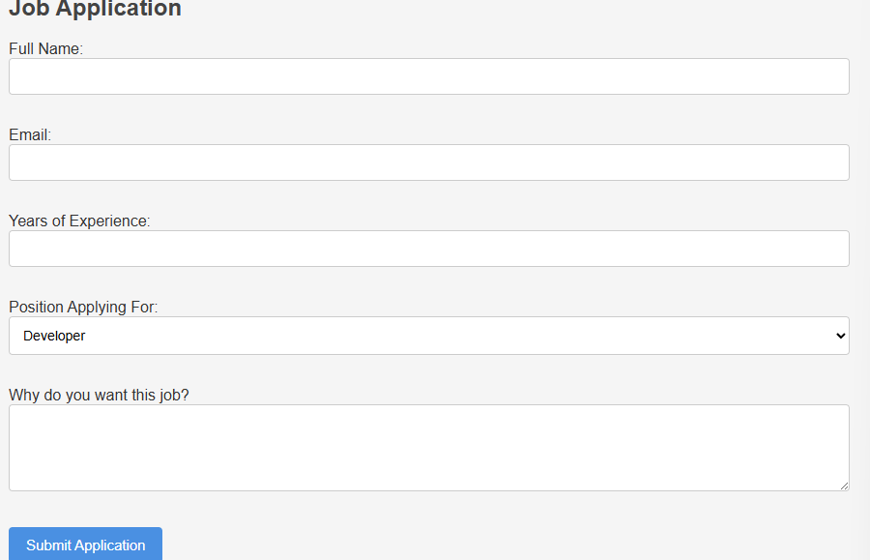

Server Setup
