Samuel Sidzyik
CSD-430
Module 4.2
9/6/26

I think I will need to take you up on that meetup. I’m able to update my program no problem, but I feel like it is a huge struggle to get the config right. For every hour I spend on actual development I’m spending 2 on config troubleshooting. And now that I have a javabean on this program I’m not even sure what changed? This has been a frustrating start on my end.

I know your not last time talked about a bland program. I have it all white and looking pretty default. I’ll add more character when I actually can get past the config and dev work and can focus on more personality.

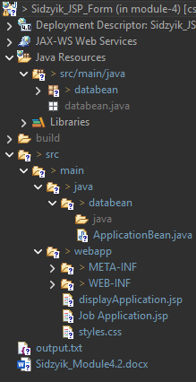
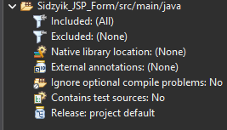

Results before running form Results after (I did the css after this screenshot)
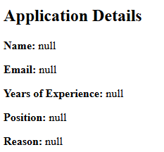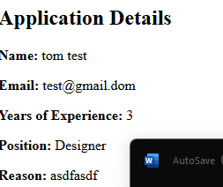
This included the CSS. It is the form
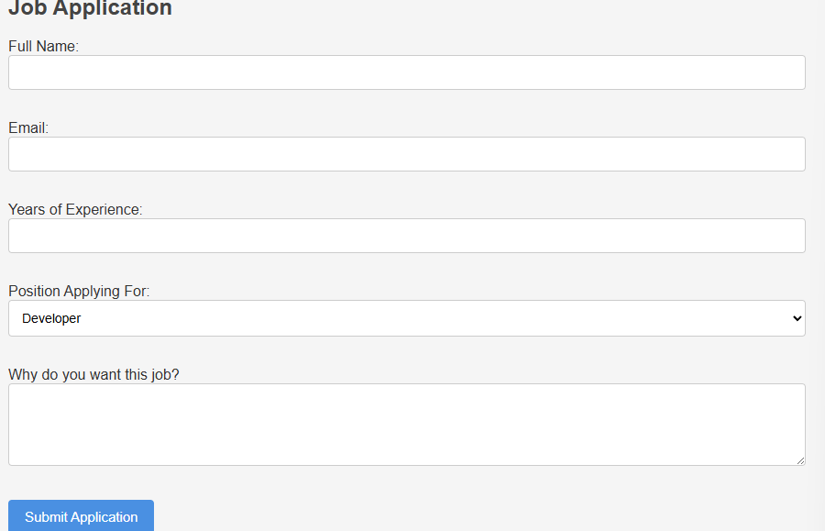

Server Setup
