Samuel Sidzyik
CSD-430
10/11/26
System Config
1.3: After successful installation and configuration of Java, Jakarta-Tomcat, and your selected IDE, capture screenshots displaying your success with each. Create a simple JSP file and capture an image showing that it is correctly functioning. Attach all screenshots along with the JSP application files.

Java
C:\Java
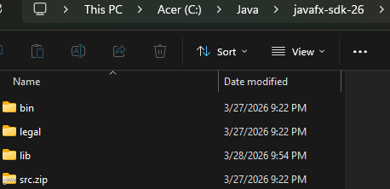

IDE
C:\eclipse
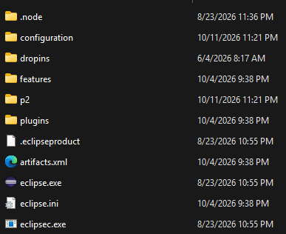

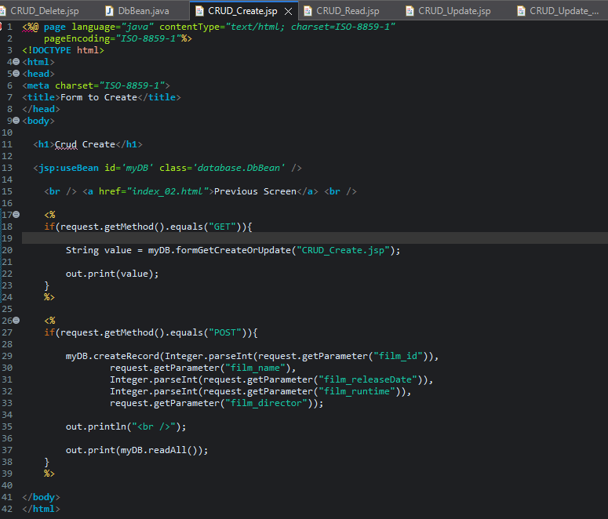

Jakarta-Tomcat
C:\Program Files\Apache Software Foundation\Tomcat 9.0
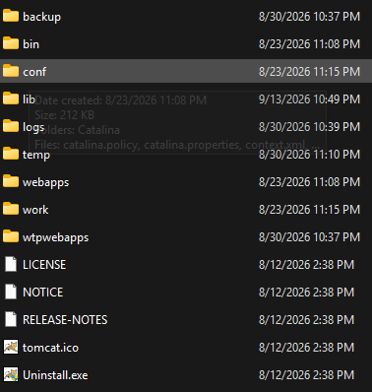
*Grammarly trying to correct my path name, lol*
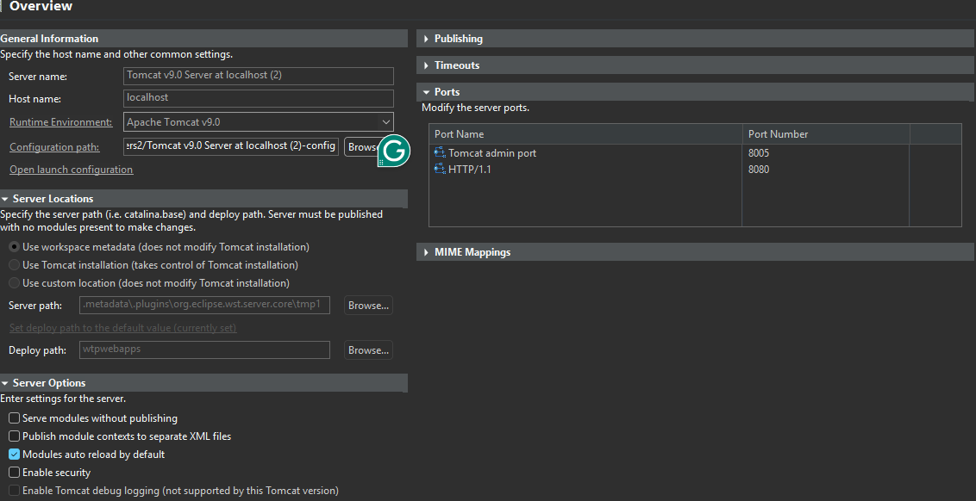

Code executing
*Console with some leftover notation
