Step

1. **Driver installation**

A: Install AP part driver

1. Power off handset, press “Power key + Voice Up key” until the screen shows green, plug in usb cable, PC will remind you of installing new hardware. Select “usbpcdriver” file, install AP driver.

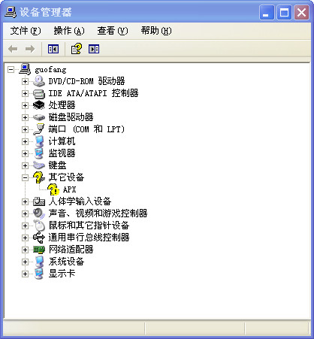 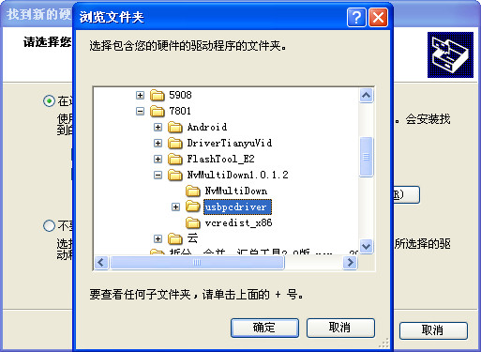

1. When you install AP driver successfully, you will find “NVIDIA USB Boot-recovery driver for Mobile devices” in device manager. As below:

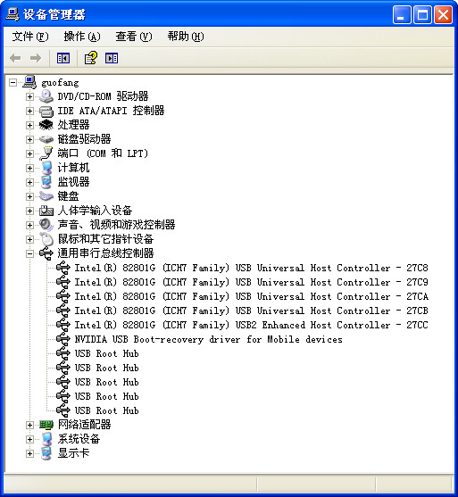

1. **Update AP part**
2. Open AP update tool “NvMultiDown.exe”, interface as below:

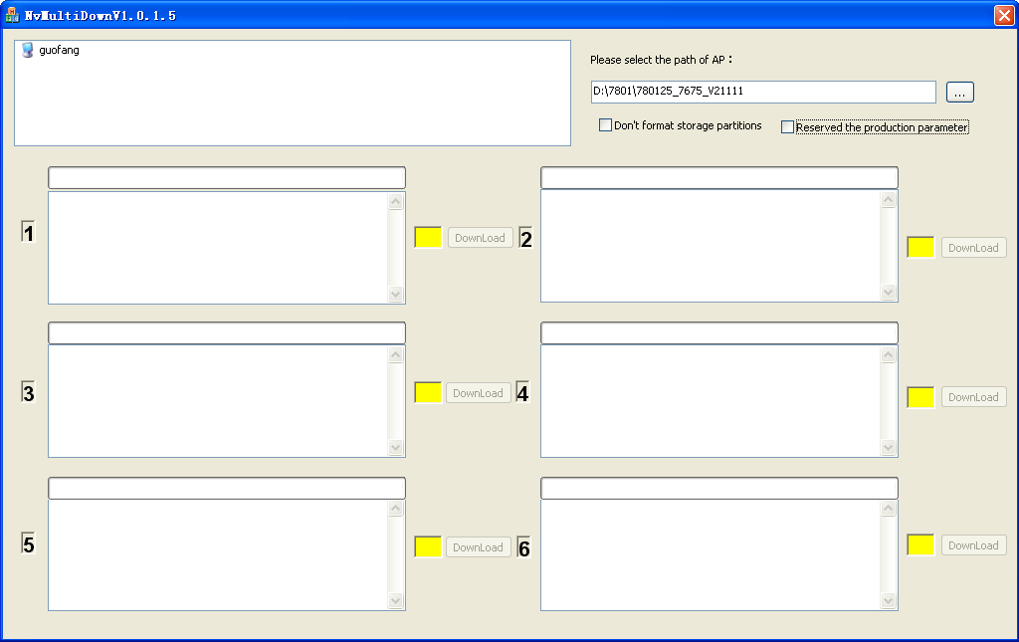

1. Select software code of AP part.

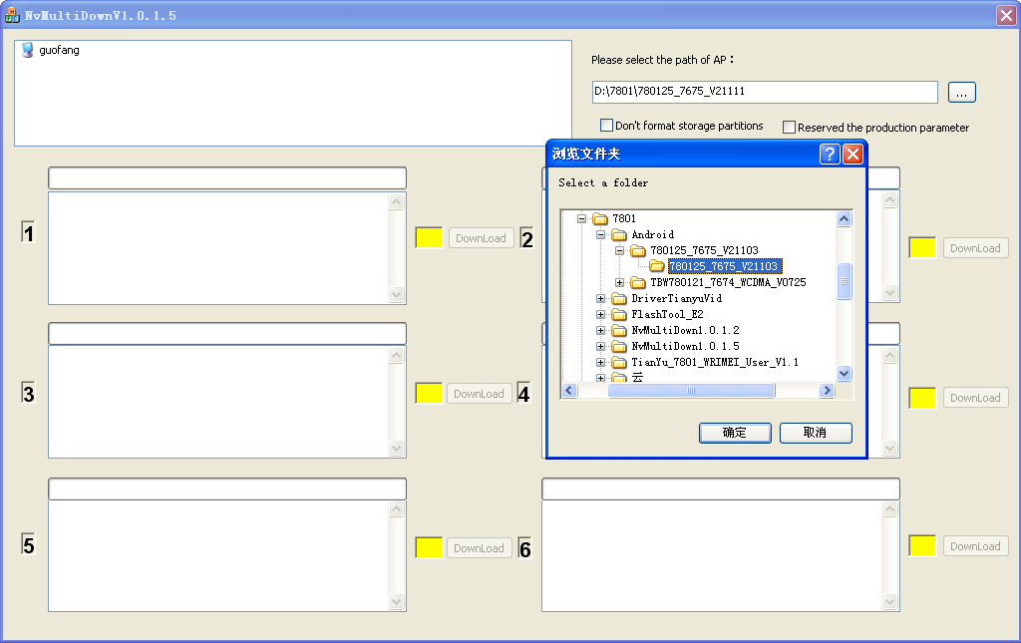

1. Power off handset, press “Power key + Voice Up key” until the screen shows green, plug in usb cable, start your update.

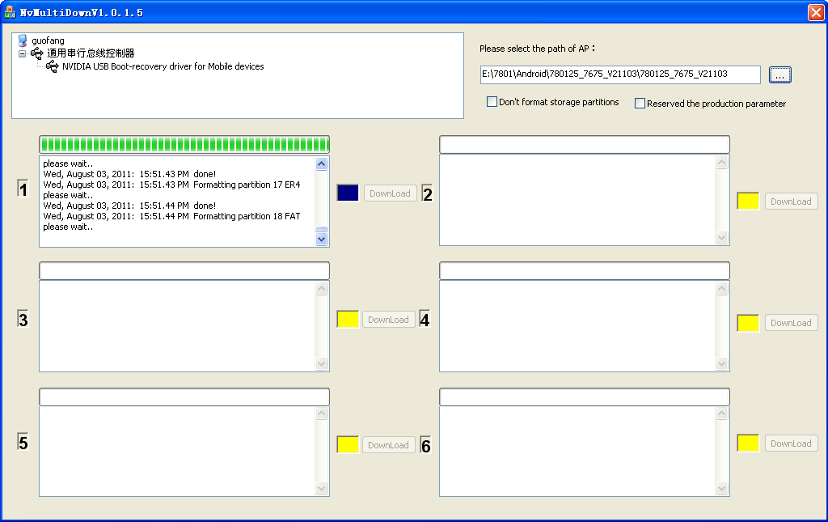

1. Complete AP part update.

