The EM2S 60kHz radio receiver module
and the MSF time signal

Deirdre O'Byrne, 6th February 2018

The EM2S module
The EM2S module is a cheap1 60kHz AM radio receiver module. It is designed to receive the MSF time signal2 transmitted by the National Physical Laboratory (NPL) from Anthorn in north-west England.
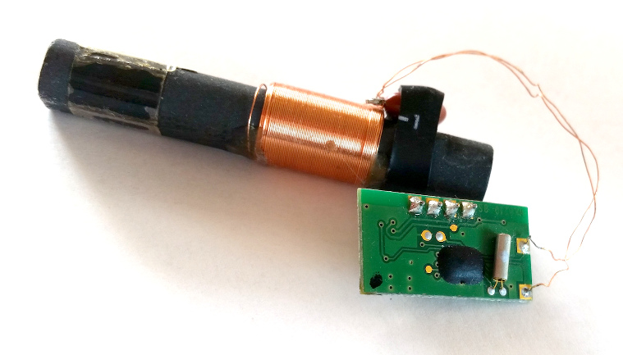
The MSF time signal consists of an accurate 60kHz carrier wave, which is turned on and off to broadcast time information. The NPL publishes3 details of how to interpret the signal.
In this paper I investigate how well the EM2S module receives this signal, with a view towards designing a noise-tolerant decoding algorithm.

The 5 different MSF signal waveforms
Each MSF signal waveform lasts for one second. The waveform starts at the start of each UTC second with the 60kHz carrier being turned off for 100ms, 200ms, 300ms or 500ms. For the purposes of this paper, the 5 different MSF signals are called “A0B0”, “A0B1”, “A1B0”, “A1B1” and “MIN”, and the waveforms transmitted by NPL are -
The EM2S module has an open collector output which is connected to ground when the carrier signal is not detected. Most EM2S decoding algorithms seem to work by detecting the relative times of the falling and rising of the carrier, which appear as falling and rising edges of the output of the module. However, this approach has two problems -
- The edges do not usually occur close to their expected locations. Algorithms tend to give up to 40ms leeway.
- Signal noise appears in the output signal of the EM2S modules as short-lived spikes – usually of less than about 15ms duration each. Algorithms have to accommodate these spikes.

Experimental setup
I attached the output of two EM2S modules, and the PPS output of a GPS receiver, to a logic analyser running at 20kHz. This logic analyser was connected to a computer, which logged the raw data to a disk. Analysis was done on the data with custom software.
The experiment was conducted in the midlands of Ireland, near 53.7°N 7.8°W, and lasted from approximately 2018/01/28 22:57:54.58 UTC for approximately 8 days, 4 hours, 17 minutes and 14.26 seconds.
The software was written with knowledge of which UTC second each GPS PPS signal represented, and was thus able to determine which of the 5 MSF signals should occur during each second.

Experiment 1 – EM2S timing signal accuracy
For the first experiement, I wanted to find out how accurately the EM2S receivers detected the loss of the MSF carrier at the start of each second. The analysis was to measure the delay between the GPS PPS signal and the first falling edge of the output of the EM2S receivers.
This graph shows a histogram of the locations within the UTC second of the first falling edge of the EM2S output signal. It is observed that receiver 1 detects the loss of the 60kHz carrier on average 20.7 milliseconds after the start of the UTC second, and receiver 2 detects it on average 22.3 milliseconds after. These two receivers were within 20cm of each other at all times.

Experiment 2 – average value of the signal
For the second experiment, I measured the value of the EM2S output for each of 1,080 millisecond intervals from the first detection of the falling edge of that output after the GPS PPS signal.
This graph shows the average value of the EM2S output signal during each of the 5 MSF second waveforms. It is observed that rising edges tend to be “late”, whereas falling edges tend to be closer to where they are supposed to be. Also, there is about 20ms - 40ms of spread in the location of the edges. This can be seen more clearly in the following histogram -
It is observed that each rising edge has noticable falling-edge noise associated with it (the dotted lines below each solid line). Indeed examination of the raw data shows that rising edges often have noise spikes close to them.

A decoding algorithm
Decoding algorithms based on the location of rising and falling edges are problematic. The edges are not where they are supposed to be, there is significant spread in their observed location, and there is significant noise associated with rising edges in particular. Noise is also occasionally observed between the edges, and accounting for this noise is not trivial in a decoding algorithm.
Decoding algorithms based on taking many samples of the signal at regular intervals seems to be a more resilient approach. The inherent inaccuracy of the EM2S modules is such that sampling at 1kHz is more than adequate, and even a sampling rate no faster than 500Hz should be sufficient. The question becomes – how many of the observed samples in each 100ms interval need to be of a given value for the overall signal to be deemed to have that value during that interval?
The key intervals are 100ms to 200ms after the start of MSF second edge, 200ms to 300ms, 300ms to 400ms, and 500ms to 600ms. The corresponding histograms are presented below -
The trickiest problem is deciding between A0B1 and A1B0 in the 200ms to 300ms interval. As can be seen by the graphs, if the average signal level is less than about 25%, the carrier should be considered to be off, and if it is more than 25%, the carrier should be considered to be on. Using this algorithm, we get the following result -

There are relatively few unknown signals, and few misidentified signals.
The unknown signals, and the signal errors, appear to come in groups as shown in the following histogram -
There also appears to be something of a 24-hour periodicity to some of the errors.
The EM2S modules and their antennas were placed in an upstairs bedroom near the floor and a 3D printer (which was turned off and powered down). Hence it is probably the case that a large number of the errors are due to poor antenna location.

Start of second detection
Algorithms for detecting the start of the second are not considered by this paper, as the algorithms in use by my analysis have access to the start of the second through the GPS PPS signal.
Histograms of the time difference between successive start of MSF second edges are presented below in the hope they will be useful.

The first histogram has a logarithmic scale, and the second is the same data with a linear scale.

Other decoding algorithms
Research was also conducted on an algorithm which splits the second into intervals from 0ms – 80ms, 160ms – 180ms, 260ms – 280ms, 360ms – 400ms, 400ms – 480ms, 560ms – 600ms, 600ms – 700ms, 700ms – 800ms, 800ms – 900ms, 900ms – 980ms. This was found to not perform as well as the algorithm presented above.
A small improvement can be obtained if a threshold of 15% is used for every 100ms interval except the 200ms – 300ms interval, which should remain at 25%. When this algorithm is used, we get -

The data, and the analysis code, used in this project have been made available on github4. The reader is welcome to try their own ideas for a decoding algorithm, as well as to test their production algorithm against a large dataset.

Future developments
It is noted that there are many disallowed patterns in the signal. For starters, the waveform for each second should broadly correspond to one of the 5 nominal waveforms given above. The following table lists the actual decoded pattern which was seen in the top 20 misidentifications of each misidentified signal. The patterns are the carrier absent (“0”) or present (“1”) during each 100ms interval of the second -
The NPL-published algorithm for determining the time from the received signal gives another way of detecting (and hence possibly correcting) received errors. There are many restraints which follow from that algorithm. For instance, the date and day-of-week should remain the same from minute to minute unless the time-of-day goes from 23:59 to 00:00. Such an algorithm was baptised the “blame algorithm” by Poul-Henning Kamp of the time-nuts mailing list5. A blame algorithm in conjunction with study of the table above may generate further improvements in an overall decoding algorithm. For instance, each pattern could be assigned a set of confidences that it should be decoded as a certain value, and the blame algorithm could be used to solidify those confidences into a most likely decoded signal. And the confidences themselves could be informed by the average signal level observed during the 100ms intervals – an observed average of 20%, for instance, could easily be either a “0” or a “1”.

Towards more absolute accuracy
It turns out6 that there is a correlation between the time interval between second markers and how late those markers are relative to UTC. Performing the calculations on the data set, we get -
 | Slope | Constant | Correlation
Receiver 1 | 0.4871 | -466,360us | 0.671
Receiver 2 | 0.4829 | -460,620us | 0.675
i.e. the second edge is late by an amount of approximately 0.48 times the second length minus 465,000 microseconds, with a correlation of about 67%.
When we apply the same correction to both signals, we get -

1 Approx €20 for a module plus antenna at the time of writing - https://www.hkw-shop.de/Empfangstechnik-AM/Empfangsmodul-EM2S-60-kHz.html?listtype=search&searchparam=em2s
2 http://www.npl.co.uk/science-technology/time-frequency/products-and-services/time/msf-radio-time-signal
3 http://www.npl.co.uk/upload/pdf/MSF_Time_Date_Code.pdf
4 https://github.com/deirdreobyrne/MSF-EM2S
5 https://www.febo.com/pipermail/time-nuts/2018-February/108775.html
6 https://www.febo.com/pipermail/time-nuts/2018-February/108804.html

