An Explainable Stacking Ensemble Framework with Disagreement-Aware Feature Selection for Loan Approval Prediction

Abstract— A loan is money borrowed from a financial institution, which is usually repaid over a period of time with interest. Therefore, accurate approval decisions are of great importance in the modern credit system. Although previous studies have shown some useful results, they have been limited in many cases by mediocre performance, poor hyperparameter tuning, lack of robust cross-validation, inadequate feature selection, limited ablation analysis, and low transparency for practical decision support. To overcome these limitations, this paper proposes an end-to-end framework for loan approval prediction, which combines Disagreement-Aware Feature Selection (DAFS), Random Over-Sampling (ROS), ensemble learning, external validation, and Explainable Artificial Intelligence (XAI). After data cleaning, label encoding, scaling, and stratified splitting, DAFS combines Elastic Net stability, permutation importance, and Genetic Algorithm (GA) search to select stable and important predictors; at the same time, it imposes penalties for disagreements among different selectors. ROS is applied only to the training data, so that class balancing can be done fairly. The main model is a stacking ensemble of K-Nearest Neighbors (KNN) and Random Forest (RF), which is combined with a Logistic Regression (LR) meta-learner. This method leverages the complementary strengths of instance-based learning and tree-based learning to provide more reliable final decisions. The proposed model achieved 96.93% accuracy on the test set, and further supported the empirical robustness of ablation analysis and external validation, with no evidence of overfitting or underfitting. For interpretability, both global and individual-level decision logics are expressed using Shapley Additive Explanations (SHAP), Local Interpretable Model-agnostic Explanations (LIME), and permutation importance. As a result, this study combines accuracy, transparency, and trust—where more intelligent approval decisions pave the way for fairer financial opportunities.
Keywords—Loan approval prediction, Disagreement-Aware Feature Selection, Stacking ensemble, Random Forest, K-Nearest Neighbors, Explainable AI.

Introduction
The creditworthiness of the applicant is assessed in the loan approval process. Conventional methods rely on manual and statistical models, which are not sufficiently scalable and adaptable; resulting in biased decisions and high risk of default [1]. The applicant’s financial, demographic and behavioral factors are used to predict the likelihood of repayment of the loan. The risk of default, financial loss and reduced access to credit due to incorrect decisions are reduced [2]. According to the World Bank, more than 1.4 billion adults worldwide are still unbanked, a major reason for which is the limited availability of formal credit [3]. The size of the global consumer credit market is expected to exceed US$1.2 trillion by 2024 and is projected to exceed US$2 trillion by 2030, indicating a rapid growth in global credit demand [4]. In addition, according to the Bank for International Settlements, global bank lending, including cross-border lending, has exceeded US$34 trillion, indicating a huge financial risk that depends on proper credit risk assessment [5]. Excessive defaults and inadequate borrower screening were among the main causes of the global financial crisis, clearly highlighting the need for a robust and data-driven credit approval system [6]. In recent times, machine learning (ML) and artificial intelligence (AI) have brought significant changes to the credit risk assessment and approval process [7]. ML models analyze high-level financial data to identify default risks early and outperform conventional methods on complex and heterogeneous datasets [8]. Ensemble learning and feature selection combine multiple models to identify important risk features, increasing the reliability of the model [9]. Explainable AI (XAI) also helps ensure transparency and regulatory compliance, enabling fair and explainable credit decisions [10]. In this study, our contributions are as follows:
- A comprehensive loan approval prediction framework is developed by integrating preprocessing, Disagreement-Aware Feature Selection (DAFS), stacking ensemble learning, comparative performance evaluation, external validation, and explainable AI.
- We propose a novel DAFS method that combines embedded stability selection, permutation importance, and genetic-algorithm search to identify a compact and robust subset of predictive features.
- An empirical evaluation is conducted using baseline and stacking models under 10-fold stratified cross-validation, held-out testing, and we also did external validation with two datasets, while an ablation study with DAFS and ROS verifies the contribution of each component.
- Interpretability is strengthened through SHAP, LIME, and permutation importance, and the overall framework demonstrates better performance, transparency, and generalization than earlier studies [11], [12], [13], [14], [15], [16].

Literature Review
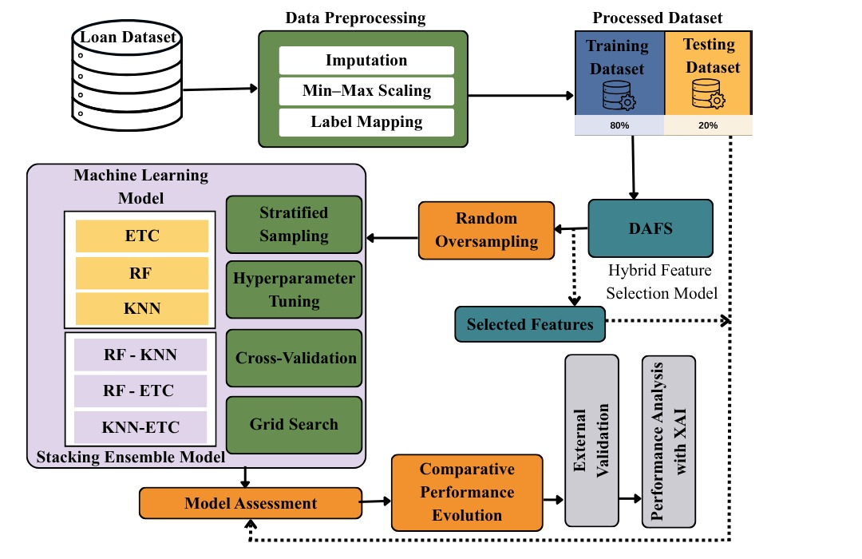
Recent research on loan approval and loan default prediction reports consistent improvements from ensemble learning. However, many studies still achieve performance below modern tuned ensembles and provide limited transparency for decision support. Hota et al. [11] evaluated baseline and ensemble classifiers for loan approval prediction using a public dataset of 614 labeled applications. Their results identified Random Forest as the best-performing model, achieving an accuracy of 0.88 and an AUC of 0.87. Although comparative analysis is presented, little emphasis is placed on explainability mechanisms to enhance auditability and transparency in lending decisions. Ko et al. [12] evaluated AI and statistical methods for P2P loan default prediction using 60,993 loan records. There, LightGBM showed the highest results, with an accuracy of 0.6857 and an AUC of 0.7492. These mediocre prediction results indicate that improved feature engineering, optimized tuning, and a stronger validation framework are needed to achieve reliable automated credit screening. Nazim Uddin et al. [13] proposed an ensemble-based machine learning model for bank loan approval prediction using 806 instances with 13 features. There, Voting Ensemble (the top three classifiers) achieved the highest accuracy of 0.8726, which outperformed the full ensemble model (0.8407). The study did not present any information about ROC–AUC, cross-validation (CV) method, hyperparameter (HP) tuning, feature selection, or explainable AI techniques, thus limiting the assessment of its robustness and explainability. Iftikhar and Ayaz [14] in their study Predicting Financial Risk for Loan Approval using Machine Learning Techniques built a credit risk prediction model using 20,000 records with 31 features. Among the evaluated algorithms, Decision Tree and KNN achieved the highest accuracy of 86.53%. However, the study only briefly mentioned CV in the context of ensemble voting; nothing was reported about ROC–AUC, detailed validation strategy, HP tuning, or explainable AI techniques. Ramaswamy Vikram Reddy et al. [15] proposed a loan eligibility prediction system on a dataset of 10,128 instances using machine learning techniques. Among the implemented models, Random Forest gave the best results, with an accuracy of 0.9188 and an AUC of 0.70. Although the study presented ROC–AUC analysis, it did not provide details about the CV method, HP tuning strategy, feature selection method, or explainable AI technique, which limits a full assessment of the robustness and explainability of the model. Kashyap et al. [16] in their study titled Design and Implementation of an Intelligent Loan Eligibility System using Machine Learning, published in TEJAS Journal of Technologies and Humanitarian Science, proposed a loan eligibility prediction model using 614 records. The study reported an accuracy of 0.82 and applied Linear Discriminant Analysis (LDA) for dimensionality reduction. However, it does not present any information about ROC–AUC, CV methods, or explainable AI techniques.

To overcome these limitations, the present study proposes an end-to-end lending decision framework, where a novel hybrid feature selection method is integrated with 10-fold StratifiedKFold cross-validation and randomized hyperparameter (HP) search. A tuned stacking ensemble increases the reliability of the predictions. Interpretable artificial intelligence (XAI) is incorporated through SHAP and LIME to provide global and applicant-level interpretation. The generalization performance is assessed through a final evaluation on a separate test set, which supports accurate and transparent lending decisions.

Methodology
As illustrated in Fig. 1, the study starts with a loan-related dataset, followed by data cleaning and consistency checking; this includes checking for missing values ​​and duplicate entries. Categorical features are then converted to numerical form using label encoding, and numerical features are normalized using Min–Max scaling to ensure a consistent input space. A hybrid feature selection (DAFS) step is then applied, combining embedded selection, permutation importance-based scoring, and genetic algorithm search; after that, a short subset is created by merging the selected features. To address class imbalance, the data is first divided into stratified training and test sets, and then random over sampling (ROS) is applied only to the training set.

A. Dataset Description
The dataset used in this study is a synthetic loan-approval classification dataset, containing 45,000 loan records [17]. Each record contains 14 predictive features, spanning a mixed data type with six continuous numeric features, which indicate quantities such as income or loan-related measures, three discrete numeric variables, which represent countable or ordinal values, and five categorical variables, which describe applicant or loan characteristics. The target column is ‘loan_status’, which is a binary variable; where 1 denotes an approved application and 0 denotes a rejected application. This structure supports supervised learning for loan-approval decision modeling and allows evaluation with standard binary-classification metrics and validation protocols.

B. Data Preprocessing
The dataset was first checked for consistency and suitability before modeling. Categorical variables were converted to numerical values using label encoding for model compatibility. Numerical features were normalized with Min–Max scaling to ensure comparable ranges, while z-score standardization was applied in scale-sensitive steps to reduce magnitude effects. The data were then split into stratified 80/20 training and test sets to preserve class distribution, and random oversampling was used on the training set to address class imbalance before final model training.

To reduce redundancy and improve generalization, a hybrid feature-selection method, Disagreement-Aware Feature Selection (DAFS) is proposed. Algorithm 1 summarizes the proposed DAFS procedure. It computes three feature-importance scores and then combines them into one final ranking. First, an embedded stability score $e_{j}$is obtained by repeatedly fitting an Elastic Net logistic model on bootstrap subsamples and measuring how consistently each feature receives a nonzero coefficient, following the stability selection idea [18], as defined in Eq. (1).

$e_{j}=\frac{1}{B}∣\left\{ b : ∣β_{j}^{\left(b\right)}∣>0 \right\}$ (1)

Here, $e_{j}$is the embedded stability score of features $j$, $B$is the number of bootstrap fits, $β_{j}^{\left(b\right)}$is the Elastic Net coefficient of feature $j$in bootstrap run $b$.

Second, a permutation-based importance score $p_{j}$ is computed as the performance drop when a feature is randomly permuted, and these permutation scores are aggregated across multiple candidate classifiers using weights based on cross validation performance [19], as expressed in Eq. (2).

$p_{j}=\text{Score}(X,y)-\text{Score }\left(X^{perm(j)} , y\right)$ (2)

Here, $p_{j}$is the permutation based importance of feature $j$, $\text{Score}(⋅)$is the chosen evaluation metric-computed on a validation set, and $X^{perm(j)}$denotes the same data matrix after randomly permuting the values of feature $j$.

Third, a wrapper-based GA score $g_{j}$is produced by a genetic algorithm that searches feature subsets using cross validated performance with a sparsity penalty; the final $g_{j}$reflects how frequently a feature appears in the best evolved subsets [20], as given in Eq. (3).

$$\begin{aligned}g_{j}=\frac{1}{∣E∣}\sum_{z∈E}{z_{j }}\#\left(3\right)\end{aligned}$$

Here, $g_{j }$is the wrapper based GA score of features $j$, $E$i s the set of elite feature subsets returned by the genetic algorithm, $∣E∣$is the number of elite subsets, and $z_{j}∈\left\{0,1\right\}$indicates whether feature $j$is included in subset $z$.

Unlike common hybrid feature selection that simply averages scores or uses voting, DAFS explicitly reduces unstable features by penalizing disagreement among the three selectors. The novel fusion equation used in this study is given in Eq. (4).

$s_{j}=σ(w_{e}e_{j}+w_{p}p_{j}+w_{g}g_{j}-η Var(e_{j},p_{j},g_{j})$ (4)
where $s_{j}$is the final importance score of feature $j$ $e_{j}$, $p_{j}$, and $g_{j}$ are the normalized importance scores obtained from the three selectors, $w_{e}$, $w_{p}$, and $w_{g}$ are nonnegative weighting, $Var\left(e_{j},p_{j},g_{j}\right)$measures disagreement among the selectors for feature $j$, $η$controls how strongly disagreement is penalized and $σ\left(⋅\right)$is the sigmoid mapping to keep scores bounded.

Algorithm 1: Disagreement Aware Feature Selection (DAFS)
Input: X in R(n × d), y
Output: F final ⊆ {1, ..., d}
Parameters: B, K, G, k min, k max, η, κ
- Compute Elastic Net stability scores e_{j} from B bootstrap resamples.
- Compute cross-validated permutation importance scores p_{j} using K-fold validation.
- Compute GA-based inclusion scores g_{j} from elite subsets over G generations.
- Normalize e_{j}, p_{j}, and g_{j} to the range [0, 1].
- Fuse the normalized scores into a disagreement-aware score s_{j} for each feature.
- Derive the adaptive cutoff τ from the score distribution using κ.
- Form the candidate set F = {j | s_{j} ≥ τ}.
- If |F| is smaller than k min, retain the top k min features ranked by s_{j}.
- If |F| is larger than k max, retain the top k max features ranked by s_{j}.
- Return the retained set as F final.

After applying DAFS, the original set of 13 predictors were reduced to 8 (Person Income , Person Home Ownership , Loan Amount , Loan Interest Rate , Loan Percent Income , Credit Score , Previous Loan Defaults On File ) selected features. This design is beneficial because it prioritizes features that are consistently supported by different selectors. This increases robustness to different data splits and reduces overfitting compared to simple averaging or voting. Here, the disagreement term, Var(e_{j},p_{j},g_{j}), acts as a stability control. If one selector gives too much weight to a feature without the support of the others, its variance increases and the final score sj decreases. In contrast, features that receive approximately equal weight from different selectors have lower variance and are selected with greater confidence. This results in a more reliable input space for subsequent classifiers.

C. RF- KNN Model Construction
The RF–KNN model is built as a stacking ensemble, which combines two complementary learning mechanisms in a loan approval prediction framework [21]. At the base level, K-Nearest Neighbors (KNN) and Random Forest are used as first-stage classifiers. KNN is incorporated to capture local similarity patterns by assigning class labels based on the nearest observations in the feature space, which is particularly useful when loan approval behavior depends on the proximity structure of applicants. On the other hand, Random Forest is used to capture extensive nonlinear relationships and interactions between features through an ensemble of decision trees, which is more robust to handle complex decision boundaries. Rather than relying on a single learner, their prediction outputs are fed to a second-stage Logistic Regression meta-classifier, which combines the strengths of both models to learn to make final decisions [22]. In the implemented stacking design, pass-through was disabled, so that the meta-learner was trained only on the prediction output of the base models, so that it could focus on their decision patterns.

To ensure robust model building, the ensemble was built under a nested cross-validation setting. Here, a 10-fold stratified outer loop was used for performance estimation, and a 3-fold randomized hyperparameter search was conducted for model tuning within each training fold. This search selected a KNN that was distance-weighted, small neighborhood-based, and followed Manhattan distance behavior. At the same time, a Random Forest was selected that used a relatively small number of trees, a relatively deep tree structure, controlled leaf constraints, and a construction method without bootstrap sampling. In addition, meta-level Logistic Regression converged to a regularized configuration, which stabilized the final combination. After each fold-based selection, the best RF–KNN stacking model is retrained on the entire training set and then applied to the held-out test set. This construction method is more powerful than the single-model approach because it combines local instance-based reasoning and ensemble learning within the same architecture. In addition, the nested tuning procedure increases the robustness of the model, reduces overfitting, and makes the model more reliable for loan approval prediction.

Result And Discussion
A 10-fold cross-validation protocol was applied to evaluate the KNN–RF stacking ensemble, where the Logistic Regression meta-learner was used, to obtain a reliable estimate of the model performance. The results for each fold, along with the mean value and its variance, are presented in Table I. The model achieved 0.9672 ± 0.0021 accuracy and 0.9951 ± 0.0009 ROC–AUC, with very little variation among the folds.
TABLE I. 10-FOLD CV RESULTS

 | Accuracy | Precision | Recall | F1-Score | ROC-AUC
Fold 1 | 0.9681 | 0.9685 | 0.9681 | 0.9681 | 0.9954
Fold 2 | 0.9696 | 0.9699 | 0.9696 | 0.9696 | 0.9951
Fold 3 | 0.9634 | 0.9638 | 0.9634 | 0.9634 | 0.9937
Fold 4 | 0.9683 | 0.9686 | 0.9683 | 0.9683 | 0.9960
Fold 5 | 0.9665 | 0.9671 | 0.9665 | 0.9665 | 0.9954
Fold 6 | 0.9676 | 0.9678 | 0.9676 | 0.9676 | 0.9958
Fold 7 | 0.9676 | 0.9681 | 0.9676 | 0.9676 | 0.9956
Fold 8 | 0.9658 | 0.9667 | 0.9658 | 0.9658 | 0.9955
Fold 9 | 0.9705 | 0.9707 | 0.9705 | 0.9705 | 0.9953
Fold 10 | 0.9643 | 0.9646 | 0.9643 | 0.9643 | 0.9933
Mean | 0.9672 | 0.9676 | 0.9672 | 0.9672 | 0.9951
Standard Deviation | 0.0021 | 0.0020 | 0.0021 | 0.0021 | 0.0009

HP optimization converged to a concise and consistent configuration, which is presented in Table II. In the case of KNN, the selected setting uses distance-based weighting with 3 neighbors, which implies that nearby samples have a greater impact on the prediction. For Random Forest, a maximum depth of 18 and 50 trees are selected, which ensures robust performance while controlling complexity. Logistic Regression with L2 regularization is finalized as the meta-learner, where C = 0.1 and solver = saga are used. This ensures stable adaptation of learners, reduced overfitting, improved generalization and predictive stability.

TABLE II. FINAL HYPERPARAMETER CONFIGURATION

Component | Hyperparameter | Best value
KNN | weights | distance
KNN | p | 1
KNN | n_neighbors | 3
KNN | leaf_size | 20
KNN | algorithm | ball_tree
RF | n_estimators | 50
RF | min_samples_split | 2
RF | min_samples_leaf | 2
RF | max_depth | 18
RF | bootstrap | False
Meta-learner (LR) | C | 0.1
Meta-learner (LR) | penalty | l2
Meta-learner (LR) | solver | saga
Using the selected hyperparameters in Table II, the final stacking model is trained on the training set and evaluated on the held-out test set. As reported in Table III, the model achieves a test accuracy of 0.9693 with an ROC–AUC of 0.9958. Fig. 2 shows the confusion matrix on the held-out test set, highlighting the distribution of correct and incorrect predictions across the two classes.

TABLE III. TEST-SET PERFORMANCE (KNN–RF Ensemble Stacking)

Metric | Value
Accuracy | 0.9693
Precision | 0.9696
Recall | 0.9693
F1-Score | 0.9693
ROC–AUC | 0.9958

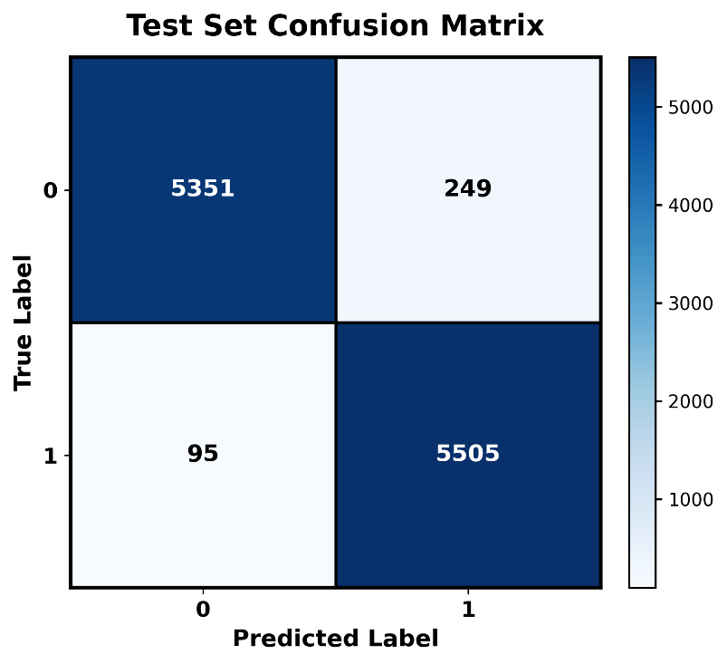
Fig.2. Confusion Matrix Test Set of KNN-RF Ensemble Stacking

Comparative Performance Evaluation:
All models are evaluated under the same experimental protocol to enable a fair comparison. Table III summarizes the held-out test-set results for the single baselines and the stacking ensembles. The stacking ensemble that combines KNN and Random Forest with a Logistic Regression meta-learner achieves the highest overall performance, while the individual classifiers show comparatively lower scores under the same evaluation setting. As illustrated in Fig. 3, the ROC curve indicates superior class separability compared to the baseline models.

TABLE III. TEST-SET PERFORMANCE COMPARISON

Model | Accuracy | Precision | Recall | F1-score | ROC-AUC
RF | 0.9614 | 0.9624 | 0.9614 | 0.9614 | 0.9951
KNN | 0.9362 | 0.9413 | 0.9362 | 0.9360 | 0.9665
ETC | 0.9305 | 0.9351 | 0.9305 | 0.9304 | 0.9878
RF + ETC | 0.9663 | 0.9665 | 0.9663 | 0.9663 | 0.9951
KNN + ETC | 0.9560 | 0.9571 | 0.9560 | 0.9560 | 0.9915
KNN + RF | 0.9693 | 0.9696 | 0.9693 | 0.9693 | 0.9958

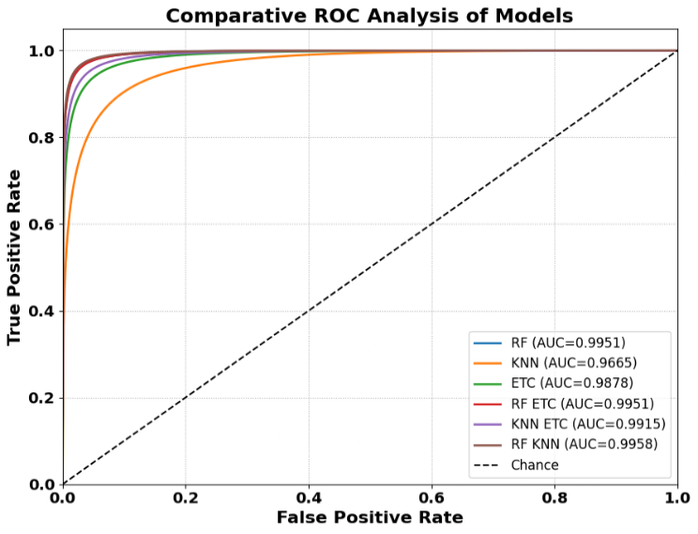
Fig 3. ROC curve comparison

The impact of DAFS and random over-sampling (ROS) is examined by switching each component on and off and the results are given in Table III. Applying DAFS without ROS results in a decrease in performance, indicating that feature selection alone is not sufficient if class imbalance is not resolved. Applying ROS alone without DAFS also does not improve performance, indicating that resampling alone is not the key effective component. The best results are seen when DAFS and ROS are used together, ensuring their joint effectiveness for reliable predictions.

TABLE III. Effect of DAFS and ROS

Combination | Accuracy | Precision | Recall | F1-Score | ROC–AUC
DAFS + No ROS | 0.7778 | 0.6049 | 0.7778 | 0.6806 | 0.6886
No DAFS + No ROS | 0.9270 | 0.9255 | 0.9270 | 0.9252 | 0.9736
No DAFS + ROS | 0.9231 | 0.9221 | 0.9231 | 0.9201 | 0.9696
DAFS + ROS | 0.9693 | 0.9696 | 0.9693 | 0.9693 | 0.9958

External Validation:
To assess the generalization ability of the proposed framework beyond the primary dataset, external validation was performed using two independent public loan approval prediction datasets from Kaggle [23], [24], as summarized in Table IV. Although the two external datasets differ in sample size and feature composition, the model preserved consistently strong predictive performance, achieving accuracies of 0.9836 and 0.9875, respectively. The stability of these results across both external datasets indicates that the learned decision patterns are not confined to a single data distribution and can be transferred effectively to unseen loan approval data.

TABLE IV. EXTERNAL VALIDATION RESULTS
Source | Shape | Acc. | Prec. | Rec. | F1-score | ROC- AUC
[21] | 4269 × 13 | 0.9836 | 0.9837 | 0.9836 | 0.9836 | 0.9962
[22] | 3,192 × 14 | 0.9875 | 0.9878 | 0.9875 | 0.9875 | 0.9963

XAI-Based Model Interpretation:
To make the model’s decision more transparent and support its interpretability, global interpretation using SHAP and local interpretation using LIME were applied to the combined test features [25]. Fig. 4, presents the SHAP summary, showing the overall influence and value-based direction of each feature on the model output. The widest spread suggests that ‘previous_loan_defaults_on_file’ is the most influential, followed by ‘loan_int_rate’ and ‘loan_percent_income’. Logically, Fig. 5 shows the LIME interpretation for a test sample, where favorable ‘previous_loan_defaults_on_file’ contributes positively, while more ‘loan_int_rate’, less favorable ‘loan_intent’, and more ‘loan_percent_income’ contribute negatively. Fig. 6 shows the permutation feature importance, which more strongly confirms the same main drivers identified by SHAP. Overall, these explanations show that decisions are primarily driven by financially meaningful risk factors [26].

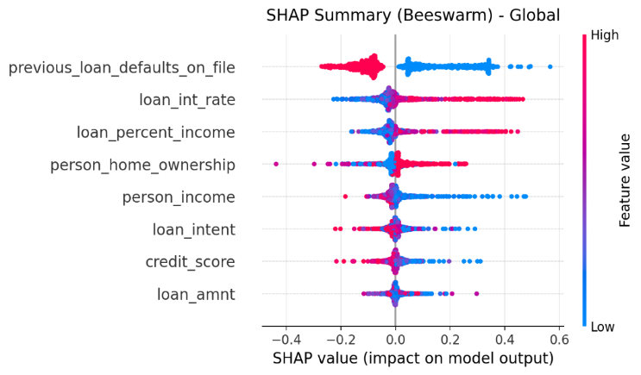
Fig. 4. SHAP summary (beeswarm) for global feature impact.

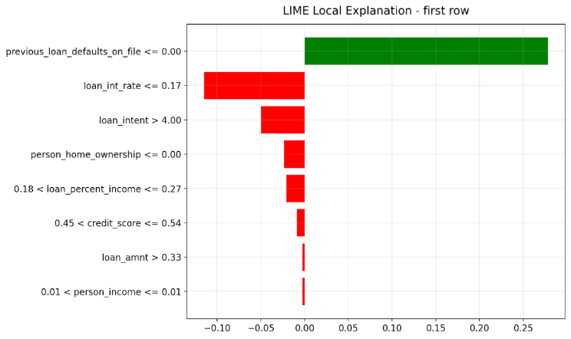
Fig. 5. LIME local explanation for a representative test instance.
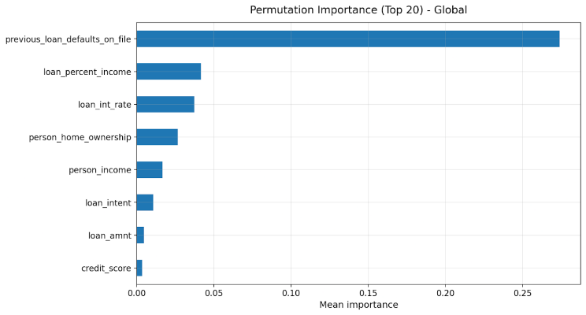
Fig. 6. Permutation feature importance for global sensitivity.

Comparison with Other Related Works:
As shown in Table V, the proposed RF-KNN model achieved 96.93% accuracy, which provided better results than the existing related studies. This result highlights the effectiveness of the adopted preprocessing technique to improve the classification performance. In addition, the selected features worked together efficiently, which increased the robustness of the model. Therefore, these results verify that the proposed method is effective, robust, and competitive with previous works for practical applications.

TABLE V: PROPOSED MODEL COMPARISON WITH OTHER RELATED WORKS

Conclusion
This study presents a comprehensive framework for loan approval prediction, which combines DAFS-based feature selection, stacking ensemble learning, external validation, and XAI. It shows that combining DAFS with explainable stacking ensembles enables reliable loan approval predictions while maintaining the clarity of the decision-making process. The proposed method achieves an accuracy of 0.9693 on a separate test set, and 0.9836 and 0.9875 on two independent public datasets, respectively, indicating its applicability beyond the main dataset. The model is explained at both global and instance levels using SHAP, LIME, and permutation importance, which increases transparency. However, the study has been validated on a limited number of public benchmarks, and there may be wider distribution shifts and additional constraints in real operational environments. Future research will examine more diverse, time-separated datasets and include calibration and application-specific threshold selection for practical applications.

References
- S. Lessmann et al., “Benchmarking state-of-the-art classification algorithms for credit scoring,” European Journal of Operational Research, 2021.
- OECD, Financial Inclusion and Consumer Credit, 2022.
- World Bank. (2022). The Global Findex Database 2021: Financial Inclusion, Digital Payments, and Resilience in the Age of COVID-19. Washington, DC.
- Statista. (2024). Global Consumer Lending Market Size and Forecast. Statista Research Department.
- Bank for International Settlements (BIS). (2024). Global Liquidity: Banking Statistics. BIS Quarterly Review.
- Ghosh, S. (2015). Credit risk management: What can we learn from the subprime crisis? Journal of Financial Stability, 20, 1–14.
- Khandani, A. E., Kim, A. J., & Lo, A. W., “Consumer credit-risk models via machine-learning algorithms,” Journal of Banking & Finance, 2021.
- Brown, I., & Mues, C., “An experimental comparison of classification algorithms for imbalanced credit scoring data,” Expert Systems with Applications, 2022.
- Louzada, F., Ara, A., & Fernandes, G. B., “Classification methods applied to credit scoring: A review,” Information Sciences, 2021.
- Barredo Arrieta, A., et al., “Explainable Artificial Intelligence (XAI): Concepts, taxonomies, opportunities and challenges,” Information Fusion, 2022.
- C. P. Hota, P. K. Jain, and A. Kumar, “A Comparative Performance Assessment for Prediction of Loan Approval in Financial Sector,” in Proc. Int. Conf. Machine Learning and Data Engineering (ICMLDE), 2024.
- Z. Zeng et al., “Auto Loan Default Prediction Based on Stacking Ensemble Learning,” in Proc. 7th Int. Conf. Control, Robotics and Cybernetics, 2023.
- N. Uddin, M. K. U. Ahamed, M. A. Uddin, et al., “An Ensemble Machine Learning Based Bank Loan Approval Predictions System with a Smart Application,” Int. J. Cognitive Computing in Engineering, vol. 4, pp. 327–339, 2023.
- Z. Iftikhar and R. Ayaz, “Predicting financial risk for loan approval using machine learning techniques,” TechRxiv, preprint, Nov. 20, 2025.
- “Loan Eligibility Prediction System,” International Journal of Creative Research Thoughts (IJCRT), vol. 11, issue 4, Apr. 2023.
- A. Kashyap et al., “Design and Implementation of an Intelligent Loan Eligibility System using Machine Learning,” TEJAS Journal of Technologies and Humanitarian Science, vol. 4, issue 2, 2025.
- https://www.kaggle.com/datasets/taweilo/loan-approval-classification-data
- N. Meinshausen and P. Bühlmann, “Stability selection,” J. Roy. Stat. Soc. Ser. B (Stat. Methodol.), vol. 72, no. 4, pp. 417–473, 2010.
- A. Altmann, L. Toloşi, O. Sander, and T. Lengauer, “Permutation importance: A corrected feature importance measure,” Bioinformatics, vol. 26, no. 10, pp. 1340–1347, 2010.
- W. Siedlecki and J. Sklansky, “A note on genetic algorithms for large-scale feature selection,” Pattern Recognit. Lett., vol. 10, no. 5, pp. 335–347, 1989.
- D. H. Wolpert, “Stacked generalization,” Neural Networks, vol. 5, no. 2, pp. 241–259, 1992, doi: 10.1016/S0893-6080(05)80023-1.
- T. Hastie, R. Tibshirani, and J. Friedman, The Elements of Statistical Learning: Data Mining, Inference, and Prediction, 2nd ed. New York, NY, USA: Springer, 2009.
- https://www.kaggle.com/datasets/ishan2106/loan-approval-prediction-dataset/data
- https://www.kaggle.com/datasets/sanjamw/loan-approval-prediction-dataset
- A. Adadi and M. Berrada, “Peeking inside the black-box: A survey on explainable artificial intelligence (XAI),” IEEE Access, vol. 6, pp. 52138–52160, 2018, doi: 10.1109/ACCESS.2018.2870052.
- C. Rudin, “Stop explaining black box machine learning models for high stakes decisions and use interpretable models instead,” Nature Machine Intelligence, vol. 1, pp. 206–215, 2019, doi: 10.1038/s42256-019-0048-x.

