 | American International University-Bangladesh
MOBILE APPLICATION DEVELOPMENT
with React Native & Expo
Lab Manual — Week 1: Environment Setup & Your First React Native App

Faculty | Md. Sazid Uddin
Department | Computer Science, Faculty of Science and Technology, AIUB
Semester | Summer 2025–26
Lab Session | Week 1
Duration | 3 hours
App to Build | StudentCard — a personal profile card with a follow/unfollow toggle

Lab Overview
In this lab session you will set up your development environment from scratch, create your first Expo project, and build a working mobile app called StudentCard. You will build the app incrementally — each section adds one new concept on top of what you already have.

📝 What you will build
StudentCard is a mobile profile card app. By the end of the 3-hour session it will display a student's name, ID, department, bio, and a list of skills. It will also have a Follow/Unfollow toggle button powered by React state. The app runs live on your phone via Expo Go.

Learning Objectives
By the end of this lab you will be able to:
- Create a new Expo project from the command line
- Open and preview a React Native app on a physical device using Expo Go
- Write functional React components with JSX
- Pass data between components using props
- Use the useState hook to manage interactive state
- Apply StyleSheet and Flexbox to layout a screen
- Create and push a Git repository with your work

Section 1 — Environment Setup
Before writing any code, follow each step below exactly.

1.1 Prerequisites Checklist
Verify each item before proceeding:
☐ | Node.js (LTS) installed — download from https://nodejs.org if missing (Lab PCs have node installed). Verify with ‘node --version’
☐ | VS Code installed with ESLint and Prettier extensions
☐ | Expo Go app installed on your Android or iOS phone (optional)
☐ | Git installed — verify with: ‘git –version’
☐ | GitHub account created
☐ | Laptop and phone connected to the same Wi-Fi network (optional)

💡 No Android Studio needed
You do not need Android Studio or Xcode for this course. Expo Go on your phone replaces the emulator entirely. If your phone is not available, you may test your app using the web version instead.

1.2 Open VS Code and verify Node.js is installed
VS Code terminal can be opened with: Ctrl+` ) and run the following commands:
Terminal
node --version
npm --version
You should see version numbers like v20.x.x and 10.x.x. If you see 'command not found', install Node.js first. (Visit https://nodejs.org/en and follow instructions there. If needed ask the faculty for assistance)
Computers in the lab class already should have Node.js installed. But always verify first.

1.3 Create the Expo Project
Create a folder called ‘MAD’ at any location you like. We will create various projects inside this folder. For today we’re going to create a project called ‘StudentCard’.
From VS Code’s top menu choose File->Open Folder and open your newly created folder in VS Code. If prompted, click the blue ‘Trust’ button. The open the terminal again and run the following commands:

Terminal
npx create-expo-app@latest StudentCard
It will ask for “Select an Expo SDK version”. Choose the 2nd option “For learning with Expo Go (SDK 54)”
⚠️ Wait for installation
The first time you run create-expo-app it downloads packages and may take 2–3 minutes on a slow connection. Do not cancel. You will see a success message when it finishes. After that, cd into the StudentCard folder:

Terminal
cd StudentCard

1.4 Start the Development Server
Terminal
npx expo start --tunnel
You should see a message ‘The package @expo/ngrok@^4.1.0 is required to use tunnels, would you like to install it globally?’ press ‘y’ to approve.
Wait for a QR code to appear in your terminal. This is the Expo Dev Server. Leave this terminal running throughout the lab — do not close it.

1.5 Open on Your Phone
Step 1: Open Expo Go on your phone
Launch the Expo Go app. On Android tap 'Scan QR Code'. On iOS use the built-in Camera app to scan.

Step 2: Scan the QR code
Point your camera at the QR code in the terminal. Expo Go will bundle and load the app. You will see the default Expo welcome screen — a dark background with some text.

Step 3: Confirm it works
If the app loads, you are ready. If scanning fails, ask the faculty.
After successfully loading the app on your phone you should see a screen like this:
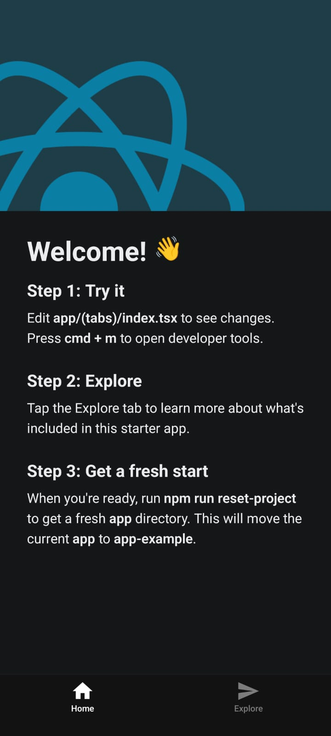

⚠️ If you do not have your phone
You can for now use the web version of the app. After QR code appears, press ‘w’ to open the app in the browser and test the app there. But ultimately you should run and test your app on the phone.

📝 Hot Reload
Every time you save a file (Ctrl+S / Cmd+S), the app on your phone updates automatically. You do not need to rescan the QR code during the session.

1.6 Open the Project in VS Code
Open VS Code -> Press ‘File’ on the top menu bar and select ‘Open Folder’. Then navigate to and open your project folder. If needed ask the faculty for instruction.

1.7 Understanding the Starting Files
Your project contains these key files:
File / Folder | Purpose
app/(tabs)/index.tsx | Entry point — the root component the app renders first
app.json | App config: name, icon, splash screen, permissions
package.json | Dependencies and npm scripts
assets/ | App icon, splash screen image, and other static assets
node_modules/ | Installed packages — never edit or commit this folder
.gitignore | Contains the list of files Git should ignore — node_modules is already listed

Section 2 — Part 1: Static Profile Card
You will now replace the default App/(tabs)/index.tsx content with your own component. In this part the card is static — all data is hardcoded. In later parts you will make it dynamic with props and interactive with state.

2.1 Define the homepage
Open app/(tabs)/index.tsx and delete everything inside. The file should be completely empty. Then type (do not paste — typing builds muscle memory) the following complete file:

app/(tabs)/index.tsx — Step 1: Welcome Message baseline
import { StyleSheet } from "react-native";
import { ThemedText } from "@/components/themed-text";
import { StatusBar } from "expo-status-bar";
import { SafeAreaView } from "react-native-safe-area-context";

export default function App() {
return (
<SafeAreaView style={styles.container}>
<StatusBar style="auto" />
<ThemedText style={styles.title}>Hello, Mobile App Development</ThemedText>
<ThemedText style={styles.subtitle}>Semester: Summer 25-26</ThemedText>
</SafeAreaView>
);
}

const styles = StyleSheet.create({
container: {
flex: 1,
backgroundColor: "#F0F4F8",
alignItems: "center",
justifyContent: "center",
},
title: {
fontSize: 24,
fontWeight: "bold",
color: "#0D1F4E",
margin: 5,
},
subtitle: {
fontSize: 18,
fontWeight: "bold",
color: "#0D1F4E",
margin: 5,
},
});

Save the file. Your phone should update and show two lines containing course name and semester, centred on the screen.

📝 What just happened?
App() is a functional component — a JavaScript function that returns JSX. StyleSheet.create() defines styles as a JavaScript object. flex: 1 makes the View fill the full screen. alignItems and justifyContent centre everything inside.
Your app now should look like this:
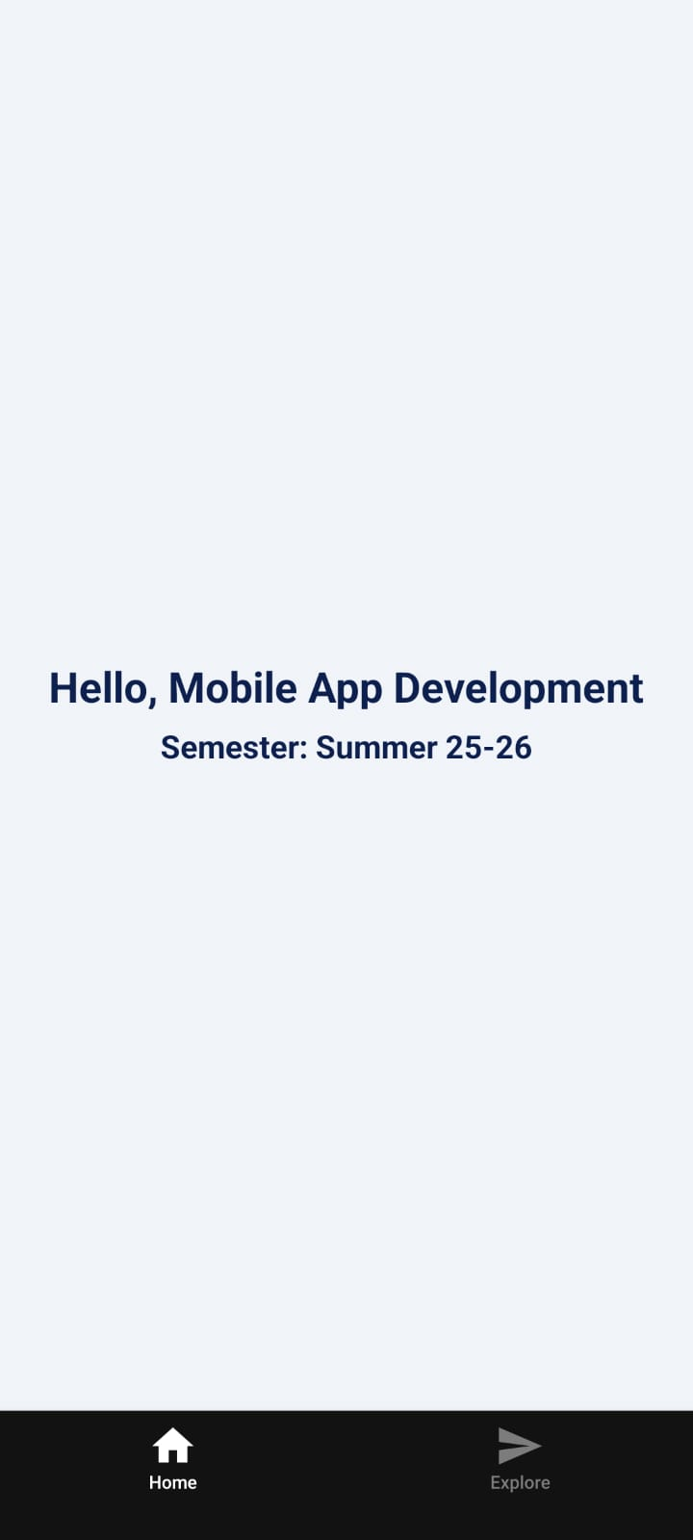
Don’t forget to create a commit!

2.2 Build the Profile Card
Now replace the entire app/(tabs)/index.tsx with the full static profile card. Read every line — there are comments explaining each new element.

app/(tabs)/index.tsx — Static Profile Card
import { StatusBar } from "expo-status-bar";
import { StyleSheet, Text, View, ScrollView } from "react-native";

export default function App() {
return (
// ScrollView allows the page to scroll if content overflows
<ScrollView contentContainerStyle={styles.screen}>
<StatusBar style="dark" />

{/* Card container */}
<View style={styles.card}>
{/* Avatar placeholder */}
<View style={styles.avatar}>
<Text style={styles.avatarText}>SU</Text>
</View>

{/* Name and role */}
<Text style={styles.name}>Md. Sazid Uddin</Text>
<Text style={styles.role}>Computer Science — AIUB</Text>

{/* Divider line */}
<View style={styles.divider} />

{/* Bio text */}
<Text style={styles.bio}>Passionate about mobile development and building tools that make everyday life easier.</Text>
</View>
</ScrollView>
);
}

const styles = StyleSheet.create({
screen: {
flex: 1,
backgroundColor: "#F0F4F8",
alignItems: "center",
paddingTop: 60,
paddingBottom: 40,
},
card: {
backgroundColor: "#FFFFFF",
borderRadius: 16,
padding: 28,
width: "88%",
alignItems: "center",
// Shadow for iOS
shadowColor: "#000",
shadowOffset: { width: 0, height: 2 },
shadowOpacity: 0.08,
shadowRadius: 8,
// Elevation for Android
elevation: 4,
},
avatar: {
width: 88,
height: 88,
borderRadius: 44,
backgroundColor: "#0D9488",
alignItems: "center",
justifyContent: "center",
marginBottom: 16,
},
avatarText: {
color: "#FFFFFF",
fontSize: 28,
fontWeight: "bold",
},
name: {
fontSize: 22,
fontWeight: "bold",
color: "#0D1F4E",
marginBottom: 4,
},
role: {
fontSize: 14,
color: "#64748B",
marginBottom: 16,
},
divider: {
width: "100%",
height: 1,
backgroundColor: "#E2E8F0",
marginBottom: 16,
},
bio: {
fontSize: 14,
color: "#64748B",
textAlign: "center",
lineHeight: 22,
},
});

Save and check your phone. You should see a white card on a light grey background with an avatar circle, your name, role, a divider, and bio text. It should look like this:
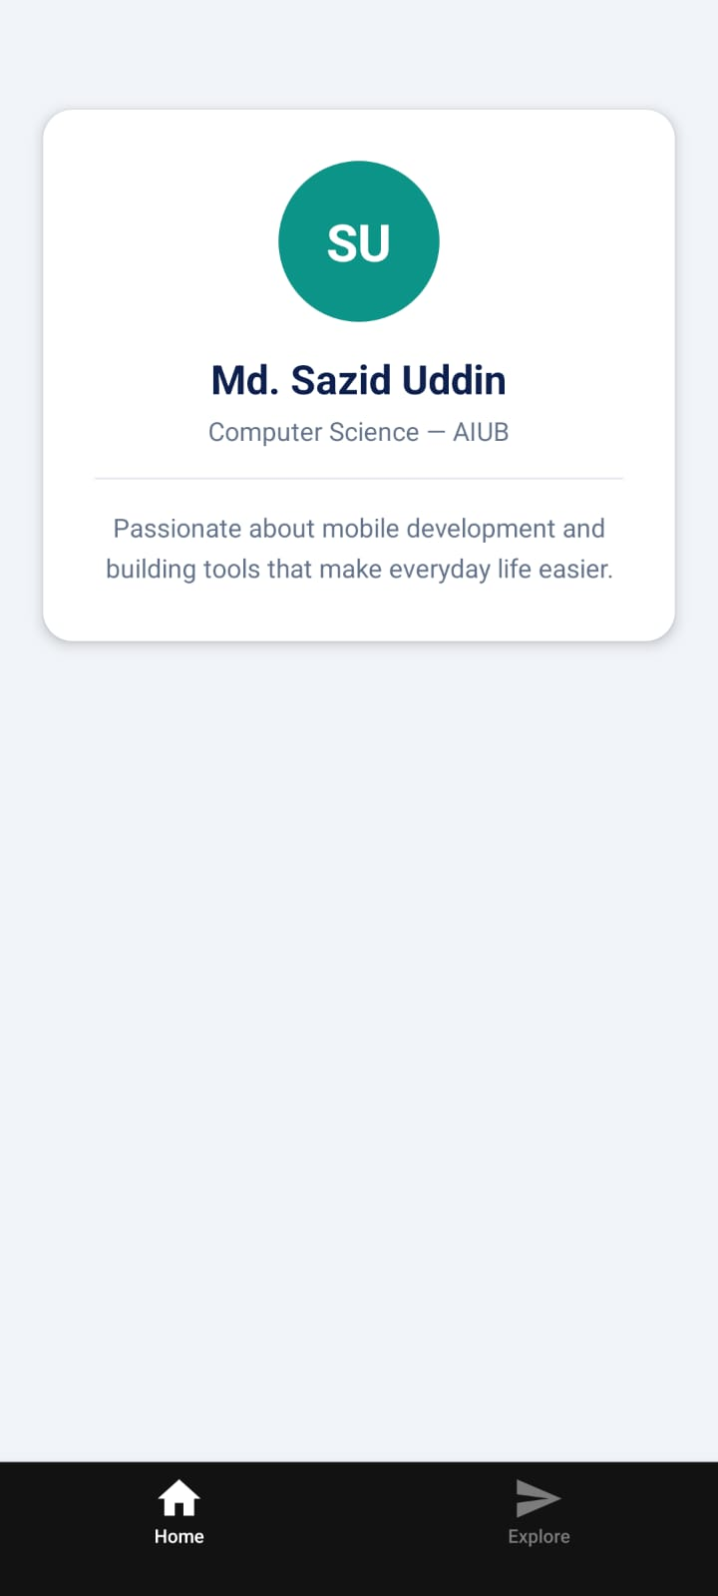
Don’t forget to create a commit!

⚠️ Common errors at this step
Red screen: 'Text strings must be rendered within a <Text> component' — you have a string directly inside a <View>. Every visible string must be inside <Text>.
Red screen: 'StyleSheet.create is not a function' — check your import on line 2.
Nothing changed on phone — did you save the file? Check the terminal for any syntax errors.

Section 3 — Part 2: Props — Reusable Components
Right now all the data is hardcoded inside app/(tabs)/index.tsx. If you wanted to show two profile cards, you would have to duplicate all that code. Props solve this — they let you pass data into a component from outside, making it reusable.

3.1 Create a new component in the components folder
In the StudentCard folder you should see a folder called components. Inside it, create a new file called profile-card.tsx.
Project structure after this step
StudentCard/
├── components/
│ └── profile-card.tsx ← create this
├── assets/
└── ...

3.2 Write the ProfileCard Component
Open components/profile-card.tsx and type the following. Notice the component receives props as its argument and uses them to render dynamic data:

components/profile-card.tsx
import { StyleSheet, Text, View } from "react-native";

// Define the shape of the props our component expects
interface ProfileCardProps {
name: string;
studentId: string;
department: string;
bio: string;
}

// The component receives 'props' — an object containing
// all the data passed in from the parent component.
// We destructure it immediately for clean code.
export default function ProfileCard(name: string, studentId: string, department: string, bio: string) {
// Build initials from the name prop
const initials = name // “Md. Sazid Uddin”
.split(" ") // ['Sazid', 'Uddin']
.map((word) => word[0]) // ['S', 'U']
.join(""); // 'SU'

return (
<View style={styles.card}>
<View style={styles.avatar}>
<Text style={styles.avatarText}>{initials}</Text>
</View>

{/* Use curly braces {} to insert JS variables into JSX */}
<Text style={styles.name}>{name}</Text>
<Text style={styles.idBadge}>ID: {studentId}</Text>
<Text style={styles.role}>{department}</Text>

<View style={styles.divider} />

<Text style={styles.bio}>{bio}</Text>
</View>
);
}

const styles = StyleSheet.create({
card: {
backgroundColor: "#FFFFFF",
borderRadius: 16,
padding: 28,
width: "88%",
alignItems: "center",
shadowColor: "#000",
shadowOffset: { width: 0, height: 2 },
shadowOpacity: 0.08,
shadowRadius: 8,
elevation: 4,
marginBottom: 20,
},
avatar: {
width: 88,
height: 88,
borderRadius: 44,
backgroundColor: "#0D9488",
alignItems: "center",
justifyContent: "center",
marginBottom: 16,
},
avatarText: {
color: "#FFFFFF",
fontSize: 28,
fontWeight: "bold",
},
name: {
fontSize: 22,
fontWeight: "bold",
color: "#0D1F4E",
marginBottom: 2,
},
idBadge: {
fontSize: 12,
color: "#0D9488",
backgroundColor: "#E1F5EE",
paddingHorizontal: 10,
paddingVertical: 3,
borderRadius: 20,
marginBottom: 4,
overflow: "hidden",
},
role: {
fontSize: 14,
color: "#64748B",
marginBottom: 16,
},
divider: {
width: "100%",
height: 1,
backgroundColor: "#E2E8F0",
marginBottom: 16,
},
bio: {
fontSize: 14,
color: "#64748B",
textAlign: "center",
lineHeight: 22,
},
});

3.3 Update app/(tabs)/index.tsx to Use the Component
Now simplify app/(tabs)/index.tsx to import and use the ProfileCard component. Replace the entire file:

app/(tabs)/index.tsx — Using ProfileCard with props
import ProfileCard from "@/components/profile-card";
import { StatusBar } from "expo-status-bar";
import { ScrollView, StyleSheet } from "react-native";

export default function App() {
return (
<ScrollView contentContainerStyle={styles.screen}>
<StatusBar style="dark" />

{/* First card — your own data */}
<ProfileCard name="Asadul Haque" studentId="22-12345-1" department="Computer Science — AIUB" bio="Passionate about mobile development and building tools that make everyday life easier." />

{/* Second card — a classmate's data (same component, different props!) */}
<ProfileCard name="Rakib Rahman" studentId="22-67890-2" department="Computer Science — AIUB" bio="Interested in AI and full-stack web development. Loves competitive programming." />
</ScrollView>
);
}

const styles = StyleSheet.create({
screen: {
backgroundColor: "#F0F4F8",
alignItems: "center",
paddingTop: 60,
paddingBottom: 40,
},
});

Save both files. You should now see two profile cards stacked on the screen — same component, different data. This is the power of props.
Your app should look like this:

Don’t forget to create a commit!

📝 Key insight
You wrote ProfileCard once. You used it twice with different data. In a real app you might render 50 cards this way — after getting information of 50 students from a database — using a single component definition.

Section 4 — Part 3: State — The Follow Button
Props are data from outside. State is data that belongs to the component itself and can change. When state changes, React re-renders the component automatically. You will add a Follow/Unfollow toggle button to the ProfileCard.

4.1 Add useState to ProfileCard
Open components/profile-card.tsx. Make the following changes — the additions are clearly marked with comments:

components/profile-card.tsx — Adding the Follow button
// ADD 'useState' to the react import
import { useState } from 'react';
import { StyleSheet, Text, TouchableOpacity, View } from 'react-native';
// ADD 'TouchableOpacity' to the react-native import

export default function ProfileCard({ name, studentId, department, bio }) {

const initials = name.split(' ').map(word => word[0]).join('');

// NEW: declare a state variable 'followed', starting as false
// setFollowed is the function we call to change it
const [followed, setFollowed] = useState(false);

// NEW: toggle function — flips followed between true and false
const handleFollow = () => {
setFollowed(!followed);
};

return (
<View style={styles.card}>

<View style={styles.avatar}>
<Text style={styles.avatarText}>{initials}</Text>
</View>

<Text style={styles.name}>{name}</Text>
<Text style={styles.idBadge}>ID: {studentId}</Text>
<Text style={styles.role}>{department}</Text>

<View style={styles.divider} />

<Text style={styles.bio}>{bio}</Text>

{/* NEW: Follow button — style changes based on followed state */}
<TouchableOpacity
style={[styles.button, followed && styles.buttonFollowed]}
onPress={handleFollow}
>
<Text style={[styles.buttonText, followed && styles.buttonTextFollowed]}>
{followed ? 'Following ✓' : 'Follow'}
</Text>
</TouchableOpacity>

</View>
);
}

const styles = StyleSheet.create({
// ... keep all existing styles ...
// ADD these new button styles at the bottom:
button: {
marginTop: 20,
paddingVertical: 10,
paddingHorizontal: 32,
borderRadius: 24,
borderWidth: 2,
borderColor: '#0D9488',
backgroundColor: 'transparent',
},
buttonFollowed: {
backgroundColor: '#0D9488', // filled when following
},
buttonText: {
fontSize: 14,
fontWeight: '600',
color: '#0D9488',
},
buttonTextFollowed: {
color: '#FFFFFF', // white text when following
},
});

⚠️ Style arrays
style={[styles.button, followed && styles.buttonFollowed]} is an array of styles. React Native merges them in order — later styles override earlier ones. The second style only applies when followed is true. This is the standard way to apply conditional styles in React Native.

Save the file. Tap the Follow button on each card. Each card tracks its own followed state independently — following Card 1 has no effect on Card 2. This is because each component instance has its own separate state.
You app should now look like this:
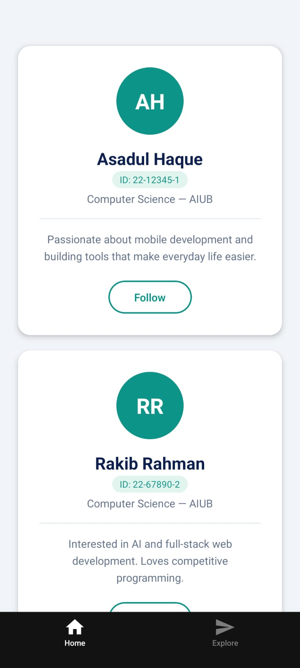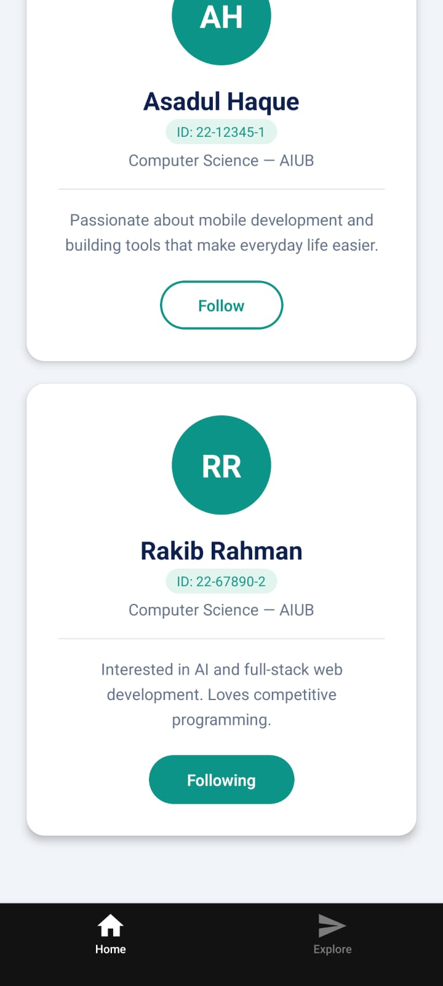

📝 Why each card is independent
Each time you use <ProfileCard .../>, React creates a separate instance of that component with its own state. The followed variable in Card 1 and the followed variable in Card 2 are different variables in memory.
Don’t forget to create a commit!

Section 5 — Part 4: Rendering a List — Skills Section
Profile cards typically show a list of skills or tags. You will add a skills prop to ProfileCard and render the skills dynamically using the map() array method — this is the the most common pattern in all React development.

5.1 Add the Skills Prop
Open app/(tabs)/index.tsx and add a skills prop to each ProfileCard. The value is an array of strings:

app/(tabs)/index.tsx — Adding skills prop
{/* First card — your own data */}
<ProfileCard name="Asadul Haque" studentId="22-12345-1" department="Computer Science — AIUB" bio="Passionate about mobile development and building tools that make everyday life easier." skills={["React Native", "JavaScript", "Node.js", "PostgreSQL"]} />

{/* Second card — a classmate's data (same component, different props!) */}
<ProfileCard name="Rakib Rahman" studentId="22-67890-2" department="Computer Science — AIUB" bio="Interested in AI and full-stack web development. Loves competitive programming." skills={["Python", "Machine Learning", "React", "Django"]} />

{/* Third card — another classmate's data without skills, card will still work */}
<ProfileCard name="Saad Al Rafi" studentId="22-54321-3" department="Computer Science — AIUB" bio="Aspiring software engineer with a passion for mobile apps and UI/UX design." />

5.2 Render the Skills in ProfileCard
Open components/profile-card.tsx. Add skills to the destructured props and add the skills section inside the return JSX, just before the Follow button:

components/profile-card.tsx — Rendering skills with map()
// Update the ProfileCardProps interface to include the new 'skills' prop, which is an optional array of strings
interface ProfileCardProps {
name: string;
studentId: string;
department: string;
bio: string;
skills?: string[]; // NEW: optional array of skills
}

// Update the function signature to include skills
export default function ProfileCard({ name, studentId, department, bio, skills }: ProfileCardProps) {
// ... existing code stays the same ...

return (
<View style={styles.card}>

{/* ... all existing JSX ... */}

{/* NEW: Skills section — add this above the Follow button */}
<View style={styles.skillsContainer}>
{skills.map((skill, index) => (
<View key={index} style={styles.skillBadge}>
<Text style={styles.skillText}>{skill}</Text>
</View>
))}
</View>

<TouchableOpacity ...>
{/* ... */}
</TouchableOpacity>

</View>
);
}

// ADD these new styles to StyleSheet.create():
skillsContainer: {
flexDirection: 'row', // lay badges out horizontally
flexWrap: 'wrap', // wrap to next line when full
justifyContent: 'center',
marginTop: 12,
gap: 8,
},
skillBadge: {
backgroundColor: '#EFF6FF',
borderRadius: 20,
paddingHorizontal: 12,
paddingVertical: 5,
borderWidth: 1,
borderColor: '#BFDBFE',
},
skillText: {
fontSize: 12,
color: '#1D4ED8',
fontWeight: '500',
},

📝 The key prop
When rendering a list with map(), React requires a key prop on each item. The key helps React identify which items have changed. Using the array index (key={index}) is acceptable for static lists. For dynamic lists with add/remove, use a unique ID instead.

Your app should now look like this:
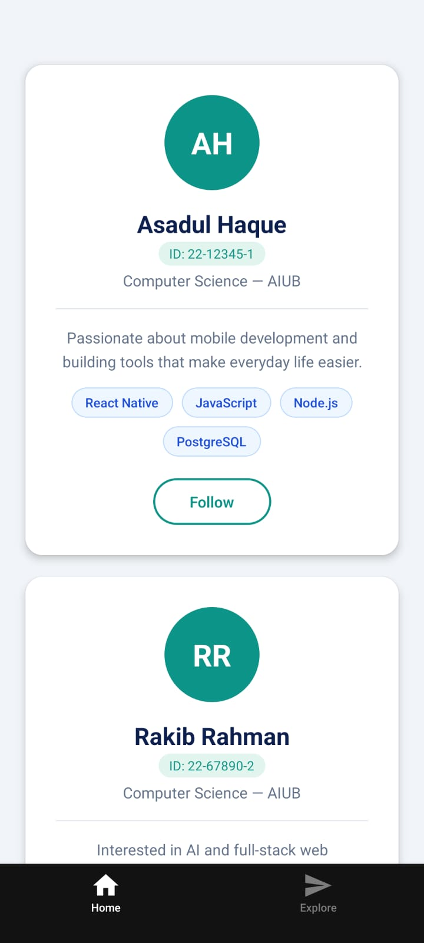
Don’t forget to create a commit!

💡 flexDirection and flexWrap
flexDirection: 'row' lines items up horizontally instead of the default vertical stack. flexWrap: 'wrap' lets badges spill onto a second line when there is not enough horizontal space. This combination is the standard way to build tag/badge layouts in React Native.

Section 6 — Part 5: Final Touches & Git

6.1 Update Your Own Data
Replace the first ProfileCard in App/(tabs)/index.tsx with your own real information (skip if already done):
- Change the name to your full name
- Change studentId to your actual AIUB student ID
- Update the bio to something genuine about yourself
- Change skills to your actual skills (or skills you want to learn)

6.2 Optional Styling Challenge
Try one or more of these improvements:
- Change the avatar background colour — try '#185FA5' (blue) or '#6D2E46' (burgundy)
- Add a 'Followers' counts using another piece of state variable
- Change the screen background colour in app/(tabs)/index.tsx
- Add a borderWidth and borderColor to the card for a more defined look

6.3 Git and GitHub
Assumption:
It is assumed that you are able to manage your project with Git and Github (as a prerequisite from previous courses such as SE and WT). Therefore, we will not cover how to use Git and Github in this course!
You should manage your project on your own. If you need a refresher, there are many great learning resources on the internet.

Remember: Your lab tasks and project submissions will be through Github.

When creating a new expo app with ‘npx create-expo-app@latest’, Expo initializes the project folder as a git repository for you automatically. After each major changes above, I suggested that you should do a git commit. This will help you to go back to an earlier version of the app if needed.

After all commits: Create a GitHub repository
Go to github.com and sign in. Click the '+' icon (top right) and select 'New repository'.
Name it: MAD-StudentCard
Set it to Public (required for lab submission).
Do NOT tick 'Add a README' or 'Add .gitignore' — your project already has these.
Click 'Create repository'.
You can find my code in: https://github.com/sazid-uddin/MAD-StudentCard
Then: Connect and push
Copy the repository URL from GitHub (i.e. https://github.com/yourusername/MAD-StudentCard.git) and run:
Terminal — replace YOURUSERNAME with your GitHub username
git remote add origin https://github.com/YOURUSERNAME/MAD-StudentCard.git
git branch -M main
git push -u origin main

Section 7 — Submission Task

📋 GRADED SUBMISSION — Week 1 Lab Task
Submit by end of tomorrow. Late submissions receive a 20% deduction per day.

7.1 What to Submit
Submit the GitHub repository URL via the following form submission link/QR code:
MAD - Summer 25 - Lab Task 1 Submission – Fill out form

Your repository must contain a working Expo project
Marks: Will be announced later (will count towards the 20% in Lab Performance)

7.3 Submission Checklist
☐ | App runs on phone via Expo Go without any red error screens
☐ | ProfileCard component is in components/profile-card.tsx
☐ | Both cards show different data passed via props
☐ | Follow button on each card works and toggles independently
☐ | Skills section shows at least 3 skills rendered with map()
☐ | First card contains your own real name and student ID
☐ | GitHub repository is public and accessible
☐ | Repository has at least 3 commits with meaningful messages
☐ | node_modules folder is NOT in the repository (skipped by the .gitignore file)
☐ | Repository URL has been submitted through the form link above

Practice Exercises
These exercises are ungraded but highly recommended. They extend what you built today.

Exercise 1 — Stats Row
Add a stats row to ProfileCard that shows 'Followers' and 'Following' counts. The counts should start at 0 and the Followers count should increase by 1 each time the Follow button is pressed (and decrease when unfollowed).

💡 Hint
You will need a second state variable: const [followerCount, setFollowerCount] = useState(0). Update it inside handleFollow based on the current value of followed.

Exercise 2 — Colour Theme Prop
Add a themeColor prop to ProfileCard. Use this prop to set the avatar background colour and the Follow button colour. Pass a different colour to each card from App/(tabs)/index.tsx — for example '#185FA5' and '#6D2E46'.

💡 Hint
In your styles, you cannot use a prop value directly — StyleSheet.create runs once at module level. Instead, pass the style as an inline object: style={{ backgroundColor: themeColor }}

Exercise 3 — Output Tracing (Quiz Practice)
Without running the code, predict the output of the following snippet. Write your answer on paper before checking in VS Code.
Output Tracing — predict without running
const [count, setCount] = useState(5);

const double = () => setCount(count * 2);
const reset = () => setCount(0);

// If the user presses: double → double → reset → double
// What is the final value of count?

Quick Reference

Common Errors & Fixes
Error Message | Fix
Text strings must be rendered within a <Text> component | Wrap all visible text in a <Text> tag. Never place a raw string directly inside <View>.
Cannot read properties of undefined (reading 'map') | The skills prop was not passed. Add a default value: skills = [] in the destructuring.
Unable to resolve module './components/ProfileCard' | Check the file path and filename capitalisation. File names are case-sensitive.
StyleSheet.create is not a function | You forgot to import StyleSheet from 'react-native'.
useState is not a function / not defined | You forgot to import useState: import { useState } from 'react';
App loads but phone shows old version | Press 'r' in the Expo terminal to force reload, or shake the phone and tap 'Reload'.

Key Commands
Command | What it does
npx create-expo-app MyApp | Create a new Expo project in a folder called MyApp
npx expo start --tunnel | Start the Expo development server and show the QR code
r (in Expo terminal) | Force reload the app on all connected devices
Ctrl+C (in terminal) | Stop the Expo development server
git init | Initialise a new Git repository in the current folder
git add . | Stage all changed files for commit
git commit -m "message" | Create a commit with the staged changes
git push | Push committed changes to GitHub

End of Week 1 Lab Manual

