 | American International University-Bangladesh
MOBILE APPLICATION DEVELOPMENT
with React Native & Expo
Lab Manual — Week 2: React Native Core UI & Building a Student Directory

Faculty | Md. Sazid Uddin
Department | Computer Science, Faculty of Science and Technology, AIUB
Semester | Summer 2025–26 Semester
Lab Session | Week 2
Duration | 3 hours
App to Build | StudentDirectory — a searchable, scrollable list of student profile cards with a tappable detail view

Lab Overview
In this session you will build StudentDirectory — a mobile app that displays a list of student profile cards, lets users search the list in real time, shows an avatar image for each student, and taps into a simple detail view. Every component from the corresponding theory class appears in this app.

📝 What you will build
StudentDirectory renders a list of students using FlatList. A TextInput search bar at the top filters the list live as the user types. Each row shows a remote avatar image, name, and department. Tapping a row expands a detail section below the list without navigation — just conditional rendering with useState. All code is TypeScript (.tsx).

Learning Objectives
By the end of this lab you will be able to:
- Use FlatList to render a dynamic list with keyExtractor and renderItem
- Filter a list in real time using TextInput and useState
- Display remote images using the Image component with resizeMode
- Apply Flexbox row layouts inside list item components
- Use TouchableOpacity to handle item selection
- Conditionally render a detail view using state
- Define component prop types using a TypeScript interface

Project Structure
By the end of the session your project will look like this:
Project structure after this session
StudentDirectory/
├── app/
│ └── (tabs)/
│ └── index.tsx ← entry point (main screen)
├── components/
│ ├── search-bar.tsx ← search input component
│ ├── student-item.tsx ← single row in the list
│ └── student-detail.tsx ← expanded detail card
├── data/
│ └── students.ts ← static student data array
└── ...

Section 1 — Project Setup
If you do not have a project from last week, create a fresh one. If you already have StudentCard from Week 1, you can create a new project alongside it.

1.1 Create the Project
Step 1: Create a new Expo project
Open a terminal and run the following. This time we are specifying that our SDK is 54, so that it doesn’t ask us like before.
Terminal
npx create-expo-app@latest StudentDirectory --template default@sdk-54

Step 2: Navigate into the project and install the tunnel package
Terminal
cd StudentDirectory
npm install -g @expo/ngrok@^4.1.0

Step 3: Start the development server
The --tunnel flag routes traffic through a public URL so Expo Go works even without shared Wi-Fi.
Terminal
npx expo start --tunnel

Step 4: Open on your device or browser
Scan the QR code with Expo Go, OR press w to open in the web browser if no device is available.

💡 No device available?
Press w in the Expo terminal to open the app in your web browser. Most functionality works. FlatList, Image, and TouchableOpacity all render in the web view. Note: some platform-specific props (elevation, shadow) may look slightly different in the browser.

1.2 Create the Data File
Create a data/ folder in the project root. Inside it create students.ts — this is the static dataset the app will render.
data/students.ts
// data/students.ts

export interface Student {
id: string;
name: string;
studentId: string;
department: string;
bio: string;
skills: string[];
avatarUrl: string;
}

export const STUDENTS: Student[] = [
{
id: "1",
name: "Rakib Rahman",
studentId: "22-12345-1",
department: "Computer Science",
bio: "Passionate about mobile development and building tools that make everyday life easier.",
skills: ["React Native", "TypeScript", "Node.js"],
avatarUrl: "https://i.pravatar.cc/150?img=1",
},
{
id: "2",
name: "Ayesha Rahman",
studentId: "22-67890-2",
department: "Computer Science",
bio: "Interested in AI and full-stack web development.",
skills: ["Python", "Machine Learning", "React"],
avatarUrl: "https://i.pravatar.cc/150?img=2",
},
{
id: "3",
name: "Tariq Hassan",
studentId: "22-11111-3",
department: "Software Engineering",
bio: "Backend enthusiast with a love for system design and databases.",
skills: ["Java", "Spring Boot", "PostgreSQL"],
avatarUrl: "https://i.pravatar.cc/150?img=3",
},
{
id: "4",
name: "Nusrat Jahan",
studentId: "22-22222-4",
department: "Computer Science",
bio: "UI/UX focused developer who loves turning wireframes into polished products.",
skills: ["Figma", "React", "CSS"],
avatarUrl: "https://i.pravatar.cc/150?img=5",
},
{
id: "5",
name: "Rafiq Islam",
studentId: "22-33333-5",
department: "Software Engineering",
bio: "Competitive programmer who enjoys algorithmic challenges.",
skills: ["C++", "Algorithms", "Python"],
avatarUrl: "https://i.pravatar.cc/150?img=8",
},
{
id: "6",
name: "Sumaiya Akter",
studentId: "22-44444-6",
department: "Computer Science",
bio: "Interested in cloud computing and DevOps practices.",
skills: ["AWS", "Docker", "Linux"],
avatarUrl: "https://i.pravatar.cc/150?img=9",
},
];

📝 pravatar.cc
https://i.pravatar.cc/150?img=N is a free placeholder avatar service. Changing N gives you a different face. No sign-up needed. The images are served over HTTPS so Expo loads them without any extra configuration.
Create a commit at this point before proceeding!

Section 2 — Part 1: The StudentItem Component
Before building the list, you need the component that renders a single row. This component uses a Flexbox row layout, an Image for the avatar, and a TouchableOpacity to handle taps.

2.1 Create components/student-item.tsx
Create the components/ folder in the project root. Inside it create student-item.tsx and type the following:

components/student-item.tsx
// components/student-item.tsx

import { Image, StyleSheet, Text, TouchableOpacity, View } from "react-native";
import { Student } from "../data/students";

// TypeScript interface — defines exactly what props this component accepts
interface StudentItemProps {
student: Student;
onPress: (student: Student) => void;
isSelected: boolean;
}

export default function StudentItem({ student, onPress, isSelected }: StudentItemProps) {
return (
<TouchableOpacity
style={[styles.row, isSelected && styles.rowSelected]}
onPress={() => onPress(student)}
activeOpacity={0.7}
>
{/* Avatar image */}
<Image
source={{ uri: student.avatarUrl }}
style={styles.avatar}
resizeMode="cover"
/>

{/* Text content */}
<View style={styles.info}>
<Text style={styles.name} numberOfLines={1}>
{student.name}
</Text>
<Text style={styles.department} numberOfLines={1}>
{student.department}
</Text>
<Text style={styles.id}>ID: {student.studentId}</Text>
</View>

{/* Chevron indicator */}
<Text style={styles.chevron}>{isSelected ? "▲" : "▶"}</Text>
</TouchableOpacity>
);
}

const styles = StyleSheet.create({
row: {
flexDirection: "row", // lay children horizontally
alignItems: "center", // vertically centre within the row
paddingVertical: 12,
paddingHorizontal: 16,
backgroundColor: "#FFFFFF",
borderBottomWidth: 1,
borderBottomColor: "#F1F5F9",
},
rowSelected: {
backgroundColor: "#E1F5EE", // highlight when selected
},
avatar: {
width: 52,
height: 52,
borderRadius: 26, // half of width/height = circle
marginRight: 14,
},
info: {
flex: 1, // take all remaining horizontal space
},
name: {
fontSize: 15,
fontWeight: "600",
color: "#0D1F4E",
marginBottom: 2,
},
department: {
fontSize: 12,
color: "#0D9488",
marginBottom: 2,
},
id: {
fontSize: 11,
color: "#94A3B8",
},
chevron: {
fontSize: 12,
color: "#CBD5E1",
marginLeft: 8,
},
});

📝 Why flex: 1 on info
The row has flexDirection: 'row'. The avatar has a fixed width (52). The chevron has a fixed width. Setting flex: 1 on the info View tells it to take all the remaining horizontal space between those two fixed elements. Without it, the text column would shrink to fit its content and the chevron would be pushed left.

⚠️ Image needs width and height
Unlike web browsers, React Native's Image component will not display if width and height are not set. The image will render as a 0×0 box. Always set explicit dimensions.

2.2 Update app/(tabs)/index.tsx to show the list of students using the newly created component
Delete all existing code in app/(tabs)/index.tsx and insert the following code. This will use the STUNDENTS data in data/students.ts and for each student, create a new instance of the StudentItem component.

app/(tabs)/index.tsx
import { StyleSheet, View } from "react-native";
// Importing our custom StudentItem component to display each student in the list
import StudentItem from "@/components/student-item";
// Importing the list of students from our data file
import { STUDENTS } from "@/data/students";

export default function HomeScreen() {
return (
// View is the container that contains the list of students.
// We map over the STUDENTS array and render a StudentItem for each student.
<View style={styles.container}>
{STUDENTS.map((student) => (
<StudentItem key={student.id} student={student} onPress={() => {}} isSelected={false} />
))}
</View>
);
}

const styles = StyleSheet.create({
container: {
flex: 1,
},
titleContainer: {
flexDirection: "row",
alignItems: "center",
gap: 8,
},
stepContainer: {
gap: 8,
marginBottom: 8,
},
reactLogo: {
height: 178,
width: 290,
bottom: 0,
left: 0,
position: "absolute",
},
});

📝 Your app now should look like this:
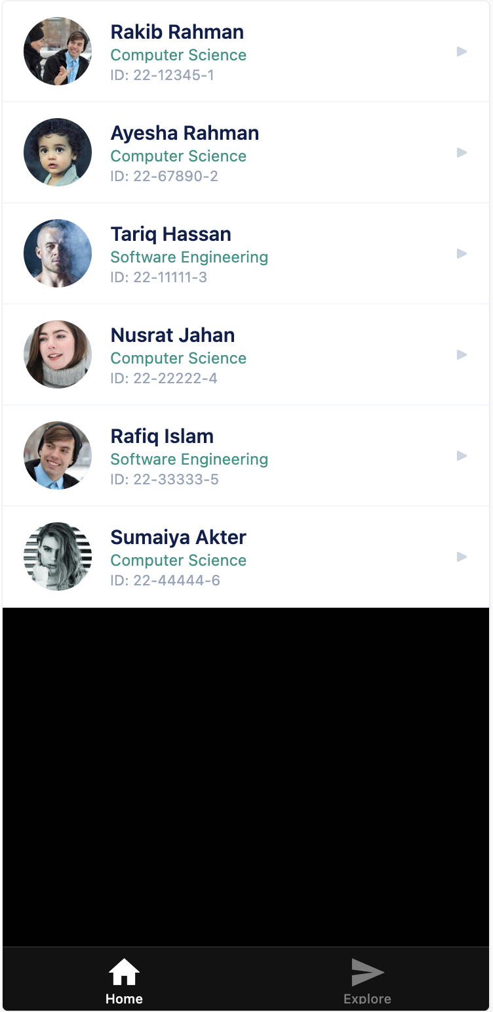
Create a commit at this point before proceeding!

Section 3 — Part 1: The SearchBar Component

3.1.1 Creating the serach bar component
The SearchBar is a controlled TextInput component. It receives its value and onChange handler as props — the parent (app/(tabs)/index.tsx) owns the state.
Create a new component file in components/search-bar.tsx

components/search-bar.tsx
// components/search-bar.tsx

import { StyleSheet, TextInput, View } from "react-native";

interface SearchBarProps {
value: string;
onChangeText: (text: string) => void;
placeholder?: string; // the ? means this prop is optional
}

export default function SearchBar({ value, onChangeText, placeholder }: SearchBarProps) {
return (
<View style={styles.container}>
<TextInput
style={styles.input}
value={value}
onChangeText={onChangeText}
placeholder={placeholder ?? "Search students..."}
placeholderTextColor="#94A3B8"
autoCapitalize="none"
autoCorrect={false}
clearButtonMode="while-editing" // iOS only: shows × button
returnKeyType="search"
/>
</View>
);
}

const styles = StyleSheet.create({
container: {
paddingHorizontal: 16,
paddingVertical: 10,
backgroundColor: "#FFFFFF",
borderBottomWidth: 1,
borderBottomColor: "#E2E8F0",
},
input: {
backgroundColor: "#F1F5F9",
borderRadius: 10,
paddingHorizontal: 14,
paddingVertical: 10,
fontSize: 15,
color: "#1E293B",
},
});

📝 ?? — the Nullish Coalescing operator
placeholder ?? "Search students..." means: use placeholder if it has a value, otherwise use the fallback string. It is similar to || but only falls back on null or undefined, not on 0 or empty string. TypeScript's optional prop (placeholder?) means the caller does not have to pass it.

3.1.2 Update app/(tabs)/index.tsx to show the search bar using the newly created component
In (app/(tabs)/index.tsx) import and add the search bar on top of the student list.
app/(tabs)/index.tsx
import { StyleSheet, View } from "react-native";
// Importing our custom StudentItem component to display each student in the list
import StudentItem from "@/components/student-item";
// Importing the list of students from our data file
import { STUDENTS } from "@/data/students";
// NEW: Importing the SearchBar component to allow users to search for students
import SearchBar from "@/components/search-bar";

export default function HomeScreen() {
return (
// View is the container that contains the list of students and search bar
<View style={styles.container}>
{/* // NEW: Search Bar */}
<SearchBar value="" onChangeText={() => {}} />

{/* // We map over the STUDENTS array and render a StudentItem for each student. */}
{STUDENTS.map((student) => (
<StudentItem key={student.id} student={student} onPress={() => {}} isSelected={false} />
))}
</View>
);
}

// existing styles remain here

Reload your app and check: the search bar has appeared in the app but we cannot type anything into it yet.
We will keep the search bar as it is now and move on to the next section.
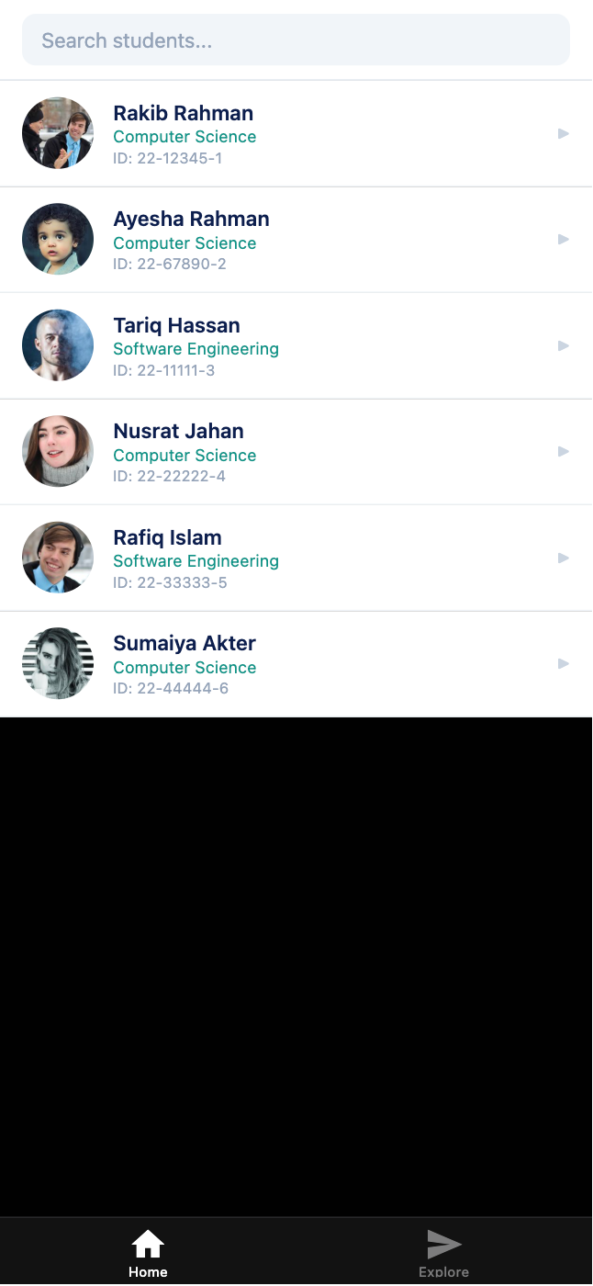

Section 3 — Part 2: Integrating the SearchBar in the Home Page (index.tsx)

3.2.1 Add the state for the search bar query in app/(tabs)/index.tsx
Along with replacing the root element View with a ScrollView. Also we have added a page title. The most important thing to note here is the state variable ‘query’. ‘query’ will store our search term for the search bar. Every time we write something new in the SearchBar, ‘setQuery’ is called to update the value of ‘query’.
app/(tabs)/index.tsx
import { ScrollView, StyleSheet, Text, View } from "react-native";
// Importing our custom StudentItem component to display each student in the list
import StudentItem from "@/components/student-item";
// Importing the list of students from our data file
import { STUDENTS } from "@/data/students";
// NEW: Importing the SearchBar component to allow users to search for students
import SearchBar from "@/components/search-bar";
import { useState } from "react";

export default function HomeScreen() {
// State 1: the current search query
const [query, setQuery] = useState<string>("");

return (
// View is the container that contains the list of students and search bar
<ScrollView style={styles.container}>
{/* NEW: Add a page title for the student list */}
<View style={styles.titleBar}>
<Text style={styles.title}>Student Directory</Text>
</View>

{/* // NEW: update the value and onChangeText function in the Search Bar */}
<SearchBar value={query} onChangeText={setQuery} />

{/* // We map over the STUDENTS array and render a StudentItem for each student. */}
{STUDENTS.map((student) => (
<StudentItem key={student.id} student={student} onPress={() => {}} isSelected={false} />
))}
</ScrollView>
);
}

const styles = StyleSheet.create({
container: {
flex: 1,
backgroundColor: "#F0F4F8",
},
titleContainer: {
flexDirection: "row",
alignItems: "center",
gap: 8,
},
stepContainer: {
gap: 8,
marginBottom: 8,
},
reactLogo: {
height: 178,
width: 290,
bottom: 0,
left: 0,
position: "absolute",
},
// NEW: styles for the title bar
titleBar: {
flexDirection: "row",
justifyContent: "space-between",
alignItems: "center",
paddingHorizontal: 16,
paddingVertical: 14,
backgroundColor: "#0D1F4E",
},
title: {
fontSize: 20,
fontWeight: "bold",
color: "#FFFFFF",
},
count: {
fontSize: 12,
color: "#CCFBF1",
},
});
At this point we can write in the search bar, but it still does not filter the student list. Next we will implement the filter system.
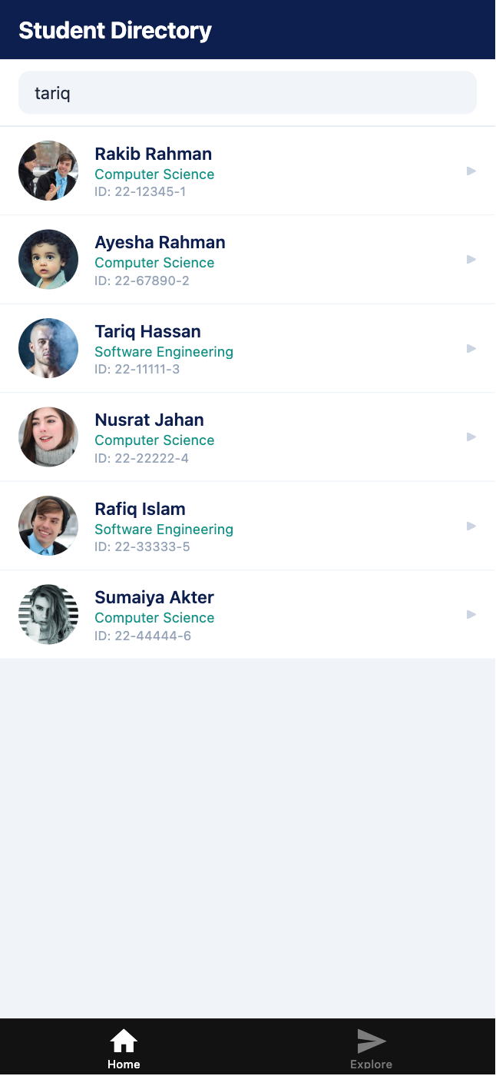

3.2.2 Filtering the students list
Currently we are showing all students in our page by the mapping the STUDENTS array:
{STUDENTS.map((student) => (
<StudentItem key={student.id} student={student} onPress={() => {}} isSelected={false} />
))}

We are going to replace it with a FlatList and add another variable called ‘filtered’ array which will hold the filtered list. Student list in the UI will now be rendered from this ‘filtered’ array instead of the original STUDENTS array:
app/(tabs)/index.tsx
import { FlatList, ScrollView, StyleSheet, Text, View } from "react-native";
// Importing our custom StudentItem component to display each student in the list
import StudentItem from "@/components/student-item";
// Importing the list of students from our data file
import { Student, STUDENTS } from "@/data/students";
// NEW: Importing the SearchBar component to allow users to search for students
import SearchBar from "@/components/search-bar";
import { useState } from "react";

export default function HomeScreen() {
// State 1: the current search query
const [query, setQuery] = useState<string>("");

// Derived value: filter students based on query
// This is NOT state — it is computed from state every render
const filtered = STUDENTS.filter((s) => {
return (
s.name.toLowerCase().includes(query.toLowerCase()) || // check if name matches query OR
s.department.toLowerCase().includes(query.toLowerCase()) // check if department matches query
);
});

return (
// View is the container that contains the list of students and search bar
<ScrollView style={styles.container}>
<View style={styles.titleBar}>
<Text style={styles.title}>Student Directory</Text>
</View>

{/* update the value and onChangeText function in the Search Bar */}
<SearchBar value={query} onChangeText={setQuery} />

{/* NEW: Student list using React Native's FlatList component*/}
<FlatList
data={filtered}
keyExtractor={(item) => item.id}
renderItem={({ item }) => <StudentItem student={item} onPress={() => {}} isSelected={false} />}
ListEmptyComponent={
<View style={styles.empty}>
<Text style={styles.emptyText}>No students match "{query}"</Text>
</View>
}
/>
</ScrollView>
);
}

const styles = StyleSheet.create({
container: {
flex: 1,
backgroundColor: "#F0F4F8",
},
titleContainer: {
flexDirection: "row",
alignItems: "center",
gap: 8,
},
stepContainer: {
gap: 8,
marginBottom: 8,
},
reactLogo: {
height: 178,
width: 290,
bottom: 0,
left: 0,
position: "absolute",
},
// NEW: styles for the title bar
titleBar: {
flexDirection: "row",
justifyContent: "space-between",
alignItems: "center",
paddingHorizontal: 16,
paddingVertical: 14,
backgroundColor: "#0D1F4E",
},
title: {
fontSize: 20,
fontWeight: "bold",
color: "#FFFFFF",
},
count: {
fontSize: 12,
color: "#CCFBF1",
},
empty: {
padding: 40,
alignItems: "center",
},
emptyText: {
fontSize: 14,
color: "#94A3B8",
},
});

📝 FlatList
FlatList is a tool that takes an array of data and renders the information in the UI according to our specifications (how each element in the array should be rendered, what should be rendered if the array empty etc.)

FlatList has these props:
1. data: the array that will be used as the data source
2. keyExtractor: works like a primary key. We are setting the student’d ‘id’ property as key
3. renderItem: for each item in ‘data’, we tell FlatList what compnent to render. In our case it is a <StudentItem> for every entry in the filtered list.
4. ListEmptyComponent: what to render when ‘data’ is empty. In our case, ‘data’ will be empty when a search query does not match with any students name or department.

Bonus tip: We know that in React Native, UI only updates when a state variable changes. But you may wonder why the list updates when the filtered array changes since ‘filtered’ is a regular variable and not a state variable. You are correct: ‘filtered’ is not a state variable. But the UI refreshes not because ‘filtered’ array updated, it refreshes because the ‘query’ variable updates. ‘query’ IS a state variable and causes the UI to re-render when its value changes.

3.3.3 Check Your App
Save all files. Your app should now show:
- A dark navy title bar showing 'Student Directory' and the student count
- A search bar below the title
- A scrollable list of 6 students, each with an avatar, name, department, and ID
- Typing in the search bar filters the list live

You can search with both name and department name:
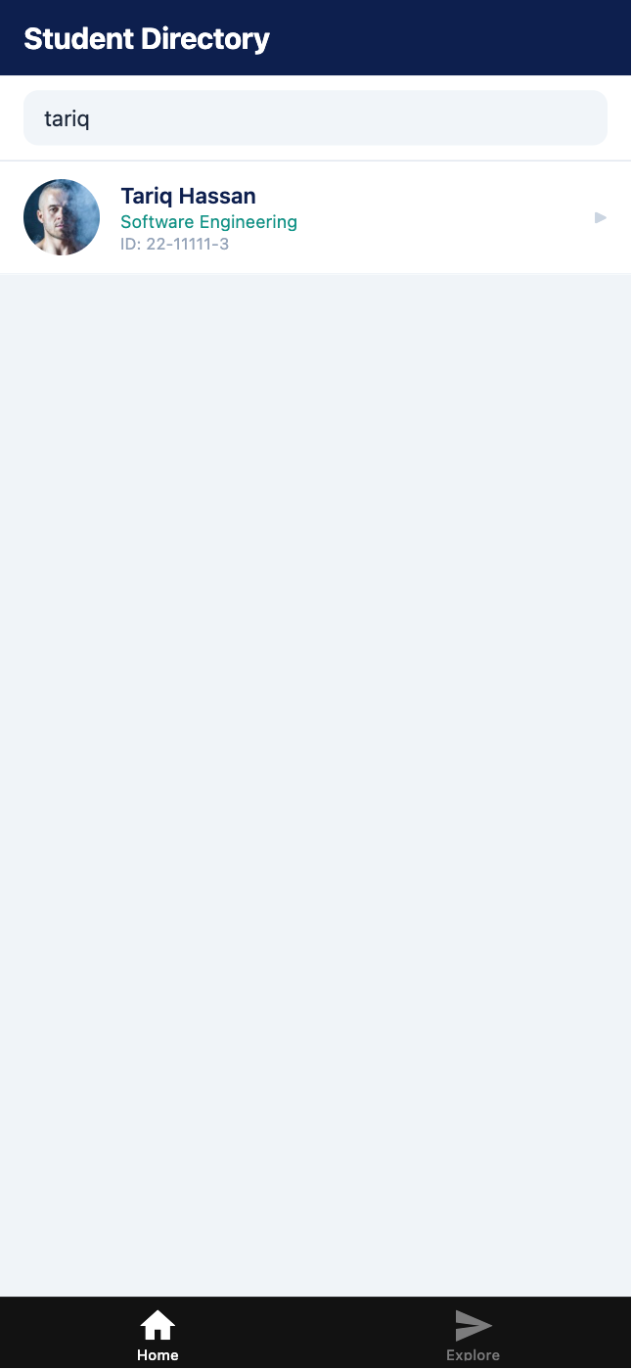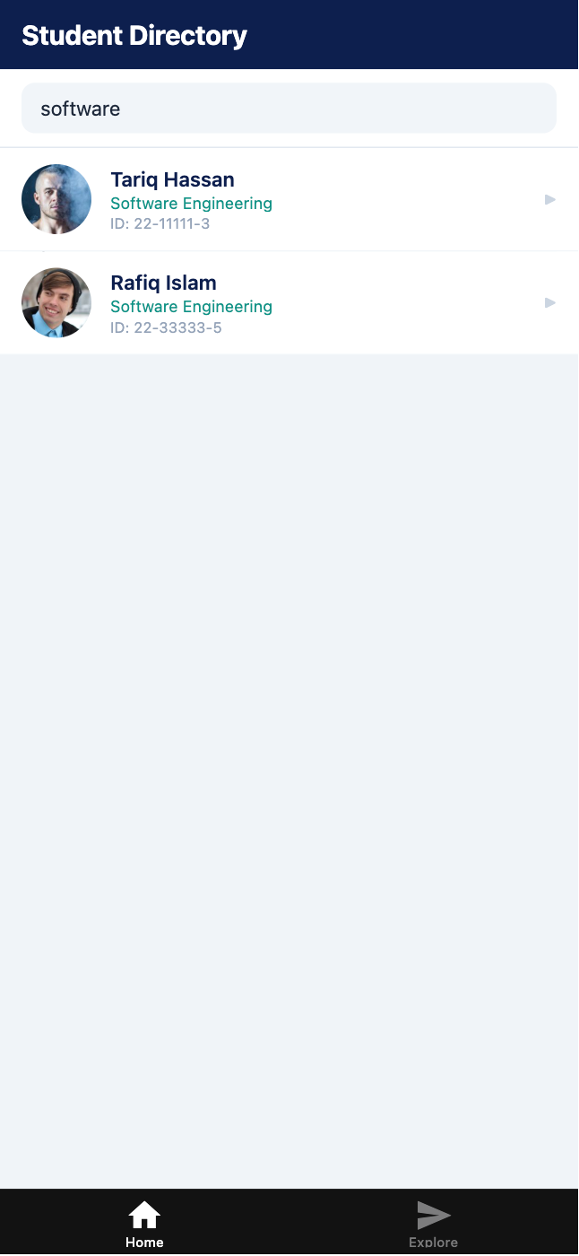
Create a commit at this point before proceeding!

💡 Understanding the derived value pattern
The filtered array is not stored in state — it is computed directly from STUDENTS and query on every render. This is the correct React pattern. If you stored filtered in state you would need to keep it in sync with query manually, which leads to bugs. React is fast enough to recompute the filter on every keystroke.

Section 5 — Part 3: The StudentDetail Component

5.1 Create the StudentDetail component
When a student row is tapped, this component renders below the list showing full details: bio and skills badges. It uses the same skill rendering pattern from Week 1. Create the following component:

components/student-detail.tsx
// components/student-detail.tsx

import { ScrollView, StyleSheet, Text, View } from "react-native";
import { Student } from "../data/students";

interface StudentDetailProps {
student: Student;
}

export default function StudentDetail({ student }: StudentDetailProps) {
return (
<View style={styles.card}>

{/* Header row: name + department */}
<Text style={styles.name}>{student.name}</Text>
<Text style={styles.department}>{student.department}</Text>
<Text style={styles.idBadge}>ID: {student.studentId}</Text>

<View style={styles.divider} />

{/* Bio */}
<Text style={styles.sectionLabel}>About</Text>
<Text style={styles.bio}>{student.bio}</Text>

{/* Skills */}
<Text style={styles.sectionLabel}>Skills</Text>
<View style={styles.skillsRow}>
{student.skills.map((skill, index) => (
<View key={index} style={styles.skillBadge}>
<Text style={styles.skillText}>{skill}</Text>
</View>
))}
</View>

</View>
);
}

const styles = StyleSheet.create({
card: {
margin: 12,
padding: 20,
backgroundColor: "#FFFFFF",
borderRadius: 14,
elevation: 3,
shadowColor: "#000",
shadowOffset: { width: 0, height: 1 },
shadowOpacity: 0.06,
shadowRadius: 6,
},
name: {
fontSize: 18,
fontWeight: "bold",
color: "#0D1F4E",
marginBottom: 2,
},
department: {
fontSize: 13,
color: "#0D9488",
marginBottom: 6,
},
idBadge: {
fontSize: 11,
color: "#0D9488",
backgroundColor: "#E1F5EE",
alignSelf: "flex-start",
paddingHorizontal: 10,
paddingVertical: 3,
borderRadius: 20,
overflow: "hidden",
marginBottom: 14,
},
divider: {
height: 1,
backgroundColor: "#F1F5F9",
marginBottom: 14,
},
sectionLabel: {
fontSize: 11,
fontWeight: "700",
color: "#94A3B8",
textTransform: "uppercase",
letterSpacing: 1,
marginBottom: 6,
},
bio: {
fontSize: 13,
color: "#64748B",
lineHeight: 20,
marginBottom: 14,
},
skillsRow: {
flexDirection: "row",
flexWrap: "wrap",
gap: 8,
},
skillBadge: {
backgroundColor: "#EFF6FF",
borderRadius: 20,
paddingHorizontal: 12,
paddingVertical: 4,
borderWidth: 1,
borderColor: "#BFDBFE",
},
skillText: {
fontSize: 12,
color: "#1D4ED8",
fontWeight: "500",
},
});

📝 alignSelf: 'flex-start'
By default, children stretch to fill the parent's cross axis (alignItems: stretch on the parent). Setting alignSelf: 'flex-start' on the ID badge overrides this just for that element, making it shrink to fit its content width rather than stretching full-width.

⚠️ selectedStudent?.id — optional chaining
selectedStudent is typed as Student | null. Writing selectedStudent.id would cause a TypeScript error because selectedStudent might be null. The ?. operator short-circuits: if selectedStudent is null, the whole expression evaluates to undefined instead of crashing.

5.2 Integrate the StudentDetails component into the home page
Import the student details component into the home page and update the code accordingly. Notice the *NEW* section of the code. We have added:
- A new state variable called ‘selectedStudent’ to keep track of which student the user has selected. Selected student’s details will be shown below the list using the StudentsDetails component
- At the end of the our home page UI we have added the StudentDetail component, but it renders conditionally: ‘selectedStudent && <StudentDetail>’ means StudentDetail componenet will only be shown when selectedStudent has a non-null value.
- In the renderItem of the FlatList, we updated the onPress and isSelected props.
  - onPress defines what happens when we press a student’s row in the student list.
  - isSelected defines styles for the selected student (it gets a light green background).
app/(tabs)/index.tsx
import { FlatList, ScrollView, StyleSheet, Text, View } from "react-native";
import StudentItem from "@/components/student-item";
import { Student, STUDENTS } from "@/data/students";
import SearchBar from "@/components/search-bar";
// NEW: import the StudentDetail component to show student details when selected
import StudentDetail from "@/components/student-detail";
import { useState } from "react";

export default function HomeScreen() {
// State 1: the current search query
const [query, setQuery] = useState<string>("");

// NEW: State 2: the currently selected student (null = none selected)
const [selectedStudent, setSelectedStudent] = useState<Student | null>(null);

// NEW: Toggle selection: tap same student to select and deselect
const handleSelect = (student: Student) => {
setSelectedStudent((prev) => (prev?.id === student.id ? null : student));
};

// Derived value: filter students based on query
// This is NOT state — it is computed from state every render
const filtered = STUDENTS.filter((s) => {
return (
s.name.toLowerCase().includes(query.toLowerCase()) || // check if name matches query OR
s.department.toLowerCase().includes(query.toLowerCase()) // check if department matches query
);
});

return (
// View is the container that contains the list of students and search bar
<ScrollView style={styles.container}>
<View style={styles.titleBar}>
<Text style={styles.title}>Student Directory</Text>
</View>

{/* update the value and onChangeText function in the Search Bar */}
<SearchBar value={query} onChangeText={setQuery} />

<FlatList
data={filtered}
keyExtractor={(item) => item.id}
// NEW: update the onPress handler to toggle selection and pass isSelected prop to StudentItem
// and the isSelected prop is used to conditionally style the selected student item in the list (e.g., highlight it)
renderItem={({ item }) => <StudentItem student={item} onPress={handleSelect} isSelected={selectedStudent?.id === item.id} />}
ListEmptyComponent={
<View style={styles.empty}>
<Text style={styles.emptyText}>No students match "{query}"</Text>
</View>
}
/>

{/* NEW: Detail panel — only shown when a student is selected */}
{selectedStudent && <StudentDetail student={selectedStudent} />}
</ScrollView>
);
}

const styles = StyleSheet.create({
container: {
flex: 1,
backgroundColor: "#F0F4F8",
},
titleContainer: {
flexDirection: "row",
alignItems: "center",
gap: 8,
},
stepContainer: {
gap: 8,
marginBottom: 8,
},
reactLogo: {
height: 178,
width: 290,
bottom: 0,
left: 0,
position: "absolute",
},
// NEW: styles for the title bar
titleBar: {
flexDirection: "row",
justifyContent: "space-between",
alignItems: "center",
paddingHorizontal: 16,
paddingVertical: 14,
backgroundColor: "#0D1F4E",
},
title: {
fontSize: 20,
fontWeight: "bold",
color: "#FFFFFF",
},
count: {
fontSize: 12,
color: "#CCFBF1",
},
empty: {
padding: 40,
alignItems: "center",
},
emptyText: {
fontSize: 14,
color: "#94A3B8",
},
});

5.1 Reload and check your app
At this point we have completed our StudentDirectory project. It lets us:
1. Search the student list.
2. Select a student to view his/her details.

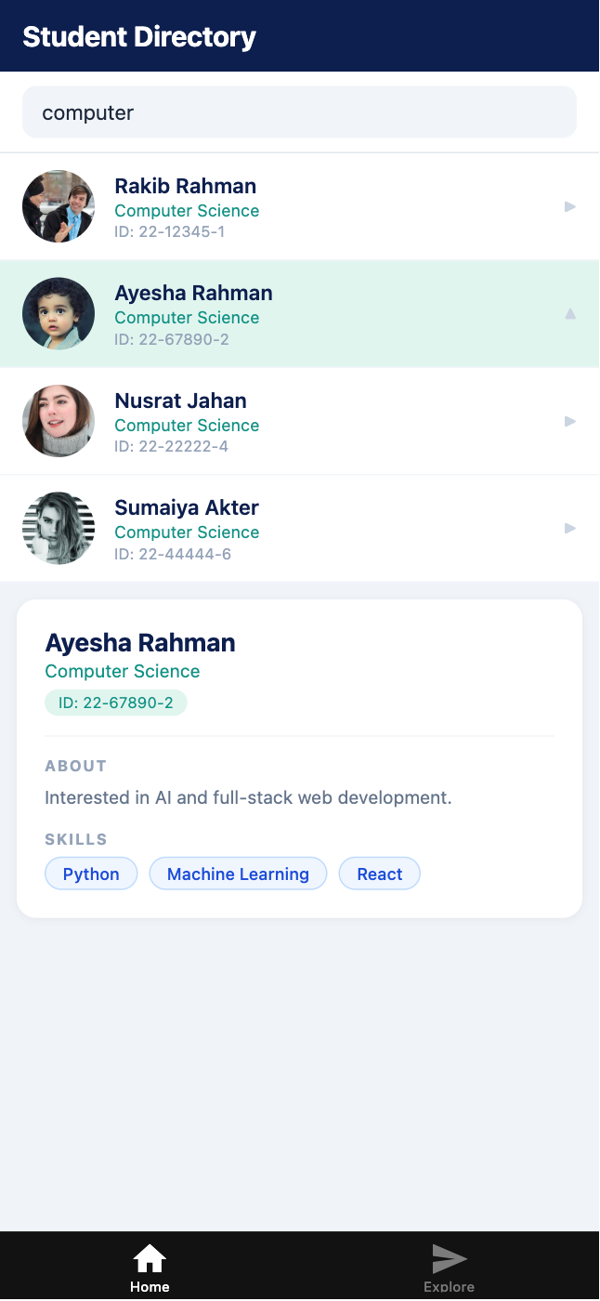
Create a commit at this point before proceeding!

Section 6 — Git Commits
Make at least 3 commits as you work — one per major section. Good commit discipline is part of the grading criteria.

Terminal — suggested commit points
git add .
git commit -m "Add student data file and TypeScript interface"

git add .
git commit -m "Add StudentItem component with Flexbox row layout and Image"

git add .
git commit -m "Add SearchBar, StudentDetail, and wire up index.tsx"

📝 Commit at each section, not just at the end
The git history reviewer will check whether your commits reflect real progress. Three commits all made at 11:58pm look suspicious. Commit after each section is complete.

Section 7 — Submission Task

📋 GRADED SUBMISSION — Week 2 Lab Task
Submit the GitHub repository URL via the course portal. Late submissions receive a 10% deduction per day.

7.1 Create a Department Filter Tab
Above the search bar, add a horizontal row of filter tabs: All, Computer Science, Software Engineering. Tapping a tab filters the list to show only students from that department. The active tab should have a highlighted style.
💡 Hint
Add a departmentFilter state (string). Combine it with the search filter: show students where name/department matches the query AND department matches the tab filter. Use a horizontal ScrollView or flexDirection: 'row' View for the tabs.

Including the dept. filter tab your app should look like this:
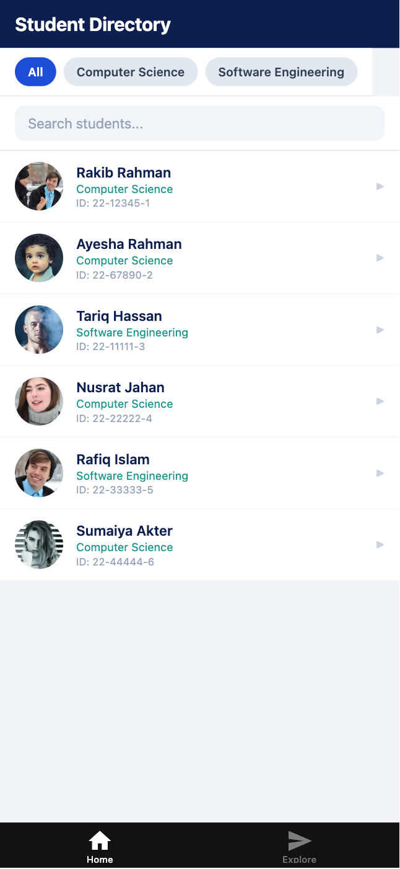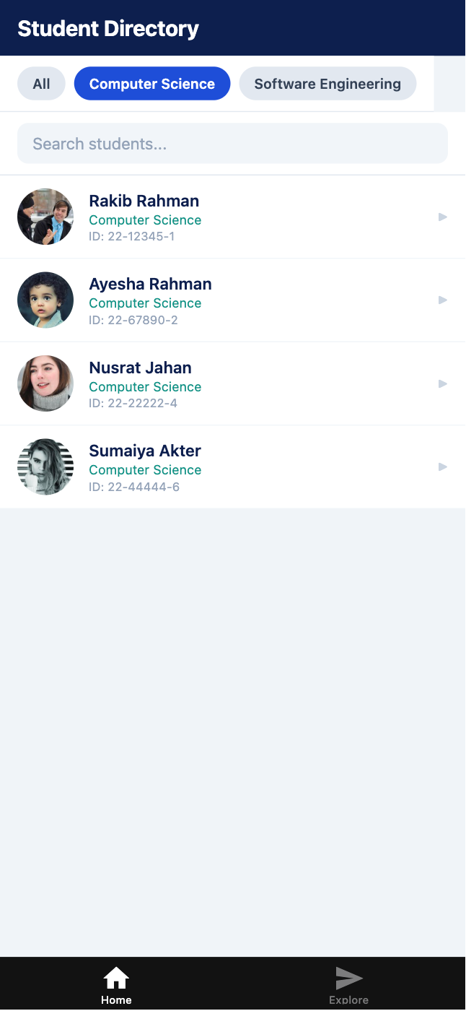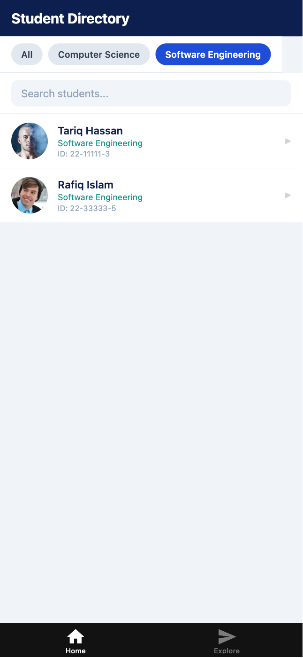

7.2 Submission Checklist
☐ | App runs without errors on Expo Go or web browser
☐ | FlatList is used (not ScrollView with manual .map) for the student list
☐ | Each row shows an avatar Image loaded from a remote URL
☐ | Flexbox row layout used in StudentItem (flexDirection: 'row', flex: 1 on info)
☐ | SearchBar TextInput filters the list live as the user types
☐ | ListEmptyComponent shows a message when search returns no results
☐ | Tapping a row shows StudentDetail; tapping again collapses it
☐ | All component files use TypeScript (.tsx) with props interfaces defined
☐ | Repository has at least 3 commits with meaningful messages
☐ | Repository URL submitted to the course portal

7.1 What to Submit
Submit the GitHub repository URL via the following form submission link/QR code:
MAD - Summer 25 - Lab Task 2 Submission – Fill out form


Practice Exercises (If You Finish Early)
These exercises are ungraded. They build on what you completed today.

Exercise 2 — FlatList Header
Add a ListHeaderComponent to the FlatList that shows a summary: the total number of students in the dataset and how many are currently shown after filtering.
💡 Hint
ListHeaderComponent accepts a React element: ListHeaderComponent={<View>...</View>}. Read STUDENTS.length for total and filtered.length for current.

Exercise 3 — Sort Toggle
Add a sort button to the title bar. Tapping it toggles the list between sorted A→Z by name and sorted Z→A by name.
💡 Hint
Add a sortAsc state (boolean). Before passing data to FlatList, sort the filtered array: [...filtered].sort((a,b) => sortAsc ? a.name.localeCompare(b.name) : b.name.localeCompare(a.name)). Spread into a new array before sorting — never mutate state directly.

Exercise 4 — Output Tracing (Quiz Practice)
Without running the code, trace through the following and write down what filtered contains at each step.
Output Tracing — answer on paper before checking
const STUDENTS = [
{ id: "1", name: "Alice", department: "CS" },
{ id: "2", name: "Bob", department: "SE" },
{ id: "3", name: "Charlie",department: "CS" },
];

const query = "c";

const filtered = STUDENTS.filter((s) =>
s.name.toLowerCase().includes(query.toLowerCase()) ||
s.department.toLowerCase().includes(query.toLowerCase())
);

// Question 1: What does filtered contain?
// Question 2: What if query = "se"?
// Question 3: What if query = ""?

Quick Reference

Common Errors & Fixes
Error | Fix
Image renders but is invisible (0×0) | Add explicit width and height to the Image style.
TypeError: filtered.map is not a function | filtered is not an array. Check your useState initial value — it should be [] not null.
Element type is invalid | You imported a default export with { braces }. Remove the braces: import StudentItem from '...'
Cannot find module '../../data/students' | Check the file path. The data/ folder must be in the project root, not inside app/.
selectedStudent.id — Object is possibly null | Use optional chaining: selectedStudent?.id
FlatList VirtualizedList warning inside ScrollView | Do not nest FlatList inside ScrollView. Use FlatList's own ListHeaderComponent instead.

Key FlatList Props
Prop | Purpose
data | The array to render. FlatList re-renders when this changes.
keyExtractor | Function returning a unique string key per item: (item) => item.id
renderItem | Function returning JSX for one item: ({ item }) => <Component item={item} />
ListEmptyComponent | JSX rendered when data is empty. Use for 'no results' messages.
ListHeaderComponent | JSX rendered above the first item. Use for headers or search summaries.
ItemSeparatorComponent | JSX rendered between items. Use for divider lines.
numColumns | Render a grid instead of a list. Pair with columnWrapperStyle.
onEndReached | Callback when user scrolls near the bottom. Use for pagination.

End of Week 2 Lab Manual

