 | American International University-Bangladesh
MOBILE APPLICATION DEVELOPMENT
with React Native & Expo
Lab Manual — Week 3: Navigation with Expo Router — Building NewsReader

Faculty | Md. Sazid Uddin
Department | Computer Science, Faculty of Science and Technology, AIUB
Semester | Summer 2025-26
Lab Session | Week 3
Duration | 3 hours
App to Build | NewsReader — a two-tab news app with Stack navigation and dynamic article routes

Lab Overview
In this session you will build NewsReader — a two-tab mobile app where the Home tab shows a list of articles that drill into a full detail screen, and the Bookmarks tab holds a placeholder for future weeks. The app is built on top of the Expo Router template that ships with create-expo-app, extending the existing structure rather than starting from scratch.

📝 What you will build
NewsReader has two tabs — Home and Bookmarks. The Home tab contains a Stack navigator: an ArticleList screen showing all articles in a FlatList, and an ArticleDetail screen that opens when an article is tapped. Article data is passed to the detail screen via the URL using a dynamic route ([id].tsx). The Bookmarks tab is a simple placeholder screen.

Learning Objectives
By the end of this lab you will be able to:
- Read and understand the Expo Router file structure that ships with the default template
- Modify (tabs)/_layout.tsx to configure tab labels, icons, and header options
- Create a Stack navigator inside a tab by adding a subfolder with its own _layout.tsx
- Use router.push() to navigate to a dynamic route with params
- Use useLocalSearchParams() to read route params on a detail screen
- Define and use a TypeScript type for route params
- Build a FlatList-based article list and a full-page article detail screen

Final Project Structure
Final project structure
app/
├── (tabs)/
│ ├── _layout.tsx <- modify: 2 tabs, icons, headerShown: false
│ ├── bookmarks.tsx <- new: placeholder Bookmarks screen
│ └── (home)/ <- new: subfolder for Home Stack
│ ├── _layout.tsx <- new: Stack navigator for Home tab
│ ├── index.tsx <- new: ArticleList screen
│ └── [id].tsx <- new: ArticleDetail dynamic screen
├── _layout.tsx <- keep as-is (root layout)
└── +not-found.tsx <- keep as-is

components/
└── article-card.tsx <- new: tappable article list item

data/
└── articles.ts <- new: static article data + TypeScript types

Section 1 - Project Setup & Template Inspection

1.1 Create the Project
Open a terminal and run the following. When prompted to choose a template, select the default (Expo SDK 54 blank template with tabs).
Step 1: Create the project
Terminal
npx create-expo-app@latest NewsReader --template default@sdk-54

Step 2: Install the tunnel package and start the server
The --tunnel flag is required for Expo Go when not on the same Wi-Fi. Press w to open in a web browser if no device is available.
Terminal
cd NewsReader
npm install -g @expo/ngrok@^4.1.0
npx expo start --tunnel

1.2 Inspect the Template Before Touching It
Open the project in VS Code and read these files before making any changes:
- app/_layout.tsx -> This is your entrypoint of the app. It is the first thing that renders. It also wrapt your whole app inside a stack navigator
- app/(tabs)/_layout.tsx -> This is your tab bar container. The default Home and Explore pages are linked to be shown in the bottom tab bar by this file.
- app/(tabs)/index.tsx -> This is your home screen aka the first page that loads when app/_layout.tsx loads the tab bar.
- app/(tabs)/explore.tsx -> This is another screen that can be navigated to using the tab bar.

📝 Understand before modifying
The root _layout.tsx and (tabs)/_layout.tsx are already wired correctly. You are building on top of them, not replacing them. Reading them first prevents accidentally breaking the working setup.

1.3 Clear Default Screen Content
Keep both tab files but clear their content. Open app/(tabs)/index.tsx and app/(tabs)/explore.tsx and delete everything inside the return() statement and their StyleSheet definitions. Leave only the import lines and an empty component function returning null or an empty View.
⚠️ Do not delete the files
If you delete index.tsx or explore.tsx while they are still referenced in (tabs)/_layout.tsx, Expo Router will throw a missing screen error. Clear the content — do not delete the files.

Section 2 - Article Data & Types

2.1 Create data/articles.ts
Create a data/ folder in the project root. Inside it create articles.ts with the type definition and the full static dataset:
data/articles.ts
// data/articles.ts

export interface Article {
id: string;
title: string;
category: string;
author: string;
date: string;
summary: string;
body: string;
}

export const ARTICLES: Article[] = [
{
id: "1",
title: "React Native 0.75 Brings New Architecture by Default",
category: "Tech",
author: "Sarah Chen",
date: "June 15, 2025",
summary: "The latest React Native release enables the New Architecture for all new projects, promising significant performance improvements.",
body: "React Native 0.75 marks a major milestone for the framework. The New Architecture, which replaces the JavaScript bridge with a direct C++ interface called JSI, is now enabled by default.\n\nThe New Architecture brings synchronous communication between JavaScript and native code, eliminating the asynchronous serialization overhead of the old bridge. Early benchmarks show up to 40% faster startup times on complex screens.",
},
{
id: "2",
title: "Bangladesh Launches National AI Strategy for 2025-2030",
category: "Policy",
author: "Rashida Khanam",
date: "June 10, 2025",
summary: "The government has released a five-year roadmap for artificial intelligence adoption across education, healthcare, and public services.",
body: "Bangladesh's ICT Division has published the National Artificial Intelligence Strategy 2025-2030, covering AI adoption in six key sectors: education, agriculture, healthcare, financial inclusion, public administration, and manufacturing.\n\nThe strategy includes a target to train 500,000 AI-skilled workers by 2028 through university curriculum reform. Funding of BDT 2,000 crore has been earmarked for a national AI research centre.",
},
{
id: "3",
title: "Expo Router 4.0 Introduces Server Components",
category: "Tech",
author: "James Watkins",
date: "June 5, 2025",
summary: "Expo Router's latest major release brings React Server Components to mobile, enabling server-side rendering for React Native apps.",
body: "Expo Router 4.0 is the first mobile framework to bring React Server Components to native apps. Server components allow parts of a screen to be rendered on the server and streamed to the device, reducing bundle size.\n\nThe release also introduces API Routes — server-side endpoints defined inside the app/ folder — enabling full-stack React Native development without a separate backend server.",
},
{
id: "4",
title: "AIUB Research Team Publishes NLP Study on Bangla Text",
category: "Research",
author: "Dr. Fahmida Akter",
date: "May 28, 2025",
summary: "A team from AIUB's CS department has published a benchmark dataset and transformer model for low-resource Bangla NLP tasks.",
body: "Researchers from AIUB have released BanglaBERT-v2, a fine-tuned transformer model trained on a 12-billion-token Bangla corpus. The model outperforms previous state-of-the-art results on sentiment analysis, NER, and question answering in Bangla.\n\nThe team also released BanglaGLUE — a benchmark containing 8 tasks with human-annotated data. The work was presented at ACL 2025 and has been cited by researchers at Google DeepMind.",
},
{
id: "5",
title: "TypeScript 5.6 Adds Pattern Matching Proposal",
category: "Tech",
author: "Elena Vasquez",
date: "May 20, 2025",
summary: "TypeScript 5.6 includes an early implementation of the TC39 pattern matching proposal, bringing switch-expression syntax to JavaScript.",
body: "TypeScript 5.6 beta includes an experimental implementation of the TC39 pattern matching proposal, introducing a match expression as a more powerful alternative to switch statements.\n\nPattern matching allows destructuring and type narrowing in a single expression. The syntax is similar to pattern matching in Rust and F#.",
},
{
id: "6",
title: "Mobile Internet Penetration in Bangladesh Reaches 70%",
category: "Industry",
author: "Tanvir Hossain",
date: "May 14, 2025",
summary: "BTRC data shows mobile internet subscriptions have crossed 130 million, making Bangladesh one of the fastest-growing mobile markets in South Asia.",
body: "The Bangladesh Telecommunication Regulatory Commission reports mobile internet subscriptions crossed 130 million in April 2025, representing 70% of the population. 4G coverage now reaches 97% of populated areas.\n\nThe growth creates a significant opportunity for mobile-first applications. Developers who can build performant React Native apps are in high demand across fintech, e-commerce, and healthcare delivery.",
},
{
id: "7",
title: "Meta Open-Sources Llama 4 Multimodal Model",
category: "AI",
author: "Marcus Johnson",
date: "May 8, 2025",
summary: "Meta has released Llama 4, a multimodal foundation model capable of processing text, images, and audio, under an open research licence.",
body: "Meta AI has released Llama 4, a multimodal large language model capable of understanding text, images, and audio. The model is available in 8B, 70B, and 405B parameter sizes under the Llama Community Licence.\n\nFor mobile developers, the 8B model can run on-device on flagship smartphones, opening possibilities for privacy-preserving AI features that do not require a server roundtrip.",
},
{
id: "8",
title: "Dhaka Startup Ecosystem Raises Record $240M in 2025 H1",
category: "Business",
author: "Nadia Islam",
date: "May 1, 2025",
summary: "Venture capital investment in Bangladesh-based startups reached a record high in the first half of 2025, led by fintech, health tech, and agritech companies.",
body: "Bangladesh-based startups raised $240 million in the first half of 2025 across 47 deals, a 180% increase over the same period in 2024. The largest rounds were raised by bKash ($60M), iFarmer ($22M), and Maya ($18M).\n\nThe growth is increasing demand for mobile developers, with companies like Pathao, Shohoz, and Chaldal actively hiring React Native engineers.",
},
];

Section 3 - ArticleCard Component
Before building the screens, create the component that renders a single article row. It lives in components/ and receives an Article and an onPress callback as props.

3.1 Create components/article-card.tsx
components/article-card.tsx
// components/article-card.tsx

import { StyleSheet, Text, TouchableOpacity, View } from "react-native";
import { Article } from "../data/articles";

interface ArticleCardProps {
article: Article;
onPress: (article: Article) => void;
}

const CATEGORY_COLOURS: Record<string, { bg: string; text: string }> = {
Tech: { bg: "#EFF6FF", text: "#1D4ED8" },
Policy: { bg: "#F0FDF4", text: "#15803D" },
Research: { bg: "#FDF4FF", text: "#7E22CE" },
Industry: { bg: "#FFF7ED", text: "#C2410C" },
AI: { bg: "#E1F5EE", text: "#0F6E56" },
Business: { bg: "#FEFCE8", text: "#854D0E" },
};
const DEFAULT_COLOUR = { bg: "#F1F5F9", text: "#475569" };

export default function ArticleCard({ article, onPress }: ArticleCardProps) {
const colour = CATEGORY_COLOURS[article.category] ?? DEFAULT_COLOUR;

return (
<TouchableOpacity
style={styles.card}
onPress={() => onPress(article)}
activeOpacity={0.7}
>
<View style={styles.meta}>
<View style={[styles.badge, { backgroundColor: colour.bg }]}>
<Text style={[styles.badgeText, { color: colour.text }]}>
{article.category}
</Text>
</View>
<Text style={styles.date}>{article.date}</Text>
</View>
<Text style={styles.title} numberOfLines={2}>{article.title}</Text>
<Text style={styles.summary} numberOfLines={2}>{article.summary}</Text>
<View style={styles.footer}>
<Text style={styles.author}>{article.author}</Text>
<Text style={styles.readMore}>Read more</Text>
</View>
</TouchableOpacity>
);
}

const styles = StyleSheet.create({
card: {
backgroundColor: "#FFFFFF",
borderRadius: 12,
padding: 16,
marginHorizontal: 14,
marginBottom: 12,
shadowColor: "#000",
shadowOffset: { width: 0, height: 1 },
shadowOpacity: 0.06,
shadowRadius: 4,
elevation: 2,
},
meta: { flexDirection: "row", justifyContent: "space-between", alignItems: "center", marginBottom: 8 },
badge: { paddingHorizontal: 10, paddingVertical: 3, borderRadius: 20 },
badgeText: { fontSize: 11, fontWeight: "600" },
date: { fontSize: 11, color: "#94A3B8" },
title: { fontSize: 15, fontWeight: "700", color: "#0D1F4E", lineHeight: 22, marginBottom: 6 },
summary: { fontSize: 13, color: "#64748B", lineHeight: 19, marginBottom: 12 },
footer: { flexDirection: "row", justifyContent: "space-between", alignItems: "center" },
author: { fontSize: 12, color: "#94A3B8", fontStyle: "italic" },
readMore: { fontSize: 12, color: "#0D9488", fontWeight: "600" },
});

📝 Record<string, ...> — TypeScript utility type
Record<string, { bg: string; text: string }> defines an object where every key is a string and every value has a bg and text property. It is the correct type for a lookup map. The ?? operator falls back to DEFAULT_COLOUR when the category is not in the map.

You can now render a single ArticleCard in the home screen:

3.1 Add a single ArticleCard to app/(tabs)/index.tsx
app/(tabs)/index.tsx
import { StyleSheet } from "react-native";

import ArticleCard from "@/components/article-card";

export default function HomeScreen() {
return (
<ArticleCard
article={{
id: "1",
title: "The Future of AI: How Artificial Intelligence is Transforming Industries",
author: "John Doe",
summary: "Artificial Intelligence (AI) is rapidly changing the way we live and work. From healthcare to finance, AI is being used to improve efficiency, reduce costs, and enhance decision-making. In this article, we explore the various applications of AI across different industries and discuss the potential benefits and challenges associated with its adoption.",
body: "Artificial Intelligence (AI) is rapidly changing the way we live and work. From healthcare to finance, AI is being used to improve efficiency, reduce costs, and enhance decision-making. In this article, we explore the various applications of AI across different industries and discuss the potential benefits and challenges associated with its adoption. In healthcare, AI is being used to analyze medical images, predict patient outcomes, and assist in diagnosis. In finance, AI algorithms are being used for fraud detection, risk assessment, and algorithmic trading. However, the adoption of AI also raises ethical concerns, such as job displacement and privacy issues. As AI continues to evolve, it is crucial for policymakers, businesses, and society to address these challenges and ensure that AI is used responsibly and ethically.",
category: "Tech",
date: "2023-10-15",
}}
onPress={() => {}}
/>
);
}

const styles = StyleSheet.create({
titleContainer: {
flexDirection: "row",
alignItems: "center",
gap: 8,
},
stepContainer: {
gap: 8,
marginBottom: 8,
},
reactLogo: {
height: 178,
width: 290,
bottom: 0,
left: 0,
position: "absolute",
},
});

Your app should look like this:

Create a commit at this point!

Section 4 - Building the Home Stack
You will now convert the Home tab from a single screen into a Stack navigator. This involves creating a subfolder inside (tabs)/, adding a Stack _layout.tsx, an ArticleList index screen, and an ArticleDetail dynamic screen.

4.1 Create the (home)/ subfolder
Inside app/(tabs)/, create a new folder called (home). The parentheses make it a route group — the folder name does not appear in the URL path. Your (tabs)/ folder now looks like this:
Folder structure after this step
app/(tabs)/
├── _layout.tsx <- existing tab layout (do not touch yet)
├── explore.tsx <- existing explore tab (cleared in Section 1)
└── (home)/ <- new folder
└── (empty for now)
Notice, that index.tsx is now replace with (home) folder.

4.2 Create (home)/_layout.tsx — the Stack navigator
app/(tabs)/(home)/_layout.tsx
// app/(tabs)/(home)/_layout.tsx

import { Stack } from "expo-router";

export default function HomeLayout() {
return (
<Stack
screenOptions={{
headerStyle: { backgroundColor: "#0D1F4E" },
headerTintColor: "#FFFFFF",
headerTitleStyle: { fontWeight: "bold" },
}}
>
<Stack.Screen name="index" options={{ title: "Top Stories" }} />
<Stack.Screen name="[id]" options={{ title: "Article" }} />
</Stack>
);
}

📝 screenOptions on Stack
screenOptions applies to all screens inside this Stack. Individual Stack.Screen options override screenOptions for that specific screen. The navy header colour applies to both screens — the detail screen will later override the title via useNavigation().setOptions().

4.3 Create (home)/index.tsx — the ArticleList screen
app/(tabs)/(home)/index.tsx
// app/(tabs)/(home)/index.tsx

import { router } from "expo-router";
import { FlatList, SafeAreaView, ScrollView, StyleSheet, Text, View } from "react-native";
import ArticleCard from "../../../components/article-card";
import { Article, ARTICLES } from "../../../data/articles";

export default function ArticleList() {
const handlePress = (article: Article) => {
router.push({
pathname: "/(home)/[id]",
params: { id: article.id },
});
};

return (
<ScrollView style={styles.screen}>
<FlatList
data={ARTICLES}
keyExtractor={(item) => item.id}
renderItem={({ item }) => <ArticleCard article={item} onPress={handlePress} />}
contentContainerStyle={styles.list}
ListHeaderComponent={
<View style={styles.listHeader}>
<Text style={styles.listHeaderText}>{ARTICLES.length} stories</Text>
</View>
}
/>
</ScrollView>
);
}

const styles = StyleSheet.create({
screen: { flex: 1, backgroundColor: "#F0F4F8" },
list: { paddingTop: 12, paddingBottom: 32 },
listHeader: { paddingHorizontal: 16, paddingBottom: 8 },
listHeaderText: { fontSize: 12, color: "#94A3B8", textTransform: "uppercase", letterSpacing: 1 },
});

💡 Why pathname + params object instead of a template literal?
router.push('/(home)/'+article.id) also works. The pathname + params form is preferred when passing multiple params: params: { id, ref: 'list' } appends extra values as query strings (/(home)/1?ref=list). Both forms deliver the values via useLocalSearchParams() on the detail screen.
Your app should now look like this:
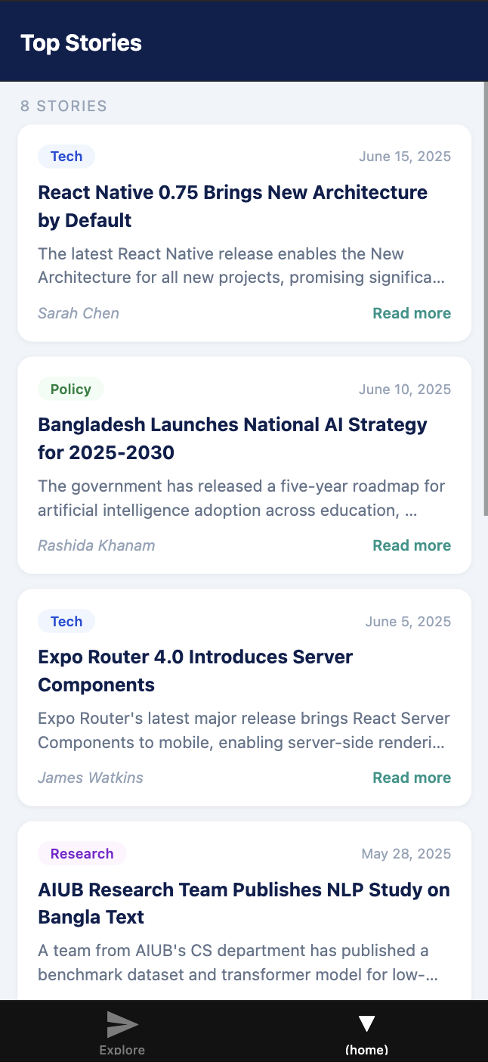
Create a commit at this point!

4.4 Create (home)/[id].tsx — the ArticleDetail screen
The filename [id].tsx creates a dynamic route. Expo Router matches any path like /(home)/1, /(home)/3, or /(home)/any-string. The id segment is available via useLocalSearchParams().
app/(tabs)/(home)/[id].tsx
// app/(tabs)/(home)/[id].tsx

import { useLocalSearchParams, useNavigation } from "expo-router";
import { useEffect } from "react";
import { ScrollView, StyleSheet, Text, View } from "react-native";
import { ARTICLES } from "../../../data/articles";

type ArticleParams = { id: string };

const CATEGORY_COLOURS: Record<string, { bg: string; text: string }> = {
Tech: { bg: "#EFF6FF", text: "#1D4ED8" },
Policy: { bg: "#F0FDF4", text: "#15803D" },
Research: { bg: "#FDF4FF", text: "#7E22CE" },
Industry: { bg: "#FFF7ED", text: "#C2410C" },
AI: { bg: "#E1F5EE", text: "#0F6E56" },
Business: { bg: "#FEFCE8", text: "#854D0E" },
};
const DEFAULT_COLOUR = { bg: "#F1F5F9", text: "#475569" };

export default function ArticleDetail() {
const { id } = useLocalSearchParams<ArticleParams>();
const navigation = useNavigation();

const article = ARTICLES.find((a) => a.id === id);

// Update the Stack header title once we have the article
useEffect(() => {
if (article) {
navigation.setOptions({ title: article.title });
}
}, [article]);

if (!article) {
return (
<View style={styles.screen}>
<Text style={styles.notFound}>Article not found.</Text>
</View>
);
}

const colour = CATEGORY_COLOURS[article.category] ?? DEFAULT_COLOUR;

return (
<ScrollView style={styles.screen}>
<ScrollView contentContainerStyle={styles.content}>
<View style={[styles.badge, { backgroundColor: colour.bg }]}>
<Text style={[styles.badgeText, { color: colour.text }]}>{article.category}</Text>
</View>
<Text style={styles.title}>{article.title}</Text>
<View style={styles.meta}>
<Text style={styles.author}>{article.author}</Text>
<Text style={styles.date}>{article.date}</Text>
</View>
<View style={styles.divider} />
{article.body.split("\n\n").map((para, i) => (
<Text key={i} style={styles.body}>
{para}
</Text>
))}
</ScrollView>
</ScrollView>
);
}

const styles = StyleSheet.create({
screen: { flex: 1, backgroundColor: "#FFFFFF" },
content: { padding: 20, paddingBottom: 48 },
badge: { alignSelf: "flex-start", paddingHorizontal: 12, paddingVertical: 4, borderRadius: 20, marginBottom: 14 },
badgeText: { fontSize: 12, fontWeight: "600" },
title: { fontSize: 22, fontWeight: "800", color: "#0D1F4E", lineHeight: 30, marginBottom: 12 },
meta: { flexDirection: "row", justifyContent: "space-between", marginBottom: 16 },
author: { fontSize: 13, color: "#64748B", fontStyle: "italic" },
date: { fontSize: 13, color: "#94A3B8" },
divider: { height: 1, backgroundColor: "#F1F5F9", marginBottom: 20 },
body: { fontSize: 15, color: "#334155", lineHeight: 24, marginBottom: 16 },
notFound: { padding: 40, textAlign: "center", color: "#94A3B8" },
});

📝 body.split('\n\n')
The article body uses double newline to separate paragraphs. Splitting on this and rendering each as a separate Text component gives natural paragraph spacing without needing a custom renderer or HTML parsing.

⚠️ navigation.setOptions inside useEffect
setOptions is called inside useEffect with [article] as the dependency — this means it runs once after the article is found. Without useEffect it would cause a render loop because setOptions triggers a re-render.

Now clicking on an ArticleCard will take you to the ArticleDetail page:
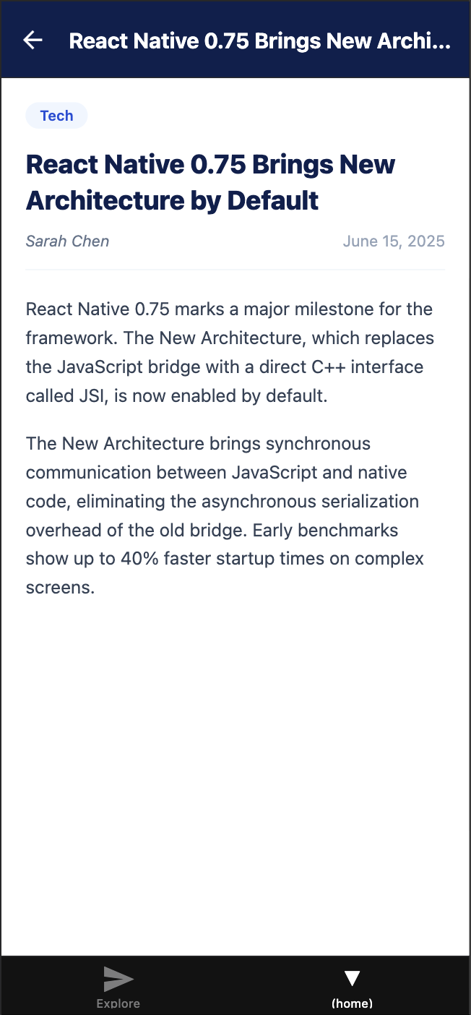
You can navigate back to Article list screen using the back button at the top or the hardware back button.
Create a commit at this point!

Section 5 - Configure Tabs & Add Bookmarks

5.1 Update (tabs)/_layout.tsx
Replace the contents of app/(tabs)/_layout.tsx with the following. The key change is that the Home tab name is now '(home)' (matching the new folder) instead of 'index':
app/(tabs)/_layout.tsx
// app/(tabs)/_layout.tsx

import { Tabs } from "expo-router";
import { Ionicons } from "@expo/vector-icons";

export default function TabLayout() {
return (
<Tabs
screenOptions={{
tabBarActiveTintColor: "#0D9488",
tabBarInactiveTintColor: "#94A3B8",
tabBarStyle: { backgroundColor: "#FFFFFF", borderTopColor: "#F1F5F9" },
headerShown: false,
}}
>
<Tabs.Screen
name="(home)"
options={{
title: "Home",
tabBarIcon: ({ color, size }) => (
<Ionicons name="newspaper-outline" size={size} color={color} />
),
}}
/>
<Tabs.Screen
name="bookmarks"
options={{
title: "Bookmarks",
tabBarIcon: ({ color, size }) => (
<Ionicons name="bookmark-outline" size={size} color={color} />
),
}}
/>
</Tabs>
);
}

📝 name='(home)' not name='index'
Previously the Home tab was a single file (index.tsx) so its Tabs.Screen name was 'index'. Now the Home tab is a folder called (home), so the name must be '(home)' — matching the folder name. Expo Router uses the folder as the tab's entry point.
At this point your app should look like this:
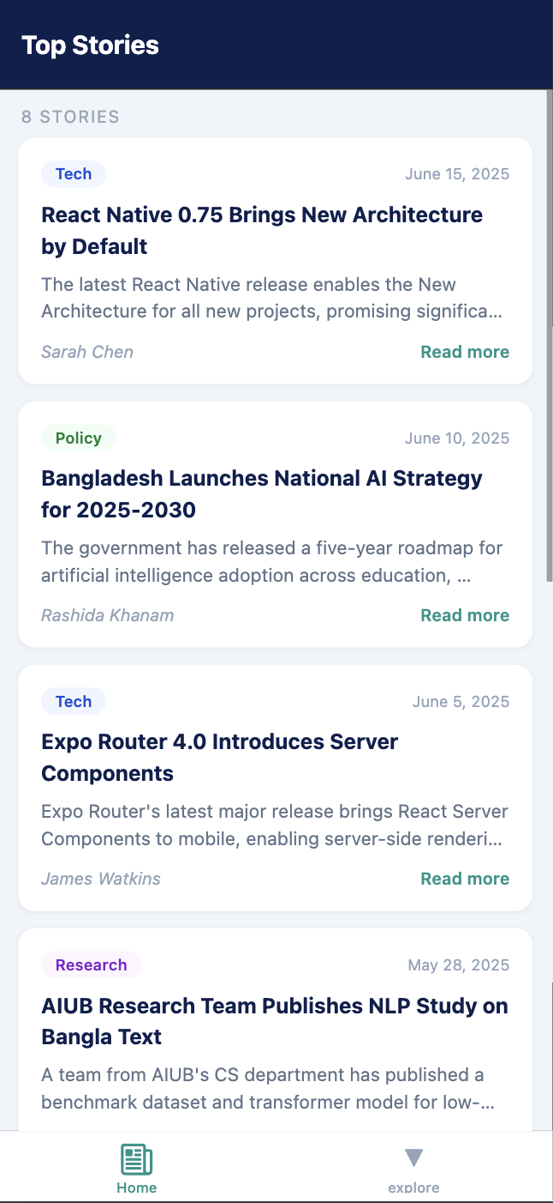
Notice that the tab bar does not include the bookmarks screen. We will create it next

5.2 Create bookmarks.tsx
app/(tabs)/bookmarks.tsx
// app/(tabs)/bookmarks.tsx

import { StyleSheet, Text, View } from "react-native";
import { SafeAreaView } from "react-native-safe-area-context";

export default function Bookmarks() {
return (
<SafeAreaView style={styles.screen}>
<View style={styles.content}>
<Text style={styles.icon}>🔖</Text>
<Text style={styles.title}>Bookmarks</Text>
<Text style={styles.subtitle}>Articles you save will appear here.{"\n"}Coming in a future week.</Text>
</View>
</SafeAreaView>
);
}

const styles = StyleSheet.create({
screen: { flex: 1, backgroundColor: "#F0F4F8" },
content: { flex: 1, alignItems: "center", justifyContent: "center", padding: 32 },
icon: { fontSize: 48, marginBottom: 16 },
title: { fontSize: 20, fontWeight: "700", color: "#0D1F4E", marginBottom: 8 },
subtitle: { fontSize: 14, color: "#94A3B8", textAlign: "center", lineHeight: 22 },
});

5.3 Delete explore.tsx
Now that explore.tsx is no longer referenced in _layout.tsx, delete app/(tabs)/explore.tsx. Always update _layout.tsx before deleting the file, not after.

Your app should now have a Bookmarks tab:
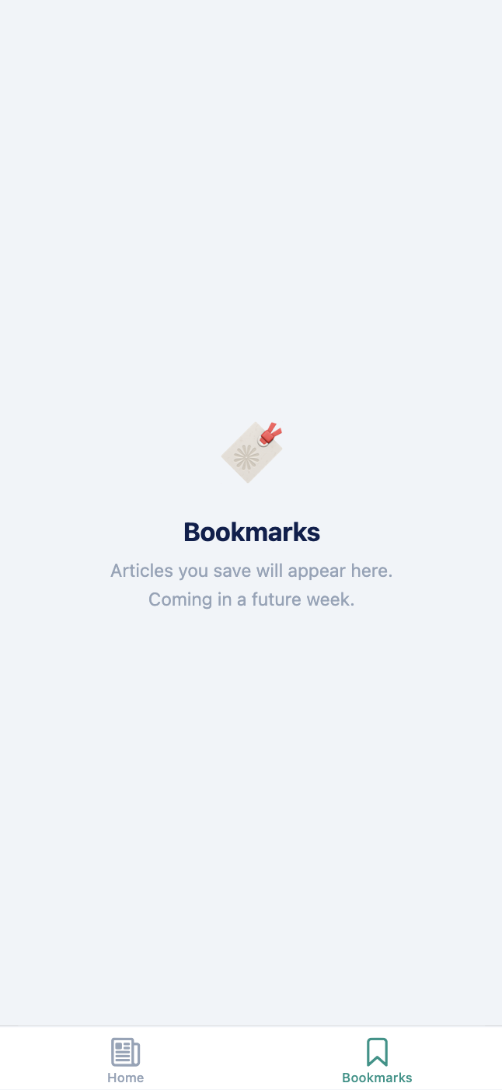

5.4 Verify the Full App
Save all files. Your app should now show:
- A bottom tab bar with Home (newspaper icon) and Bookmarks (bookmark icon) tabs
- Home tab: FlatList of 8 article cards with title, summary, author, date, and category badge
- Tapping an article: navigates to a detail screen with a navy header and a back button
- Detail screen: full title, author, date, category badge, and body text in paragraphs
- The Stack header title updates to the article's category via useEffect
- Bookmarks tab: placeholder screen with the bookmark emoji and message

Section 6 - Git Commits
Push to GitHub with at least 4 commits — one per major section.
Terminal — commit at each major section
git add .
git commit -m "Add article data, Article interface, and ArticleCard component"

git add .
git commit -m "Add (home) Stack: _layout, ArticleList, and ArticleDetail screens"

git add .
git commit -m "Configure tabs layout with icons, add Bookmarks placeholder"

git add .
git commit -m "Final cleanup and polish"
Your can find my repository at: https://github.com/sazid-uddin/MAD-NewsReader.git

Practice Exercises (If You Finish Early)

Exercise 1 - Category Filter
Add a horizontal ScrollView of category filter pills above the FlatList on the ArticleList screen. Tapping a pill filters the list to that category. An 'All' pill resets the filter. The active pill has a filled teal background.
💡 Hint
Add selectedCategory state (string | null). Derive filtered = selectedCategory ? ARTICLES.filter(a => a.category === selectedCategory) : ARTICLES. Build the pill list using [...new Set(ARTICLES.map(a => a.category))].

Exercise 2 - Bookmark Toggle on Detail Screen
Add a bookmark icon button to the Stack header on the ArticleDetail screen. Tapping it toggles a local bookmarked state. The icon fills when bookmarked and is outlined when not.
💡 Hint
Use useState<boolean>(false) for bookmarked. In useEffect, call navigation.setOptions({ headerRight: () => <Pressable onPress={toggle}><Ionicons name={bookmarked ? 'bookmark' : 'bookmark-outline'} /></Pressable> }). Include [bookmarked] in the dependency array.

Exercise 3 - Estimated Read Time
On the ArticleDetail screen, calculate and display an estimated reading time below the author/date row. Assume 200 words per minute.
💡 Hint
const words = article.body.split(' ').length; const minutes = Math.ceil(words / 200); Display: minutes + ' min read'.

Exercise 4 - Output Tracing (Quiz Practice)
Without running the code, answer these questions on paper:
Output Tracing — answer on paper before checking
// Current screen: app/(tabs)/(home)/index.tsx
// Stack history: [(home)/index]

// Q1: What does the Stack history look like after this?
router.push({ pathname: '/(home)/[id]', params: { id: '3' } });

// Q2: What happens after calling router.back() on the detail screen?

// Q3: If router.replace() is used instead of router.push() in Q1,
// what is different about the Stack history?

// Q4: What does useLocalSearchParams() return on [id].tsx
// when navigated with params: { id: '3' }?

Quick Reference

File-to-Route Mapping
File path | Behaviour
app/_layout.tsx | Root layout — wraps whole app in a Stack (headerShown: false)
app/(tabs)/_layout.tsx | Tab layout — defines the bottom tab bar
app/(tabs)/(home)/_layout.tsx | Stack inside the Home tab group
app/(tabs)/(home)/index.tsx | ArticleList — default Home screen
app/(tabs)/(home)/[id].tsx | ArticleDetail — dynamic screen, matches /(home)/1, /(home)/2, ...
app/(tabs)/bookmarks.tsx | Bookmarks placeholder screen

Common Errors & Fixes
Error | Fix
Attempted to navigate before mounting | Move router.push() inside an event handler or useEffect — never at component top level.
No route named '(home)' found in Tab | _layout.tsx still has name='index'. Change it to name='(home)' to match the new folder.
useLocalSearchParams returns undefined | The screen is not inside an Expo Router navigator, or it is called in a non-screen component.
Two headers stacked on detail screen | headerShown: false is missing from the Tab navigator's screenOptions.
Module not found: ../../../data/articles | Count the folder levels: [id].tsx is 3 levels deep. The import needs exactly three ../ segments.
article is undefined on detail screen | The id param doesn't match any ARTICLES entry — likely a string/type mismatch. Log both to compare.

End of Week 3 Lab Manual

