Carlina Sales Aid-1
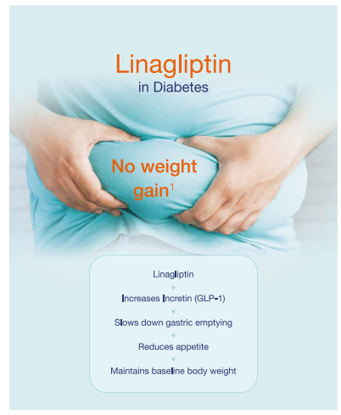
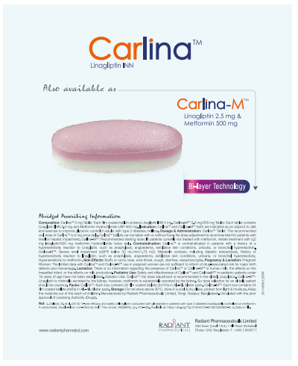

1st page:
Linagliptin in Diaabetes; No weight gain
Linagliptin increases incretin (GLP-1) which slows down gastric emptying and reduces appetite. Thus maintains baseline body weight.
2nd page:
Also available as Carlina M with Bi-Layer Technology
Contents of detailing
- Linagliptin in Diaabetes; No weight gain
- Linagliptin increases incretin (GLP-1) which slows down gastric emptying and reduces appetite. Thus maintains baseline body weight.
- Also available as Carlina M with Bi-Layer Technology

Carlina M Sales Aid-1
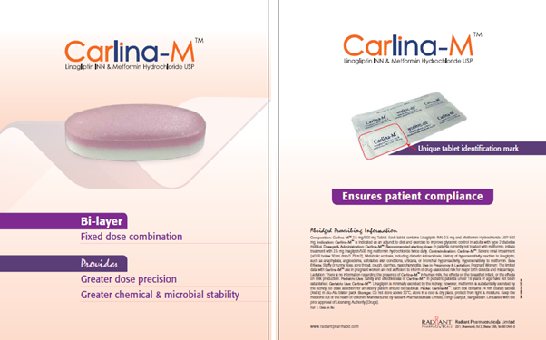

1st page:
Carlina-M Manufactured with bi-layer fixed dose combination
Bi-layer technology ensures- Greater dose precision & greater chemical and microbial stability
2nd page:
Individual identification mark
Ensures patient compliance

Contents of detailing
- Carlina-M comes with bi-layer technology which ensures-
- Greater dose precision and greater chemical and microbial stability
- Carlina-M comes with unique & individual identification mark that ensures patient compliance

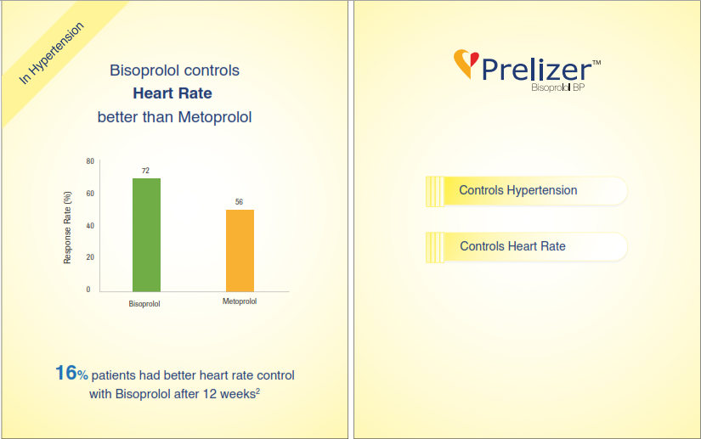
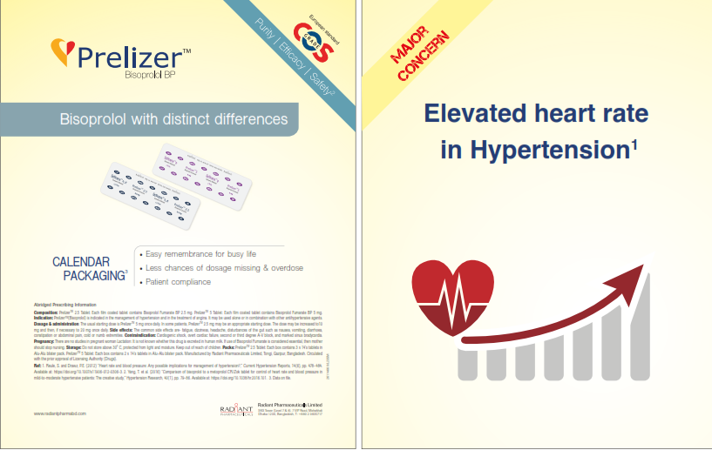
Prelizer Sales Aid-1

1st page:
Major concern- Elevated heart rate in hypertension
2nd page:
In hypertension Bisoprolol controls heart rate better than Metoprolol; 16% patients had better heart rate control with Bisoprolol after 12 weeks of treatment
3rd page:
Prelizer controls hypertension; controls heart rate
4th page:
Bisoprolol with distinct differences
Calendar packaging ensures- easy remembrance for busy life, no chance of dosage missing, patient compliance
Contents of detailing
- Major concern- Elevated heart rate in hypertension
- In hypertension Bisoprolol controls heart rate better than Metoprolol; In a comparison study of Bisoprolol & Metoprolol it was found that 16% patients had better heart rate control with Bisoprolol after 12 weeks of treatment
- Prelizer controls hypertension; controls heart rate
- Bisoprolol with distinct differences
- COS grade ensures- purity, efficacy & safety
- Calendar packaging ensures- easy remembrance for busy life, no chance of dosage missing, patient compliance

Radiglip M Sales Aid-1
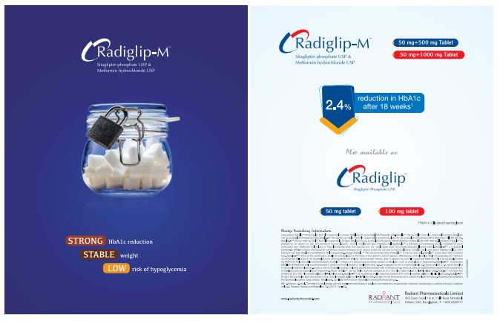

1st page:
Strong HbA1c reduction
Stable weight
Low risk of hypoglycemia
2nd page:
2.4% reduction in HbA1c after 18 weeks
Contents of detailing
Radiglip M i.e. Sitagliptin & Metformin combination provides- Strong HbA1c reduction; Stable weight & Low risk of hypoglycemia
Because it reduces 2.4% HbA1c after 18 weeks
Also available as Radiglip

