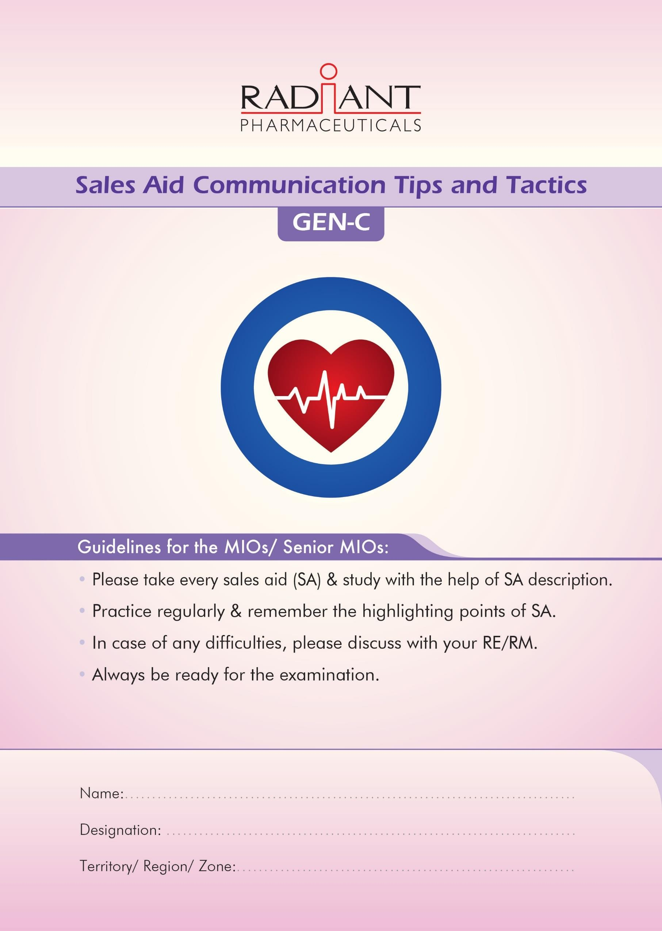
Promotional Month: April-2023

Brand | Theme of Sales Aid | Page No.
Duovas | ESC-2021 | 3
Duovas | Obesity | 4
Sevitan | Calendar Packaging | 5
Carlina/M | Less chance of hypoglycemia | 6
Carlina/M | Bi-layer technology | 7
Creva | Superior to any other statin | 8
Creva | CYP mediated Drug-Drug Interaction | 9
Ardance | 1 in 3 | 10
Ardance | 1st line therapy | 11
Prelizer | Elevated heart rate in hypertension | 12
Radizid | Added advantage | 13
Radimet | Old but better | 14
Pidogrel/Plus | Bi-layer | 15
Triginal-MR | Quick & sustained | 15
Frenvas | TG | 16
Raditrend | Biggest killer | 17
Gadget brief |  | 18-20

Duovas Sales Aid-1
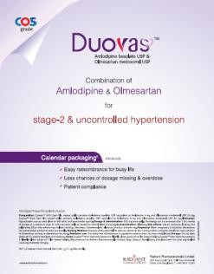
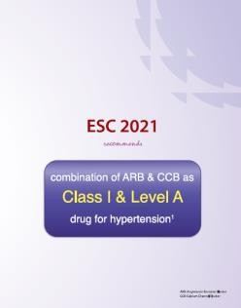
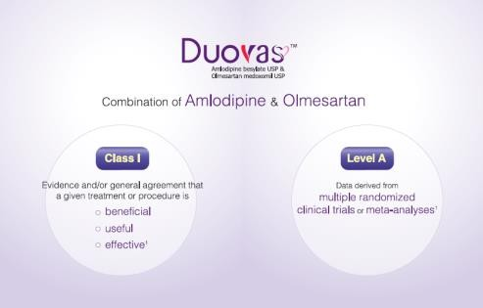

Content of the page

1st page: ESC 2021 recommends combination of ARB & CCB as Class I & Level A drug for hypertension.
2nd & 3rd Page: Duovas: Combination of Amlodipine & Olmesartan. Class I- Evidence and/or general agreement that a given treatment or procedure is- beneficial, useful & effective. Level A- Data derived from multiple clinical trials or meta-analyses
4th Page: Duovas: Combination of Amlodipine & Olmesartan for stage-2 & uncontrolled hypertension Calendar packaging ensures-
1. Easy remembrance for busy life
2. Less chances of dosage missing or overdose
3. Patient compliance
Contents of detailing
- ESC 2021 recommends combination of ARB (Angiotensin-2 type-1 receptor blocker) & CCB (Calcium channel blocker) as Class I & Level A drug for hypertension.
- Duovas is the combination of ARB (Olmesartan) & CCB (Amlodipine)
- Class-I means Evidence and/or general agreement that a given treatment or procedure is- beneficial, useful & effective
- Level A means Data derived from multiple clinical trials or meta-analyses
- COS grade amlodipine & olmesartan ensures purity, effiacy & safety.
- Calendar packaging ensures- Easy remebrance for busy life, Less chances of dosage missing & patient compliance

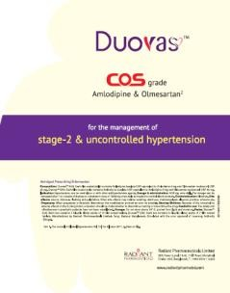
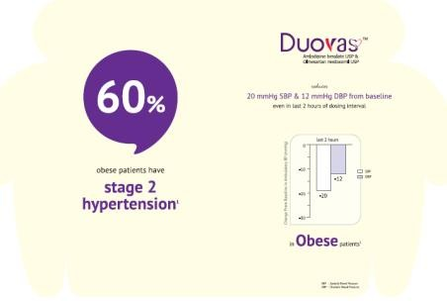
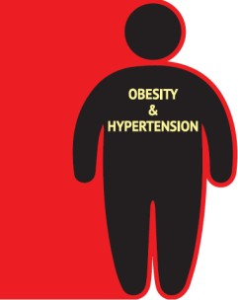
Duovas Sales Aid-2

Content of the page
1st Page: Obesity & hypertension
2nd Page: 60% obese patients have hypertension.
3rd page: Duovas reduces 20 mmHg SBP & 12 mmHg DBP from baseline even in las 2 hours of dosing interval in obese patients.
4th Page: COS grade amlodipine & olmesartan for managing stage-2 & uncontrolled hypertension.
Contents of detailing
- Obese patients are more prone to stage-2 hypertension
- 60% obese patients have stage-2 hypertension
- Duovas reduces 20 mmHg SBP (Systolic Blood Pressure) & 12 mmHg DBP (Diastolic Blood Pressure) from baseline even in las 2 hours of dosing interval in obese patients.
- Last two hours of dosing interval means- two hours before taking the next dose
- Combination of Amlodipine & Olmesartan for stage-2 & uncontrolled hypertension
- COS grade ensures- purity, efficacy & safety.

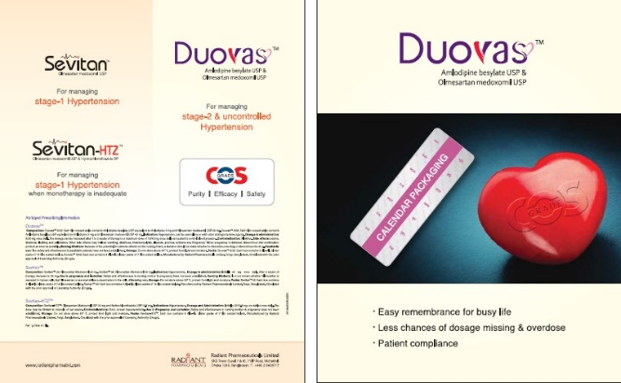
Sevitan Sales Aid

Content of the page
1st Page: Duovas: Calendar packaging-
- Easy remembrance for busy life
- Less chances of dosage missing or overdose
- Patient compliance
2nd Page: Sevitan- For stage-1 hypertension, Sevitan-HTZ for stage-1 hypertension when monotherapy is inadequate Duovas- for stage-2 & uncontrolled hypertension. COS grade ensures- Purity, efficacy & safety.
Contents of detailing

Calendar packaging ensures-
Easy remebrance for busy life
Less chances of dosage missing or overdose
- COS grade amlodipine & olmesartan ensures purity, effiacy & safe

Carlina Sales Aid-1
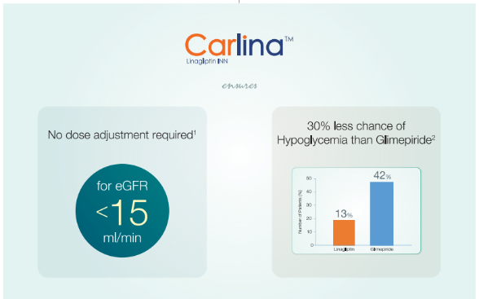
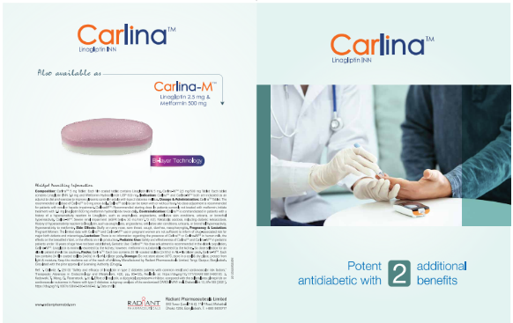

1st page:
Potential antidiabetic with 2 additional benefits
2nd page:
No dose adjustment required for eGFR <15 ml/min
Linagliptin Vs Glimepiride; CAROLINA trial- N= 6033
Linagliptin shows 30% less chance of Hypoglycemia than Glimepiride
Only 13% patients show Hypoglycemia with Linagliptin and 42% patients show Hypoglycemia with Glimepiride
4th page: Also available as Carlina M with Bi-Layer Technology
Contents of detailing
- Linagliptin is the potential antidiabetic with 2 additional benefits
- No dose adjustment required for eGFR <15 ml/min
- CAROLINA study trial with 6033 patients showed
- Only 13% patients had Hypoglycemia with Linagliptin and 42% patients had Hypoglycemia with Glimepiride
- It indicates Linagliptin shows 30% less chance of Hypoglycemia than Glimepiride
- Also available as Carlina M with Bi-Layer Technology

Carlina M Sales Aid-1
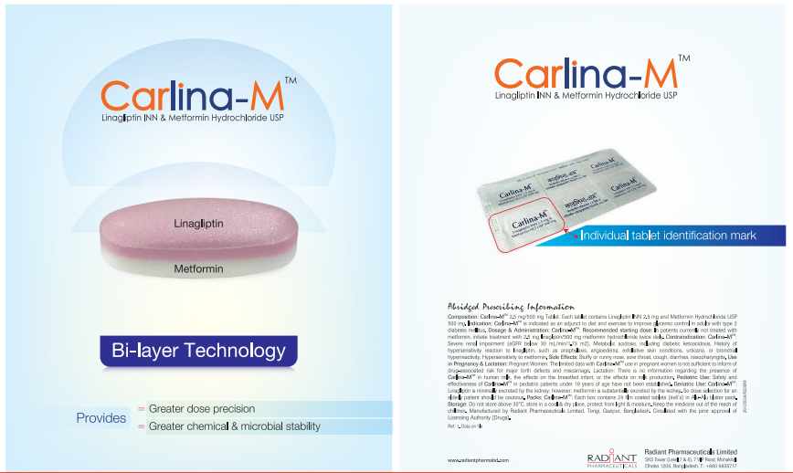

1st page:
Carlina-M Manufactured with bi-layer fixed dose combination
Bi-layer technology ensures- Greater dose precision & greater chemical and microbial stability
2nd page:
Individual identification mark
Ensures patient compliance

Contents of detailing
- Carlina-M comes with bi-layer technology which ensures-
- Greater dose precision and greater chemical and microbial stability
- Carlina-M comes with unique & individual identification mark that ensures patient compliance

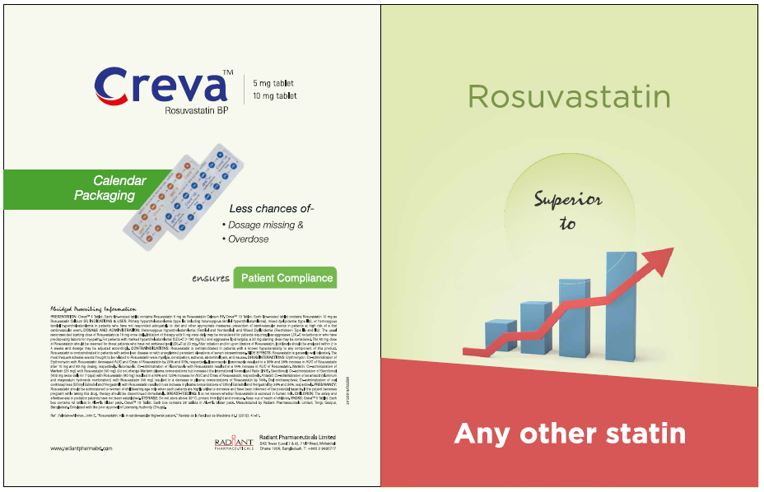
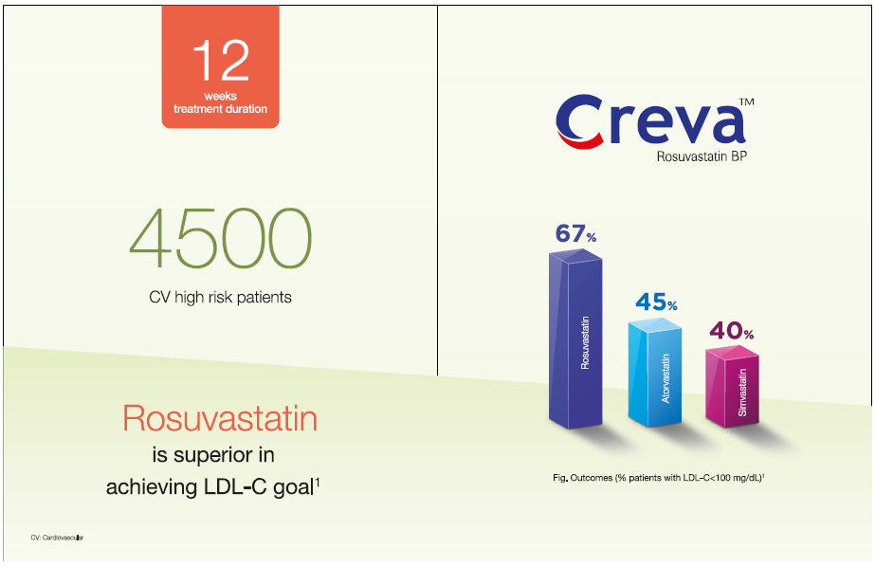
Creva Sales Aid-1

Content of the page
1st page: Rosuvastatin is superior to any other statin.
2nd Page: A 12 month trial is conducted with 4500 CV high risk patients for acieving goal.
3rd Page: In 67% patients with rosuvastatin had managed to achieve Cholesterol goal and 45%, 40% patients acieved goal with Atorvastatin and Simvastatin.
4th Page: Radiant offers COS grade Rosuvastatin, Creva with calendar packaging which ensures better management with patient compliance
Contents of detailing
- Rosuvastatin contains methyl sulfonamide group, which ensures higher affinity for HMG- CoA reductase. As a result, Rosuvastatin shows greater result in reducing LDL-C than any other statins
- There is less incidence of treatment discontinuation due to adverse than Atorvastatin, therefore safe molecule than Atorvastatin.
- Radiant offers COS grade Rosuvastatin, Creva with calendar packaging which ensures better management with patient compliance.

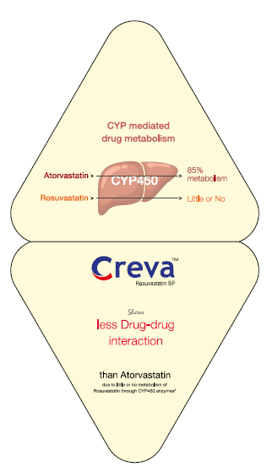
Creva Sales Aid-2
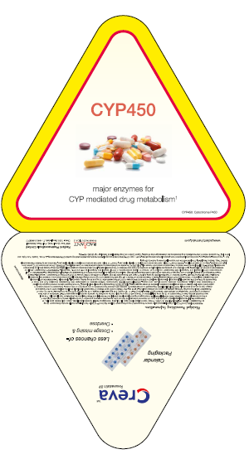

Content of the page
1st Page: CYP450 enzymes & Drug-drug interaction
2nd Page: 85% Atorvastatin is metabolized through CYP 450 enzymes whereas Rosuvastatin has less or no metabolism.
3rd page: Rosuvastatin shows less drug drug interaction than any other statins.
4th Page: Radiant offers COS grade Rosuvastatin, Creva with calendar packaging which ensures better management with patient compliance
Contents of detailing
- More than 50% of all drugs metabolized through CYP 450 enzymes.
- Rusuvastatin is not metabolized through CYP 450 enzymes therefore less chances of drug drug interaction.
- Radiant offers COS grade Rosuvastatin, Creva with calendar packaging which ensures better management with patient compliance.

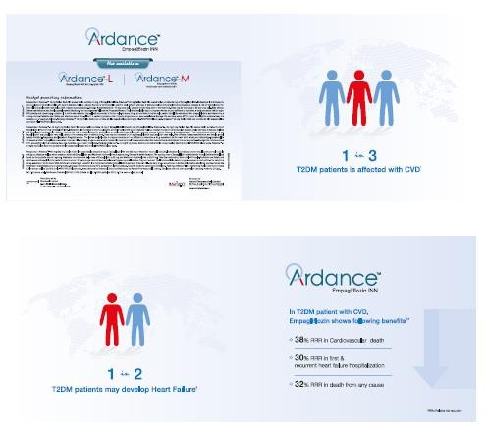
Ardance Sales Aid-1

Content of the page

1st page: 1 in 3 T2DM patients is affected with CVD
2nd Page: 1 in 2 T2DM patients may develop heart failure
3rd Page: In T2DM patients with CVD, Empagliflozin shows following benefits: 38% RRR in cardiovascular death; 30% RRR in first & recurrent heart failure hospitalization; 32% RRR in death from any cause.
4th Page: Ardance is also available as Ardance-L & Ardance-M
Contents of detailing
- 1 in 3 T2DM patients is affected with CVD
- 1 in 2 T2DM patients may develop heart failure
- Ardance ensures-
38% RRR in cardiovascular death
30% RRR in first & recurrent heart failure hospitalization
32% RRR in death from any cause.

Ardance Sales Aid-2
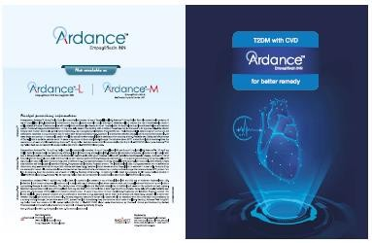
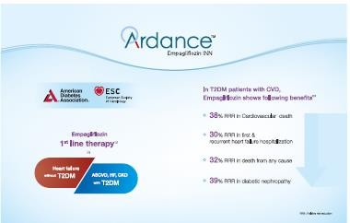
Content of the page
1st Page: T2DM with CVD , Ardance for better remedy
2nd Page: Empagliflozin is first line therapy for heart failure without T2DM & ASCVD,HF,CVD with T2DM
3rd Page: In T2DM patients with CVD, Empagliflozin shows following benefits:
38% RRR in cardiovascular death; 30% RRR in first & recurrent heart failure hospitalization; 32% RRR in death from any cause.
4th Page: Ardance is also available as Ardance-L & Ardance-M

Contents of detailing
- T2DM with CVD, Ardance for better remedy
- Empagliflozin is first line therapy for heart failure without T2DM & ASCVD,HF,CVD with T2DM
- Ardance ensures-
38% RRR in cardiovascular death
30% RRR in first & recurrent heart failure hospitalization
32% RRR in death from any cause

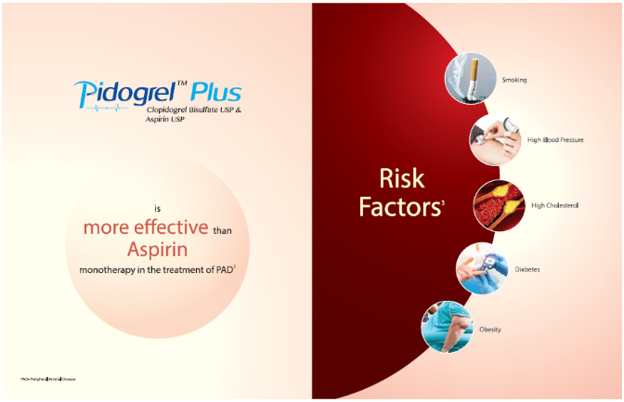
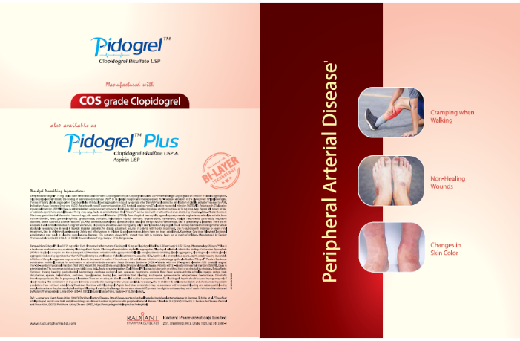
Pidogrel Sales Aid-1

Content of the page
1st page: Symptoms of Peripheral Artery Disease
2nd page: Combination therapy is more effective than Aspirin monotherapy in the treatment of PAD
3rd page: Risk factors of PAD
4th page: Pidogrel-Plus is manufactured with bi-layer fixed dose combination. Bi-layer technology ensures- Greater dose precision & greater chemical and microbial stability.

Contents of detailing
- Pidogrel is made of COS grade API which ensures- Purity, Safety & Efficacy
- Pidogrel Plus is manufactured with Bilayer technology which provides greater dose precision & greater chemical & microbial stability.

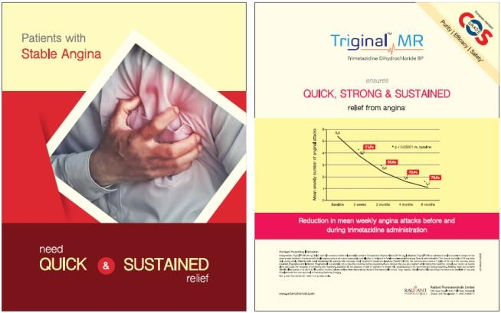
Triginal Sales Aid

Content of the page
1st page: Thematic image of Angina
2nd page: Triginal is made of COS grade Trimetazidine with Calendar packaging.

Contents of detailing
Our Triginal is distictly different from others because Triginal has 2 unique & exclusive benefits-

- Triginal MR is made of COS grade API which ensures- Purity, Safety & Efficacy
- Triginal MR is manufactured with calendar packaging which ensures- Easy remembrance for busy life, no chances of dosage missing & ultimately ensure Patient compliance.

Prelizer Sales Aid-1
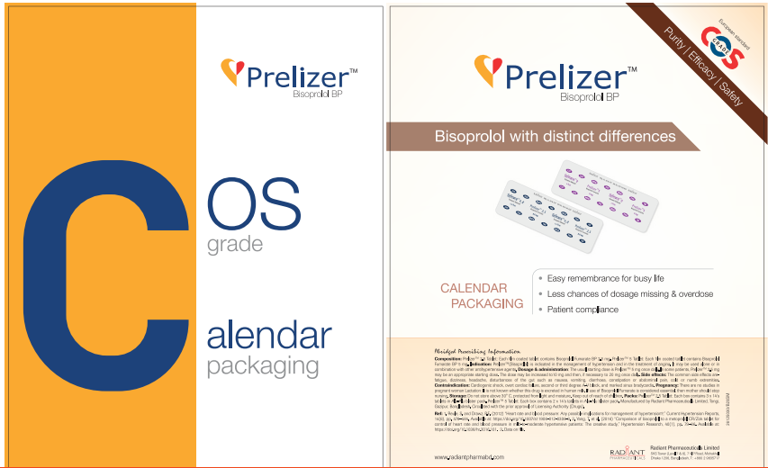

1st page:
Bisoprolol with COS grade & Calendar packaging
2nd page:
Bisoprolol with distinct differences
Calendar packaging ensures- easy remembrance for busy life, no chance of dosage missing, patient compliance

Contents of detailing
- COS grade ensures- purity, efficacy & safety
- Bisoprolol with distinct differences
- Calendar packaging ensures- easy remembrance for busy life, less chances of dosage missing & overdose & Patient compliance

Radizid Sales Aid
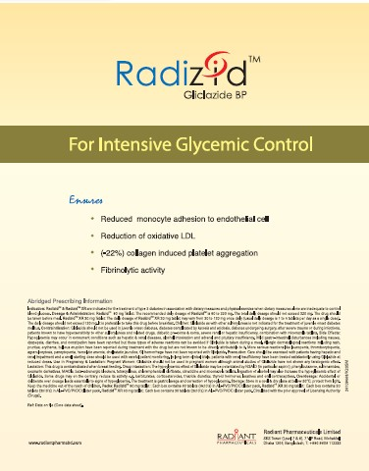
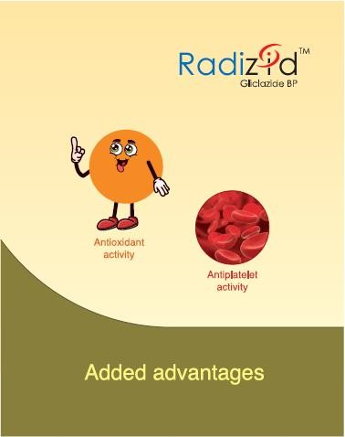

Content of the page

1st Page: Added advantages:- Antioxidant activity & Antiplatelet activity
2nd Page:
• Reduced monocyte adhesion to endothelial cell
• Reduction of oxidative LDL
• (-22%) Collagen induced platelet aggregation
• Fibrinolytic activity
Contents of detailing
- Radizid shows added advantages like antioxidant activity & antiplatelet activity as pleiotropic effects.
- To ensure these advantages, Radizid inhibits monocyte adhesion to endothelial cell, reduces oxidative LDL, significant inhibition of collagen induced platelet aggregation & shows the fibrinolytic activity.

Radimet Sales Aid
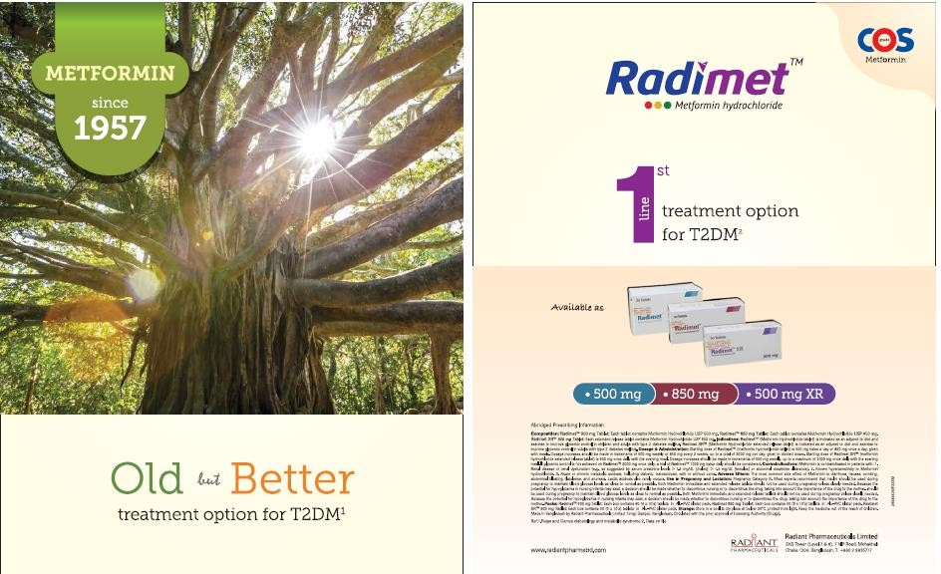

Content of the page
1st Page: Metformin since 1957. Old but better treatment option for T2DM.
2nd Page: 1st line treatment option for T2DM. Ensures the COS grade API
Contents of detailing
- From the inception of Metformin in 1957, still now Metformin is being used as the 1st line treatment option for T2DM according to updated ADA guideline
- We, the Radiant Pharmaceuticals, are providing COS grade API to ensure quality Metformin.

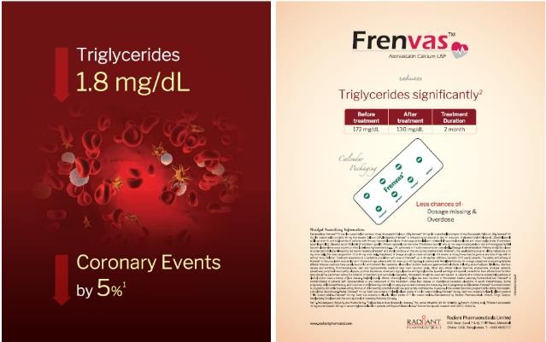
Frenvas Sales Aid

Content of the page
1st page: 1.8mg/dL reduction of TG reduces the Coronary events by 5%.
2nd page: Atorvastatin significantly reduces TG within 2month of tretment duration.

Contents of detailing
- Triglycerides is independent risk factor for CVD.
- 1.8mg/dL reduction of TG reduces CVD risk by 3-5%.
- Frenvas, COS grade Atorvastin reduces TG significantly.

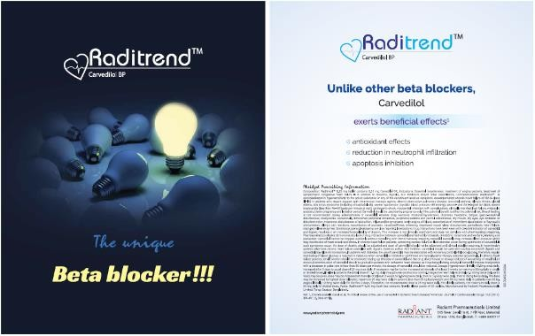
Raditrend Sales Aid

Content of the page
1st page: Here the unique beta blocker means the beta blocker with unique benefits
2nd page: All beta blocker improves heart rate & myocardial contractility, On top of these benefits carvedilol exerts other beneficial effects such as antioxidant effects, reduction in neutrophil infiltration, apoptosis inhibition.
Contents of detailing
- Raditrend, Carvedilol exerts other beneficial effects such as antioxidant effects, reduction in neutrophil infiltration, apoptosis inhibition.
- Radiant offers COS grade Carvedilol, Raditrend which ensures better management with patient compliance.

Communications Tips (April-2023)

Product name | Item details | Communication tips
Duovas | Bombay Sweets Food Combo | This combo is a special souvenir from our amlodipine&Olmesartan combination brand Duovas.
Duovas | Mens Fotua | Fotua is a traditional dress that resembles Bengali culture. On the occasion of Pahela Baishakh , this Souvenir is a special reminder from our brand.
Sevitan | Comely Handmade Soap | Soap helps us to manage our body neat and clean. Sevitan helps to manage stage-1 hypertension.
Carlina | Comely Restoring Nourishment Shampoo-180 | This is a very useful souvenir from our pioneer DPP4 inhibitor brand Carlina. It will give a fresh and healthy feeling like our product.
Carlina | Wave air-freshner Jasmine 125ml | This is a useful souvenir from our pioneer DPP4 inhibitor brand Carlina. It will give a fresh feeling in the room like our brand gives healthy and fresh feeling to the patients.
Prelizer | Crystal Clean Liquid Detergent, Weigh: 4 | This is a special souvenir from our product Prelizer.
Prelizer | Comely Restoring Nourishment Shampoo-180 | This is a very useful souvenir from our brand Prelizer. It will give a fresh and healthy feeling like our product.
Ardance | Gillette Blue 3 (02 pcs ) and Gillette S | This is a very useful souvenir from our brand. It will give a fresh and healthy feeling like our product.
Ardance | Different colour Table Runner (as per Sa | This is a very useful souvenir from our brand. It will give a fresh and healthy feeling like our product.
Ardance | Hogla Leaf Busket Hand Paint | This is a very useful souvenir from our brand. It will give a fresh and healthy feeling like our product.
Cardicil | Sunlite Aerosol (Insect killer 475ml) | This is a very useful souvenir from our brand. It will give a fresh and healthy feeling like our product.
Cardicil | Flower Vase Tulip (Medium) (Shape-PG-09) | This is a very useful souvenir from our brand. It will give a fresh and healthy feeling like our product.
Cardicil | Coffee Mug Progoti (Deco-21473) Flower | This is a very useful souvenir from our brand. It will give a fresh and healthy feeling like our product.
Creva | Holder | This is a very useful souvenir from our brand. It will give a fresh and healthy feeling like our product.
Creva | Bombay Sweets Food Combo ( Premium Biriyani Masala) | This is a very useful souvenir from our brand. It will give a fresh and healthy feeling like our product.
Creva | Raxoll Anti-Bacterial Hand wash- 200ml-P | This is a very useful souvenir from our brand. It will give a fresh and healthy feeling like our product.
Radizid | Premium Lachcha 250gm | This is a very useful souvenir from our brand. It will give a fresh and healthy feeling like our product.
Radizid | Glass Coaster-6 pcs Set | This is a very useful souvenir from our brand. It will give a fresh and healthy feeling like our product.
RAD | SKB Jug-02 Ltr | This is a very useful souvenir from our brand. It will give a fresh and healthy feeling like our product.



