# Siemens TWIX data: orientation information

In this experiment, an understanding is acquired for the orientation information of an acquired volume on a Siemens scanner. In particular, the orientation information from the NIFTI header is looked at and compared with the orientation information extracted from the raw data (TWIX object).

To do this, a phantom scan was acquired with a different object geometry in all 3 dimensions:  
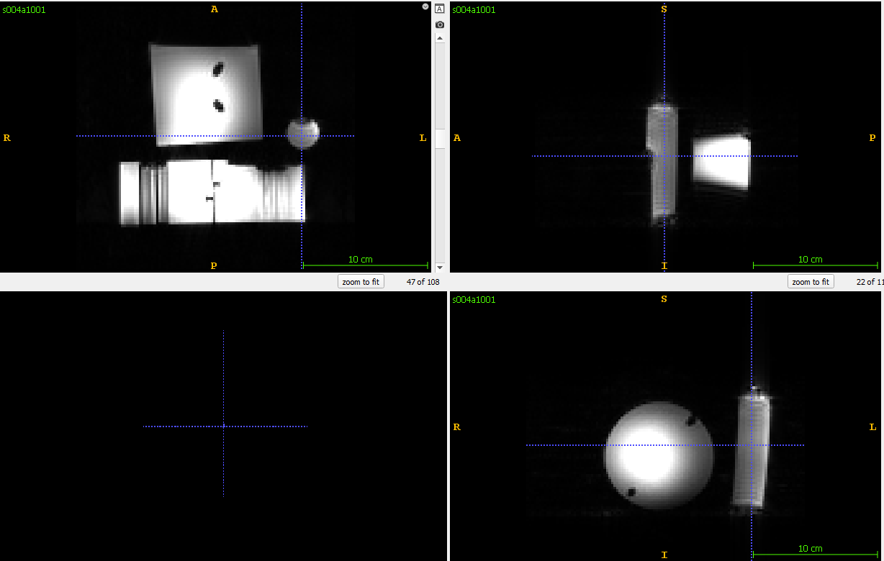

Next, acquisitions were repeated with repeating the FOV around one of the axes:

* 20210302_FID18142_P_GRE_MIDRES_DISO_16_16_LIN_LIP
  + Default scan: No rotation
* 20210302_FID18149_P_GRE_DISO_HFRot10v2
  + FOV rotation of 10 degrees around **Head Foot** axis  
    Attention: Also contains additional rotation around LR axis.
* 20210302_FID18150_P_GRE_DISO_LRRot10v2
  + FOV rotation of 10 degrees around **Left Right** axis
* 20210302_FID18151_P_GRE_DISO_PARot10v2
  + FOV rotation of 10 degrees around **Anterior Posterior** axis  
    Attention: Naming is wrong due to confusion of the FOV axes during acquisition.

First, the NIFTI head will be look at and afterwards the same orientation is tried to be extracted from the raw data.

See MATLAB files for examples.

To run the NIFTI reading/writing function in the repository, need to extend the file name with subscript (e.g. image.nii 🡪 image_.nii).

Helper functions for this experiment are taken from the DISORDER repository.